3GPP TSG-RAN WG2 #118-e Tdoc R2-22xxxxx

Electronic meeting, 9th May – 20th May 2022

Agenda Item: 6.4.1.3

Source: Ericsson

Title: Summary of [AT118-e][064][eIAB] RRC (Ericsson)

Document for: Discussion, Decision

# 1 Introduction

This document addresses the following email discussion:

* [AT118-e][064][eIAB] RRC (Ericsson)

Scope: 1. Address the remaining RRC issues from tdocs submitted under AI 6.4 (and below) and RILs (if needed), except those issues addressed in specific discussion. Review collect comments identify agreement points, points for online CB etc. 2. Progress the RRC CR, merge all RRC impacts into a single CR (except UE caps).

Intended outcome: Report, CR

Deadline: 1 for CB W2 Wed, 2 CR agreement is expected in Post meeting discussion

Rapporteur would like to set the deadline for this email discussion to Tuesday 17th May 10:00 UTC

# 2 Discussion

The following agreement has been reached during the online discussion in RAN2#118-e:

* all the propAgree, propReject and propModify states are confirmed, except H044 H045 which can be discussed

This email discussion focuses on RILs that require further discussion as captured in the RIL excel sheet in R2-2206346.

## 2.1 RIL v222

The current implementation of the new Rel.17 availabilityCombinations (defined as availabilityCombinationsRBGroup-r17 in the current ASN1) is as follows:

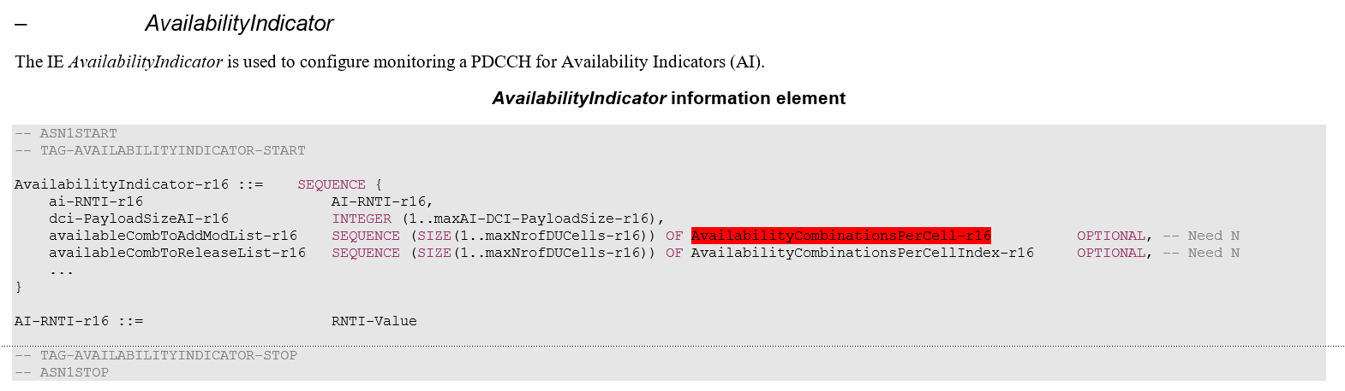

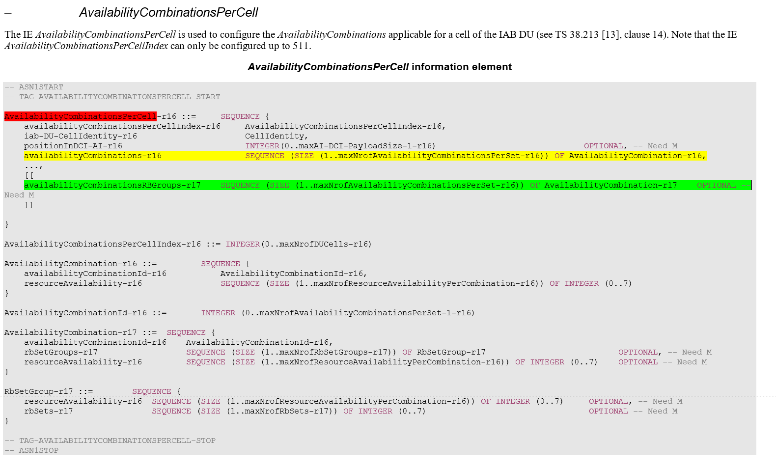

From the above ASN1 excerpt, the legacy availabilityCombinations-r16 table, and the new Rel.17 availabilityCombinationsRBGroups are configured separately within the AvailabilityCombinationsPerCell-r16 which is configured per DU cell. In particular, th new Rel-17 availabilityCombinationsRBGroups-r17 is included as an optional configuration within the legacy Rel.16 AvailabilityCombinationsPerCell.

In the RIL v222, it is proposed to decouple from the AvailabilityCombinationsPerCell-r16, the new Rel-17 availabilityCombinationsRBGroups and the legacy Rel.16 AvailabilityCombinationsPerCell. The solution for this RIL would imply introducing a new AvailabilityCombinationsPerCell-r17 in the form of a Add/ReleaseModList structure within the AvailabilityIndicator IE. Then we would need to create a new AvailabilityCombinationPerCell type, e.g. AvailabilityCombinationPerCellExt, which would basically have the same structure as the AvailabilityCombinationPerCell-r16, and also a lot of parameters in common with the legacy AvailabilityCombinationPerCell-r16, e.g. the availability combination ID, the cell ID, the position in DCI, etc.

Rapporteur also highlights that the following was just agreed in RAN1, and no concern were specifically raised on this RAN2 design:

|  |
| --- |
| **RAN1 agreement from this meeting:**  An IAB node can be configured with two availabilityCombinations tables, one for TDM and one for FDM |

Hence, RAN2 should discuss whether there is a strong need to pursue the change in RIL v222, considering the potential ASN.1 impact.

* **Q1: [v222] Do you see the need to decouple from the legacy AvailabilityCombinationsPerCell-r16, the new Rel-17 availabilityCombinationsRBGroups and the legacy Rel.16 AvailabilityCombinationsPerCell?**
  + **This change would imply introducing a new AvailabilityCombinationsPerCell-r17 (which would include the new Rel-17 availabilityCombinationsRBGroups) in the form of a Add/ReleaseModList structure within the AvailabilityIndicator**

|  |  |  |
| --- | --- | --- |
| **Company** | **Yes, need to decouple**  **No need to decouple** | **Comments** |
| QCOM | Prefer not to decouple unless the majority prefers it that way.  See comment. | Yes, it might look nicer if they both were decoupled. Apart from that, there seems to be no technical reason to go the extra mile. One might actually ask why the AvailabilityCombinationPerCell-r16 IE was made extensible if not for the purpose of extending it, e.g., in Rel-17. |
| LGE | No need to decouple | We prefer to keep the structure as it is unless RAN1 request to make it separate, but no strong view, if majority want, we can follow as a compromise. |
|  |  |  |
|  |  |  |
|  |  |  |
|  |  |  |
|  |  |  |
|  |  |  |
|  |  |  |
|  |  |  |

## 2.2 RIL H044

In the current implementation two resourceAvailability IEs are included, one within the AvailabilityCombination-r17 (green entry below), the other within the RBSetGroup-r17 within the AvailabilityCombination-r17 (yellow entry). The field description clarifies that the one within the AvailabilityCombination-r17 (green entry) is only used in case the one in the RBSetGroup-r17 (yellow entry) is not configured.

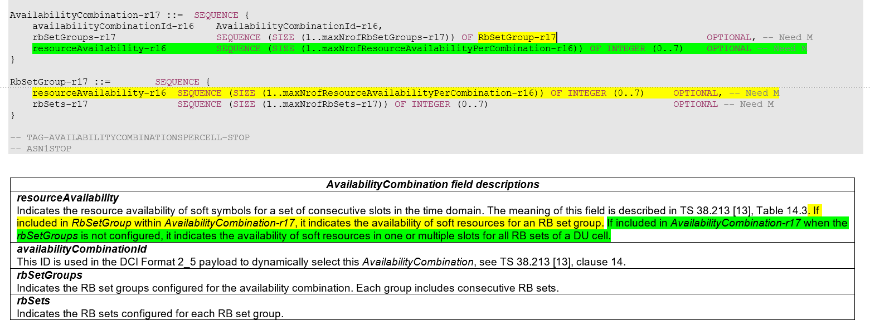

The reason for this implementation originates from the following RAN1 agreements indicated in the RAN1 LS:

1) "each resourceAvailaibity-Rel17 indicates the availability of soft resources in one or multiple slots for each configured RB set group in sequence."

2) "If an RB set group is not provided, only one resourceAvailablity-Rel17 is included in AvailabilityCombination-Rel17 to indicate availability of soft resources in one or multiple slots for all RB sets of a DU cell."

In Rapporteur´s view, the agreement in yellow above is represented by the resourceAvailability in the RBSetGroup-r17 within the AvailabilityCombination-r17 (yellow entry in the ASN1 code above), whereas the agreement in green is represented by the resourceAvailability included within the AvailabilityCombination-r17 (green entry in the ASN1 code above).

The RIL H044 claims that the resourceAvailability-r16 in AvailabilityCombination-r17 is redundant with the one in RbSetGroup-r17, and it should be deleted. Rapporteur believes that the current implementation seems to reflect the RAN1 agreements cited above.

* **Q2: [H044] Do you believe that the resourceAvailability-r16 in AvailabilityCombination-r17 should be deleted from the ASN1?** 
  + **If yes, please clarify how you would represent in the ASN.1 the case in which the RB set group in not provided (which is considered in the above cited RAN1 agreement)**

|  |  |  |
| --- | --- | --- |
| **Company** | **Yes, should be deleted**  **No (keep current spec)** | **Comments** |
| QCOM | No (keep current spec) |  |
| LGE | No |  |
|  |  |  |
|  |  |  |
|  |  |  |
|  |  |  |
|  |  |  |
|  |  |  |
|  |  |  |
|  |  |  |

## 2.3 RIL H045

In the current Rapporteur CR, the rbSets is represented as a sequence of RB set indexes, one for each RB set configured in one RB set group. See the ASN.1 code below:

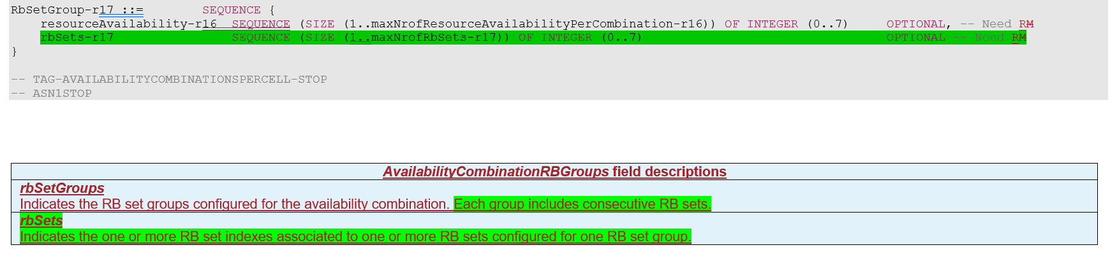

This design choice was motivated by the following RAN1 agreement in the RAN1 LS:

|  |
| --- |
| From RAN1 LS:  The RB set groups are configured in availabilityCombinationsPerCell-r17  for all availabilityCombinationId(s)  with the following parameters   * Number of RB set groups.   Number of RB sets for each group. Each group includes consecutive RB sets. |

Hence, from the above agreement, it seems that in RAN2 we should represent a sequence of consecutive RB sets within each RB set group. This seems in line with what currently implemented in the ASN.1.

The RIL H045 claims that based on the R3 signalling, we can just use the index of RbSetGroup without the need of SEQUENCE, i.e. “rbSets-r17 ~~SEQUENCE (SIZE (1..maxNrofRbSets-r17)) OF~~ INTEGER (0..7)”. Rapporteur notes that in the RAN3 F1AP signalling there is no RBSetGroup defined, because the RBSetGroup configuration is only related to the availabilityCombinationsPerCell defined in RAN2.

* **Q3: [H045] Do you believe that the rbSets configuration should not be a sequence of consecutive RB set?** 
  + **If yes, please clarify how you would represent in the ASN.1 this consecutive RB sets within each RB set group, as indicated by RAN1?**

|  |  |  |
| --- | --- | --- |
| **Company** | **Yes, change needed**  **No (keep current spec)** | **Comments** |
| QCOM | No (keep current spec) | RAN3 signaling only has RB set, no RB set groups. |
| LGE | No |  |
|  |  |  |
|  |  |  |
|  |  |  |
|  |  |  |
|  |  |  |
|  |  |  |
|  |  |  |
|  |  |  |

## 2.4 RIL F005

In the RIL F005, it is proposed to clarify in the field description of *iab-donor-DU-BAP-Address*, that for a boundary IAB node’s descendant node, this field may be a pseudo BAP address. RAN2 should discuss the need of addressing this issue.  
Rapporteur notes that RRC procedures are currently agnostic with respect to whether the IAB node is boundary IAB node or descendant IAB node, and that the IAB-MT operations of the descendant IAB node may not be affected by inter-topology routing at the boundary IAB node. Whether the *iab-donor-DU-BAP-Address* configured at the descendant IAB node is a pseudo BAP address seems to be more an implementation aspect in the IAB donor (or a stage-2 detail, if needed), rather than an RRC-specific issue.

* **Q4: [F005] Do you see the need to to clarify in the field description of iab-donor-DU-BAP-Address, that for the descendant node of a boundary IAB node, this field may be a pseudo BAP address?**

|  |  |  |
| --- | --- | --- |
| **Company** | **Yes, see the need**  **No need** | **Comments** |
| QCOM | No | The term “pseudo BAP address” was only used by companies in a colloquial manner during discussion. It has never been used in the spec. It has not been defined anywhere. Introducing such a term would add confusion rather than clarification. |
| LGE | No | Agree with rapporteur’s analysis that RRC procedures should be agnostic. |
|  |  |  |
|  |  |  |
|  |  |  |
|  |  |  |
|  |  |  |
|  |  |  |
|  |  |  |
|  |  |  |

## 2.5 RIL H046

In the RIL H046, it is proposed to clarify that the *f1c-TransferPathNRDC* is only used for CP/UP separation (not for topology redundancy). RAN2 could clarify in the field description that the *f1c-TransferPathNRDC* is used only when the IAB-MT is configured with NR-DC with one non-donor CU (i.e. no BH RLC channels in one leg).

* **Q5: [H046] Do you see the need to clarify that f1c-TransferPathNRDC is only used for CP/UP separation, i.e. when the IAB-MT is configured with NR-DC with one non-donor CU (no BH RLC channels in one leg)?**

|  |  |  |
| --- | --- | --- |
| **Company** | **Yes, see the need**  **No need** | **Comments** |
| QCOM | No need | RAN2 never restricted F1C -based transfer to CP-UP separation.  RAN2 solely agreed:   * F1-C over RRC and F1-C over BAP should not be supported simultaneously on the same parent link.   To comply with this agreement, F1-C-over-BAP could be restricted to only one leg via configuration, e.g., by only providing one UL mapping for F1-C, even if the IAB-node has both legs configured with BAP. |
| LGE | No | This restriction may not be needed and anyway it is up to NW implementation which decides whether this should be transferred via the non-donor CU or not. |
|  |  |  |
|  |  |  |
|  |  |  |
|  |  |  |
|  |  |  |
|  |  |  |
|  |  |  |
|  |  |  |

## 2.6 RIL Z632

In the RIL Z632, it is proposed that if the *f1c-TransferPathNRDC* is configured with ”both”, it should not be left to the IAB-MT to select the MCG or the SCG for F1-C transfer, rather the IAB-MT should prioritize F1-C transmission over the CG with configured BH RLC CH.   
Rapporteur notes that RAN2 just agreed that if the IAB node selects a leg where there is a BH RLC channel, then the IAB-MT should use F1-C over BAP, otherwise F1-C over RRC. But we did not agree that when “both” is configured the IAB-MT should prioritize F1-C over BAP. Additionally, if the network wants the IAB node selects F1-over BAP, it would be just enough for the network to configure the *f1c-TransferPathNRDC* with “mcg” or “scg” depending on the leg in which BAP is configured.

* **Q6: [Z632] Do you see the need to introduce a rule for the f1c-TransferPathNRDC such that when the f1c-TransferPathNRDC is configured with ”both”, the IAB-MT should select F1-C transmission over the CG with configured BH RLC channels?**

|  |  |  |
| --- | --- | --- |
| **Company** | **Yes, need the change**  **No (keep current spec)** | **Comments** |
| QCOM | No (keep current spec) | To make it clear: If “both” is configured, the IAB-node can freely decide to use either path, i.e., via RRC or via BAP. There is no pre-defined priority.  This is the same behavior as we defined for ENDC in Rel-16. We should have common behavior for Rel-16 ENDC and Rel-17 NRDC.  RAN2 NEVER agreed to such a prioritized behavior for the “both” configuration.  If we restricted the IAB-node’s behavior for the “both” configuration, it wouldn’t make sense to even support the “both” configuration.  Note that the whole purpose of the “both” configuration is to provide robustness to the C-plane. This only works if the IAB-node can freely use either path. |
| LGE | No | Note that same issue is now discussing in “[AT118-e][068][eIAB] 37340 (vivo)”.  As indicated by the rapporteur and QC above, RAN2 never agreed to such prioritization for “both” configuration.  We think that they may misinterpret the below agreement. This agreement is for one Cell Group, not per UE. So, the current field description has no problem.   * As long as the BH RLC CH for F1-C on the indicated Cell Group is configured (the CG is indicated by the field *f1c-TransferPath-r17*), IAB node can be aware of whether to use F1-C transferring over BH or F1-C transferring over RRC, i.e. F1-C-over-BAP is selected as long as BH RLC CH for F1-C on the indicated CG is configured. |
|  |  |  |
|  |  |  |
|  |  |  |
|  |  |  |
|  |  |  |
|  |  |  |
|  |  |  |
|  |  |  |

## 2.7 RIL S733

In the S733, it is proposed that the *logicalChannelGroup* configuration for IAB should go from 0 to 255, rather than from 8 to 255. The reason for specifying it from 8 to 255 was that in case the network does not want to configure the extended LCGs, it can simply configure the legacy logicalChannelGroup with 0 to 7 LCGs. Companies that see the need for this change argue that the extended short BSR allows 8bits buffer size, rather than 5bits buffer size as the legacy short BSR.   
Rapporteur´s view is that the network can configure the IAB-MT with the new extend logicalChannelGroup if more granularity in the short BSR is required.

* **Q7: [S733] Do you see the need to define the logicalChannelGroup-IAB-Ext-r17 from 0 to 255, rather than from 8 to 255 (as it is in the current spec)?**

|  |  |  |
| --- | --- | --- |
| **Company** | **Yes, need the change**  **No (keep current spec)** | **Comments** |
| QCOM | No strong view. |  |
| LGE | Yes. | We think that this causes a potential issue in BSR procedure and the related discussion is undergoing in “[AT118-e][065][eIAB] MAC (Samsung)”.  For the rapporteur’s comment above, i.e., “**Rapporteur´s view is that the network can configure the IAB-MT with the new extend logicalChannelGroup if more granularity in the short BSR is required.**”, the problem is that even though the network wants more granularity in the short BSR for the logical channel 0 to 7, the IAB-node cannot report the extended Short BSR for the logical channel 0 to 7 because logicalChannelGroup-IAB-Ext-r17 starts from 8 to 255. We think that this is unnecessary restriction to the extended BSR procedure and it should be resolved.  Also note that considering that 5bits buffer size field in the Legacy Short BSR is designed only for one UE, not for backhaul traffic from many UEs, the IAB node should use an extended Short BSR if the IAB node support extended BSR format.  Based on these reasons, the MAC discussion rapporteur’s suggestion in “[AT118-e][065][eIAB] MAC (Samsung)” on this issue is to update the extended BSR procedure in MAC spec and he mentioned that the logicalChannelGroup-IAB-Ext-r17 should start from 0 to 255 in RRC offline discussion. We think that just changing start from 0 is very simple from RRC spec change perspective and this also removes all concerns and problems. |
|  |  |  |
|  |  |  |
|  |  |  |
|  |  |  |
|  |  |  |
|  |  |  |
|  |  |  |
|  |  |  |

## 2.8 RIL F008

In the RIL F008, it is proposed that if the iab-IP-AddressConfigurationList was received within an RRCReconfiguration message generated by the non-F1-terminating donor-CU of the boundary IAB node, the boundary IAB node considers the IAB IP address configuration is for the non-F1-terminating topology. Whereas, if the iab-IP-AddressConfigurationList was received within an RRCReconfiguration message generated by the F1-terminating donor-CU of the boundary IAB node, the boundary IAB node considers the IAB IP address configuration is for the F1-terminating topology

Rapporteur notes that in the rapporteur CR, it has been clarified that the IAB-IP-AddressConfigurationList can be included in the SCG configuration (besides the MCG). Hence it seems clear, without further clarifications, that the IAB node should use the received IAB-IP-AddressConfigurationList in the respective CG.

* **Q8: [F008] Do you see the need to clarify, e.g. in a note, that the IAB node should use the *iab-IP-AddressConfigurationList* configured in the SCG for communication towards the SCG, and the iab-IP-AddressConfigurationList configured in the MCG for communication towards the MCG?**

|  |  |  |
| --- | --- | --- |
| **Company** | **Yes, need to clarify**  **No (keep current spec)** | **Comments** |
| QCOM | No (keep current spec) | Obviously, all configurations received in the SCG apply to the SCG leg and all configurations received in the MCG apply to the MCG leg. It is not clear why we would need such a clarification just for IP address configurations. |
| LGE | No | Agree with rapporteur and QC. |
|  |  |  |
|  |  |  |
|  |  |  |
|  |  |  |
|  |  |  |
|  |  |  |
|  |  |  |
|  |  |  |

# Conclusion

[To be updated]