3GPP TSG-RAN WG2 Meeting #118 Electronic R2-220xxxx
Online, May, 2022

Agenda item: 5.1.4.1.2
Source: Apple
Title: DRAFT Summary of [AT118-e][018][NR1516] RRM and measurements (Apple)
WID/SID: NR_newRAT-Core
Document for: Discussion and Decision

1 Introduction
This document reflects the content and outcome of the following email discussion:
- [AT118-e][018][NR1516] RRM and measurements (Apple)
Scope: Treat R2-2204483, R2-2205678, R2-2206093, R2-2205294, R2-2205295, R2-2205296, R2-2205297, R2-2205213, R2-2205214, R2-2204611, R2-2204612, R2-2204613
Ph1 Determine agreeable parts, Ph2 for agreeable parts agree CRs (offline agreement, CB online only if necessary).
Intended outcome: Report, Agreed CRs
Deadline: Schedule 1

NOTE: Discussions with Deadline Schedule 1:
A first round with Deadline for comments W1 Thursd May 12th 1200 UTC to settle scope what is agreeable etc
A Final round with Final deadline W2 Wednesd May 18th 1200 UTC to settle details / agree CRs etc.
Additional deadlines check points etc if needed are defined by the Rapporteur of each discussion respectively. In case some parts of an email discussion need more time, doesn’t converge, need on-line treatment, then please contact the chair.

The discussion covers the following documents from AI 5.1.4.1.2 RRM and Measurements.

2 Contact Points
Respondents to the email discussion are kindly asked to fill in the following table.
Company | Name | Email Address
Huawei, HiSilicon | Lili Zheng | zhenglili4@huawei.com
Apple | Fangli XU | fangli_xu@apple.com

3 Discussion

3.1 L3 Filter
L3 filter
R2-2204483 Reply LS to RAN2 on L3 filter configuration (R4-2207041; contact: Apple) RAN4 LS in Rel-15 NR_newRAT-Core To:RAN2
R2-2205678 Clarification on L3 filtering configuration (filterCoefficient) Apple, Ericsson CR Rel-16 38.331 16.8.0 3111 - F NR_newRAT-Core
R2-2205961 Clarification on L3 filtering configuration (filterCoefficient) Apple, Ericsson CR Rel-16 38.331 16.8.0 3139 - A NR_newRAT-Core Late
=> Revised in R2-2206093
R2-2206093 Clarification on L3 filtering configuration (filterCoefficient) Apple, Ericsson CR Rel-17 38.331 17.0.0 3139 1 A NR_newRAT-Core
R2-2205294 Discussion on L3 filtering Huawei, HiSilicon discussion Rel-15 NR_newRAT-Core
R2-2205295 Correction to L3 filtering (R15) Huawei, HiSilicon CR Rel-15 38.331 15.17.0 3063 - F NR_newRAT-Core
R2-2205296 Correction to L3 filtering (R16) Huawei, HiSilicon CR Rel-16 38.331 16.8.0 3064 - A NR_newRAT-Core
R2-2205297 Correction to L3 filtering (R17) Huawei, HiSilicon CR Rel-17 38.331 17.0.0 3065 - A NR_newRAT-Core

For the NR L3 filtering design is inherited from LTE. According to RRC spec description, for the filterCoefficient configuration, NW and UE operation should comply with the following principle:
- UE’s L3 filter input rate is (from L1) is UE implementation dependent (as described in NOTE3);
- NW provides the filterCoefficient configuration based on the assumed sample rate (according to the description marked in yellow as below);
- UE adapts its Layer 3 filter implementation and scales the filter coefficient based on the UE’s actual L1 input rate; (according to the description marked in green as below).
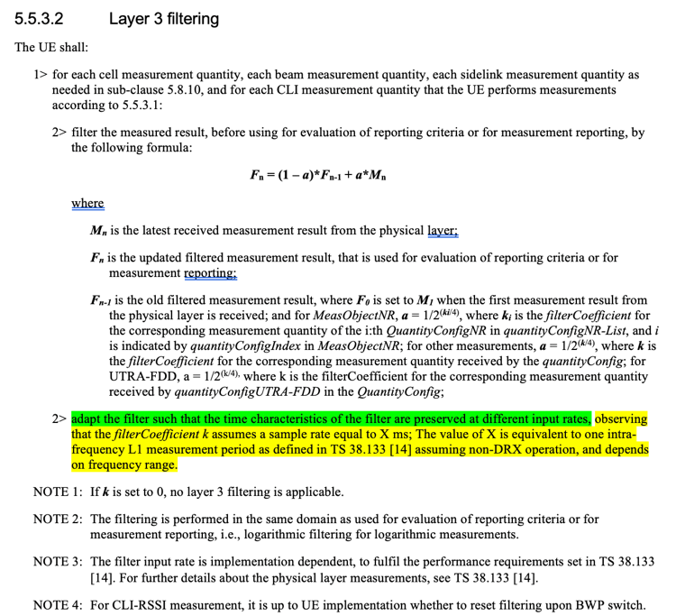

In RAN2#116e meeting, RAN2 discussed the sample rate X(ms) associated to the L3 filter configuration (i.e., filterCoefficient k) based on R2-2110022. And RAN2 reached the following common understandings during the offline discussion which were indicated in the LS to RAN4 (R2-2111590).
- The UE and gNB have the same understanding on the sample rate X.
- The sample rate X is not changed due to L1/L2 operation, e.g. SCell activation/deactivation, BWP switching, etc.
In RAN4 LS (R2-2204483/ R4-2207041), RAN4 provided the following feedback:
- According to current spec, the value of the sample rate X will be changed due to the L1/L2 operation, since the parameters which influence the value is changeable by the L1/L2 operation.
- The lower bound(200ms, 400ms) of intra-frequency measurement period, which is only related to FR is unchangeable by the L1/L2 operation.

Taking RAN4 feedback into account, in order to avoid the X value changeable due to L1/L2 operation, R2-2205678 and R2-2206093 propose to clarify that the sample rate X is set to the fix value as RAN4 indicated, i.e. 200ms for FR1 and 400ms for FR2.
Proposal: Change the value setting of the sample rate X for L3 filtering and set X value to 200ms for FR1 and 400ms for FR2.
TP:

But R2-2205294 - R2-2205297 propose to make the sample rate X changeable and use the configured value of the filter coefficient k without adaptation.
Proposal 1: When performing L3 filtering, the filter coefficient k uses the value received from the network, which is independent from the L1/L2 operation; the sample rate X follows the definition of 38.133, which is changeable by the L1/L2 operation.
TP:
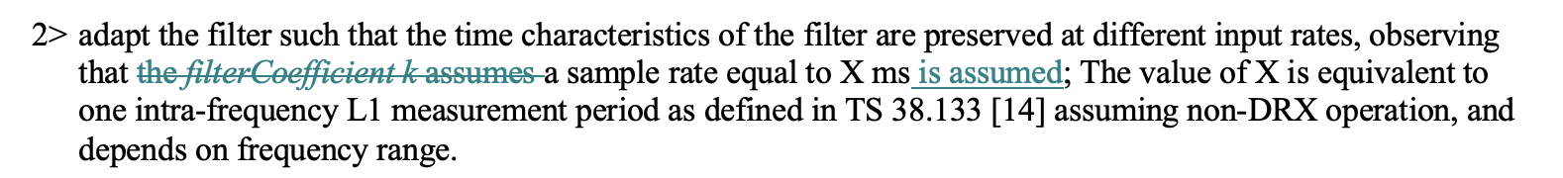

Question 1: Which option of the L3 filter clarification do you prefer?
- Option 1: Set the sample rate X for L3 filtering as the fix value (R2-2205678 and R2-2206093)
- Option 2: The sample rate X is changeable due to L1/L2 operation, and UE uses the configured value of the filter coefficient k without adaptation. (R2-2205294 - R2-2205297)
Company | Preferred Option? | Comments
Huawei, HiSilicon | Option 2 | Proponent of Option2.  According to RAN4 LS, the value of the sample rate X will be changed due to the L1/L2 operation, so Option 1 is NBC and not aligned with RAN4 spec.  We would like to further clarify whether filterCoefficient k or sample rate X is changeable:  In LTE, the sample rate is a fixed value, but the L1 measurement period is changeable, so it is reasonable to adapt the filter coefficient k considering the relationship between sample rate and L1 measurement period, as captured in 36.331:  2> adapt the filter such that the time characteristics of the filter are preserved at different input rates, observing that the filterCoefficient k assumes a sample rate equal to 200 ms;  In NR, the sample rate X equals to L1 measurement period and both of them are changeable, which means the sample rate has already been adapted to the L1 measurement period. In this case, the UE should directly use the filter coefficient k configured by the network and no further adaptation is needed. If needed, it is unclear which principle should the adaptation follow.  Based on the above, the filter coefficient k is the value received from the network, which is independent from the L1/L2 operation; the sample rate X follows the definition of 38.133, which is changeable by the L1/L2 operation.
Apple | Option 1 | Option 1 is aligned with the RAN2 common understanding, i.e., UE and NW should hav ehte same understanding on the sample rate X for configuration.  But Option 2 is not aligned with it.  < from RAN2#115e meeting chairman notes>  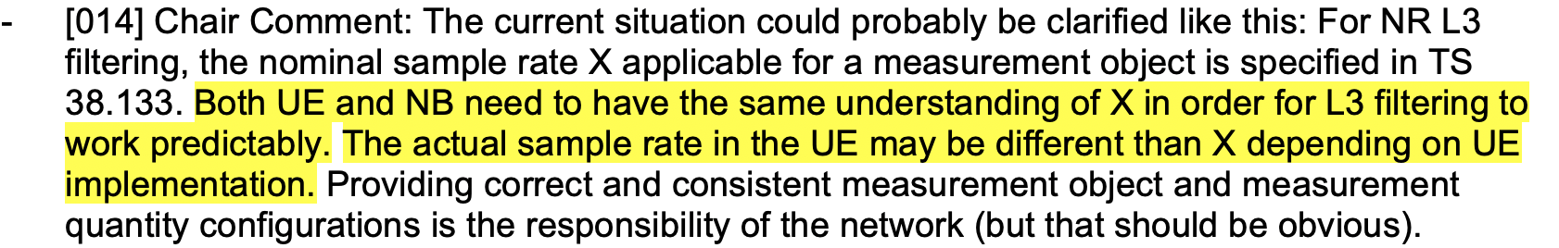  <RAN2 common understanding in RAN2#116e is reflected in the LS to RAN4 - R2-2111590>  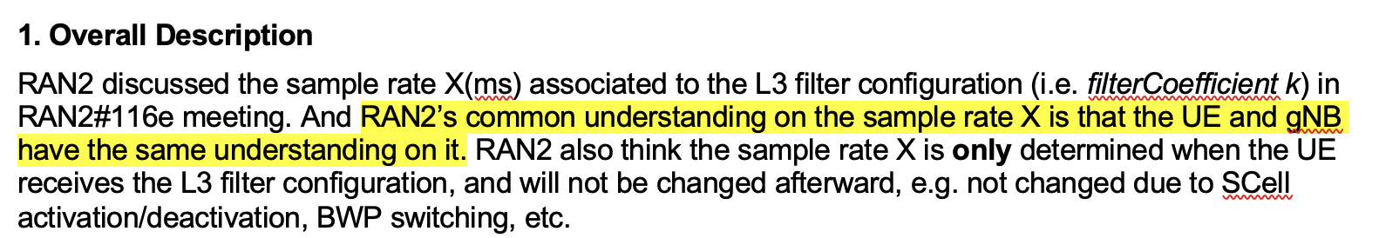

Question 2: Which release of the spec do you prefer the clarification to start with, i.e. Rel-15 or Rel-16?
Company | Release? | Comments
Huawei, HiSilicon | R15 | Note that the changes in R2-2205295 (and accompanying shadow CRs) do not change the logic of current text, and bring no backward compatibility issues.
Apple | Rel-15

3.2 Correction on quantity configuration (R2-2205313/14)
R2-2205313 Correction on quantity configuration Xiaomi CR Rel-15 38.331 15.17.0 3067 - F NR_newRAT-Core
R2-2205314 Correction on quantity configuration Xiaomi CR Rel-16 38.331 16.8.0 3068 - A NR_newRAT-Core

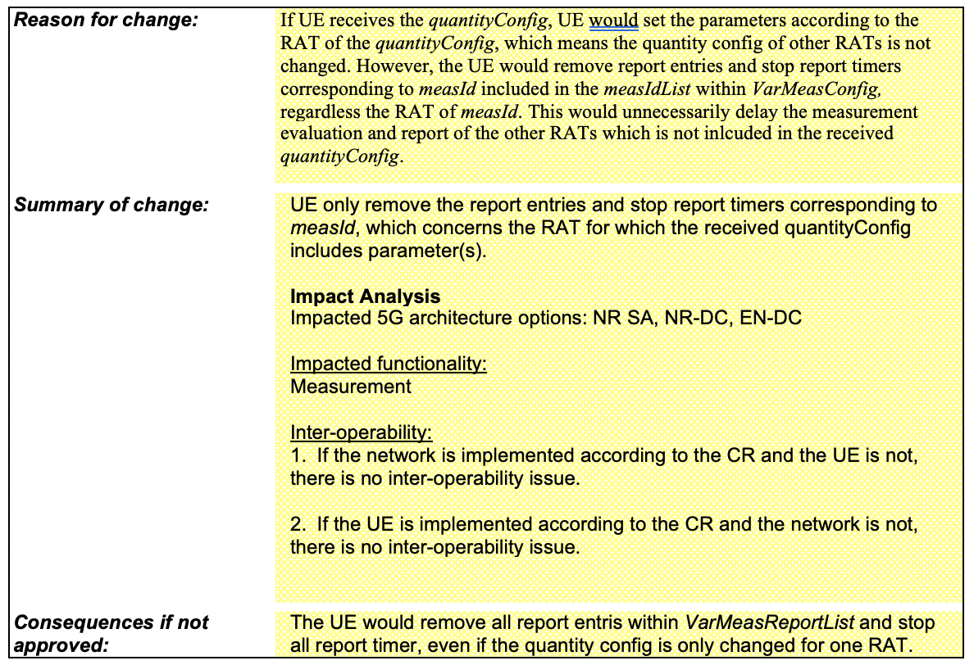

Question 3: Do you agree with the CR?
Company | Agree or not? | Comments
Huawei, HiSilicon | No | The logic inherits from LTE. The same proposal was discussed in R2-090471 and was rejected.  R2-090471: Correction on Quantity Configuration LG Electronics Inc. CR 36.331 F Disc  Proposal 1:  - NTT DCM indicates that we agreed yesterday that the quanity config should always be present. This is covered in the NTT DCM CR so no need for this.  => Noted  Proposal 2:  => Noted (already covered by NTT DCM CR)  Proposal 3:  - Samsung indicates this was discussed when this was introduced. Network can configure all RAT’s initially and then there is no problem.  => Not needed  Proposal 4:  - Nokia thinks it is a bit more clearer.  => Proposal 4 will be included by ASN.1 rapporteur.
Apple | No | This is a change of UE behaviour. We dont see a strong reason for that.

3.3. Corrections on T321&T322 timer start (R2-2204611/12/13)
R2-2204611 38331CR Corrections on T321 and T322 timer start-R15 OPPO CR Rel-15 38.331 15.17.0 2981 - F NR_newRAT-Core
R2-2204612 38331CR Corrections on T321 and T322 timer start-R16 OPPO CR Rel-16 38.331 16.8.0 2982 - A NR_newRAT-Core
R2-2204613 38331CR Corrections on T321 and T322 timer start-R17 OPPO CR Rel-17 38.331 17.0.0 2983 - A NR_newRAT-Core

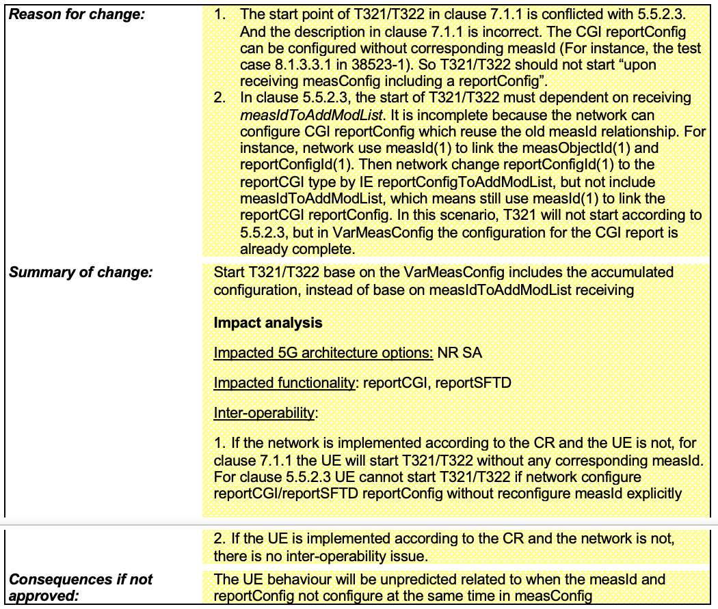

Question 4: Do you agree with the CR?
Company | Agree or not? | Comments
Apple | No | The change looks like a cleanup. The purpose is already understandable from the original text, even though it is not optimum.

4 Conclusion
TBD.

