**3GPP TSG-RAN WG2 #113bis-e *R2-210xxxx***

**E-meeting, April 2021**

Agenda Item: 6.2.2

Source: OPPO

Title: Summary of [704]

Document for: Discussion, Decision

# Introduction

This is to discuss the [704] as follows.

* [AT113bis-e][704][V2X/SL] PSFCH transmission (OPPO)

**Scope:** Discuss what the current TX synchronization procedure is and what is limitation of PSFCH transmission, and what is RAN2 common understanding on PSFCH transmission (e.g. PSFCH is transmitted regardless of its own synchronization defined in the procedure or PSFCH may not be transmitted due to limitation of single synchronization defined in the procedure).

**Intended outcome:** Discussion summary in R2-2104469.

**Deadline:** 4/19, 14:00 (UTC).

# Discussion

According to sync procedure of R16 NR-V2X, specified in TS 38.331 section 5.8.6, for two UEs communicating via PC5



Figure 1 Sync procedure for UEs communication via PC5

Each UE (UE1 and UE2) based on the sync source in the proximity (gNB, GNSS and UE), and the sync configuration, to derive the sync reference, of which the sync is used as the reference of Tx sync of its own:

* UE1 to derive the sync for UE1 transmission, e.g., sync-1;
* UE2 to derive the sync for UE2 transmission, e.g., sync-2;

Since besides the GNSS, the gNB/UE sync reference may be different for different UE’s proximity, so the Tx-sync of each UE may be different.

Actually, the issue has previously already identified by RAN4, in LS of **R4-1912826**

*RAN4 is discussing the need of requirements for sidelink synchronization when multiple asynchronized sources are presented. RAN4 noticed that RAN1 agreed the following synchronization source priority.*

*[…]*

*With the above synchronization source priority, RAN4 identifies the following scenarios in which timing misalignment may exist between UEs communicating on SL*

* *UE1 and UE2 synced to two different gNBs, but the 2 gNBs are with different timing*
* *UE1 and UE2 synced to two different eNBs, but the 2 eNBs are with different timing*
* *UE1 synced to eNB, UE2 synced to gNB, eNB and gNB are with different timing*

*RAN4 would ask RAN2 to check if there is any signalling available for timing adjustment in the above scenarios where multiple gNB/eNB with different timing are presented.*

Where sync-1 and sync-2 are different, as shown below, symbol boundary is not aligned, which can be even larger than CP.

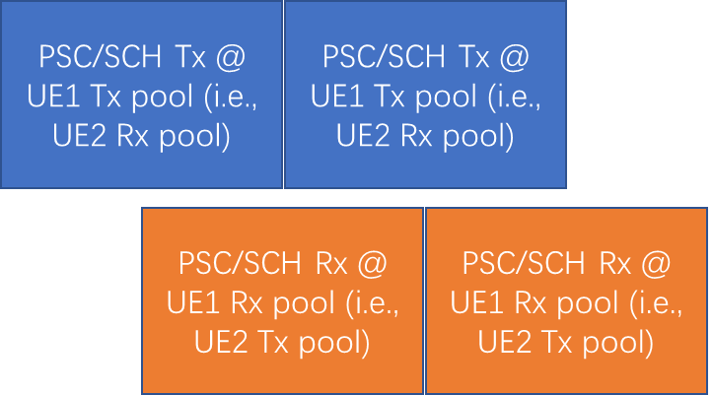

Figure 2 Un-sync-ed PSCCH/PSSCH Tx, and PSCCH/PSSCH Rx (when FB disabled)

According to the latest RAN1 discussion on UE feature, i.e., R1-2005111, RAN1 has evaluated the 3 alternatives below:

**Alt. 1: Delete FG 15-24 (i.e., UE supports sidelink reception using up to one synchronization reference in a band)**

**Alt. 2:**

|  |  |  |  |  |  |  |  |  |  |  |  |  |
| --- | --- | --- | --- | --- | --- | --- | --- | --- | --- | --- | --- | --- |
| 15-24 | Support of multiple synchronization references | 1) UE can support sidelink reception using up to A synchronization reference~~s~~ Rx timings in a ~~carrier/BWP~~ band | At least one of 15-1, 15-2, 15-3 | Yes | No | UE supports only a single synchronization reference in a ~~carrier/BWP~~ band. | Per band | N.A. | N.A. | N.A. | Component-1 candidate value set: {~~1,~~ 2, 3, 4}  Note: A UE that does not support FG 15-24 supports sidelink reception using up to one synchronization reference RX timingin a band | Optional with capability signalling |

**Alt. 3:**

|  |  |  |  |  |  |  |  |  |  |  |  |  |
| --- | --- | --- | --- | --- | --- | --- | --- | --- | --- | --- | --- | --- |
| 15-24 | ~~Support of multiple synchronization references~~  Number of tx and rx timings | 1. ~~UE can support sidelink reception using up to A synchronziaion references in a carrier/BWP~~ 2. This parameter indicates the number of multiple reference TX/RX timings in a band for V2X sidelink communication | At least one of 15-1, 15-2, 15-3 | Yes | No | UE supports only a single synchronization reference in a ~~carrier/BWP~~ band. | Per band | N.A. | N.A. | N.A. | Component-1 candidate value set: {~~1,~~ 2, 3, 4}  Note: A UE that does not support FG 15-24 supports sidelink reception using up to one synchronization reference TX/RX timing in a band | Optional with capability signalling |

And finally reached the following conclusion

**Conclusion:**

For Rel-16, UE supports sidelink transmission and reception using one reference timing.

1. RAN1 has concluded on single sync limitation for both Tx and Rx.

On the other hand, according to rapporteur understanding, in LTE (equivalent to NR when feedback is disabled), this problem can be solved in a way that the UE can perform

* Tx for PSCCH/PSSCH on sync-1;
* Rx for PSCCH/PSSCH on sync-2;

Please note that in this case, both UEs keep a single sync for Tx and for Rx. But when extending this scenario to 3 or more UEs, and when extending this to broadcast case, it is hard to secure single sync limitation for all the UEs as agreed by RAN1 for R16 NR-V2X.

1. In LTE, two UEs with different Tx-Sync can communicate with each other.

On the other hand, however, as copied from LTE, NR also include the Rx-sync configuration in pool configuration

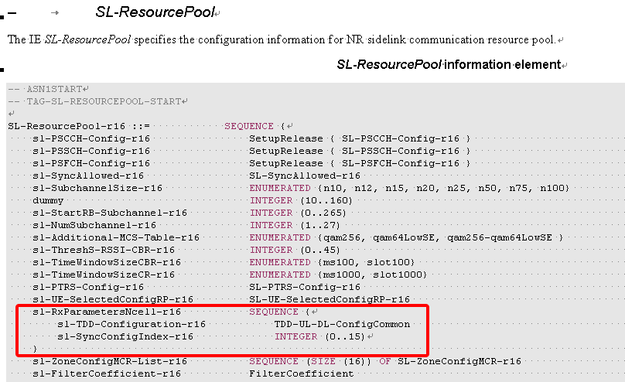

This parameter is to help the UEs in cell-1, following sync-1, to get the sync-2 from cell-2, for reception of data of sync-2, i.e., it hints the scenario where R16 NR-V2X UEs bases on the Rx-sync configuration for each Rx pool, to perform reception on another sync.

1. ASN.1 in R16 NR-V2X includes the configuration for UEs in cell-1 following sync-1, to get the sync-2 from cell-2 for reception of data of sync-2.

So given all the colliding information above, we can start from checking the companies view. Maybe, we can start from no PSFCH case, i.e., exactly the same case as in LTE, where HARQ FB is disabled.

So Q1-1 is to ask for confirmation from companies whether this scenario can happen in R16 NR-V2X.

**Q1: In R16 NR V2X, for HARQ FB disabled case (i.e., same as LTE), is it possible that two UEs using different Tx-sync (larger than CP), can communicate with each other or not?**

**Interpretation-1 Yes, as in LTE, UE1 use its Tx-sync to transmit PSCCH/PSSCH to UE2, and UE1 receive PSCCH/PSSCH from UE2 based on UE2’s Tx-sync;**

**Interpretation-2: No, different from LTE, UE1 use its Tx-sync to transmit PSCCH/PSSCH to UE2, and also use the same sync to receive PSCCH/PSSCH from other nearby UEs**

* **2A: R16 NR-V2X only targets at the scenario where all UEs always have the same Tx-sync or at least Tx-sync with difference less than CP;**
* **2B: It may happen in R16 NR-V2X that neighbouring UE have different Tx-Sync (larger than CP), but if that happens, UEs cannot communicate with UEs who have Tx-sync with difference larger than CP**

|  |  |  |
| --- | --- | --- |
| Company | Interpretation | Comment |
| OPPO | 2B | Even though 1 is feasible for 2 UEs, it does not work for >= 3UEs and for G/B-cast case, considering the conclusion/limitation from R1 on the sync Tx/Rx sync.  2A is not possible considering the existence of UE-based sync. |
| Nokia | 2B with comments | We share same understanding as OPPO. For better understanding we like to add that the word “neighbouring” in Q1 is referring to Fig.1 i.e. the two UEs are connected to different gNBs with different gNB sync references (no GNSS i.e. SLSS=1…335). In some (rare) scenarios option 2A may be possible, e.g. when gNB/eNB sync source is disabled (*sl-SyncPriority* P3,P4,P5) and GNSS is (pre)configured. For the standalone (InC=”0”) the UEs may rely on GNSS (SLSS=0) or UE-autonomous sync (SLSS=338…671).  Apart from that the general problem raised in this discussion exists as recognized by RAN1 and RAN4. |
| Ericsson | 2B | Share the same views as OPPO and Nokia |
| Apple | 2B | NR V2X at least need target scenarios as same as LTE V2X, but include groupcast and unicast. In LTE, there is a UE capability “v2x-numberTxRxRTiming-r14” indicates the multiple reference timing that the UE can track so to make UE to receive simultaneous broadcast with different timings. Interpretation 1 is only a subset case which is allowed in LTE V2X. We think the interpretation 2B is the end result of NR V2X only support one Tx/RX timing, as regressed from LTE -V2X. |

The second step is what is the companies understanding of the current spec when HARQ FB is **enabled**, i.e., different from LTE, what the UE behaviour is.

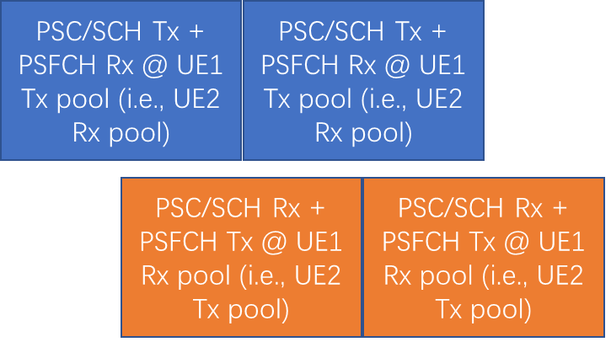

Figure 3 Un-sync-ed PSCCH/PSSCH Tx + PSFCH Rx, and PSCCH/PSSCH Rx + PSFCH Tx (when FB enabled)

**Q2: In R16 NR V2X, is it possible that two UEs communicating via PC5 adopt different Tx-sync, for HARQ FB enabled case?**

**Interpretation-1: Yes**

* **1A: But PSFCH transmission cannot be performed on the different sync;**
* **1B: PSFCH transmission can be performed, but will be performed using the Tx-sync same as for PSCCH/PSSCH;**
* **1C: PSFCH transmission can be performed regardless of the sync used for PSCCH/PSSCH (i.e., the Tx-sync for PSFCH and for PSCCH/PSSCH can be different)**

**Interpretation-2: No, different from LTE, UE1 use its Tx-sync to transmit PSCCH/PSSCH to UE2, and also use the same sync to receive PSCCH/PSSCH from other nearby UEs**

* **2A: R16 NR-V2X only targets at the scenario where all UEs always have the same Tx-sync or at least Tx-sync with difference less than CP;**
* **2B: It may happen in R16 NR-V2X that neighbouring UE may have different Tx-Sync (larger than CP), and if that happens, UEs cannot communicate with UEs who have Tx-sync with difference larger than CP**

|  |  |  |
| --- | --- | --- |
| Company | Interpretation | Comment |
| OPPO | 2B | see response above. |
| Nokia | 2B |  |
| Ericsson | 2B |  |
| Apple | 2B |  |

And for Q1/Q2, it is helpful to understand the consequence.

If one holds the view on 2A for Q1 and/or Q2, given the specified sync selection procedure

4> if *sl-SyncPriority* corresponding to the concerned frequency is set to *gnbEnb*:

5> UEs of which SLSSID is part of the set defined for in coverage, and *inCoverage*, included in the *MasterInformationBlockSidelink* message received from this UE, is set to *true*, starting with the UE with the highest PSBCH-RSRP result (priority group 1);

5> UE of which SLSSID is part of the set defined for in coverage, and *inCoverage*, included in the *MasterInformationBlockSidelink* message received from this UE, is set to *false*, starting with the UE with the highest PSBCH-RSRP result (priority group 2);

5> GNSS that is reliable in accordance with TS 38.101-1 [15] and TS 38.133 [14] (priority group 3);

5> UEs of which SLSSID is 0, and *inCoverage*, included in the *MasterInformationBlockSidelink* message received from this UE, is set to *true,* or of which SLSSID is 0 and SLSS is transmitted on slot(s) indicated by *sl-SSB-TimeAllocation3*, starting with the UE with the highest PSBCH-RSRP result (priority group 4);

5> UEs of which SLSSID is 0 and SLSS is not transmitted on slot(s) indicated by *sl-SSB-TimeAllocation3*, and *inCoverage*, included in the *MasterInformationBlockSidelink* message received from this UE, is set to *false*, starting with the UE with the highest PSBCH-RSRP result (priority group 5);

5> UEs of which SLSSID is 337 and *inCoverage*, included in the *MasterInformationBlockSidelink* message received from this UE, is set to *false*, starting with the UE with the highest PSBCH-RSRP result (priority group 5);

5> Other UEs, starting with the UE with the highest PSBCH-RSRP result (priority group 6);

4> if *sl-SyncPriority* corresponding to the concerned frequency is set to *gnss*, and *sl-NbAsSync* is set to *true:*

5> UEs of which SLSSID is 0, and *inCoverage*, included in the *MasterInformationBlockSidelink* message received from this UE, is set to *true*,or of which SLSSID is 0 and SLSS is transmitted on slot(s) indicated by *sl-SSB-TimeAllocation3*, starting with the UE with the highest PSBCH-RSRP result (priority group 1);

5> UEs of which SLSSID is 0 and SLSS is not transmitted on slot(s) indicated by *sl-SSB-TimeAllocation3*, and *inCoverage*, included in the *MasterInformationBlockSidelink* message received from this UE, is set to *false*, starting with the UE with the highest PSBCHS-RSRP result (priority group 2);

5> UEs of which SLSSID is 337 and *inCoverage*, included in the *MasterInformationBlockSidelink* message received from this UE, is set to *false*, starting with the UE with the highest PSBCH-RSRP result (priority group 2);

5> the cell detecteted by the UE as defined in 5.8.6.3 (priority group 3);

5> UEs of which SLSSID is part of the set defined for in coverage, and *inCoverage*, included in the *MasterInformationBlockSidelink* message received from this UE, is set to *true*, starting with the UE with the highest PSBCH-RSRP result (priority group 4);

5> UE of which SLSSID is part of the set defined for in coverage, and *inCoverage*, included in the *MasterInformationBlockSidelink* message received from this UE, is set to *false*, starting with the UE with the highest PSBCH-RSRP result (priority group 5);

5> Other UEs, starting with theUE with the highest S-RSRP result (priority group 6);

4> if *sl-SyncPriority* corresponding to the concerned frequency is set to *gnss*, and *sl-NbAsSync* is set to *false:*

5> UEs of which SLSSID is 0, and *inCoverage*, included in the *MasterInformationBlockSidelink* message received from this UE, is set to *true*, or of which SLSSID is 0 and SLSS is transmitted on slot(s) indicated by *sl-SSB-TimeAllocation3*, starting with the UE with the highest PSBCH-RSRP result (priority group 1);

5> UEs of which SLSSID is 0 and SLSS is not transmitted on slot(s) indicated by *sl-SSB-TimeAllocation3*, and *inCoverage*, included in the *MasterInformationBlockSidelink* message received from this UE, is set to *false*, starting with the UE with the highest PSBCHS-RSRP result (priority group 2);

5> UEs of which SLSSID is 337 and *inCoverage*, included in the *MasterInformationBlockSidelink* message received from this UE, is set to *false*, starting with the UE with the highest PSBCH-RSRP result (priority group 2);

5> Other UEs, starting with the UE with the highest PSBCH-RSRP result (priority group 3);

Rapporteur understand that even though network configuration can ensure sync between cells, and sync between gNB/GNSS, as long as UE-based sync reference is selected, there is no guarantee on the sync difference less than CP.

So good to check the view by companies

**Q2-1: If company holds the interpretation 2A to Q1 and/or Q2, what is your view to achieve that**

**Option-1: by network implementation (if this selected, please explain how)**

**Option-2: by UE implementation (if this selected, please explain how)**

**Option-3: other**

|  |  |  |
| --- | --- | --- |
| Company | Option | Comment |
| Nokia | Option 3 with comments | The purpose of cyclic prefix is to tackle dispersion over fading channel in order to prevent inter-symbol-interference. Channel delay spread and the length of the cyclic prefix determine the level up to which ISI can be addressed by the phy numerology (neither the UE nor the network can influence the delay spread or the CP length).  Different synchronization for UE1 and UE2 can partly be seen as having the same effect wrt ISI, i.e. to some extend the CP can counteract the different synchronization if the sync difference plus the dispersion observed over the channel is less than the CP length. That may happen by accident (for small sync differences between UE1 and UE2) but nothing can ensure that (except a new phy numerology with large CP length). |
|  |  |  |
|  |  |  |
|  |  |  |

Or if companies holds the interpretation of 2B:

Firstly, rapporteur understand it is against V2X design spirit that for safety reason, packet loss should be minimized as much as possible.

**Q2-2a: if company holds the interpretation 2B to Q1 and/or Q2, will it cause reception failure due to sync reference difference between nearby UEs in a V2X system?**

* **Yes**
* **No**

|  |  |  |
| --- | --- | --- |
| Company | Yes/No | Comment |
| OPPO | Yes | It is very unfortunate that R1 ends up with a solution different from LTE that may cause reception failure (to us, it can be easily solved by allowing more than 1 Rx sync), but that is the consequence. |
| Nokia | Yes | To our understanding the problem raised in Fig.1 is valid and a concern to us, both for shared sidelink carrier and dedicated sidleink carrier. We would like to remind that cellular systems typically span larger logical and physical areas that may (for whatever reason) have different synchronization, e.g. for UEs associated to different PLMNs or in different Uu carriers, cross-border sidelink scenarios (gNB-1 in country-1 and gNB-2 in country-2).  For the use of the term “nearby” in Q2-2a see our comment in answer 1. |
| Ericsson | Yes | Large difference of the timing sync sources would lead to misalignment of symbol/slot boundary between TX UE and RX UE(s), which leads to reception failure of PSFCH transmission at the TX UE. |
| Apple | Yes |  |

Secondly, it seems colliding with the ASN.1 configuration of Rx-sync in pool configuration, i.e. since the UE will always relies on the Tx-sync to perform reception, what is the point to include a Rx-sync configuration in Rx pool?

|  |
| --- |
| ***sl-SyncConfigIndex***  Indicates the synchronisation configuration that is associated with a reception pool, by means of an index to the corresponding entry *SL-SyncConfigList* of in *SIB12* for NR sidelink communication. |

**Q2-2b: if company holds the interpretation 2B to Q1 and/or Q2, do you agree that the sl-SyncConfigIndex-r16 in SL-ResourcePool-r16 is useless, and thus can be dummified?**

* **Yes**
* **No**

|  |  |  |
| --- | --- | --- |
| Company | Yes/No | Comment |
| OPPO | Yes | Given the current R1 conclusion, we fail to understand how this parameter will work. |
| Nokia | No with comment | We agree that sl-SyncConfigIndex-r16 does not solve the issue (and it seems it has no practical use), however we fail to see any advantage in dummifying it in ASN.1. We fail to see the need that RAN2 should touch ASN.1 |
| Ericsson | comment | Share the same views as Nokia |
| Apple | See comment | There exist the system design limits on the current spec and there is a need to capture this in Chairman’s note. Honestly speaking, there are some other ASN.1 parameters in SL configuraitons which are at least “sub-optimal”. There is no need to eradicate all those deficiencies. We can live with no change in ASN.1, but with correct understanding on the usefulness of those configurations. |

# Conclusion

Considering the latest R1 conclusion on single sync for both Tx and Rx, companies converge on interpretation B2 for both Q1 and Q2.

1. RAN2 understand in R16 NR-V2X it is possible that UEs have Tx-Sync with difference larger than CP, and if that happens, UEs cannot communicate with each other for both FB enabled and disabled cases.

And also in Q2-2b, companies tend to agree the sl-SyncConfigIndex is not useful so good for R2 to clarify but no need to dummy that either.

1. RAN2 understand *sl-SyncConfigIndex* is of no use due to the R16 single Tx/Rx sync NR-V2X UE capability limitation, yet no need to dummy that IE.

We have the following proposal:

Proposal 1 RAN2 understand in R16 NR-V2X it is possible that UEs have Tx-Sync with difference larger than CP, and if that happens, UEs cannot communicate with each other for both FB enabled and disabled cases.

Proposal 2 RAN2 understand *sl-SyncConfigIndex* is of no use due to the R16 single Tx/Rx sync NR-V2X UE capability limitation, yet no need to dummy that IE.

# Reference

1. R2-2102881 Left issue on synchronization of PSSCH vs. PSFCH OPPO, Ericsson, Apple, Nokia, Nokia Shanghai Bell discussion Rel-16 5G_V2X_NRSL-Core
2. R1-2005111, Summary of email discussion/approval [101-e-Post-NR-UE-Features-05]