3GPP TSG-RAN WG2 Meeting #112e R2-20xxxx
Online Meeting, 02 – 13 November 2020

Agenda item: 6.6.2
Source: Ericsson (Rapporteur)
Title: Offline 604 Positioning RRC proposals
WID/SID: NR_POS-Core - Release 16
Document for: Discussion and Decision

1 Introduction
This document is the report of the following email discussion.
- [AT112-e][604][POS] Positioning RRC proposals (Ericsson)
Scope: Discuss and resolve proposals 1 and 2 from R2-2010709.
Intended outcome: Agreeable CR in R2-2010864
Deadline: Tuesday 2020-11-10 1200 UTC

The reference document and the proposals to be discussed are listed below.
R2-2010709 Summary for RRC Corrections for Positioning Ericsson discussion

Proposal 1 RAN2 to agree the posSIB validity inclusion in RRC and review the CR for posSIB validity check provided in R2-2008806 by email discussion.
Proposal 2 RAN2 to provide correction for field description for fields (sfn-Offset and sfn-SSB-Offset) available in SSB-Configuration. The exact changes are captured via email discussion review.

2 PosSIB Validity Check
The CR R2-2008806 provides the changes needed to describe how UE will determine the posSIB validity in RRC. The valueTag and expiration duration are defined in LPP layer however the areaScope and SystemInformationAreaID are part of RRC.
Question 1: do you agree with the changes in the CR in R2-2008806 where the posSIB validity has been provided in RRC?
Please use the comments column to provide any suggested changes to the CR or to add explanations/alternatives if you disagree with the CR or any parts of it.
Answers to Question 1
Company | Yes/No | Comments
Intel | Yes
Huawei, HiSilicon (Yinghao) | No | We don’t this should be done in the RRC spec for the following reasons:  1/ In the RRC spec, the valueTag and ExpirationTime are not defined. For RRC spec, posSIB are OCTET STRINGs that are defined in the upper layer.  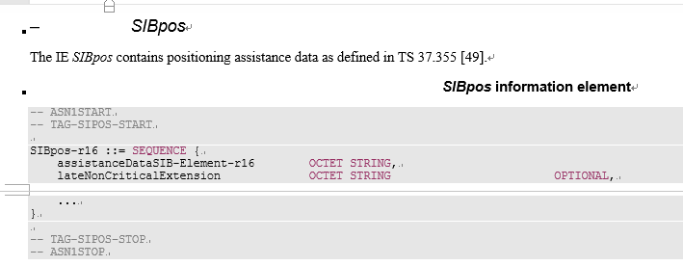  Hence, from modeling perspective, putting posSIB validity procedure in RRC spec is not reasonable.  2/ In the RRC spec, requirement for posSIB are from upper layer. So, if the request is already from upper layer, why the validity check should be performed in the RRC?  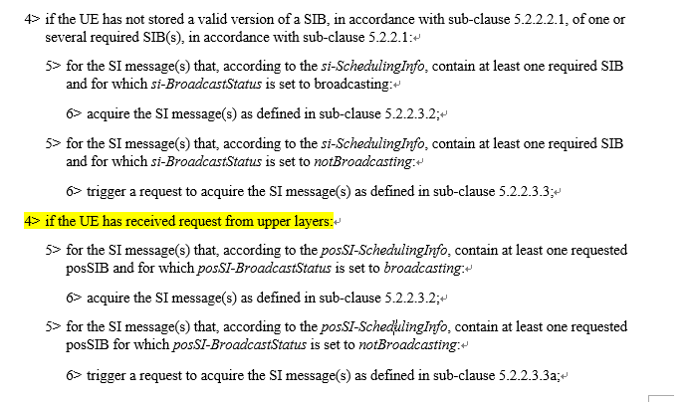  For us, this is a legacy issue that has already been existing in R15. We prefer not to address this or if this is the intention from all the other companies, address it in the LPP spec.
CATT | Yes | posSIB validity based on area scope is introduced in R16. It is not a legacy issue.  The requirement for posSIB are from upper layer doesn’t mean that the posSIB validity should not happen in RRC. We do not see the logical consequence of request and check.  The requirement for posSIB comes from higher layer because higher layer needs AD data in posSIB.  Considering the area scope in SIB1 which should not be transferred to higher layer, the posSIB validity in RRC makes sense.  Majority (5 companies within 7 companies' replies) preferred to capture posSIB validity in RRC in R2-2008268 in last meeting.
vivo | Yes
Xiaomi | Yes
Qualcomm | Yes | In Rel-15 we have only the value tag and the expiration time. Those two fields are described in the LPP field description and they imply the corresponding UE behaviour. However, the area scope is an addition in Rel-16 and should be clarified.  However, from the text in 5.2.2.2.1 it may be difficult (for "non-positioning people") to understand that the value tag and expiration time are defined in LPP ASN.1. Maybe we could make it more explicit:  If the UE stores the acquired posSIB, then the UE shall store the associated areaScope, if present, the cellIdentity, the systemInformationAreaID, if present, the valueTag, if provided in assistanceDataSIB-Element, and the expirationTime if provided in assistanceDataSIB-Element. The UE may use a valid stored version of the SI except MIB, SIB1, SIB6, SIB7 or SIB8 e.g. after cell re-selection, upon return from out of coverage or after the reception of SI change indication. The valueTag and expirationTime for posSIB is optionally provided in assistanceDataSIB-Element, as specified in TS 37.355 [49].  I think this may avoid some confusion of the RRC value tag and LPP value tag. Also, the value tag is not provided in "LPP signalling" (its just defined in LPP).
Nokia | Yes | First, we agree with the changes proposed by Qualcomm. Just saying the valueTag and expirationTime are optionally provided in LPP signalling implies these values are provided via dedicated LPP signalling. So, clarifying that it is from the assistanceDataSIB-Element is good.  Then, the assistanceDataSIB-Element IE, as described in 7.4.1 in 37.355, is a broadcast information element which are encoded as 'basic production' for other purposes than encoding the IE within an LPP message. So, referring to a field in the assistanceDataSIB-Element IE when used in an RRC message, seems OK to us. Anyway, what is described in the CR is the UE behaviour and UE does have access to valueTag and expirationTime after decoding the assistanceDataSIB-Element.  The paragraph at the top which starts with “When the UE acquires a MIB or a SIB1 or an SI message in a serving cell as described in…” seem too long with multiple conditions making it too complex to read. Can we structure it something like the following:  When the UE acquires a MIB or a SIB1 or an SI message in a serving cell as described in clause 5.2.2.3, the UE shall:  - if the UE stores the acquired SIB;  2> store the associated areaScope, if present, the first PLMN-Identity in the PLMN-IdentityInfoList for non-NPN-only cells or the first NPN identity (SNPN identity in case of SNPN, or PNI-NPN identity in case of PNI-NPN) in the NPN-IdentityInfoList for NPN-only cells, the cellIdentity, the systemInformationAreaID, if present, and the valueTag, if present, as indicated in the si-SchedulingInfo for the SIB.  - If the UE stores the acquired posSIB;  2> store the associated areaScope, if present, the cellIdentity, the systemInformationAreaID, if present, the valueTag, if provided, and the expirationTime if provided.  - The UE may use a valid stored version of the SI except MIB, SIB1, SIB6, SIB7 or SIB8….
Ericsson | Yes | Agree with Nokia on the restructuring; however it is good to take that as a separate CR as it would take more time to review.

Summary 1:
8 companies responded. 7 companies agree to the changes with few more needed updates
Proposal 1: posSIB validity is specified in RRC.

3 sfn-SSB-Offset, sfn-Offset, sfn0-offset
R2-2008807, R2-2008808, R2-2010071, R2-2010270 provides CR for correction of field description for SSB-Configuration related to fields: sfn-Offset and sfn-SSB-Offset and sequence sfn0-offset.
The CR R2-2010991 in consolidates the changes and provides a merged version.
Question 2: do you agree with the changes in the CR in R2-2010991?
Please use the comments column to provide any suggested changes to the CR or to add explanations if you disagree with the CR or any parts of it.
Answers to Question 3
Company | Yes/No | Comments
Intel | Yes
Huawei, HiSIlicon (Yinghao) | Yes
CATT | Yes
vivo | Yes
Xiaomi | Yes
Qualcomm | Yes | I think this  "Indicates the SFN offset of the transmitted SSB related to the start of the SSB period."  should be  "Indicates the SFN offset of the transmitted SSB relative to the start of the SSB period."
Nokia | No | We understand, the sfn-Offset and integerSubframeOffset are the frame-level and subframe-level offsets for sfn0-Offset. So, we should add a field definition for integerSubframeOffset and clarify that sfn-Offset and integerSubframeOffset are the frame level and subframe level offsets to represent sfn0-Offset. This is what I got from our RAN1 delegate but if this is not correct, then we need to a confirmation from RAN1 if RAN2 interpretation is correct or not.
Ericsson | Yes

Summary 1:
8 companies responded. 7 companies agree to the changes with one more update. One company view differs but should be sorted by offline discussion.
Proposal 2: Agree to the field description correction for sfn-SSB-Offset and sfn-Offset.

4 Conclusion
Based on the discussion in the previous sections we propose the following:
Proposal 1: posSIB validity is specified in RRC.
Proposal 2: Agree to the field description correction for sfn-SSB-Offset and sfn-Offset.
Proposal 2: Agree to the CR in capturing above Proposals.

