3GPP TSG-RAN WG2 Meeting #112e R2-20xxxx
Online Meeting, 02 – 13 November 2020

Agenda item: 6.6.2
Source: Ericsson (Rapporteur)
Title: Offline 604 Positioning RRC proposals
WID/SID: NR_POS-Core - Release 16
Document for: Discussion and Decision

1 Introduction
This document is the report of the following email discussion.
- [AT112-e][604][POS] Positioning RRC proposals (Ericsson)
Scope: Discuss and resolve proposals 1 and 2 from R2-2010709.
Intended outcome: Agreeable CR in R2-2010864
Deadline: Tuesday 2020-11-10 1200 UTC

The reference document and the proposals to be discussed are listed below.
R2-2010709 Summary for RRC Corrections for Positioning Ericsson discussion

Proposal 1 RAN2 to agree the posSIB validity inclusion in RRC and review the CR for posSIB validity check provided in R2-2008806 by email discussion.
Proposal 2 RAN2 to provide correction for field description for fields (sfn-Offset and sfn-SSB-Offset) available in SSB-Configuration. The exact changes are captured via email discussion review.

2 PosSIB Validity Check
The CR R2-2008806 provides the changes needed to describe how UE will determine the posSIB validity in RRC. The valueTag and expiration duration are defined in LPP layer however the areaScope and SystemInformationAreaID are part of RRC.
Question 1: do you agree with the changes in the CR in R2-2008806 where the posSIB validity has been provided in RRC?
Please use the comments column to provide any suggested changes to the CR or to add explanations/alternatives if you disagree with the CR or any parts of it.
Answers to Question 1
Company | Yes/No | Comments
Intel | Yes
Huawei, HiSilicon (Yinghao) | No | We don’t this should be done in the RRC spec for the following reasons:  1/ In the RRC spec, the valueTag and ExpirationTime are not defined. For RRC spec, posSIB are OCTET STRINGs that are defined in the upper layer.  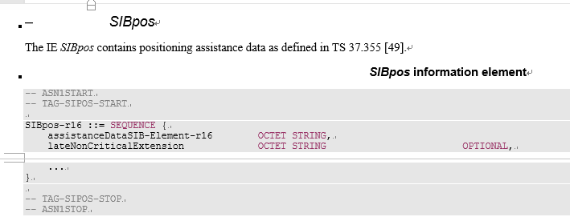  Hence, from modeling perspective, putting posSIB validity procedure in RRC spec is not reasonable.  2/ In the RRC spec, requirement for posSIB are from upper layer. So, if the request is already from upper layer, why the validity check should be performed in the RRC?  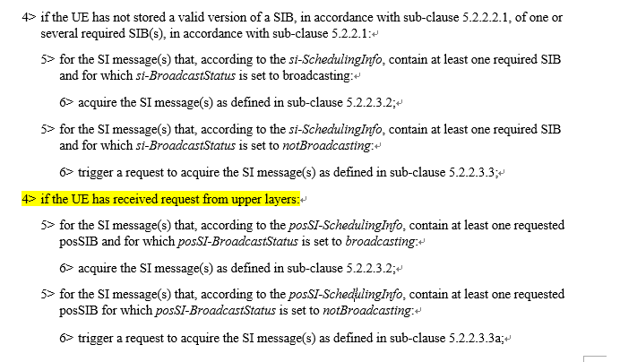  For us, this is a legacy issue that has already been existing in R15. We prefer not to address this or if this is the intention from all the other companies, address it in the LPP spec.
CATT | Yes | posSIB validity based on area scope is introduced in R16. It is not a legacy issue.  The requirement for posSIB are from upper layer doesn’t mean that the posSIB validity should not happen in RRC. We do not see the logical consequence of request and check.  The requirement for posSIB comes from higher layer because higher layer needs AD data in posSIB.  Considering the area scope in SIB1 which should not be transferred to higher layer, the posSIB validity in RRC makes sense.  Majority (5 companies within 7 companies' replies) preferred to capture posSIB validity in RRC in R2-2008268 in last meeting.
vivo | Yes

3 sfn-SSB-Offset, sfn-Offset, sfn0-offset
R2-2008807, R2-2008808, R2-2010071, R2-2010270 provides CR for correction of field description for SSB-Configuration related to fields: sfn-Offset and sfn-SSB-Offset and sequence sfn0-offset.
The CR R2-2010991 in consolidates the changes and provides a merged version.
Question 2: do you agree with the changes in the CR in R2-2010991?
Please use the comments column to provide any suggested changes to the CR or to add explanations if you disagree with the CR or any parts of it.
Answers to Question 3
Company | Yes/No | Comments
Intel | Yes
Huawei, HiSIlicon (Yinghao) | Yes
CATT | Yes
vivo | Yes

4 Conclusion
Based on the discussion in the previous sections we propose the following:
No table of figures entries found.

