3GPP TSG-RAN WG2 Meeting #110 R2-200xxxx

Electronic, 1 June – 12 June 2020

Agenda item: 5.4.1.1
Source: Apple
Title: Offline-007: DC Configuration
Document for: Discussion & Decision

Introduction
This is a summary of the following offline discussion on DC configuration:
- [AT110e][007][NR15] DC Configuration (Apple)
Scope: Treat R2-2005531, R2-2005532, R2-2005533, R2-2005534, R2-2005634, R2-2005635, R2-2004488, R2-2004489 (proponents are responsible to explain and drive)
Part 1: Decision whether to make corrections or not, identify agreeable corrections. Deadline: June 4, 0700 UTC.
Part 2: For agreeable parts, continuation to agree CRs. Deadline: June 10, 0700 UTC
This document covers the following contributions submitted to RAN2#110-e meeting:
PSCell Addition NR-DC - SMTC
R2-2005531 SMTC Configuration for PSCell Addition for NR-DC Apple, ZTE Corporation, Sanechips, Qualcomm Incorporated CR Rel-15 38.331 15.9.0 1675 - F NR_newRAT-Core
R2-2005532 SMTC Configuration for PSCell Addition for NR-DC Apple, ZTE Corporation, Sanechips, Qualcomm Incorporated CR Rel-16 38.331 16.0.0 1676 - A NR_newRAT-Core
R2-2005533 SMTC Configuration for PSCell Addition for NR-DC Apple, ZTE Corporation, Sanechips, Qualcomm Incorporated CR Rel-15 38.306 15.9.0 0340 - F NR_newRAT-Core
R2-2005534 SMTC Configuration for PSCell Addition for NR-DC Apple, ZTE Corporation, Sanechips, Qualcomm Incorporated CR Rel-16 38.306 16.0.0 0341 - A NR_newRAT-Core
4 Treated by email [007]

SCG establishment – MAC default
R2-2005634 MAC Default Configuration for SCG Qualcomm Incorporated CR Rel-16 38.331 16.0.0 1685 - A NR_newRAT-Core
R2-2005635 MAC Default Configuration for SCG Qualcomm Incorporated CR Rel-15 38.331 15.9.0 1686 - F NR_newRAT-Core
2 Treated by email [007]
Radio bearer config NR-DC NE-DC
R2-2004488 Clarification for radioBearerConfig and radioBearerConfig2 vivo discussion
R2-2004489 Clarification for radioBearerConfig and radioBearerConfig2 vivo CR Rel-15 38.331 15.9.0 1608 - F NR_newRAT-Core
2 Treated by email [007]
Companies are invited to provide their views for each issue.

Discussion: Part 1

2.1 Issue #1. SMTC Configuration for PSCell Addition for NR-DC (R2-2005531 to R2-2005534)

Regarding which issues that need resolution, it is suggested to use the reason for change from R2-2005531 to R2-2005534 as the input:

For EN-DC, the SMTC configuration for NR PSCell addition is provided in LTE RRCConnectionReconfiguration message.
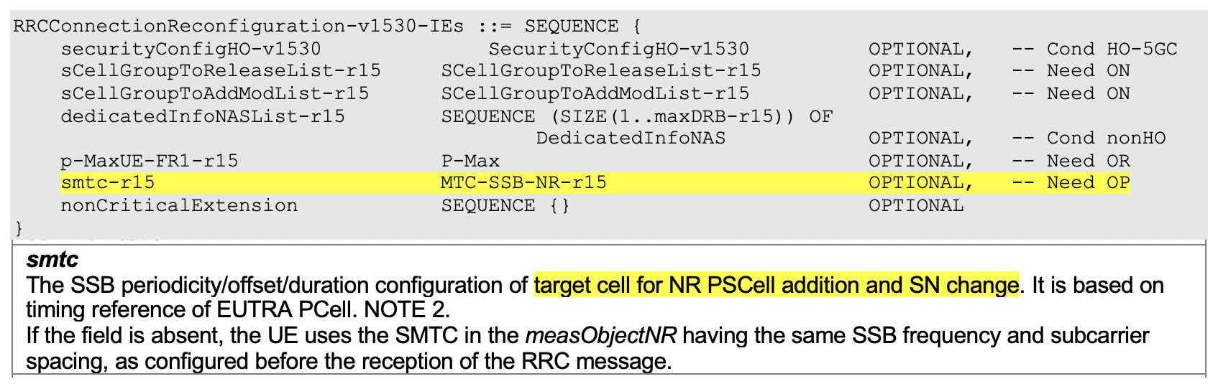

For NR PSCell change in MR-DC, the SMTC configuration is provided in secondaryCellGroup -> SpCellConfig -> reconfigurationWithSync.
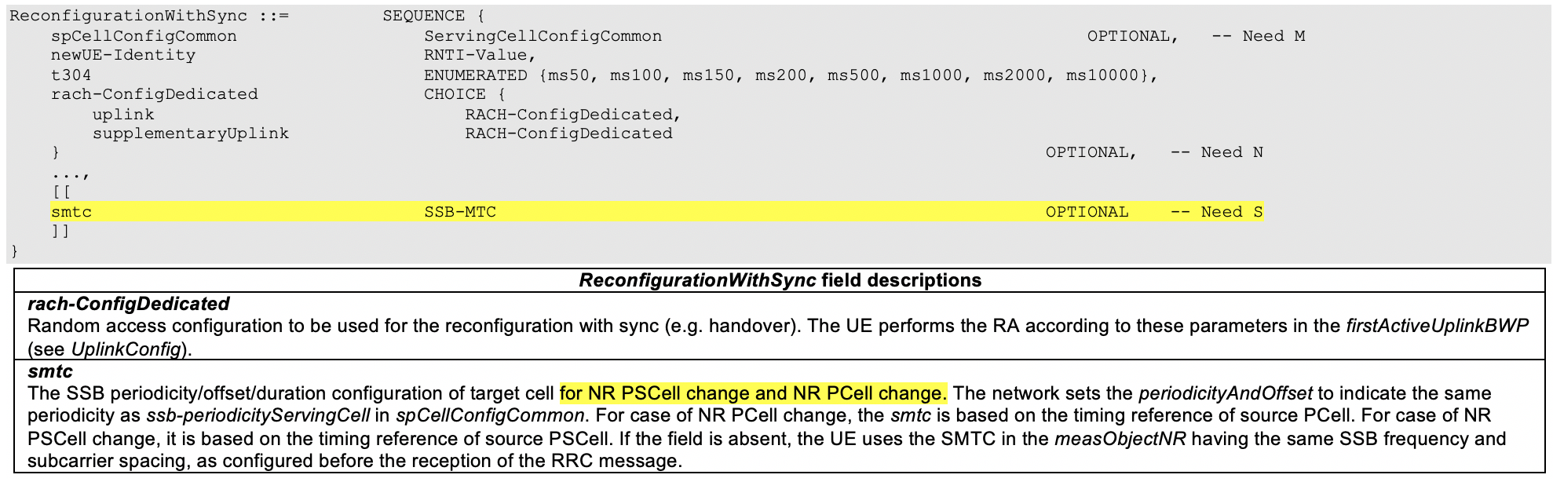

But for NR-DC, the SMTC configuration for NR PSCell addition and SN change is missing.

Q1.1) Do companies agree with the reason for change in R2-2005531 to R2-2005534?
Company | Agree/Disagree | Comments (if any)

In R2-2005531 to R2-2005534, it is proposed to add the SMTC configuration in NR RRCReconfiguration message for NR PSCell addition and SN change.

If it is not approved, for PSCell addtion and SN change in NR-DC, the UE cannot know the timing information of the target PSCell for the initial cell search if UE is not configured with the measObjectNR (incl. SMTC configuration) having the same SSB frequency and subcarrier spacing before.

Q1.2) If the answer to Q1.1 is “Yes”, do you agree with the changes made in R2-2005531 to R2-2005534?
Company | Agree/Disagree | Comments

2.2 Issue #2. MAC Default Configuration for SCG (R2-2005634, R2-20056345)
The MAC-CellGroupConfig IE is an optional Need M, therefore network may or may not include it when configuring or adding a cell group.
Per the spec, when configuring or adding the MCG (with FullConfig or during establishment or during IRAT HO to NR) the UE shall apply the default configuration.
Q2.1) Do you agree that the spec has ensured when MCG is being established/configured, if MAC configuration is not provided UE applies the default MAC configuration as per the 9.2.2 table?
Company | Agree/Disagree | Comments

Q2.2) Do you agree that per the spec, when network adds an SCG, if MAC-CellGroupConfig IE was not included (or partially included) in the reconfiguration message, the expected UE behavior is not defined?
Company | Agree/Disagree | Comments

Q2.3) as solution to address the concern in Q2.2, do you agree to let the UE applies the default MAC configuration upon SCG establishment if MAC-CellGroupConfig IE was not included (or partially included) in the reconfiguration message?
Company | Agree/Disagree | Comments

Q2.4) if you don’t agree with the solution provided in Q2.3, please provide an alternate solution.
Company | Agree/Disagree | Comments

2.3 Issue #3. Clarification for radioBearerConfig and radioBearerConfig2 (R2-2004488, R2-2004489)
In TS 38.331, the current field descriptions of radioBearerConfig and radioBearerConfig2 in RRCReconfiguration are insufficient to clearly express the corresponding usage.
radioBearerConfig issue:
radioBearerConfig
Configuration of Radio Bearers (DRBs, SRBs) including SDAP/PDCP. In EN-DC this field may only be present if the RRCReconfiguration is transmitted over SRB3.
nr-SecondaryCellGroupConfig
Includes the NR RRCReconfiguration message as specified in TS 38.331 [82]. In this version of the specification, the NR RRC message only includes fields iab-F1AP-TransferOverSRB-r16, secondaryCellGroup, conditionalReconfiguration and/ or measConfig. If nr-SecondaryCellGroupConfig is configured, the network always includes this field upon MN handover to initiate an NR SCG reconfiguration with sync and key change.
Q3.1) Do companies agree that radioBearerConfig can also be used for NR-DC and NE-DC case?
Company | Agree/Disagree | Comments

Q3.2) Do companies agree the CR in R2-2004489, to clarify the field description of radioBearerConfig, that in NR-DC it is only absent if the RRCReconfiguration is received within mrdc-SecondaryCellGroup, like EN-DC case.
Company | Agree/Disagree | Comments
radioBearerConfig and radioBearerConfig2 issue:
Since that both radioBearerConfig and radioBearerConfig2 can be used in NR-DC and NE-DC, it is not clear how to use them.
Clarify which of the following usages applies to radioBearerConfig and radioBearerConfig2 in NE-DC and NR-DC:
- Option1: The usage of RadioBearerConfig and radioBearerConfig2 in NE-DC and NR-DC are the same;
- Option2: RadioBearerConfig is used to configure MN terminated radio bearers via SRB1 and to configure SN terminated radio bearers via SRB3, while RadioBearerConfig2 is only used to configure SN terminated radio bearer via SRB1.
radioBearerConfig2
Configuration of Radio Bearers (DRBs, SRBs) including SDAP/PDCP. This field can only be used if the UE supports NR-DC or NE-DC.
radioBearerConfig
Configuration of Radio Bearers (DRBs, SRBs) including SDAP/PDCP. In EN-DC this field may only be present if the RRCReconfiguration is transmitted over SRB3.
Q3.3) Do companies think which of the above usages applies to radioBearerConfig and radioBearerConfig2 in NE-DC and NR-DC.
Company | Option1/Option2 or other | Comments

Conclusion: Part 1
Based on the above, RAN2 is request to agree the following proposals:
TBD

Reference

