

Invitation to the 3GPP TSG RAN
WG1#77, WG2 #86, WG3 #84, WG4 #71, WG5 #63 Meetings
MAY 19 – 23, 2014 Seoul, Korea

Dear 3GPP Colleagues,

On behalf of LG Electronics, I am pleased to invite you to the 3GPP TSG WG1,2,3,4 and 5 meetings in Seoul, Korea. The meetings will be held at the COEX InterContinental Seoul, Korea. A block of rooms has been reserved at the COEX InterContinental and GRAND InterContinental under the group code 3GPP and the cut off date for the hotel book is April 11, 2014. Please read the reservation section of the invitation for more information regarding booking your room.

In addition to making your hotel reservation, it is strongly recommended to make the online meeting registration as well. This provides the MCC and meeting sponsor with important planning information. The registration form can be found on the 3GPP website. Please visit http://webapp.etsi.org/3GPPRegistration to register online. Those who do not register for the meeting in a timely fashion will not have a name badge at the registration desk. Please let the on-site coordinator know if you need a badge.
VISA may be required for some delegates to visit Korea. Please contact the Korean Embassy at your country for information. If you need invitation letters or documents to apply for a VISA, please fill-in the provided request form and send it no later than Mar 31, 2014.

We appreciate your participation and dedication to 3GPP standardization, and wish all delegates and workgroups a successful meeting in Seoul.

Meeting directions and general information are provided in the following pages.

I am looking forward to seeing you in Seoul, Korea.

Sincerely yours,

Gohee Choi
Vice President, Head of Advanced Communication Technology Lab.
LG Electronics Inc., Korea

General Meeting Information

Meetings & Dates:
RAN1 #77 – May19 - 23, 2014
RAN2 #86 – May19 - 23, 2014
RAN3 #84 – May19 - 23, 2014
RAN4 #71 – May19 - 23, 2014
RAN5 #63 – May19 - 23, 2014

Meeting venue:
The COEX InterContinental Seoul, Korea

Social Event:
On Wednesday(21st of May), LG Electronics will host the Dinner.
LG Electronics will sponsor the dinner and delegates can attend this event free of charge.
- Venue : Harmony Ballroom (COEX InterContinental)
- Time: 19 : 00 ~

Hotel Information:
Grand InterContinental SEOUL
521, Teheran-ro, Gangnam-gu, Seoul, Korea (135-732)
Tel: +82-2-555-5656, Fax: +82-2-559-7990
https://www.grandicparnas.com:444/eng/index.do

COEX InterContinental SEOUL
524 Bongeunsa-ro, Gangnam-gu, Seoul, Korea (135-975)
Tel: +82-2-3452-2500, Fax: +82-2-3430-8000
https://www.iccoex.com/eng/index.do

Hosts :
LG Electronics Inc.

Mobile Phones:
SK Telecom and KT provide nationwide WCDMA/HSPA services over 2100 MHz band in Korea and SK Telecom, KT, LG U+ provide nationwide LTE services over 800MHz and 1800MHz. However, GSM/GPRS/EDGE services are not available. Please check the following roaming and rental services. You can apply roaming and rental service at the airport too.

SK Telecom – Global Roaming
http://www.sktroaming.com/tworld/gate.html

KT – Global Roaming
http://roaming.kt.com/renewal/eng/rental/phone_rental.asp

LG U+ – Global Roaming
http://www.uplus.co.kr/cmg/engl/ouse/peos/RetrievePeOsRooming.hpi

WLAN :
The meeting will be paperless and WLAN will be provided. Please make sure you have AC adapters for 220 volts at 60 Hz. (plug type C & F)

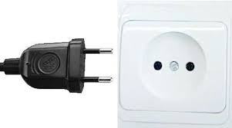 (Type C) 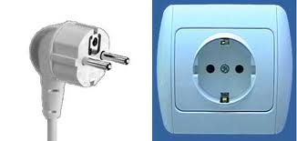 (Type F)
Climate :
Information : http://www.visitseoul.net/en/information/weather/seoul-weather.jhtml
Seoul has a fine weather during spring. It has four distinct seasons and an average May temperature of 17.4℃ (63.3°F).

Country |  | City |  | Winter |  |  |  | Spring |  |  |  |  |  | Summer |  |  |  |  |  | Fall |  |  |  |  |  | Winter
 |  |  |  | Jan |  | Feb |  | Mar |  | Apr |  | May |  | Jun |  | Jul |  | Aug |  | Sep |  | Oct |  | Nov |  | Dec
South  Korea |  | Seoul |  | -2.5 |  | -0.3 |  | 5.2 |  | 12.1 |  | 17.4 |  | 21.9 |  | 24.9 |  | 25.4 |  | 20.8 |  | 14.4 |  | 6.9 |  | 0.2
South  Korea |  | Incheon |  | 0.9 |  | 4.1 |  | 6.2 |  | 10.8 |  | 16.6 |  | 21.6 |  | 23 |  | 25.5 |  | 21.3 |  | 15.3 |  | 7.4 |  | 2.5
South  Korea |  | Busan |  | 5.2 |  | 7.9 |  | 9.1 |  | 13.2 |  | 17.8 |  | 20.5 |  | 22.8 |  | 26.7 |  | 22.9 |  | 18.3 |  | 11.9 |  | 7.3
South  Korea |  | Jeju |  | 7.2 |  | 9.1 |  | 10.8 |  | 13.9 |  | 18.9 |  | 21.5 |  | 24.8 |  | 28.1 |  | 23.3 |  | 18.3 |  | 12 |  | 9.6

Accommodation
The meeting will be held at COEX InterContinental but Delegates can make an accommodation either at the Grand InterContinental or COEX InterContinental. A block of rooms has been reserved at COEX InterContinental and Grand InterContinental Seoul under the name “3GPP”. The room rates are as follows.

Four classes of rooms are reserved and rates of the Grand InterContinental & COEX Intercontinental Seoul are as follows:
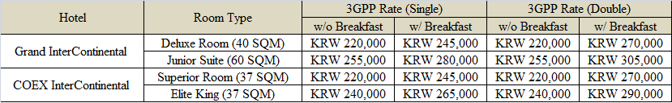
- 10 % service charge and 10% cumulative tax will be added to the rates above.
- (KRW: Korean Won, 1 USD ≈1063 KRW, 1 EUR ≈1446 KRW, as of January 10, 2014)
- The above rates are inclusive of in-room internet access.
- Daily full buffet breakfast will be served at KRW25,000++ per person and charged as consumption basis.
- Complimentary use of hotel swimming pool (above age of 18) and fitness center.
- Any individual cancellation made within 7 days before the Customer’s arrival shall entail payment of compensation of 100% of the cost of the cancelled services.

Delegates are responsible for their own hotel reservations. The reservation at the Grand InterContinental and COEX InterContinental should be made at the following web site and send the reservation form to Grand InterContinental and Coex InterContinental by e-mail ;

On-line Registration : Grand InterContinental
http://www.ihg.com/redirect?path=hd&brandCode=6c&localeCode=en&regionCode=1&hotelCode=SEOHA&_PMID=99801505&GPC=CGG

One-line Registration : COEX InterContinental
http://www.ihg.com/redirect?path=hd&brandCode=6c&localeCode=en&regionCode=1&hotelCode=SEOHB&_PMID=99801505&GPC=CVU
(Please click the VIEW ROOMS & RATES icons to reserve room under the group code 3GPP)
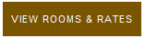

Off-line Registration : Email: reservation@parnas.co.kr, Fax: +82-2-559-7896

Reservations must be made by April 11, 2014

COEX InterContinental Seoul, Korea
HOTEL RESERVATION FORM (3GPP TSG WG1,2,3,4 and 5 meeting)
Reservation Department: Phone: +82 2 559 7777 / Fax: +82 2 559 7896
Email: reservation@parnas.co.kr

Last Name (Mr./Ms.) First & Middle Name

Company Name
Address

Phone No. Fax No.
E-Mail

Arrival Date (Flt No./Time )
Airport Pick-up request (price per vehicle): By New Chairman Limo (KRW160,000) / By Van (KRW180,000)
*The driver will be waiting for the guest at the gate of the flight with name picket on. In case the guest is not able to locate the driver, please consult at the hotel concierge desk at 82 2 3430 8525 or hotel information desk at the airport.

Departure Date (Flt No./Time )
Airport Sending request (price per vehicle): By New Chairman Limo (KRW160,000) / By Van (KRW180,000)

♦Please return this form directly by fax or email to us by Apr 11, 2014 to ensure room availability and special discount.
♦Please, choose your choice of accommodations:
Hotel | Room Type | Single Occupancy | Double Occupancy
Grand  InterContinental | □ Deluxe Room  (40 SQM) | □ KRW220,000  □ Smoking / □ Non - Smoking | □ KRW220,000  □ Smoking / □ Non - Smoking
Grand  InterContinental | □ Junior Suite  (60 SQM) | □ KRW255,000  □ Smoking / □ Non - Smoking | □ KRW255,000  □ Smoking / □ Non - Smoking
COEX  InterContinental | □ Superior Room  (37 SQM) | □ KRW220,000  □ Smoking / □ Non - Smoking | □ KRW220,000  □ Smoking / □ Non - Smoking
COEX  InterContinental | □ Elite King  (37 SQM) | □ KRW240,000  □ Smoking / □ Non - Smoking | □ KRW240,000  □ Smoking / □ Non – Smoking
- The above rates are inclusive of in-room internet access.
- Daily full buffet breakfast will be served at KRW25,000++ per person and charged as consumption basis.
- The above rates are subject to 10% service charge & 10% cumulative tax.
- Check-in time – 3:00 pm / Check-out time – 12:00 noon

♦ A credit card number is required to guarantee your reservation.
Card: □ Amex □ Diners □ Master □ Visa □ JCB | 4 digit # for AMEX: _ _ _ _
Card Number: | Expiry Date:
- One night room payment inclusive of tax and service charge in case of no-show or late cancellation made within 30 days prior to check-in.

Date: Signature:

Hotel Reservation Form :
VISA
VISA may be required for delegates from some countries to visit Korea. Please contact the Korean Embassy at your country as soon as possible. If you need an invitation letter for applying a VISA, complete the provided request form and send it to the person below no later than March 31, 2014. Late submission will not be accepted. Please contact the Korean Embassy at your country for further information.

INVITATION LETTER REQUEST FORM
Date:

- Family name (last name):
- Forename (first name):
- Birth date (month/date/year):
- Passport number and issuing country:
- Gender:
- Company name:
- Occupation/Position:
- Company/mailing address:
- Postal Code:
- Country:
- Telephone number:
- Fax number:

Dear ,

On behalf of the LG Electronics, I am pleased to invite you to the 3GPP TSG WG meetings in Seoul, Korea. This technical standardization meeting of the 3GPP will take place on May 19 – 23, 2014. This meeting will further the technical work of developing specifications for wireless communications. Your technical expertise is necessary for ensuring good progress and will help to further this work and as your company is a member of 3GPP, you are specifically invited to participate.

The meetings will take place as follows:
Title | Date | Venue
3GPP TSG WG1 #77 | 19 - 23 May 2014 | COEX Intercontinental Hotel  (524 Bongeunsa-ro, Gangnam-gu, Seoul, Korea (135-975))
3GPP TSG WG2 #86 | 19 - 23 May 2014
3GPP TSG WG3 #84 | 19 - 23 May 2014
3GPP TSG WG4 #71 | 19 - 23 May 2014
3GPP TSG WG5 #63 | 19 - 23 May 2014

Please allow adequate travel time to reach the meeting. Your company is responsible for all your expenses while in the Korea.

I look forward to seeing you at the meeting and please feel free to contact me should you have any questions.

Gohee Choi
Vice President,
Head of Advanced Communication Technology Lab., LG Electronics

Contact person for invitation letter:

- Mr. Heetae Lee (ht.lee@lge.com , +82-10-2242-7731)
- Ms. Misun Hwang (misun7.hwang@lge.com , +82-10-4261-5415)

HOW TO GET TO THE COEX AND GRAND Intercontinental Seoul

<From Incheon International Airport>
It takes from 60 to 90 minutes between Incheon International Airport and the hotels above (by Taxi or Bus or Subway).

- Taxi: Estimated taxi fares are about 60,000 KRW for regular taxi and 90,000 KRW for deluxe taxi. (Toll fee (KRW 7,600) will be the passenger’s responsibility. And the estimated fare is based on no traffic congestion, so the actual rates may vary. )

- Bus :
Information : : http://www.calt.co.kr/index.html?menu=trans&sub=sub2
CALT(City Airport,Logis & Travel , near the hotel) Limousine Bus: This bus goes directly between CALT and the airport. Tickets of the limousine bus can be purchased at Exit 4 and 9 (indoors) & Exit 4, 6, 7, 8, 11, 13, and 9C (outdoors). Tickets are available at the airport. Bus Fare is KRW 15,000.
Bus Stop: Platform #4A (East) or Platform #10B (West) at the Incheon International Airport.

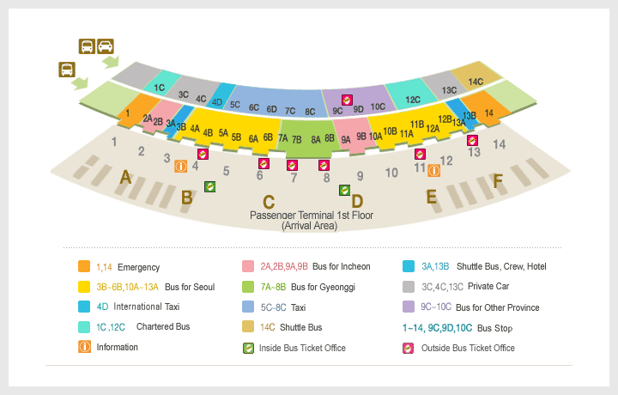
East

Bus Number | CALT → Airport |  | Airport → CALT |  | Interval
Bus Number | Start | End | Start | End | Interval
6103  (CALT↔Incheon Airport) | 05:20 | 20:00 | 05:30 | 22:30 | 10~15min.

- Subway:
Airport railroad station is located on the B1 floor and you can buy ticket in the ticket machine.
To take Airport railroad and transit to Subway Line 2 at Hongik Univ. Station. The hotels can be reached via the Samseong Subway Station, Line 2.
Exit 5: It connects directly to the Grand InterContinental SEOUL hotel.
Exit 6: It takes 10 minutes walk to the COEX InterContinental SEOUL hotel.
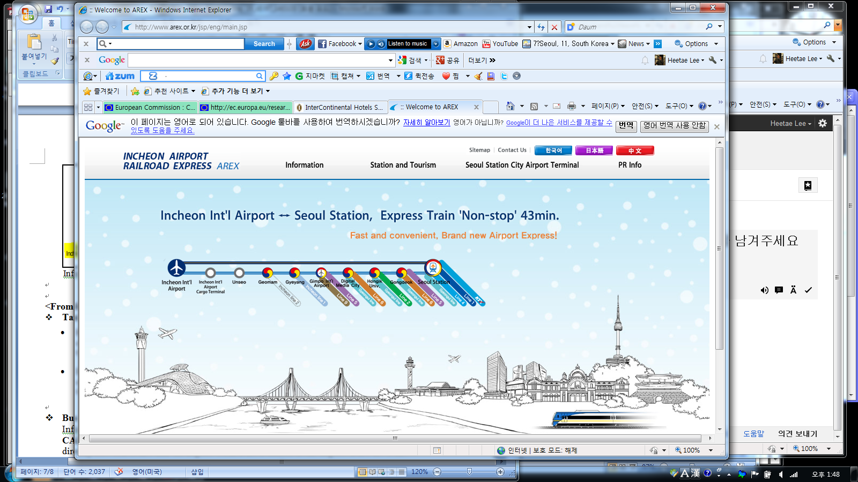

Information : Airport Railroad from Incheon to Seoul Station : http://www.arex.or.kr/jsp/eng/main.jsp

<From Kimpo Airport>
- Taxi: Types of Taxi
- Regular Taxi
at the no. 1 platform in front of the ground floor of the domestic line office building.
the minimum fare in Seoul is KRW 3,000, and KRW 100 are added per 144m
- Deluxe Taxi
at the no. 2 platform in front of the ground floor of the domestic line office building.
the minimum fare is KRW 5,000 per 3km, and KRW 200 are added per 164m

- Bus
Information : : http://www.calt.co.kr/index.html?menu=trans&sub=sub2
CALT¹⁾ (City Airport, Logis & Travel , near the hotel) Limousine Bus: This bus goes directly between CALT and the airport. Tickets are available at the airport. Bus Fare is KRW 7,000.
Bus Stop: Platform #6 (Kimpo Airport 1st Floor)

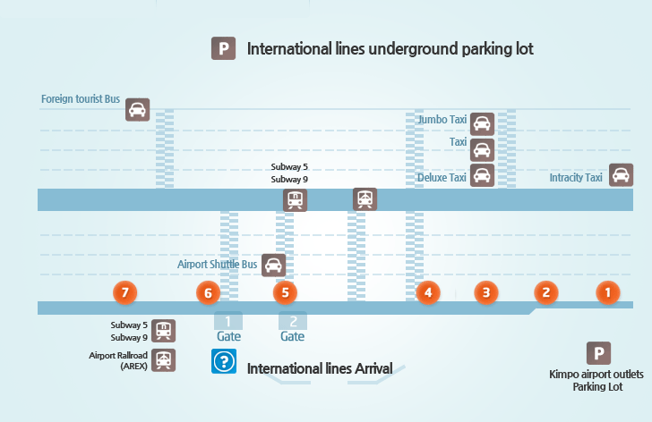

Bus Number | CALT → Airport |  | Airport → CALT |  | Interval
Bus Number | Start | End | Start | End | Interval
6104 (CALT↔Kimpo Airport) | 05:30 | 20:00 | 07:35 | 22:30 | 30min.

- Subway: To take Line 5 and transit to Line 2 at Yeongdeungpo-gu Office Subway Station. The hotels above can be reached via the Samseong Subway Station, Line 2.
Exit 5: It connects directly to the Grand InterContinental SEOUL hotel.
Exit 6: It takes 10 minutes walk to the COEX InterContinental SEOUL hotel.

Attachment 1 : Map

<COEX InterContinental Hotel , Grand InterContinental Hotel>
