3GPP TSG-RAN WG1 Meeting #116bis R1-240XXXX
Changsha, Hunan Province, China, April 15th – 19th, 2024

Title: [draft] LS on Ambient-IoT evaluation scenarios and assumptions
Response to:
Release: Rel-19
Work Item:

Source: CMCC [RAN1]
To: RAN4
Cc:

Contact Person:
Name: Xiaodong Shen
E-mail Address: shenxiaodong@chinamobile.com

Send any reply LS to: 3GPP Liaisons Coordinator, mailto:3GPPLiaison@etsi.org

Attachments: None

1. Overall Description:
RAN1 has discussed and agreed the following aspects,
Scenarios
Agreement
The following scenarios are defined,
- FFS: which of these scenarios will be evaluated

Scenario | CW Inside/outside topology | Diagram of the scenario | Description of the scenario | Device 1/2a/2b | CW spectrum | D2R spectrum | R2D spectrum
D1T1-A1 | CW inside topology | 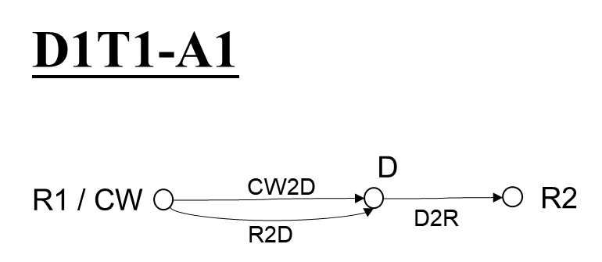 | - CW node inside topology 1  - ‘CW’ in CW2D and ‘R2’ in D2R are different  - ‘CW’ in CW2D and ‘R1’ in R2D are same  - ‘R1’ in R2D and ‘R2’ in D2R are different | Device 1, 2a | Case 1-1 (inside topology, DL)  Case 1-2 (inside topology, UL) | Same as CW
D1T1-A2 |  | 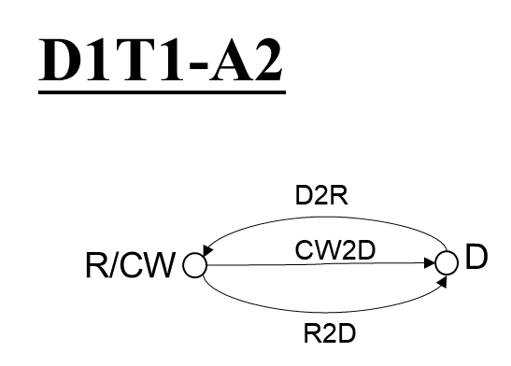 | - CW node inside topology 1  - same ‘CW’ and ‘R’ node for CW2D, D2R and R2D |  | Same as D1T1-A1 | Same as CW
D1T1-B | CW outside topology | 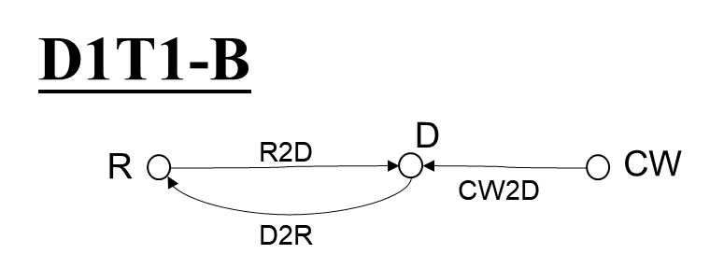 | - CW node outside topology 1  - ‘CW’ in CW2D and ‘R’ in D2R are different  - ‘CW’ in CW2D and ‘R’ in R2D are different  - ‘R’ in R2D and ‘R’ in D2R are same |  | Case 1-4 (outside topology, UL) | Same as CW
D1T1-C | No CW | 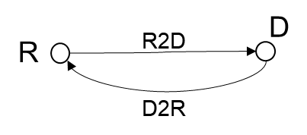 | - No CW Node. | Device 2b | N/A | UL
D2T2-A1 | CW inside topology | 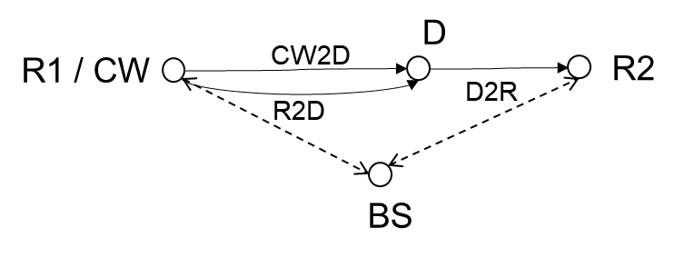 | - CW node inside topology 2  - ‘CW’ in CW2D and ‘R2’ in D2R are different  - ‘CW’ in CW2D and ‘R1’ in R2D are same  - ‘R1’ in R2D and ‘R2’ in D2R are different  - BS communicates with R1 and R2 | Device 1, 2a | Case 2-2 (inside topology, UL) | Same as CW
D2T2-A2 |  | 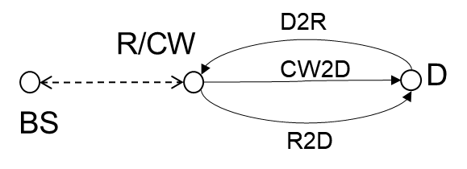 | - CW node inside topology 2  - same ‘CW’ and ‘R’ node for CW2D, D2R and R2D  - BS communicates with R |  | Same as D2T2-A1 | Same as CW
D2T2-B | CW outside topology | 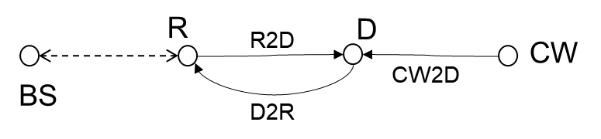 | - CW node outside topology 2  - ‘CW’ in CW2D and ‘R’ in D2R are different  - ‘CW’ in CW2D and ‘R’ in R2D are different  - ‘R’ in R2D and ‘R’ in D2R are same  - BS communicates with R |  | Case 2-3 (outside topology, DL)  Case 2-4 (outside topology, UL) | Same as CW
D2T2-C | No CW | 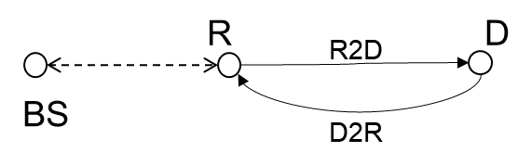 | - No CW Node.  - BS communicates with R | Device 2b | N/A | FFS
Note: this table is for the case where D2R is in the same spectrum as CW2D.
Assumptions for LLS
Agreement
In the link level simulation, considering the following channel model,
- For D1T1, TDL-A channel model is used for R2D link and for D2R link for InF-DH scenario.
- For D2T2,
  - TDL-A channel model is used for R2D link and for D2R link if InF scenario is considered
  - TDL-D channel model is used for R2D link and for D2R link if InH-Office scenario is considered
- FFS delay spread for each case.

Assumptions for Link budget calculation
Agreement
For this study item, the coverage evaluation methodology is based on the following steps.

For an evaluation scenario
- For each of the link i,
  - Step 1: Obtain the required SINR for the physical channels under target scenarios and service/reliability requirements if Budget-Alt2 is used for this link i.
  - Step 2: Obtain the receiver sensitivity using the method Budget-Alt1 (if a predefined threshold is assumed to derive the receiver sensitivity) or Budget-Alt2 (if no predefined threshold is assumed to derive the receiver sensitivity).
  - Step 3: Obtain the coverage performance for link i based on the receiver sensitivity from step 2 and link budget template.
- The coverage results for each link are provided.
- FFS: what links are evaluated besides R2D and D2R (e.g., RF-EH)
- FFS whether/how to model the interferenceFFS: for which device(s) a predefined threshold is assumed

Note the following alternatives for obtaining receiver sensitivity are defined,

- Budget-Alt1: receiver sensitivity is derived by a predefined threshold and no LLS is needed for link budget calculation
  - The results rely on the received sensitivity and maximum transmit power, and directly calculate the maximum distance / pathloss based on these values and other related parameters. The link-level simulation (LLS) performances, such as required SINR can be satisfied for such case and no LLS is needed for link budget calculation.

- Budget-Alt2: receiver sensitivity is derived by required SINR which is given by LLS results
  - The results rely on link-level simulation results, e.g., required SINR which corresponds to detail LLS assumptions (e.g., BW, coding, data rate). And based on the required SINR, the received sensitivity can be calculated and then the maximum distance / pathloss can be derived.
  - Note: For noise power, a noise figure value needs to be provided.

Agreement
MPL and distance is used as performance evaluation metric for link budget calculation.
- Note: the distance is derived from MPL and corresponding pathloss model.
- FFS: Pathloss model

Agreement
For R2D link in the coverage evaluation, for device 1
- Budget-Alt1 is used (note: receiver architecture is RF ED)
For D2R link in the coverage evaluation,
- Budget-Alt2 is used.

Agreement
For D1T1,
- InF-DH NLOS model defined in TR38.901 is used for D2R and R2D links as pathloss model in coverage evaluation.

For D2T2,
- InF-DL and InH-Office model defined in TR38.901is used as pathloss model in coverage evaluation,
  - NLOS for D2R and R2D links if InF-DL is used
  - LOS for D2R and R2D links if InH-Office is used

Agreement
The following layout is used for evaluation purpose,
- FFS: CW distribution for D1T1-B and D2T2-B
Parameter | Assumptions for D1T1 | Assumptions for D2T2
Scenario | InF-DH | InH-office | InF-DL
Hall size | 120x60 m | 120 x50 m | 300x150 m
Room height | 10 m | 3m | 10 m
Sectorization | None
BS deployment / Intermediate UE dropping | 18 BSs on a square lattice with spacing D, located D/2 from the walls.  - L=120m x W=60m; D=20m  - BS height = 8 m  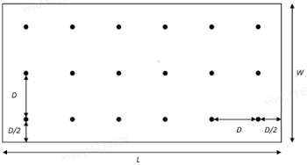 | - L=120m x W=50m;  - Intermediate UE height = 1.5 m  FFS: Intermediate UE dropping | - L=300m x W=150m;  - Intermediate UE height = 1.5 m  FFS: Intermediate UE dropping
Device distribution | Device Height= 1.5 m  AIoT devices drop uniformly distributed over the horizontal area | Device Height= 1.5 m  AIoT devices drop uniformly distributed over the horizontal area  FFS: which devices are involved in the evaluations | Device Height= 1.5m  AIoT devices drop uniformly distributed over the horizontal area  FFS: which devices are involved in the evaluations
Device mobility (horizontal plane only) | 3 kph | 3 kph | 3 kph

Agreement
For coverage evaluation, subject to further discussion on which scenarios to evaluate,
- In the case of CW inside topology with ’A2’ scenarios
  - The digital baseband processing of CW self-interference handling is not modelled in link level simulation (LLS). It is included in the link budget analysis by reporting the CW cancellation capability value.
- FFS: In the case of CW outside topology with ‘B’ scenarios or CW inside topology with ’A1’ scenarios

Agreement
The table below is agreed (except for the yellow part)

No. | Item | Reader-to-Device | Device-to-Reader
(0) System configuration
[0A] | Scenarios | D1T1-A1/A2/B/C  D2T2-A1/A2/B/C | D1T1-A1/A2/B/C  D2T2-A1/A2/B/C
[0A1] | CW case | N/A | 1-1/1-2/1-4/2-2/2-3/2-4
[0B] | Device 1/2a/2b | Device 1/2a/2b | Device 1/2a/2b
[0C] | Center frequency (MHz) | 900MHz (M), 2GHz (O) | 900MHz (M), 2GHz (O)
(1) Transmitter
[1D] | Number of Tx antenna elements / TxRU/ Tx chains modelled in LLS | For BS:  - 2(M) or 4(O) antenna elements for 0.9 GHz  For Intermediate UE:  - 1(M) or 2(O) | 1
[1E] | Total Tx Power (dBm) | - For BS in DL spectrum for indoor  - 33dBm(M), FFS: 38dBm(O), one smaller value [FFS: 23 or 26] dBm(M)  - FFS: additional constraints on PSD  - FFS: For UE in DL spectrum for indoor  - For UL spectrum for indoor,  - 23dBm (M)  - FFS: 26dBm(O)  Other valuesare NOT precluded subject to future discussion. | - For device 1/2a:  - D2R-CWRxPower-Alt1:  - Company to report CW Tx/Rx power together with CW2D distance (see [1E1]~[1E5])  - D2R-CWRxPower-Alt2:  - Balanced MPL/distance (see [1E1]~[1E5], and subject to [1E3] = = [4B])  - For device 2b:  - D2R-dev2bTxPower-Alt1: -10 dBm(O)  - D2R-dev2bTxPower-Alt2: -20 dBm(M)  Other values are NOT precluded subject to future discussion.
[1E1] | CW Tx power (dBm) | N/A | - 23dBm for UL spectrum, FFS 26dBm  - 33dBm(M), 38dBm (O) for DL spectrum  Note: only applicable for device 1/2a
[1E2] | CW Tx antenna gain (dBi) | N/A | - Company to report, the value equals to  - UE Tx ant gain, or  - BS Tx ant gain  Note: only applicable for device 1/2a
[1E3] | CW2D distance (m) | N/A | - For D2R-CWRxPower-Alt1:  - [Company to report]  - For D2R-CWRxPower-Alt2:  - Calculated  Note: only applicable for device 1/2a
[1E4] | CW2D pathloss (dB) | N/A | Calculated  Note: only applicable for device 1/2a
[1E5] | CW received power (dBm) | N/A | Calculated  Note: only applicable for device 1/2a
[1F] | Transmission Bandwidth used for the evaluated channel (Hz) | 180k(M),  360k(O),  1.08MHz(O) | UL data rate: xx bps  FFS: data rate for each case
[1G] | Tx antenna gain (dBi) | - For BS for indoor, 6 dBi(M), 2dBi(M)  - For intermediate UE, 0 dBi | - For A-IoT device, 0dBi (M), -3dBi (O)
[1H] | Ambient IoT backscatter loss (dB)  Note: due to, e.g.,  - impedance mismatch  - Modulation factor | N/A | - OOK: Y dB  - PSK: X dB  Note: Only for device 1  FFS: for device 2a
[1J] | FFS: Ambient IoT on-object antenna penalty | - 0.9dB or 10.4 | - 0.9dB or 10.4
[1K] | Ambient IoT backscatter amplifier gain (dB) | N/A | - 10 dB (M)  - 15 dB (O)  Note: Only for device 2a
[1N] | FFS: Cable, connector, combiner, body losses, etc. (dB) | FFS | N/A
[1M] | EIRP (dBm) | Calculated  FFS: any limitation of the EIRP subject to future discussion | Calculated
(2) Receiver
[2A] | Number of receive antenna elements / TxRU / chains modelled in LLS | Same as [1D]-D2R | Same as [1D]-R2D
[2B] | Bandwidth used for the evaluated channel (Hz) | FFS: relation with the transmission bandwidth used for the evaluated channel | - FFS: whether the values are single side-band or double side-band  - Note: The value is used for calculating the noise power  FFS: relation with the transmission bandwidth used for the evaluated channel
[2B1] | FFS: RF CBW (Hz) | FFS:  - 10MHz  - 20MHz  - Other values  Note: The value is used for calculating the noise power | N/A
[2C] | Receiver antenna gain (dBi) | same as [1G]-D2R | Same as [1G]-R2D
[2X] | FFS: Cable, connector, combiner, body losses, etc. (dB) | N/A | FFS
[2D] | Receiver Noise Figure (dB) | FFS: 20dB or 24dB or 30dB for Budget-Alt2  FFS: different values for device architecture | For BS as reader  - 5dB  For UE as reader  - 7dB
[2E] | Thermal Noise power spectrum density (dBm/Hz) | -174 | -174
[2F] | Noise Power (dBm) | Calculated | Calculated
[2G] | Required SNR | Reported by company | Reported by company
[2H] | FFS: Ambient IoT on-object antenna penalty | - 0.9dB or 10.4 | - 0.9dB or 10.4
[2J] | Budget-Alt1/ Budget-Alt2 | For R2D link in the coverage evaluation, for device 1  - Budget-Alt1 is used (note: receiver architecture is RF ED)  FFS: device 2 | Budget-Alt2
[2K] | CW cancellation (dB) | N/A | For [monostatic backscatter], FFS  - [140dB for BS]  - [120dB for UE]  For [bistatic backscatter]  - Assuming CW has no impact to the receiver sensitivity loss.
[2K1] | Remaining CW interference (dB) | N/A | Calculated
[2K2] | Receiver sensitivity loss(dB) | N/A | Calculated
[2L] | Receiver Sensitivity (dBm) | For Budget-Alt1,  - For device 1 (RF-ED),  - FFS:{-30dBm ~ -36dBm}  - For device 2 if RF-ED is used  - FFS  - For device 2 if RF-ED is not used  - N/A  For Budget-Alt2,  - Calculated | Calculated  Note: the receiver sensitivity includes the receiver sensitivity loss [2K2], i.e. after CW cancellation at least if ‘A2’ scenario is used
(3) System margins
[3A] | Shadow fading margin (function of the cell area reliability and lognormal shadow fading std deviation) (dB) | TBD | TBD
[3B] | polarization mismatching loss (dB) | 3 dB | 3 dB
[3C] | BS selection/macro-diversity gain (dB) | 0 dB  FFS: other values are not precluded | 0 dB  FFS: other values are not precluded
[3D] | Other gains (dB) (if any please specify) | Reported by companies with justification | Reported by companies with justification
(4) MPL / distance
4A | MPL (dB) | Calculated | Calculated
4B | Distance (m) | Calculated | Calculated

<Editor Notes: Note 1 will be updated once the table has stabilized >
Note1: calculated values in the Table XXXX are derived according to the followings,
- 1E
  - For D2R, and device 1/2(backscatter), whether this value is need (not regarded as an input variable but regarded as indirect variable), or based on backscatter activation power threshold
- 1M
  - For R2D, $\left[1M\right]=\left[1E\right]+\left[1G\right]$
  - For D2R,
    - Device 1: $\left[1M\right]=\left[1E\right]+\left[1G\right]-\left[1H\right]-\left[1J\right]+\left[1L\right]$
    - Device 2a: $\left[1M\right]=\left[1E\right]+\left[1G\right]-\left[1J\right]+\left[1K\right]+\left[1L\right]$
    - Device 2b: $\left[1M\right]=\left[1E\right]+\left[1G\right]-\left[1J\right]+\left[1L\right]$
- 2F: $\left[2F\right]=\left[2E\right]+\left[2D\right]+lin2dB([2B])$
- 2L
  - For R2D and Budget-Alt1, [2L] = [2H]
  - For R2D and Budget-Alt2, [2L] = [2G]+[2F]
  - For D2R and Budget-Alt2, Refer to section [xxx] (Proposal [P4-3])
- 4A
  - $\left[4A\right]=\left[1M\right]+\left[2C\right]-\left[2L\right]-\left[3A\right]-\left[3B\right]+\left[3C\right]+[3D]$
- 4B is derived from pathloss model
  - Refer to section [XXX] (Proposal [P4-3-2])

Note2: (M) denotes the value is mandatory to be evaluated. (O) denotes the value can be optionally evaluated.

2. Actions:
To RAN4: RAN1 respectfully asks RAN4 to take the above information into account for coexistence studies.

3. Date of Next TSG-RAN1 Meetings:
RAN1#117 May 20th - 24th 2024 Fukuoka City, Fukuoka, JP
RAN1#118 August 19th - 23th 2024 Maastricht, NL

