**3GPP TSG RAN WG1 #116-bis R1-24xxxxx**

**Changsha, Hunan Province, China, April 15th – 19th, 2024**

**Source: Moderator (MediaTek)**

**Title: Moderator summary 1 for R1-2402945 about mux-HARQ-ACK-withoutPUCCH-onPUSCH-r16**

**Agenda item: 7**

**Document for:** **Discussion and Decision**

Introduction

This document is for the RAN1 discussion for the following:

**Rel-17 New RAT**

R1-2402945       On R17 UE behavior without mux-HARQ-ACK-withoutPUCCH-onPUSCH-r16     MediaTek

To be moderated by James (MediaTek)

As guided by the Chairman, this contribution provides discussion points (Section 2), and possible RAN1 consensus during this meeting (Section 3, TBD).

Discussion points (Phase 1 until 17-Apr)

**Background for** **R1-2402945**

In RAN1 #109, companies were discussing HARQ-ACK multiplexing on PUSCH without PUCCH ([109-e-NR-CRs-01]). When multiple PUSCHs are overlapped with one missing PUCCH carrying HARQ-ACK as shown in Figure 1, RAN1 aims to define a unified PUSCH selection rule in R16 or R17.

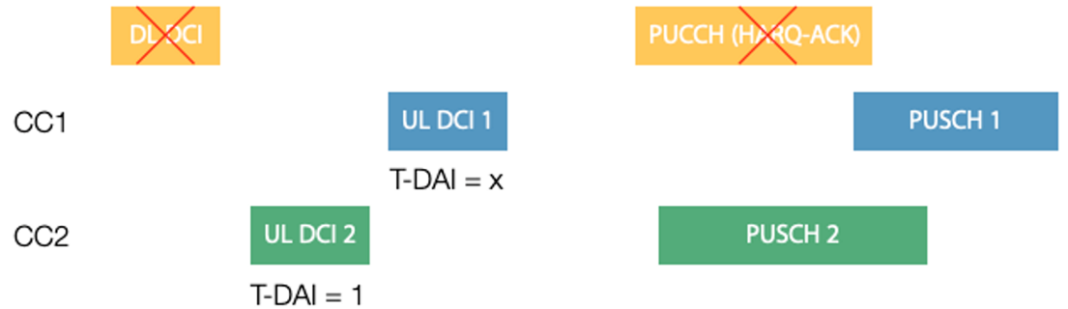

**Figure 1. Illustration of HARQ-ACK multiplexing on PUSCH without PUCCH**

The RAN1 #109 discussion turns out with a R16 UE capability, while it was expected to have a unified UE behavior in R17. For a R16 UE, if it does not report *mux-HARQ-ACK-withoutPUCCH-onPUSCH-r16*, the PUSCH selection for HARQ-ACK multiplexing is up to UE implementation.

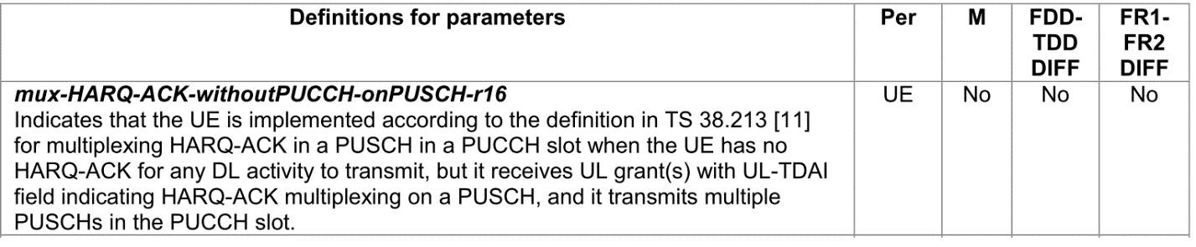

However, reading from the R17 mirror CR (R1-2205629) as copied in Figure 2, it seems that for a R17 UE, if it does not report mux-HARQ-ACK-withoutPUCCH-onPUSCH-r16, the PUSCH selection for HARQ-ACK multiplexing is still up to UE implementation.

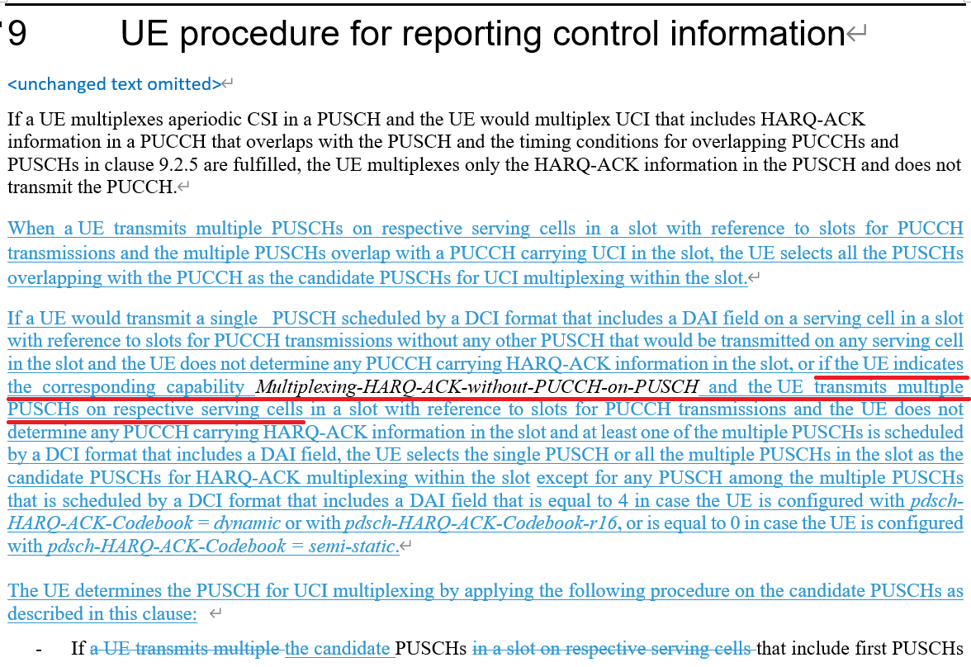

**Figure 2. Text from the R17 mirror CR (R1-2205629)**

Hence, the following is proposed in R1-2402945:

**Proposal 1: RAN1 to clarify,** **for a R17 UE which does not report *mux-HARQ-ACK-withoutPUCCH-onPUSCH-r16*, the PUSCH selection when multiple PUSCHs are overlapped with one missing PUCCH carrying HARQ-ACK is**

* + **up to UE implementation, or**
  + **should be aligned with the latest UE behavior defined in RAN1 #109:**
    - **R1-2205628 (TS38.213, Rel-16, Cat. F) and R1-2205629 (TS38.213, Rel-17, CR#0317, Cat. A)**

The following discussions points are devised for potential clarfications.

### Discussion point 1:

**For a R17 UE which does not report *mux-HARQ-ACK-withoutPUCCH-onPUSCH-r16*, the PUSCH selection when multiple PUSCHs are overlapped with one missing PUCCH carrying HARQ-ACK should be**

* + **Alt 1: up to UE implementation**
  + **Alt 2: aligned with the latest UE behavior defined in RAN1 #109:**
    - **R1-2205628 (TS38.213, Rel-16, Cat. F) and R1-2205629 (TS38.213, Rel-17, CR#0317, Cat. A)**

|  |  |  |
| --- | --- | --- |
| **Company** | **Alt 1 or Alt 2** | **Comment** |
| Nokia | Alt2 | The intent was to make the feature as “optional with capability” for Rel-16 and “mandatory with capability” for Rel-17 onwards.  Would propose sending an LS to RAN2 asking the 38.306 to reflect this |
| ZTE | Alt2 | The discussion in the maintenance was to aim to achieve the unified UE behaviour. However, the Rel-16 UE capability was introduced as compromise since it was too late to discuss this issue and there has already been Rel-16 UE in the market. Rel-17 UE should have the unified UE behaviour, which follows the current spec. |
| Huawei, HiSilicon | Alt1 | There is no motivation to make same UE capability as release dependent. For R16, the capability is optional and we think in R17 it should be optional as well. On the other hand, even in R17, there is still some less capabilities UEs cannot support complex UCI multiplexing behaviour.  We do not agree the point from ZTE that it is not late for changing R17 UE behaviour. R17 spec is also frozen two years which cannot be changed easily as well. |

### Discussion point 2:

**If you answer to discussion point 1 is Alt 2, what’s you suggested revision in current spec? For example, making the *mux-HARQ-ACK-withoutPUCCH-onPUSCH-r16* mandatory for R17, or delete this UE capability from R17 RAN1 38.213 spec with a RAN1 CR, or other possible methods.**

|  |  |
| --- | --- |
| **Company** | **Suggested solution** |
| ZTE | Either way is OK. We slightly prefer to make the UE capability is mandatory for Rel-17 in the UE capability part. |
|  |  |
|  |  |

Resulted RAN1 conclusion/agreement

TBD