**3GPP TSG RAN WG1 #116-bis R1-24xxxxx**

**Changsha, Hunan Province, China, April 15th – 19th, 2024**

**Source: Moderator (MediaTek)**

**Title: Moderator summary 1 for R1-2402945 about mux-HARQ-ACK-withoutPUCCH-onPUSCH-r16**

**Agenda item: 7**

**Document for:** **Discussion and Decision**

Introduction

This document is for the RAN1 discussion for the following:

**Rel-17 New RAT**

R1-2402945       On R17 UE behavior without mux-HARQ-ACK-withoutPUCCH-onPUSCH-r16     MediaTek

To be moderated by James (MediaTek)

As guided by the Chairman, this contribution provides discussion points (Section 2), and possible RAN1 consensus during this meeting (Section 3, TBD).

Discussion points (Phase 1 until 17-Apr)

**Background for** **R1-2402945**

In RAN1 #109, companies were discussing HARQ-ACK multiplexing on PUSCH without PUCCH ([109-e-NR-CRs-01]). When multiple PUSCHs are overlapped with one missing PUCCH carrying HARQ-ACK as shown in Figure 1, RAN1 aims to define a unified PUSCH selection rule in R16 or R17.

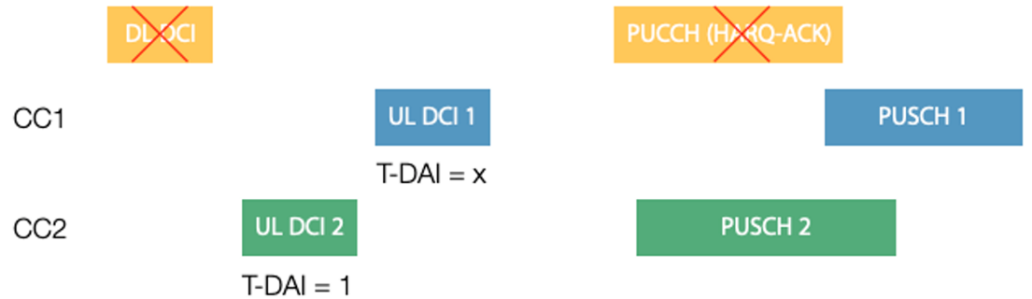

**Figure 1. Illustration of HARQ-ACK multiplexing on PUSCH without PUCCH**

The RAN1 #109 discussion turns out with a R16 UE capability, while it was expected to have a unified UE behavior in R17. For a R16 UE, if it does not report *mux-HARQ-ACK-withoutPUCCH-onPUSCH-r16*, the PUSCH selection for HARQ-ACK multiplexing is up to UE implementation.

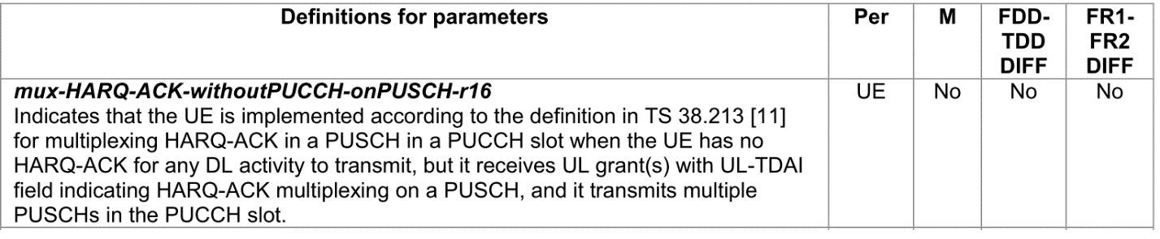

However, reading from the R17 mirror CR (R1-2205629) as copied in Figure 2, it seems that for a R17 UE, if it does not report mux-HARQ-ACK-withoutPUCCH-onPUSCH-r16, the PUSCH selection for HARQ-ACK multiplexing is still up to UE implementation.

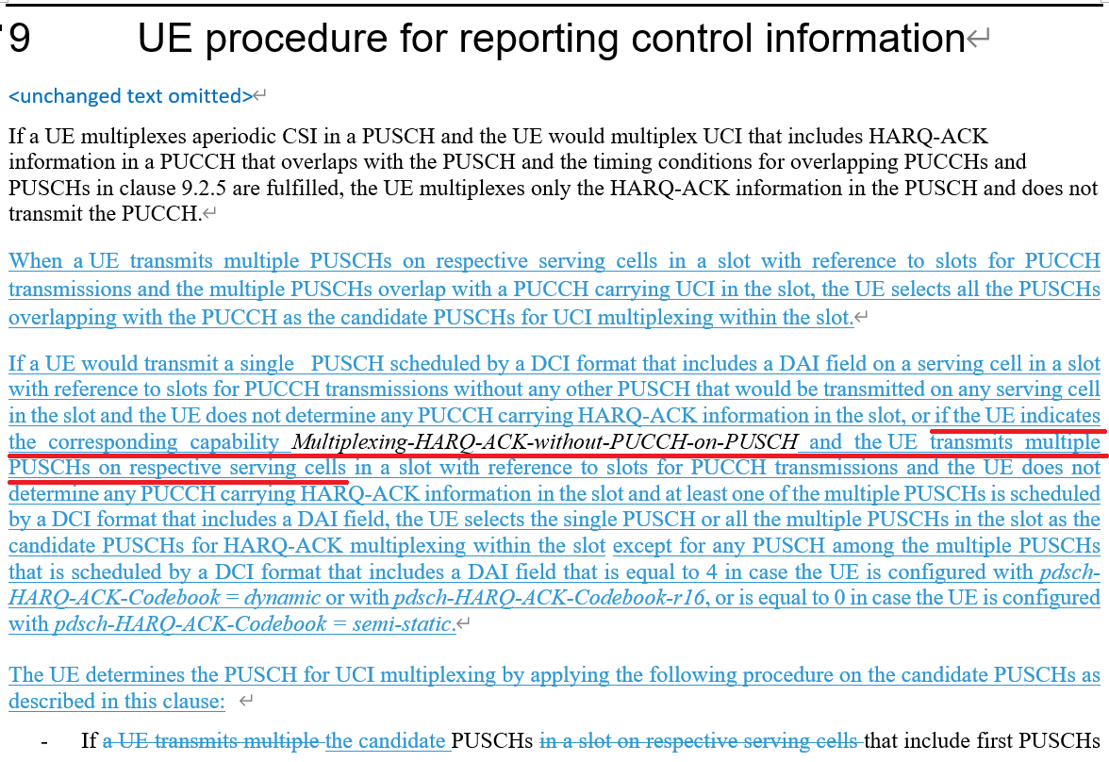

**Figure 2. Text from the R17 mirror CR (R1-2205629)**

Hence, the following is proposed in R1-2402945:

**Proposal 1: RAN1 to clarify,** **for a R17 UE which does not report *mux-HARQ-ACK-withoutPUCCH-onPUSCH-r16*, the PUSCH selection when multiple PUSCHs are overlapped with one missing PUCCH carrying HARQ-ACK is**

* + **up to UE implementation, or**
  + **should be aligned with the latest UE behavior defined in RAN1 #109:**
    - **R1-2205628 (TS38.213, Rel-16, Cat. F) and R1-2205629 (TS38.213, Rel-17, CR#0317, Cat. A)**

The following discussions points are devised for potential clarfications.

### Discussion point 1:

**For a R17 UE which does not report *mux-HARQ-ACK-withoutPUCCH-onPUSCH-r16*, the PUSCH selection when multiple PUSCHs are overlapped with one missing PUCCH carrying HARQ-ACK should be**

* + **Alt 1: up to UE implementation**
  + **Alt 2: aligned with the latest UE behavior defined in RAN1 #109:**
    - **R1-2205628 (TS38.213, Rel-16, Cat. F) and R1-2205629 (TS38.213, Rel-17, CR#0317, Cat. A)**

|  |  |  |
| --- | --- | --- |
| **Company** | **Alt 1 or Alt 2** | **Comment** |
|  |  |  |
|  |  |  |
|  |  |  |

### Discussion point 2:

**If you answer to discussion point 1 is Alt 2, what’s you suggested revision in current spec? For example, making the *mux-HARQ-ACK-withoutPUCCH-onPUSCH-r16* mandatory for R17, or delete this UE capability from R17 RAN1 38.213 spec with a RAN1 CR, or other possible methods.**

|  |  |
| --- | --- |
| **Company** | **Suggested solution** |
|  |  |
|  |  |
|  |  |

Resulted RAN1 conclusion/agreement

TBD