3GPP TSG RAN WG1#116bis R1-24xxxxx
Changsha, China, April 15th – 29th, 2024

Source: Moderator (Nokia)
Title: [116bis-Pre-R18-NR] Summary on SCell A-CSI reporting UE capabilities
Agenda Item: 7
Release: Release 15, Release 16, Release 17
WI code: NR_newRAT-Core, LTE_NR_DC_CA_enh-Core, NR_DSS-Core
Document for: Discussion and Decision

Introduction
A contribution [1] submitted to the RAN1#116bis raised questions on the needed UE capabilities for a number of different A-CSI reporting cases with DL carrier aggregation.
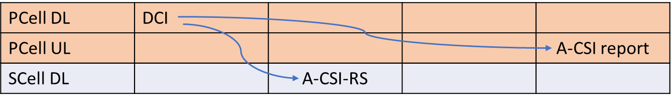  Case 1a (same SCS):  - PUSCH carrying A-CSI report is self-scheduled  - A-CSI-RS is cross-carrier triggered | 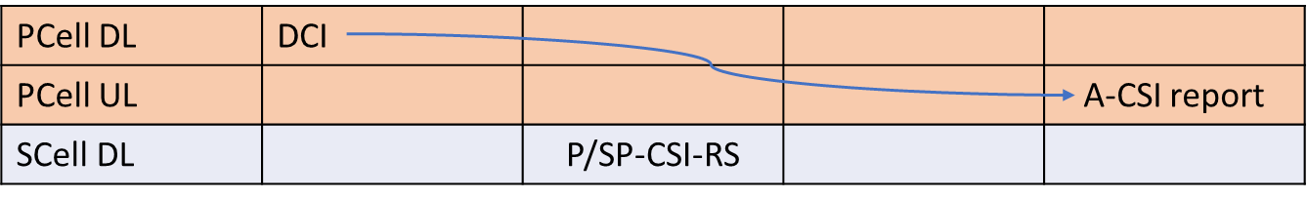  Case 1b/1c (same SCS):  - PUSCH carrying A-CSI report is self-scheduled  - 1b: A-CSI report is derived from P-CSI-RS  - 1c: A-CSI report is derived from SP-CSI-RS
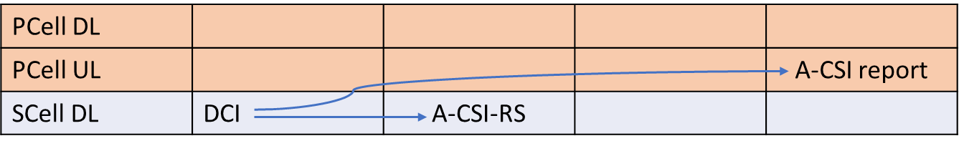  Case 2a (same SCS):  - PUSCH carrying A-CSI report is cross-cc-scheduled  - A-CSI-RS is same-carrier triggered | 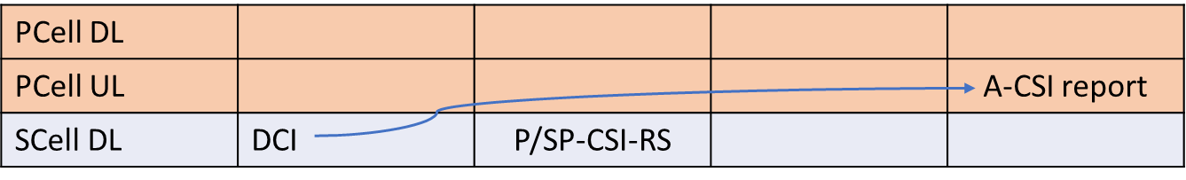  Case 2b/2c (same SCS):  - PUSCH carrying A-CSI report is cross-cc-scheduled  - 2b: A-CSI report is derived from P-CSI-RS  - 2c: A-CSI report is derived from SP-CSI-RS
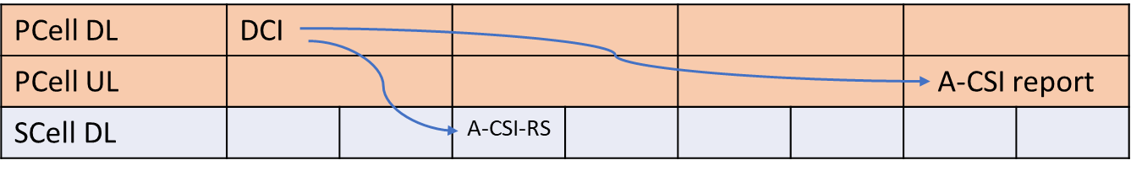  Case 3a (different SCS):  - PUSCH carrying A-CSI report is self-scheduled  - A-CSI-RS is cross-carrier triggered | 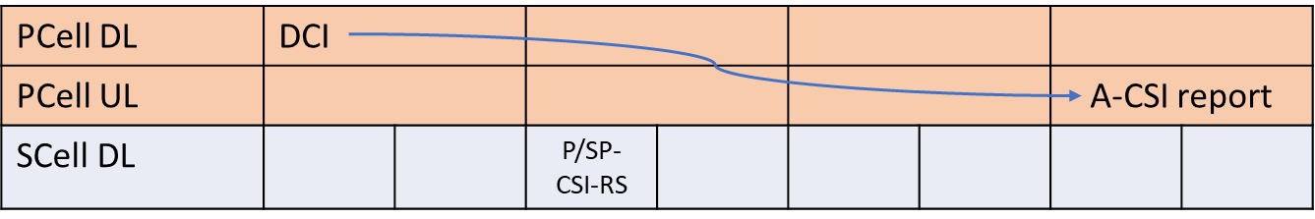  Case 3b/3c:  - PUSCH carrying A-CSI report is self-scheduled  - 3b: A-CSI report is derived from P-CSI-RS  - 3c: A-CSI report is derived from SP-CSI-RS
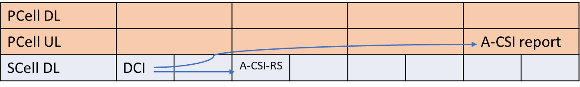  Case 4a (different SCS):  - PUSCH carrying A-CSI report is cross-cc-scheduled  - A-CSI-RS is same-carrier triggered | 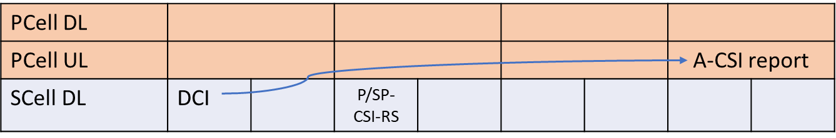  Case 4b/4c (different SCS):  - PUSCH carrying A-CSI report is cross-cc-scheduled  - 4b: A-CSI report is derived from P-CSI-RS  - 4c: A-CSI report is derived from SP-CSI-RS

The following proposals were made:
Proposal 1: RAN1 to conclude the following:
For the case where an SCell A-CSI report is
- Triggered by a DCI on PCell, and
- The A-CSI report is transmitted on a PUSCH on the PCell
the following optional UE capabilities are needed for the following cases:
SCell CSI-RS | PCell/SCell SCS | Optional UE capabilities needed
A-CSI-RS | Same | None (mandatory features only)
P-CSI-RS | Same | None (mandatory features only)
SP-CSI-RS | Same | UE support of SP-CSI-RS configuration
A-CSI-RS | Different | crossCarrierA-CSI-trigDiffSCS
P-CSI-RS | Different | None (mandatory features only)
SP-CSI-RS | Different | UE support of SP-CSI-RS configuration

Proposal 2: RAN1 to conclude the following:
For the case where a an SCell A-CSI report is
- Triggered by a DCI on SCell, and
- The A-CSI report is transmitted on a PUSCH on the PCell
the following optional UE capabilities are needed for the following cases:
SCell CSI-RS | PCell/SCell SCS | Optional UE capabilities needed
A-CSI-RS | Same | crossCarrierSchedulingSCell-SpCellTypeA, or crossCarrierSchedulingSCell-SpCellTypeB
A-CSI-RS | Same
SP-CSI-RS | Same | One of the above and support for SP-CSI-RS configuration
A-CSI-RS | Different | crossCarrierSchedulingSCell-SpCellTypeA, or crossCarrierSchedulingSCell-SpCellTypeB
P-CSI-RS | Different
SP-CSI-RS | Different | One of the above and support for SP-CSI-RS configuration

References
- R1-2403312 Ambiguities in SCell A-CSI reporting UE capabilities Nokia

Discussion
Question 1: Do you have a concern with the following interpretation of the needed UE capabilities for the case where the triggering DCI and the PUSCH with the A-CSI report are both on the PCell:
SCell CSI-RS | PCell/SCell SCS | Optional UE capabilities needed
A-CSI-RS | Same | None (mandatory features only)
P-CSI-RS | Same | None (mandatory features only)
SP-CSI-RS | Same | UE support of SP-CSI-RS configuration
A-CSI-RS | Different | crossCarrierA-CSI-trigDiffSCS
P-CSI-RS | Different | None (mandatory features only)
SP-CSI-RS | Different | UE support of SP-CSI-RS configuration

Please provide your comment on the question to the table below
Company | Comments
Apple | Our comments are in Red  SCell CSI-RS PCell/SCell SCS Optional UE capabilities needed  A-CSI-RS Same None (mandatory features only) Agree  P-CSI-RS Same None (mandatory features only) Agree  SP-CSI-RS Same UE support of SP-CSI-RS configuration sp-CSI-RS, sp-CSI-IM  A-CSI-RS Different crossCarrierA-CSI-trigDiffSCS Agree  P-CSI-RS Different None (mandatory features only) Agree  SP-CSI-RS Different UE support of SP-CSI-RS configuration sp-CSI-RS, sp-CSI-IM
Nokia | Thanks Apple for the comments, fully agree with the additional clarification.  In our view the critical question is that all companies are aligned that no other UE capabilities are needed for the abovementioned cases than indicated in the table.

Question 2: Do you have a concern with the following interpretation of the needed UE capabilities for the case where the triggering DCI is on the SCell and the PUSCH with the A-CSI report is on the PCell:
SCell CSI-RS | PCell/SCell SCS | Optional UE capabilities needed
A-CSI-RS | Same | crossCarrierSchedulingSCell-SpCellTypeA, or crossCarrierSchedulingSCell-SpCellTypeB
AP-CSI-RS | Same
SP-CSI-RS | Same | One of the above and support for SP-CSI-RS configuration
A-CSI-RS | Different | crossCarrierSchedulingSCell-SpCellTypeA, or crossCarrierSchedulingSCell-SpCellTypeB
P-CSI-RS | Different
SP-CSI-RS | Different | One of the above and support for SP-CSI-RS configuration

Please provide your comment on the question to the table below
Company | Comments
Apple | Our comments are in Red  First, we need to clarify that this is the case where CSI-RS and DCI are on the same SCell and have the same SCS, specification also allows the CSI-RS to be on PCell or a different SCell  SCell CSI-RS PCell/SCell SCS Optional UE capabilities needed  A-CSI-RS Same crossCarrierSchedulingSCell-SpCellTypeA, or crossCarrierSchedulingSCell-SpCellTypeB Agree  AP-CSI-RS Same  SP-CSI-RS Same One of the above and support for SP-CSI-RS configuration sp-CSI-RS, sp-CSI-IM  A-CSI-RS Different crossCarrierSchedulingSCell-SpCellTypeA, or crossCarrierSchedulingSCell-SpCellTypeB and crossCarrierSchedulingUL-DiffSCS-r16  P-CSI-RS Different  SP-CSI-RS Different One of the above and support for SP-CSI-RS configuration and crossCarrierSchedulingUL-DiffSCS-r16, sp-CSI-RS, sp-CSI-IM
Nokia | Thanks Apple for the comments and the correction to the table. We agree that for the last three cases, also the different SCS cross-carrier scheduling capability is needed.

Question 3: Would you be able to agree to one of the two RAN1 conclusion:
Alt 1: [The two conclusion proposals of R1-2403312]
Alt 2: No concerns were seen with the interpretation of UE capabilities for the indicates A-CSI reporting cases of R1-2403312

Please provide your comment on the question to the table below
Company | Comments
Apple | We are fine to draw conclusion for both cases
Nokia | Would support a RAN1 conclusion along the lines of the original proposal with the corrections from Apple.

