3GPP TSG RAN WG1#116bis R1-24xxxxx
Changsha, China, April 15th – 29th, 2024

Source: Moderator (Nokia)
Title: [116bis-Pre-R18-NR] Summary on SCell A-CSI reporting UE capabilities
Agenda Item: 7
Release: Release 15, Release 16, Release 17
WI code: NR_newRAT-Core, LTE_NR_DC_CA_enh-Core, NR_DSS-Core
Document for: Discussion and Decision

Introduction
A contribution [1] submitted to the RAN1#116bis raised questions on the needed UE capabilities for a number of different A-CSI reporting cases with DL carrier aggregation.
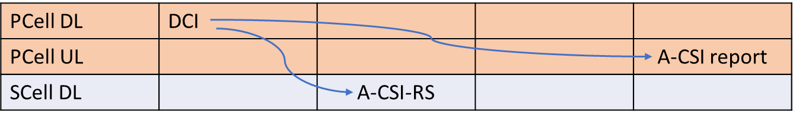  Case 1a (same SCS):  - PUSCH carrying A-CSI report is self-scheduled  - A-CSI-RS is cross-carrier triggered | 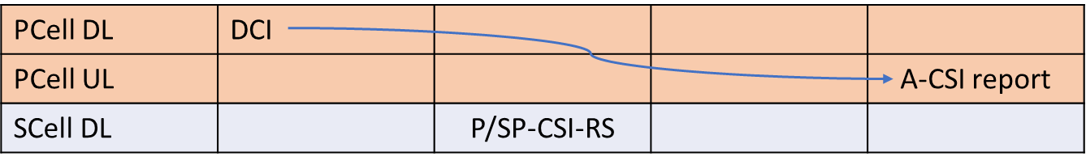  Case 1b/1c (same SCS):  - PUSCH carrying A-CSI report is self-scheduled  - 1b: A-CSI report is derived from P-CSI-RS  - 1c: A-CSI report is derived from SP-CSI-RS
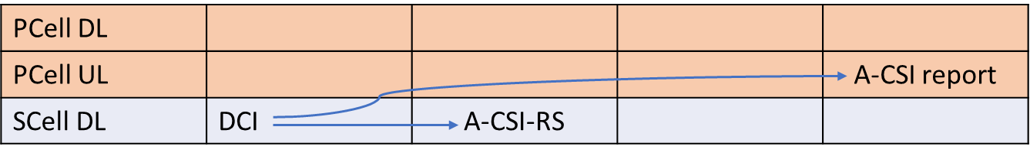  Case 2a (same SCS):  - PUSCH carrying A-CSI report is cross-cc-scheduled  - A-CSI-RS is same-carrier triggered | 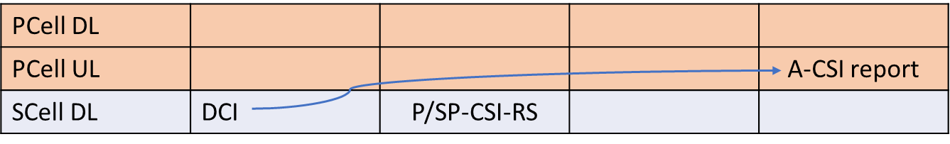  Case 2b/2c (same SCS):  - PUSCH carrying A-CSI report is cross-cc-scheduled  - 2b: A-CSI report is derived from P-CSI-RS  - 2c: A-CSI report is derived from SP-CSI-RS
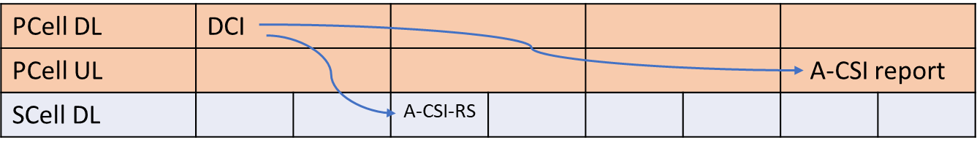  Case 3a (different SCS):  - PUSCH carrying A-CSI report is self-scheduled  - A-CSI-RS is cross-carrier triggered | 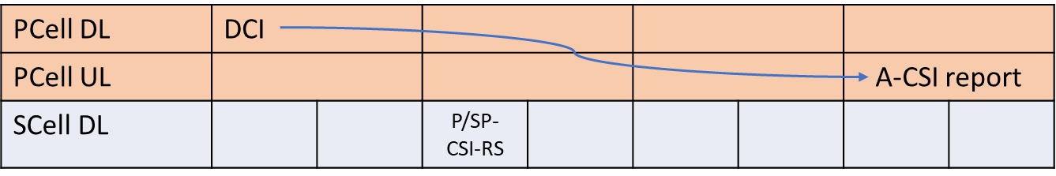  Case 3b/3c:  - PUSCH carrying A-CSI report is self-scheduled  - 3b: A-CSI report is derived from P-CSI-RS  - 3c: A-CSI report is derived from SP-CSI-RS
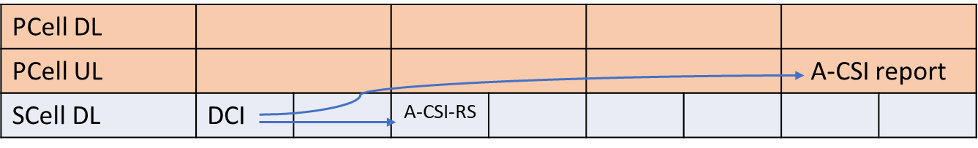  Case 4a (different SCS):  - PUSCH carrying A-CSI report is cross-cc-scheduled  - A-CSI-RS is same-carrier triggered | 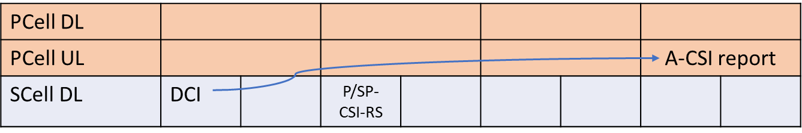  Case 4b/4c (different SCS):  - PUSCH carrying A-CSI report is cross-cc-scheduled  - 4b: A-CSI report is derived from P-CSI-RS  - 4c: A-CSI report is derived from SP-CSI-RS

The following proposals were made:
Proposal 1: RAN1 to conclude the following:
For the case where an SCell A-CSI report is
- Triggered by a DCI on PCell, and
- The A-CSI report is transmitted on a PUSCH on the PCell
the following optional UE capabilities are needed for the following cases:
SCell CSI-RS | PCell/SCell SCS | Optional UE capabilities needed
A-CSI-RS | Same | None (mandatory features only)
P-CSI-RS | Same | None (mandatory features only)
SP-CSI-RS | Same | UE support of SP-CSI-RS configuration
A-CSI-RS | Different | crossCarrierA-CSI-trigDiffSCS
P-CSI-RS | Different | None (mandatory features only)
SP-CSI-RS | Different | UE support of SP-CSI-RS configuration

Proposal 2: RAN1 to conclude the following:
For the case where a an SCell A-CSI report is
- Triggered by a DCI on SCell, and
- The A-CSI report is transmitted on a PUSCH on the PCell
the following optional UE capabilities are needed for the following cases:
SCell CSI-RS | PCell/SCell SCS | Optional UE capabilities needed
A-CSI-RS | Same | crossCarrierSchedulingSCell-SpCellTypeA, or crossCarrierSchedulingSCell-SpCellTypeB
A-CSI-RS | Same
SP-CSI-RS | Same | One of the above and support for SP-CSI-RS configuration
A-CSI-RS | Different | crossCarrierSchedulingSCell-SpCellTypeA, or crossCarrierSchedulingSCell-SpCellTypeB
P-CSI-RS | Different
SP-CSI-RS | Different | One of the above and support for SP-CSI-RS configuration

References
- R1-2403312 Ambiguities in SCell A-CSI reporting UE capabilities Nokia

Discussion
Question 1: Do you have a concern with the following interpretation of the needed UE capabilities for the case where the triggering DCI and the PUSCH with the A-CSI report are both on the PCell:
SCell CSI-RS | PCell/SCell SCS | Optional UE capabilities needed
A-CSI-RS | Same | None (mandatory features only)
P-CSI-RS | Same | None (mandatory features only)
SP-CSI-RS | Same | UE support of SP-CSI-RS configuration
A-CSI-RS | Different | crossCarrierA-CSI-trigDiffSCS
P-CSI-RS | Different | None (mandatory features only)
SP-CSI-RS | Different | UE support of SP-CSI-RS configuration

Please provide your comment on the question to the table below
Company | Comments
Apple | Our comments are in Red  SCell CSI-RS PCell/SCell SCS Optional UE capabilities needed  A-CSI-RS Same None (mandatory features only) Agree  P-CSI-RS Same None (mandatory features only) Agree  SP-CSI-RS Same UE support of SP-CSI-RS configuration sp-CSI-RS, sp-CSI-IM  A-CSI-RS Different crossCarrierA-CSI-trigDiffSCS Agree  P-CSI-RS Different None (mandatory features only) Agree  SP-CSI-RS Different UE support of SP-CSI-RS configuration sp-CSI-RS, sp-CSI-IM

Question 2: Do you have a concern with the following interpretation of the needed UE capabilities for the case where the triggering DCI is on the SCell and the PUSCH with the A-CSI report is on the PCell:
SCell CSI-RS | PCell/SCell SCS | Optional UE capabilities needed
A-CSI-RS | Same | crossCarrierSchedulingSCell-SpCellTypeA, or crossCarrierSchedulingSCell-SpCellTypeB
A-CSI-RS | Same
SP-CSI-RS | Same | One of the above and support for SP-CSI-RS configuration
A-CSI-RS | Different | crossCarrierSchedulingSCell-SpCellTypeA, or crossCarrierSchedulingSCell-SpCellTypeB
P-CSI-RS | Different
SP-CSI-RS | Different | One of the above and support for SP-CSI-RS configuration

Please provide your comment on the question to the table below
Company | Comments
Apple | Our comments are in Red  First, we need to clarify that this is the case where CSI-RS and DCI are on the same SCell and have the same SCS, specification also allows the CSI-RS to be on PCell or a different SCell  SCell CSI-RS PCell/SCell SCS Optional UE capabilities needed  A-CSI-RS Same crossCarrierSchedulingSCell-SpCellTypeA, or crossCarrierSchedulingSCell-SpCellTypeB Agree  AP-CSI-RS Same  SP-CSI-RS Same One of the above and support for SP-CSI-RS configuration sp-CSI-RS, sp-CSI-IM  A-CSI-RS Different crossCarrierSchedulingSCell-SpCellTypeA, or crossCarrierSchedulingSCell-SpCellTypeB and crossCarrierSchedulingUL-DiffSCS-r16  P-CSI-RS Different  SP-CSI-RS Different One of the above and support for SP-CSI-RS configuration and crossCarrierSchedulingUL-DiffSCS-r16, sp-CSI-RS, sp-CSI-IM

Question 3: Would you be able to agree to one of the two RAN1 conclusion:
Alt 1: [The two conclusion proposals of R1-2403312]
Alt 2: No concerns were seen with the interpretation of UE capabilities for the indicates A-CSI reporting cases of R1-2403312

Please provide your comment on the question to the table below
Company | Comments
Apple | We are fine to draw conclusion for both cases

