**3GPP TSG-RAN WG1 Meeting #108-e R1-211xxxx**

**e-Meeting, February 21th – March 3rd, 2022**

**Agenda item:** 8.1.2.1

**Source:** Moderator (Qualcomm)

**Title:** Discussion Summary for mTRP PDCCH Reliability Enhancements

**Document for:** Discussion/Decision

# **Summary of Issues**

|  |  |  |
| --- | --- | --- |
|  | **Summary of the issue** | **Moderator’s assessment** |
| **Issue 1**  **[4, 5, 6, 7, 10, 13, 14, 15, 16]** | PUCCH resource determination ambiguity in the case of AL8 and AL16 having same start CCE. | See Section 1.1 for the FL proposal. |
| **Issue 2**  **[16]** | Discuss in RAN1 to determine whether PDCCH repetition is supported for *searchSpaceBroadcast, peiSearchSpace*, and *sdt-SearchSpace* | See Section 1.2 for discussions. |
| **Issue 3**  **[12, 15]** | Aligning the text in 38.214 for describing PDCCH repetition | This is editorial and I suggest discussing the TPs directly in Section 1.3. |
| **Issue 4**  **[6]** | TP for Definition of counter DAI/total DAI and Type 2 HARQ-Ack codebook construction and determining the last DCI for PUCCH resource determination | During the spec review phase, there were some discussions regarding whether the existing text in 38.213 already captures this given that PDCCH MO is defined to include both PDCCH candidates.  Companies are encouraged to provide their inputs regarding this. |
| **Issue 5**  **[6, 17]** | Capture the agreed list of configuration restriction on linked search space sets in TS 38.213 or TS 38.331.  Send LS to RAN2 to capture the agreement on cross-carrier scheduling and linked SS sets in scheduled CC in 38.331. | This can be discussed if there are strong preferences, but I suggest leaving this to RAN2 to capture these restrictions in 38.331.  Companies can discuss if LS to RAN2 is needed or not. |
| **Issue 6**  **[1]** | The issue is related to a Rel-16 conclusion for span-based monitoring, which indicates that UE may not do the CCE/BD counting for the purpose of dropping in spans except the first one within a slot.  **Proposal**: UE does not expect one of the linked PDCCH candidates overlapping with an individual PDCCH candidate in spans except for the first span in a slot, when the candidates use the same set of CCEs in the same CORESET and have the same scrambling and DCI size. | More discussions are needed. It is not clear to the moderator why the Rel-16 conclusion was only for the primary cell.  Companies are encouraged to check the background on this issue. |
| **Issue 7**  **[3]** | Different PDCCH repetitions in different CCs:  **Proposal**: It should be supported that two linked SS sets are in two serving cells. | Moderator’s understanding is that this an optimization with various spec impacts and is not an essential issue to be handled during maintenance phase. |
| **Issue 8**  **[2]** | Issue related to the case that “Monitoring of individual candidates” in FG 23-2-1-a is not supported. The proposal is based on the assumptions that “UE would perform one individual decoding in first PDCCH repetition occasion and one soft bit combining decoding in second PDCCH repetition occasion” and “Given gNB transmits one PDCCH only in single TRP rather than M-TRP”  Proposal: When UE does not support the capability of monitoring individual PDCCH candidates, the individual PDCCH candidate associated with which repetition candidate should be clarified. | The assumptions in the contribution are not clear and not based on agreements. When UE does not support this capability, gNB should not send the individual candidate as UE does not monitor it.  More clarifications seem to be needed. |
| **Issue 9**  **[8, 9, 11]** | A specific value larger than larger d1,1 value is supported for soft combining, or  Processing time relaxation for PDSCH/PUSCH/DCI/AP-CSI | This has been discussed multiple times, and majority of companies do not support it.  Suggest to not discuss this again. |
| **Issue 10**  **[13]** | Capturing the agreement on reference PDCCH candidate for SPS release DCI | Moderator’s understanding is that this is already captured by the general statement in Section 9 and 10 of 38.213 for defining PDCCH reception (“the end of the PDCCH reception is the end of the PDCCH candidate that ends later”).  Hence, it seems there is no need to discuss it. |
| **Issue 11**  **[15]** | Clarify that UE does not expect to decode two different DCI payloads in two linked PDCCH candidates. | Companies are encouraged to discuss if this clarification is needed or not. |

## **Issue 1: AL8 and AL16 ambiguity on PUCCH resource determination**

Issue 1 is related to the ambiguity on PUCCH resource selection (when size of resource set is larger than 8, and DL DCI is detected) in the case that AL8 candidate and AL16 candidate have the same start CCE in a non-interleaved CORESET with 1-symbol duration.

The issue was discussed in the previous meeting and is illustrated below: Assuming UE decodes a DCI over the AL8 or AL16 candidates (in CORESET2 with the same start CCE, and CORESET2 is non-interleaved with 1-symbol duration), then we will use the reference candidate for PUCCH resource determination, but the reference is in the other CORESET (CORESET 1) as SS set 1 has lower ID. If the two candidates on CORESET1 do not have the same start CCE, then the ambiguity can happen:

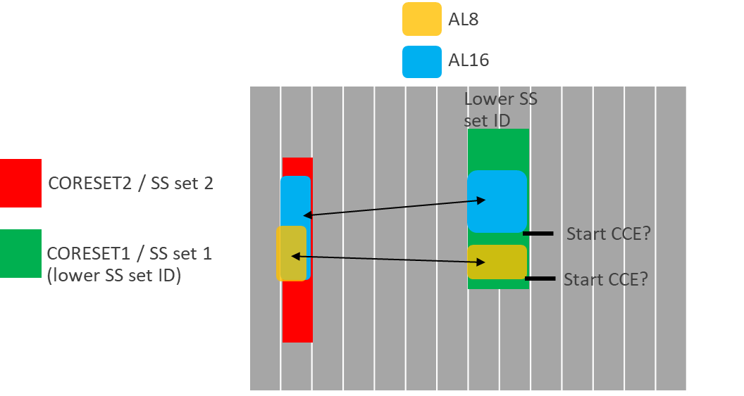

In the previous meeting, two alternatives were discussed: Either the above situation is not expected by UE, or a rule is specified to address the ambiguity issue. It has been pointed out by multiple companies that it is not easy for gNB to make sure that this situation is avoided since the location of candidates is determined based on the hashing function and changes in different slots. The following example is provided in [14], where the 4 cases can randomly happen in different slots according to hash function.

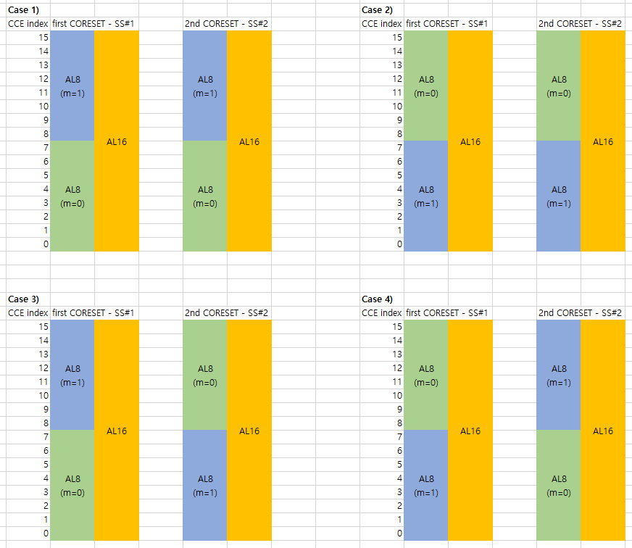

Based on the contributions, the following alternatives can be considered:

* Alt1: The issue is handled by gNB, and UE does not expect this ambiguity to happen.
* Alt2: The issue is handled by a rule:
  + Alt2-1: The lowest start CCE index among AL8 and AL16 candidates in the second SS set is used
  + Alt2-2: The start CCE index of AL16 candidates in the second SS set is used
  + Alt2-3: The first SS set (in which both AL8 and AL16 candidates have the same start CCE) is used.

Hence, the following proposal can be considered:

* ***FL Proposal 1: If two PDCCH candidates with AL8 and AL16 have the same start CCE in a non-interleaved CORESET with one OFDM symbol, and the two PDCCH candidates are in a first SS set that is linked to a second SS set, and UE detects a DL DCI via any of the AL8 candidates or AL16 candidates in any of the first and second SS sets indicating a PUCCH resource for HARQ-Ack and the corresponding PUCCH resource set has a size larger than eight***
  + ***Alt1: UE expects the linked AL8 candidate and the linked AL16 candidate in the second SS set to also have the same start CCE if the second SS set has lower ID compared to the first SS set.***
  + ***Alt2-1: If the linked AL8 candidate and the linked AL16 candidate in the second SS set do not have the same start CCE and the second SS set has lower ID compared to the first SS set, the one with lower starting CCE is used as reference for PUCCH resource determination***
  + ***Alt2-2: If the linked AL8 candidate and the linked AL16 candidate in the second SS set do not have the same start CCE and the second SS set has lower ID compared to the first SS set, the linked AL16 candidate is used as reference for PUCCH resource determination.***
  + ***Alt2-3: If the linked AL8 candidate and the linked AL16 candidate in the second SS set do not have the same start CCE, the first SS set is used as reference for PUCCH resource determination.***

|  |  |
| --- | --- |
| Company | Comments |
| Samsung | Based on the explanation on our tdoc as well as the further pointing by FL, considering as an error case causes degradation in PDCCH scheduling flexibility and increased PDCCH blocking probability. Hence we support a rule based method to resolve an ambiguity.  Since a PUCCH resource determination by PDCCH repetition (indicating a PUCCH resource for HARQ-Ack and the corresponding PUCCH resource set has a size larger than eight) was agreed to follow the CORESET associated with the lowest SS ID, it seems that Alt2-1 and Alt2-2 are aligned with the previous agreement. Among two Alts, we support Alt2-1. |
| NTT Docomo | We prefer Alt.2. We don’t have strong preference among Alt.2-1/2-2/2-3. |
| LG | We prefer Alt.2-1, which is aligned with the previous agreement. |
| OPPO | We are ok with either Alt.2-1 or Alt.2-2.  Alt.2-3 is conflicting with the basic principle used for the general cases. |
| Apple | It seems this issue could happen for sTRP operation as well?  In our view, Alt 2-1/2-2/2-3 do not provide additional flexibility to gNB on PUCCH resource selection, since the location for one AL8 or AL16 PDCCH candidate cannot be used for PUCCH resource selection. Thus, Alt1 seems to be the easiest way. |
| Lenovo/MotM | We prefer Alt.1 on account of simplicity and exploiting the freedom of gNB’s implementation. Also, we can live up with Alt.1 and Alt.2-1 since both of them can work. |

## **Issue 2: Other Rel-17 SS sets**

In [16], it is proposed to discuss and decide whether PDCCH repetition can be supported or not for other SS sets introduced in Rel-17 including *searchSpaceBroadcast*, *peiSearchSpace*, and *sdt-SearchSpace*. These search space sets are respectively defined for broadcast service (CSS Type0B), paging early indication (CSS Type2A), and small data transmission in RRC inactive mode (CSS Type1A).

Given that the above CSS are similar to CSS Type0/0A/1/2, it should be ok to have a similar outcome as the previous agreement on *SS set 0, searchSpaceSIB1, searchSpaceOtherSystemInformation, pagingSearchSpace, ra-SearchSpace*. Hence, the following proposal can be considered:

***FL Proposal 2: The following SS sets cannot be linked with another SS set for PDCCH repetition: searchSpaceBroadcast, peiSearchSpace, and sdt-SearchSpace.***

|  |  |
| --- | --- |
| Company | Comments |
| Samsung | Support FL proposal 2. |
| NTT Docomo | Support |
| LG | Support FL proposal 2. |
| OPPO | Support |
| Apple | OK, and since other agreements were planned to be captured in 38.331, we suggest we include this as part of comments in RRC list LS to RAN2. |
| Lenovo/MotM | Support FL proposal 2. |

## **Issue 3: Editorial TPs**

The following editorial TPs consider the TPs in both [12] and [15] to make the description of PDCCH repetition consistent within 38.214 and also align it with 38.213.

============TP for 38.214 Section 5.1 ====================================

--Unchanged part omitted------------------------

… For any two HARQ process IDs in a given scheduled cell, if the UE is scheduled to start receiving a first PDSCH starting in symbol *j* by a PDCCH ending in symbol *i*, the UE is not expected to be scheduled to receive a PDSCH starting earlier than the end of the first PDSCH with a PDCCH that ends later than symbol *i*. When the PDCCH reception includes two PDCCH candidates from two respective search space sets, as described in clause 10.1 of [6, TS38.213], ~~are associated with a search space set configured with~~ *~~searchSpaceLinking~~*~~,~~ the PDCCH ending in symbol *i* is determined based on the PDCCH candidate that ends later in time.

--Unchanged part omitted------------------------

… When the PDCCH reception includes two PDCCH candidates from two respective search space sets, as described in clause 10.1 of [6, TS38.213] ~~are associated with a search space set configured with~~ *~~searchSpaceLinking~~*, for the purpose of determining the PDCCH with C-RNTI, CS-RNTI or MCS-C-RNTI scheduling the PDSCH ends at least 14 symbols before the earliest starting symbol of the PDSCH(s) without the corresponding PDCCH transmission, the PDCCH candidate that ends later in time ~~among the two configured PDCCH candidates~~ is used.

===============================================================

============TP for 38.214 Section 5.1.2.1 ====================================

--Unchanged part omitted------------------------

- if configured with *referenceOfSLIVDCI-1-2*, and when receiving PDSCH scheduled by DCI format 1_2 with CRC scrambled by C-RNTI, MCS-C-RNTI, CS-RNTI with *K0=0*, and PDSCH mapping Type B, the starting symbol *S* is relative to the starting symbol *S0* of the PDCCH monitoring occasion where DCI format 1_2 is detected; when the PDCCH reception includes two PDCCH candidates from two respective search space sets, as described in clause 10.1 of [6, TS38.213] ~~two PDCCH candidates are configured for repetition~~, the PDCCH candidate that starts later in time is used for the purpose of determining the starting symbol *S0*;

--Unchanged part omitted------------------------

The UE is not expected to receive a PDSCH with mapping type A in a slot, if the PDCCH scheduling the PDSCH was received in the same slot and was not contained within the first three symbols of the slot. When the PDCCH reception includes two PDCCH candidates from two respective search space sets, as described in clause 10.1 of [6, TS38.213] ~~are associated with a search space set configured with~~ *~~searchSpaceLinking~~*, if the two ~~linked~~ PDCCH~~s~~ candidates scheduling the PDSCH with mapping Type A were received in the same slot as the PDSCH, both ~~linked~~ PDCCH candidates are expected to be contained within the first three symbols of the slot.

The UE is not expected to receive a PDSCH with mapping type B in a slot, if the first symbol of the PDCCH scheduling the PDSCH was received in a later symbol than the first symbol indicated in the PDSCH time domain resource allocation. When the PDCCH reception includes two PDCCH candidates from two respective search space sets, as described in clause 10.1 of [6, TS38.213] ~~are associated with a search space set configured with~~ *~~searchSpaceLinking~~*, the UE is not expected to receive a PDSCH with mapping type B in a slot, if the first symbol of the PDCCH candidate that starts later in time scheduling the PDSCH was received in a later symbol than the first symbol indicated in the PDSCH time domain resource allocation.

===============================================================

============TP for 38.214 Section 5.1.2.2 ====================================

--Unchanged part omitted------------------------

For a PDSCH scheduled with a DCI format 1_0 in any type of PDCCH common search space, regardless of which bandwidth part is the active bandwidth part, RB numbering starts from the lowest RB of the CORESET in which the DCI was received; otherwise RB numbering starts from the lowest RB in the determined downlink bandwidth part. When the PDCCH reception includes two PDCCH candidates from two respective search space sets, as described in clause 10.1 of [6, TS38.213] ~~are associated with a search space set configured with~~ *~~searchSpaceLinking~~*, for the purpose of determining the downlink RB set of a PDSCH when scheduled by DCI format 1_0, the CORESET with lower ID among two CORESETs associated with the two PDCCH candidates is used.

===============================================================

============TP for 38.214 Section 5.1.4.1 ====================================

--Unchanged part omitted------------------------

If a PDSCH scheduled by a PDCCH would overlap with resources in the CORESET containing the PDCCH, the resources corresponding to a union of the detected PDCCH that scheduled the PDSCH and associated PDCCH DM-RS are not available for the PDSCH. When the PDCCH reception includes two PDCCH candidates from two respective search space sets, as described in clause 10.1 of [6, TS38.213] ~~are associated with a search space set configured with~~ *~~searchSpaceLinking~~*, the resources corresponding to a union of the two ~~configured~~ PDCCH candidates scheduling the PDSCH and the associated PDCCH DM-RS are not available for the PDSCH. When *precoderGranularity* configured in a CORESET where the PDCCH was detected is set to 'allContiguousRBs*'*, the associated PDCCH DM-RS are DM-RS in all REGs of the CORESET. Otherwise, the associated DM-RS are the DM-RS in REGs of the PDCCH.

===============================================================

============TP for 38.214 Section 5.1.5 ====================================

--Unchanged part omitted------------------------

When the PDCCH reception includes two PDCCH from two respective search space sets, as described in clause 10.1 of [6, TS38.213] ~~candidates are associated with a search space set configured with~~ *~~searchSpaceLinking~~*, for the purpose of determining the time offset between the reception of the DL DCI and the corresponding PDSCH, the PDCCH candidate that ends later in time ~~among the two linked PDCCH candidates~~ is used. When the PDCCH reception includes two PDCCH candidates from two respective search space sets, as described in clause 10.1 of [6, TS38.213] ~~are associated with a search space set configured with~~ *~~searchSpaceLinking~~*, for the configuration of *tci-PresentInDCI* or *tci-PresentDCI-1-2*, the UE expects the same configuration in the first and second CORESETs associated with the ~~configured~~ two PDCCH candidates; and if the PDSCH is scheduled by a DCI format not having the TCI field present and if the scheduling offset is equal to or larger than *timeDurationForQCL,* if applicable, PDSCH QCL assumption is based on the CORESET with lower ID among the first and second CORESETs associated with the ~~configured~~ two PDCCH candidates.

===============================================================

============TP for 38.214 Section 5.2.1.5.1 ====================================

--Unchanged part omitted------------------------

- when the PDCCH reception includes two PDCCH candidates from two respective search space sets, as described in clause 10.1 of [6, TS38.213] ~~are configured for PDCCH reception~~, the span that involves the PDCCH candidate~~s~~ that ends later in time ~~among the two configured PDCCH candidates~~ is used.

--Unchanged part omitted------------------------

When the PDCCH reception includes two PDCCH candidates from two respective search space sets, as described in clause 10.1 of [6, TS38.213] ~~are associated with a search space set configured with~~ *~~searchSpaceLinking~~*, for the purpose of determining scheduling offset between the last symbol of the PDCCH carrying the triggering DCI and the first symbol of the aperiodic CSI-RS resources, the PDCCH candidate that ends later in time ~~among the two configured PDCCH candidates~~ is used, and the UE does not expect that the aperiodic CSI-RS is transmitted before the first symbol of the PDCCH candidate that starts later in time ~~among the two configured PDCCH candidates~~.

===============================================================

============TP for 38.214 Section 5.2.1.5.1a ====================================

--Unchanged part omitted------------------------

When the PDCCH reception includes two PDCCH candidates from two respective search space sets, as described in clause 10.1 of [6, TS38.213] ~~are associated with a search space set configured with~~ *~~searchSpaceLinking~~*, for the purpose of determining *Ncsirs*, the PDCCH candidate that ends later in time ~~among the two configured PDCCH candidates~~ is used.

===============================================================

============TP for 38.214 Section 5.2.1.6 ====================================

--Unchanged part omitted------------------------

- An aperiodic CSI report occupies CPU(s) from the first symbol after the PDCCH triggering the CSI report until the last symbol of the scheduled PUSCH carrying the report. When the PDCCH reception includes two PDCCH candidates from two respective search space sets, as described in clause 10.1 of [6, TS38.213] ~~are associated with a search space set configured with~~ *~~searchSpaceLinking~~*, for the purpose of determining the CPU occupation duration, the PDCCH candidate that ends later in time ~~among the two linked PDCCH candidates~~ is used.

- An initial semi-persistent CSI report on PUSCH after the PDCCH trigger occupies CPU(s) from the first symbol after the PDCCH until the last symbol of the scheduled PUSCH carrying the report. When the PDCCH reception includes two PDCCH candidates from two respective search space sets, as described in clause 10.1 of [6, TS38.213] ~~are associated with a search space set configured with~~ *~~searchSpaceLinking~~*, for the purpose of determining the CPU occupation duration, the PDCCH candidate that ends later in time ~~among the two linked PDCCH candidates~~ is used.

--Unchanged part omitted------------------------

In any slot, the UE is not expected to have more active CSI-RS ports or active CSI-RS resources in active BWPs than reported as capability. NZP CSI-RS resource is active in a duration of time defined as follows. For aperiodic CSI-RS, starting from the end of the PDCCH containing the request and ending at the end of the scheduled PUSCH containing the report associated with this aperiodic CSI-RS. When the PDCCH reception includes two PDCCH candidates from two respective search space sets, as described in clause 10.1 of [6, TS38.213] ~~are associated with a search space set configured with~~ *~~searchSpaceLinking~~*, for the purpose of determining the NZP CSI-RS resource active duration, the PDCCH candidate that ends later in time ~~among the two linked PDCCH candidates~~ is used. For semi-persistent CSI-RS, starting from the end of when the activation command is applied, and ending at the end of when the deactivation command is applied. For periodic CSI-RS, starting when the periodic CSI-RS is configured by higher layer signalling, and ending when the periodic CSI-RS configuration is released. If a CSI-RS resource is referred *N* times by one or more CSI Reporting Settings, the CSI-RS resource and the CSI-RS ports within the CSI-RS resource are counted *N* times. For a CSI-RS Resource Set for channel measurement configured with two Resource Groups and $N$ Resource Pairs, if a CSI-RS resource is referred $X$ times by one of the $M$ CSI-RS resources, where $M$ is defined in clause 5.2.1.4.2, and/or one or two Resource Pairs, the CSI-RS resource and the CSI-RS ports within the CSI-RS resource are counted $X$ times.

===============================================================

============TP for 38.214 Section 5.3 ====================================

--Unchanged part omitted------------------------

For PDSCH with mapping Type B, if PDSCH is scheduled by a PDCCH reception that includes two ~~DCI in~~ PDCCH candidates from two respective search space sets, as described in clause 10.1 of [6, TS38.213] ~~that are configured for repetition~~, *d1,1* for PDSCH processing time is determined by considering the PDCCH candidate that results in larger d1,1 value.

===============================================================

============TP for 38.214 Section 5.3.1 ====================================

--Unchanged part omitted------------------------

When the DCI format 0_1 or 1_1 with '*Minimum applicable scheduling offset indicator*'field is received outside the first three symbols of the slot, value of *Zµ* from Table 5.3.1-1 is incremented by one before determining the application delay *X*. When the PDCCH reception includes two PDCCH candidates from two respective search space sets, as described in clause 10.1 of [6, TS38.213] ~~are associated with a search space set configured with~~ *~~searchSpaceLinking~~*, for the purpose of determining '*Minimum applicable scheduling offset indicator*'field is received outside the first three symbols of the slot, the PDCCH candidate that ends later in time ~~among the two configured PDCCH~~ is used.

===============================================================

============TP for 38.214 Section 5.4 ====================================

--Unchanged part omitted------------------------

When the PDCCH reception includes two PDCCH candidates from two respective search space sets, as described in clause 10.1 of [6, TS38.213] ~~are associated with a search space set configured with~~ *~~searchSpaceLinking~~*, for the purpose of determining the last symbol of the PDCCH triggering the CSI report(s), the PDCCH candidate that ends later in time ~~among the two configured PDCCH candidates~~ is used.

===============================================================

============TP for 38.214 Section 5.5 ====================================

--Unchanged part omitted------------------------

When the PDCCH reception includes two PDCCH candidates from two respective search space sets, as described in clause 10.1 of [6, TS38.213] ~~are associated with a search space set configured with~~ *~~searchSpaceLinking~~*, for the purpose of determining *Npdsch*, the PDCCH candidate that ends later in time ~~among the two configured PDCCH candidates~~ is used.

===============================================================

============TP for 38.214 Section 6.1 ====================================

--Unchanged part omitted------------------------

… When the PDCCH reception includes two PDCCH candidates from two respective search space sets, as described in clause 10.1 of [6, TS38.213] ~~are associated with a search space set configured with~~ *~~searchSpaceLinking~~*, for the purpose of determining the PDCCH ending in symbol *i*, the PDCCH candidate that ends later in time ~~among the two configured PDCCH candidates~~ is used.

===============================================================

============TP for 38.214 Section 6.1.1.1 ====================================

--Unchanged part omitted------------------------

When the PDCCH reception includes two PDCCH candidates from two respective search space sets, as described in clause 10.1 of [6, TS38.213] ~~are associated with a search space set configured with~~ *~~searchSpaceLinking~~*, for the purpose of determining the most recent transmission of SRS resource identified by the SRI, the PDCCH candidate that starts earlier in time ~~among the two configured PDCCH candidates~~ is used.

===============================================================

============TP for 38.214 Section 6.1.1.2 ====================================

--Unchanged part omitted------------------------

When the PDCCH reception includes two PDCCH candidates from two respective search space sets, as described in clause 10.1 of [6, TS38.213] ~~are associated with a search space set configured with~~ *~~searchSpaceLinking~~*, for the purpose of determining the most recent transmission of SRS resource(s) identified by the SRI, the PDCCH candidate that starts earlier in time ~~among the two configured PDCCH candidates~~ is used.

===============================================================

============TP for 38.214 Section 6.1.2.2.3 ====================================

--Unchanged part omitted------------------------

… When the PDCCH reception includes two PDCCH candidates from two respective search space sets, as described in clause 10.1 of [6, TS38.213] ~~are associated with a search space set configured with~~ *~~searchSpaceLinking~~*, for the purpose of determining the uplink RB set of a PUSCH when scheduled by DCI 0_0 monitored in a CSS with CRC scrambled by an RNTI other than TC-RNTI, the CORESET with lower ID among two CORESETs associated with the two PDCCH candidates is used.

===============================================================

============TP for 38.214 Section 6.4 ====================================

--Unchanged part omitted------------------------

… When the PDCCH reception includes two PDCCH candidates from two respective search space sets, as described in clause 10.1 of [6, TS38.213] ~~are associated with a search space set configured with~~ *~~searchSpaceLinking~~*, for the purpose of determining the last symbol of the PDCCH carrying the DCI scheduling the PUSCH, the PDCCH candidate that ends later in time ~~among the two configured PDCCH candidates~~ is used.

===============================================================

|  |  |
| --- | --- |
| Company | Comments |
| Samsung | We are okay with aligning the description for PDCCH repetition between TS38.213 and TS38.214. |
| NTT Docomo | We are fine with the editorial TPs. |
| LG | We are fine with the editorial TPs. |
| OPPO | we are fine with the TPs |
| Apple | We suggest not to discuss such editorial TPs at current stage, and it can be proposed by companies as comments to spec editor for CR review. |
| Lenovo/MotM | We are fine with either description for PDCCH repetition between TS38.213 and TS38.214. |

## **Issues 4-11**

Please provide your input regarding issues 4-11 summarized in Section 1.

|  |  |
| --- | --- |
| **Issue 4** | Samsung: As Moderator mentioned, it has been discussed in Editor CR phase and we think that the current spec. wording is sufficient.  LG: agree with Moderator’s assessment  OPPO: The current spec has reflected the corresponding agreement. No additional description is needed.  Apple: open to discuss  Lenovo/MotM: Thanks for Moderator’s comments. We understand that the agreement is implicitly realized in Spec. by defining PDCCH MO including both PDCCH candidates. Also, we want to check whether it is needed to make this clear or explicitly align with agreement in spec. on account that there are anyway two monitoring occasions in the union based on current specification.  … |
| **Issue 5** | Samsung: We prefer to leave this to RAN2.  LG: We prefer to leave this to RAN2.  OPPO: Agree with FL  Apple: We think we can send an LS to RAN2.  Lenovo/MotM: We are fine to leave this to RAN2. It will be beneficial to RAN2 work if an LS can be sent to RAN2.  … |
| **Issue 6** | Samsung: Since the conclusion in Rel-16 UE feature for eURLLC is only applied to two paragraph in TS38.213 and the overlapped case between one of the linked candidate and an individual candidate is written in the separate paragraph, we think that the conclusion is not applied to the overlapped case between one of the linked candidate and an individual candidate. Anyway, if majority wants, we are open to discuss whether the conclusion is also applied to the above overlapped case or not.  LG: we are open to discuss this issue further.  OPPO: For other spans, no overbooking is assumed according to the R16 conclusion. But what’s the relationship between this conclusion and the proposal? Could the proponent(s) give more clarification?  Apple: open to discuss  Lenovo/MotM: We are open to discuss this issue further.  … |
| **Issue 7** | Samsung: We have similar thinking with Moderator that this issue would make lots of spec impact which is not appropriate in the maintenance phase.  LG: it is not essential issue.  OPPO: Agree with FL/SS/LG. This is a new feature we never discussed before.  Apple: The proposal seems to be an enhancement, but maybe we can conclude it in an opposite way.  Lenovo/MotM: This proposal seems to be an enhancement. It may be not an essential issue.  … |
| **Issue 8** | Samsung: The UE capability “Monitoring of individual candidates” is only meaningful when one of linked PDCCH candidates and an individual candidate is overlapped. As Moderator said, when UE does not support this capability, since the UE cannot monitor the individual candidate which is overlapped with one of linked PDCCH candidate, gNB may not schedule an individual PDCCH candidate.  LG: we also have similar understanding with Samsung and more clarification may be needed.  OPPO: Agree with with FL  Apple: we think more clarification is needed.  Lenovo/MotM: We think more clarification is needed.  … |
| **Issue 9** | Samsung: Although we are fine with further discussion, given the situation on this issue in RAN1 which has been discussed multiple times, we agree with Moderator’s initial assessment.  LG: Relaxation is needed due to increased decoding time for soft combining operation compared to conventional individual decoding. UE implemented with soft combining has a trouble in satisfying the current processing time when linked PDCCH candidates are configured.  OPPO: Agree with with FL  Apple: We think this should be discussed and there is one agreement that this is FFS.  Lenovo/MotM: Agree with Moderator’s initial assessment  … |
| **Issue 10** | Samsung: Agree with Moderator’s initial assessment.  LG: Agree with Moderator’s initial assessment.  OPPO: Agree with with FL  Apple: Agree with Moderator’s initial assessment  Lenovo/MotM: Agree with Moderator’s initial assessment.  … |
| **Issue 11** | Samsung: Our understanding is that the sentence in current 38.213-h00 “PDCCH candidates $m_{s_{i},n_{CI}}^{(L)}$ and $m_{s_{j},n_{CI}}^{(L)}$, with $m_{s_{i},n_{CI}}^{(L)}=m_{s_{j},n_{CI}}^{(L)}$, for detection of a DCI format with same information.” can prevent the case.  LG: we also have similar understanding with Samsung.  OPPO: We share the same view as Samsung.  Apple: it seems current spec is clear  Lenovo/MotM: It seems current spec. is clear  … |

# **Reference**

[1] R1-2200930 Remaining issues on multi-TRP for reliability and robustness in Rel-17 Huawei, HiSilicon

[2] R1-2201079 Maintenance on Multi-TRP for PDCCH, PUCCH and PUSCH enhancements vivo

[3] R1-2201186 Remaining issues on multi-TRP enhancements for PDCCH, PUCCH and PUSCH ZTE

[4] R1-2201224 Enhancements on Multi-TRP for PDCCH, PUCCH and PUSCH OPPO

[5] R1-2201329 Discussion on remaining issues on multi-TRP/panel for PDCCH, PUCCH and PUSCH CATT

[6] R1-2201427 Enhancements on Multi-TRP for PDCCH, PUCCH and PUSCH Lenovo, Motorola Mobility

[7] R1-2201464 Remaining issues on MTRP for reliability NTT DOCOMO, INC.

[8] R1-2201535 Discussion on enhancements on Multi-TRP for PDCCH, PUCCH and PUSCH Spreadtrum Communications

[9] R1-2201568 Enhancements on Multi-TRP for PDCCH, PUCCH and PUSCH LG Electronics

[10] R1-2201683 Maintenance of multi-TRP PDCCH, PUCCH and PUSCH enhancements Intel Corporation

[11] R1-2201759 Views on Rel-17 multi-TRP reliability enhancement Apple

[12] R1-2201939 Enhancements on Multi-TRP for PDCCH, PUSCH and PUCCH Xiaomi

[13] R1-2201959 Remaining issues on Multi-TRP for PDCCH, PUCCH and PUSCH TCL Communication Ltd.

[14] R1-2201997 Maintenance on Rel-17 Multi-TRP for PDCCH, PUCCH and PUSCH Samsung

[15] R1-2202123 Remaining details of Multi-TRP for PDCCH, PUCCH and PUSCH Qualcomm Incorporated

[16] R1-2202266 Remaining issues on PDCCH, PUSCH and PUCCH enhancements for multi-TRP Ericsson

[17] R1-2202284 Remaining issues for mTRP PDCCH and PUSCH ASUSTeK