3GPP TSG RAN WG1 Meeting #108-e R1-22xxxxx
21st February – 3rd March 2022
Agenda Item: 7.2.3
Source: Moderator (Qualcomm Incorporated)
Title: Summary of [108-e-Prep-AI7.2.3] on preparation phase for maintenance of IAB NR
Document for: Discussion and decision

Introduction
This contribution provides a summary of recommendations for the discussion of AI 7.2.3 on maintenance of IAB for NR.

Discussion and recommendations
One contribution [1] was submitted for this agenda item. This contribution provides a draft CR to address primarily a sub-bullet alignment issue in TS38.213 as illustrated below:
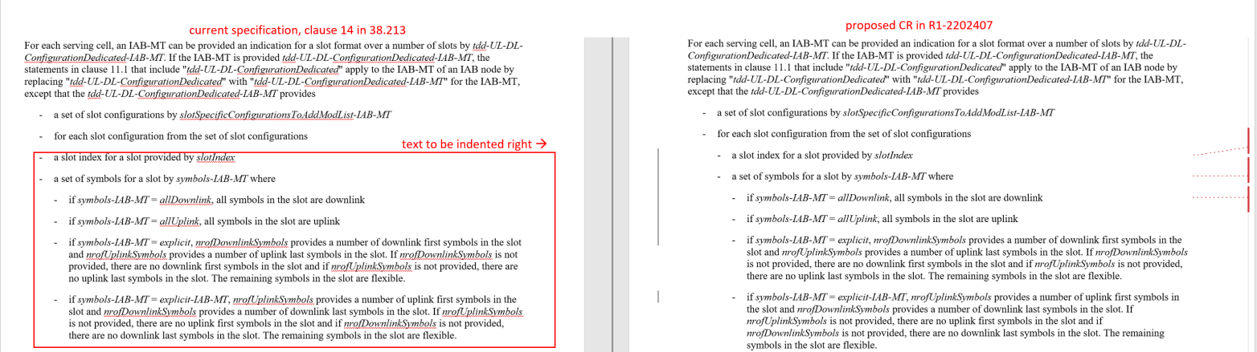

The contribution also points out the same alignment issue is present in clause 11.1 of TS38.213, which is not IAB specific (Moderator’s note: the text in clause 14 for IAB was inherited from clause 11.1).
The moderator’s assessment is that the CR is valid as it reflects the intended correct interpretation of the specification. Moreover, while it may not be considered a critical change, it should not be controversial and hence it should not require a long discussion. Furthermore, it is noted that in the content of this agenda item 7.2.3 we may only be able to agree to the proposed change to clause 14.

Therefore, the following is proposed:
Moderator Proposal 1:
RAN1 to discuss in RAN1#108-e under 7.2.3 AI the proposed CR for clause 14 in R1-2202407.
Company | Any comments on Moderator Proposal 1?
ZTE, Sanechips | Propose to confirm the CR for clause 14 directly(in R1-2202407), not necessary to further discuss it.

References
[1] R1-2202407 – Draft CR on properties of tdd-UL-DL-ConfigurationDedicated and tdd-UL-DL-configurationDedicated-IAB-MT – Ericsson

