3GPP TSG RAN WG1 Meeting #108-e R1-22xxxxx
21st February – 3rd March 2022
Agenda Item: 7.2.3
Source: Moderator (Qualcomm Incorporated)
Title: Summary of [108-e-R16-IAB-01] Email discussion on IAB draft CR in R1-2202407
Document for: Discussion and decision

This document provides a summary of the following email discussion on the draft CR in R1-2202407 [1]:
[108-e-R16-IAB-01] Email discussion on IAB draft CR in R1-2202407 by February 22 – Luca (Qualcomm)
The contribution in [1] provides a draft CR to address primarily a sub-bullet alignment issue in TS38.213 as illustrated below for clause 14:
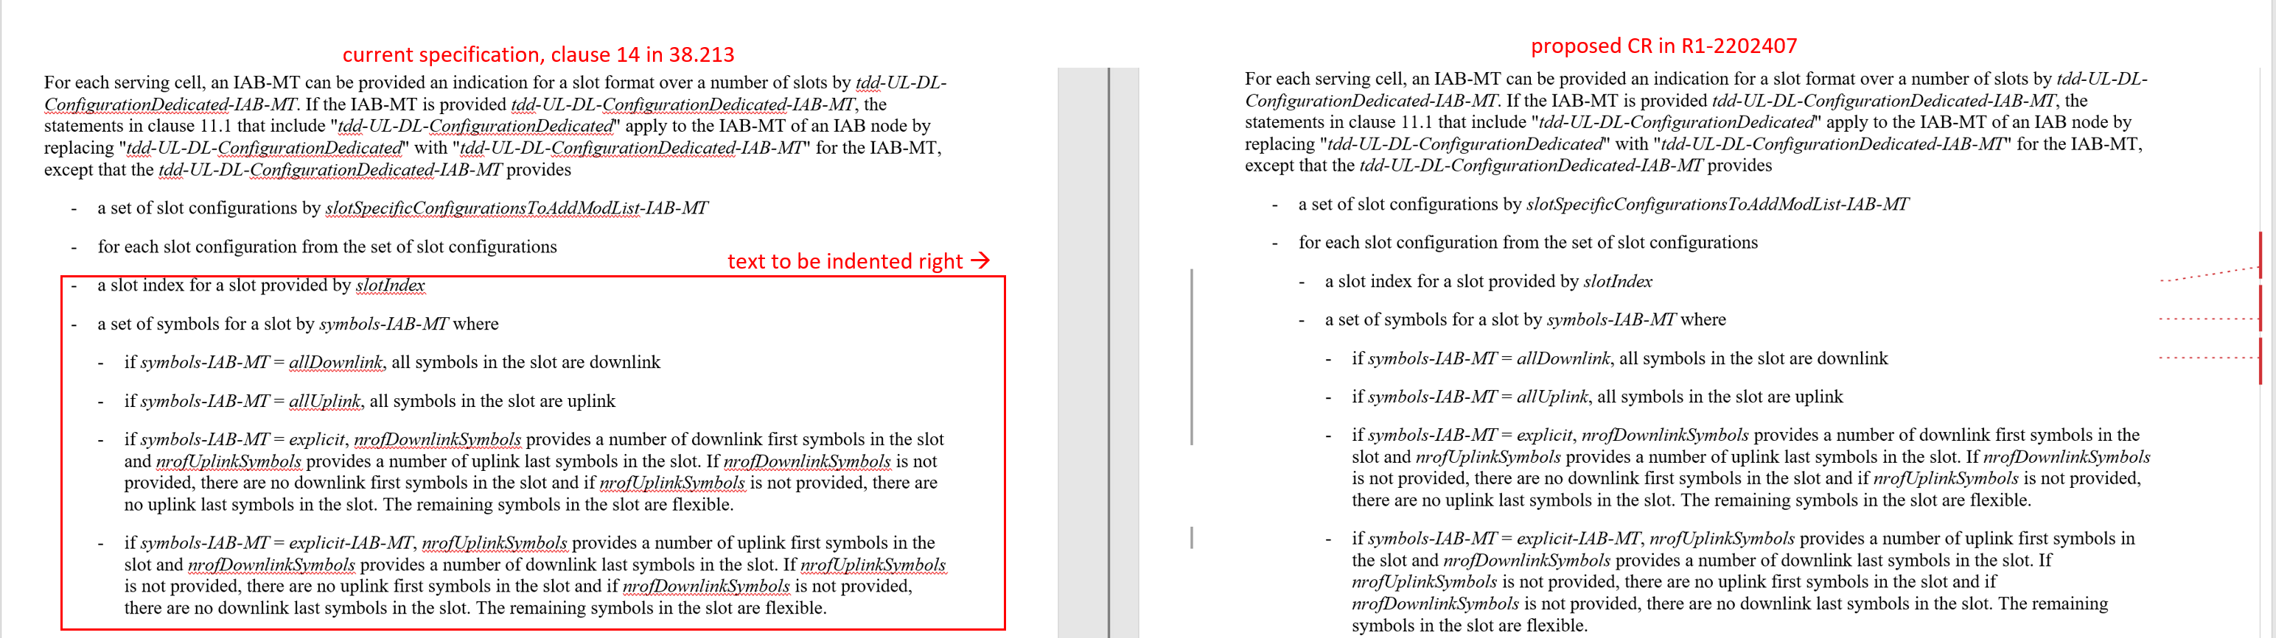

The contribution also points out the same alignment issue is present in clause 11.1 of TS38.213, which is not IAB specific.
The moderator’s assessment is that the CR is valid as it reflects the intended correct interpretation of the specification.
Therefore, the following is proposed:
Moderator Proposal 1:
Adopt the proposed CR for clause 14 in R1-2202407.
Company | Any comments on Moderator Proposal 1?
ETRI | Support the proposal.
Nokia | Support the proposal.

References
[1] R1-2202407 – Draft CR on properties of tdd-UL-DL-ConfigurationDedicated and tdd-UL-DL-configurationDedicated-IAB-MT – Ericsson

