3GPP TSG RAN WG1 #108-e R1-22XXXXX
e-Meeting, February 21st – March 3rd, 2022

Source: Moderator (vivo)
Title: Summary of [108-e-R16-NR-U-03] Issue#T2: Frequency hopping for NR-U CG-PUSCH
Agenda Item: 7.2.2
Document for: Discussion and Decision
- Introduction
The document is to collect companies’ inputs and provide a summary for the email discussion thread
[108-e-R16-NR-U-03] Email discussion/approval on frequency hopping for NR-U CG-PUSCH (Issue T2 in R1-2202492) by February 25 – Gen Li (vivo)
Companies are highly appreciated providing your Round 1 inputs before the 1st checkpoint:
- 1st checkpoint: 22nd Feb. 23:59 UTC
- 2nd checkpoint: 24th Feb. 23:59 UTC
- Discussions

Background
In RAN1#107-e, it was agreed that only intra slot frequency hopping is supported for each of multiple PUSCHs scheduled by a single DCI for both licensed and unlicensed band. Besides, the frequency hopping is applied only when the two hops are in the same RB set for PUCCH/SRS/PUSCH, where corresponding CRs were endorsed in R1-2112822 (CR0265) on TS38.213 and R1-2112823 (CR0220) on TS38.214 [1].
In NR-U Rel-16, a new type of configured grant PUSCH transmission is specified by providing cg-nrofSlots and cg-nrofPUSCH-InSlot in a configuration. The resource allocation refers to the following text in TS 38.214 [1]:
6.1.2.3 Resource allocation for uplink transmission with configured grant
A set of allowed periodicities P are defined in [12, TS 38.331]. The higher layer parameter cg-nrofSlots, provides the number of consecutive slots allocated within a configured grant period. The higher layer parameter cg-nrofPUSCH-InSlot provides the number of consecutive PUSCH allocations within a slot, where the first PUSCH allocation follows the higher layer parameter timeDomainAllocation for Type 1 PUSCH transmission or the higher layer configuration according to [10, TS 38.321], and UL grant received on the DCI for Type 2 PUSCH transmissions, and the remaining PUSCH allocations have the same length and PUSCH mapping type, and are appended following the previous allocations without any gaps. The same combination of start symbol and length and PUSCH mapping type repeats over the consecutively allocated slots.
Besides, repetition scheme for NR-U CG-PUSCH refers to the following text in TS 38.214 [1]:
6.1.2.3.1 Transport Block repetition for uplink transmissions of PUSCH repetition Type A with a configured grant
For both Type 1 and Type 2 PUSCH transmissions with a configured grant, when K > 1, the UE shall repeat the TB across the K consecutive slots applying the same symbol allocation in each slot, except if the UE is provided with higher layer parameters cg-nrofSlots and cg-nrofPUSCH-InSlot, in which case the UE repeats the TB in the repK earliest consecutive transmission occasion candidates within the same configuration. A Type 1 or Type 2 PUSCH transmission with a configured grant in a slot is omitted according to the conditions in Clause 9, Clause 11.1 and Clause 11.2A of [6, TS38.213].
Obviously, NR-U CG-PUSCH belongs to PUSCH repetition Type A, where applicable frequency hopping modes are specified below:
6.3.1 Frequency hopping for PUSCH repetition Type A
For PUSCH repetition Type A (as determined according to procedures defined in Clause 6.1.2.1 for scheduled PUSCH, or Clause 6.1.2.3 for configured PUSCH), a UE is configured for frequency hopping by the higher layer parameter frequencyHoppingDCI-0-2 in pusch-Config for PUSCH transmission scheduled by DCI format 0_2, and by frequencyHopping provided in pusch-Config for PUSCH transmission scheduled by a DCI format other than 0_2, and by frequencyHopping provided in configuredGrantConfig for configured PUSCH transmission. One of two frequency hopping modes can be configured:
- Intra-slot frequency hopping, applicable to single slot and multi-slot PUSCH transmission and each of multiple PUSCH transmissions scheduled by a DCI if the higher layer parameter pusch-TimeDomainAllocationListForMultiPUSCH is configured.
- Inter-slot frequency hopping, applicable to multi-slot PUSCH transmission.

However, it is not clear which frequency hopping mode is applicable to the new NR-U CG-PUSCH when cg-nrofSlots and cg-nrofPUSCH-InSlot are provided. Therefore, this issue is discussed in [2], [5] and [6] while related Rel-16 CRs are provided in [3], [4]and [7].
In [2], the following three candiates for frequency hopping are analyzed: intra-slot, inter-slot and inter-repetition frequency hopping. Geenrally, it is proposed in [2] to support intra-slot FH only for NR-U CG-PUSCH to achive a good tradeoff of gain and impact by considering comparison in the following aspects.
 | More Spec impact | Diversity gain | LBT impact
Intra-slot FH | No | Yes | No
Inter-slot FH | No | No | Yes
Inter-repetition FH | Yes | Yes | Yes
In [5], it is also proposed to support intra-slot FH only for NR-U CG-PUSCH due to the fact that inter-slot FH is not suitable for NR-U CG-PUSCH repetition. This is because the same TB may be included in the same hop but different TB included in the different hop.
In [6], it is proposed that the applicable frequency hopping mode depends on the value of repK. Namely, intra-slot FH is supported for NR-U CG-PUSCH with repK=1 and inter-repetition frequency hopping is supported with repK>1.
In general, the following alternatives are proposed for applicable FH mode to NR-U CG-PUSCH:
- Alt. 1 ([2] and [5]): Only intra-slot frequency hopping is applicable to NR-U CG-PUSCH
- Alt. 2 ([6]): Intra-slot frequency hopping is applicable to NR-U CG-PUSCH with repK=1 and inter-repetition frequency hopping is applicable to NR-U CG-PUSCH with repK>1

Company views (Round 1, closed)
Please kindly provide your views in the tables below.

Question 1: Which one of the following alternatives is preferred for applicable frequency hopping mode of NR-U CG-PUSCH?
- Alt. 1: Only intra-slot frequency hopping is applicable to NR-U CG-PUSCH
- Alt. 2: Intra-slot frequency hopping is applicable to NR-U CG-PUSCH with repK=1 and inter-repetition frequency hopping is applicable to NR-U CG-PUSCH with repK>1
- If there is no preferred one from the above two alternatives, please provide other alternatives below
Company | Preferred Alternative | Comment
Huawei, HiSilicon | Alt. 2 | We understand that the benefit of frequency diversity should be attained per TB. As such, intra-slot FH is the only way to achieve the frequency diversity when Krep=1.  However, due to the similarity between NR-U CG PUSCH resource allocation and PUSCH repetition type B from one TB perspective, we think applying inter-repetion FH as specified for PUSCH repetition type B is more natural approach as shown in the figure below.  Comparing the 1st and 3rd rows of the table above, we do not understand what additional LBT impact is implied if inter repetition FH is adopted for repK>1 given that the 1st and 2nd hps are in the same RB set. We do understand though that there would be some more spec impact, but we believe it is minor as shown in TP3 below.  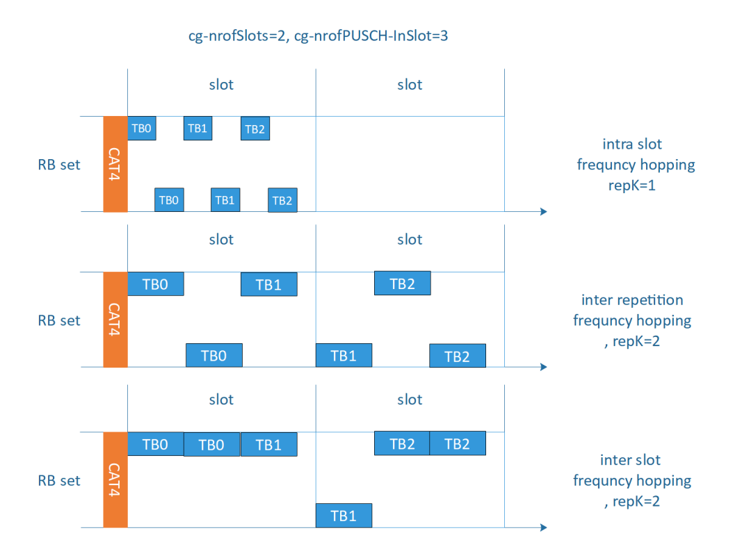  Figure 1 Intra slot, inter repetition and inter slot frequency hopping for configured grant PUSCH transmission when with cg-nrofSlots, cg-nrofPUSCH-InSlot are configured.
Intel | Neither alternative is preferred. | In unlicensed operation, frequency hopping is highly detrimental since a device is mandated to perform LBT at each hop, and in case the LBT may fail any benefits deriving from frequency diversity will be lost. For this reason, we are not OK with neither alternatives, and we would prefer to leave the spec as is.
Samsung | Alt 1
ZTE, Sanechips | Alt1
LG Electronics | Alt 1
Lenovo, Motorola Mobility | Alt 1
Nokia, NSB | Neither option is prefered | Agree with Intel: the use case for frequency hopping at unlicensed bands is questionable, considering the need to perform LBT and implications on other users LBT procedures. We prefer not to change the specs.
vivo | Alt 1 | Response to intel and Nokia:  The endorsed CR R1-2112823 was agreed in RAN1 107-e: For operation with shared spectrum channel access, the UE does not expect that two hops of a PUSCH transmission are in different RB sets.  In our understanding, it means that once the LBT success, the frequency diversity would be achived with the two hops are within one RB set.  Response to Huawei:  Thanks for question. In our contribution R1-2201070, we have explained the LBT impact, we copy here for your convenience. Hope it can help your understanding  In figure 1 and figure 2, for the inter-repetition frequency hopping for CG-PUSCH repetition, the position of first hop is dependent on the LBT result. From gNB’ perspective, the decoding complexity is increased.  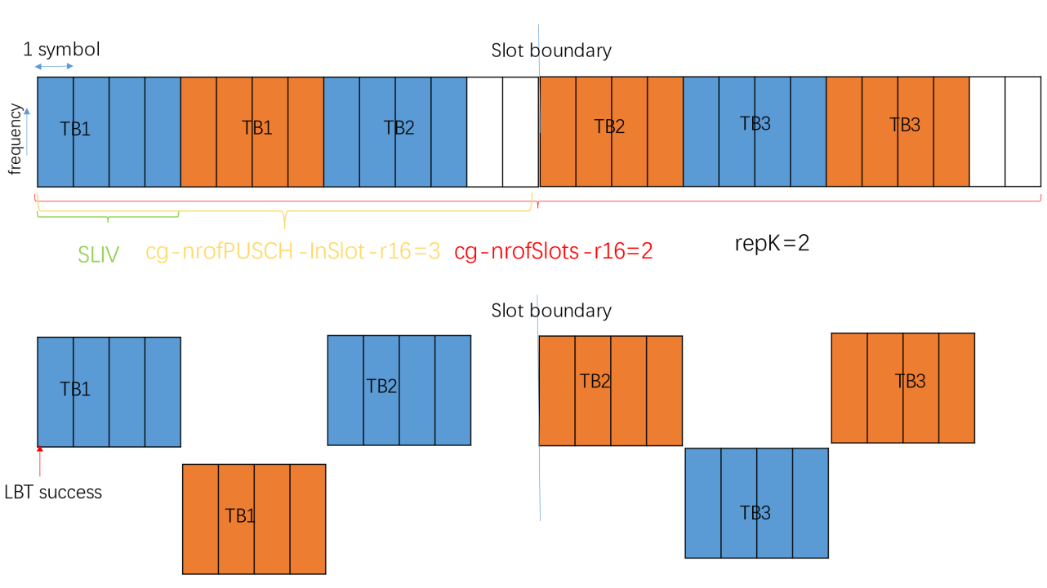  Figure 3-1 Inter-repetition frequency hopping for CG-PUSCH repetition  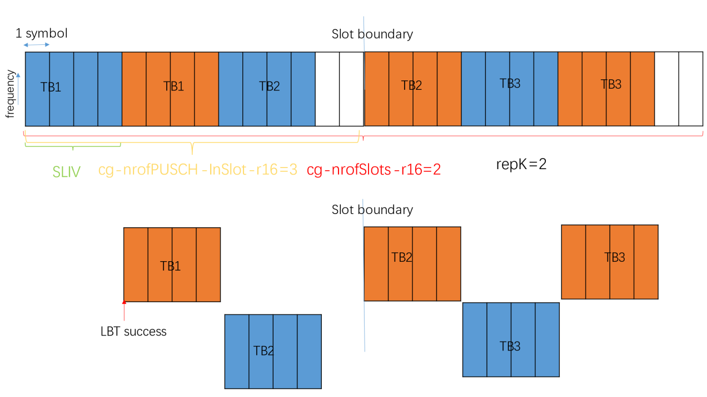  Figure 3-2 Inter-repetition frequency hopping for CG-PUSCH repetition
Huawei, HiSilicon 2 | OK with either Alt2 or Alt1 | @Intel and Nokia, we agree with Vivo’s comment; we have already agreed and captured in the endorsed CR in R1-2112823 in RAN1 107-e: that “For operation with shared spectrum channel access, the UE does not expect that two hops of a PUSCH transmission are in different RB sets.”  @Vivo, thanks for clarifying what is meant by the ‘LBT impact’ of inter-repetition FH. We do not see an increase to the decoding complexity at gNB though since the gNB knows exactly on which RBs to attempt decoding the repetition PUSCH if the previous one was not detected due to LBT failure.  Having said so, we are OK with either Alt2 or Alt1
Ericsson | Alt-1 | For simplicity and uniformity with single PUSCH and multi-PUSCH

Question 2: If Alt. 1 is adopted, which one of the following TPs is preferred for Rel-16 CR?
- TP1 in [2]
-----------------------------------------------------------TP1 for 38.214 6.3.1-------------------------------------------------------------
<unchanged part omitted>
For PUSCH repetition Type A (as determined according to procedures defined in Clause 6.1.2.1 for scheduled PUSCH, or Clause 6.1.2.3 for configured PUSCH), a UE is configured for frequency hopping by the higher layer parameter frequencyHoppingDCI-0-2 in pusch-Config for PUSCH transmission scheduled by DCI format 0_2, and by frequencyHopping provided in pusch-Config for PUSCH transmission scheduled by a DCI format other than 0_2, and by frequencyHopping provided in configuredGrantConfig for configured PUSCH transmission. One of two frequency hopping modes can be configured:
- Intra-slot frequency hopping, applicable to single slot and multi-slot PUSCH transmission and each of multiple PUSCH transmissions scheduled by a DCI if the higher layer parameter pusch-TimeDomainAllocationListForMultiPUSCH is configured and each of multiple configured grant PUSCH transmissions in a configuration where the higher layer parameter cg-nrofSlots and cg-nrofPUSCH-InSlot are provided.
- Inter-slot frequency hopping, applicable to multi-slot PUSCH transmission.
<unchanged part omitted>
-----------------------------------------------------------TP1 for 38.214 6.3.1-------------------------------------------------------------

- TP2 in [5] (Note: It seems original TP in [5] is based Rel-17 spec and thus changed based on Rel-16 spec)
-----------------------------------------------------------TP2 for 38.214 6.3.1-------------------------------------------------------------
<unchanged part omitted>
For PUSCH repetition Type A (as determined according to procedures defined in Clause 6.1.2.1 for scheduled PUSCH, or Clause 6.1.2.3 for configured PUSCH), a UE is configured for frequency hopping by the higher layer parameter frequencyHoppingDCI-0-2 in pusch-Config for PUSCH transmission scheduled by DCI format 0_2, and by frequencyHopping provided in pusch-Config for PUSCH transmission scheduled by a DCI format other than 0_2, and by frequencyHopping provided in configuredGrantConfig for configured PUSCH transmission. One of two frequency hopping modes can be configured:
- Intra-slot frequency hopping, applicable to single slot and multi-slot PUSCH transmission and each of multiple PUSCH transmissions scheduled by a DCI if the higher layer parameter pusch-TimeDomainAllocationListForMultiPUSCH is configured and configured PUSCH transmission when cg-RetransmissionTimer is configured.
- Inter-slot frequency hopping, applicable to multi-slot PUSCH transmission.
<unchanged part omitted>
-----------------------------------------------------------TP2 for 38.214 6.3.1-------------------------------------------------------------
- Please indicate your preference and comments to the above TPs if Alt. 1 is adopted.
Company | Preferred TP | Comment
Huawei, HiSilicon |  | We prefer Alt 2.
Intel |  | See comments above.
Samsung | TP2 | Either TP is ok to us, and TP2 is slightly preferred.
ZTE, Sanechips | TP2 | Compared with TP1, we prefer the wording of TP2.
LG Electronics | TP2 | Either TP is ok to us but TP2 is slightly preferred.
Lenovo, Motorola Mobility | TP2 | TP2 seems more concise and is slightly preferred to us.
vivo | TP1 | We prefer TP1. The difference of TP1 and TP2 is the RRC parameter. cg-RetransmissionTimer is always configured for operation with shared spectrum channel access. cg-nrofSlots and cg-nrofPUSCH-InSlot are used for time domain allocation for CG-PUSCH. As we discuss the resource allocation here, the latter is more direct. While, if the majority support TP2, we can also accept it.
Huawei, HiSilicon 2 | TP1 | If Alt 1 is adpted, we share the same views as Vivo that TP1 should be used for the same reasons.
Ericsson | TP1 | @Moderator  Before agreeing to TP1, can you clarify if the TP only affects CG for operation with shared spectrum channel access (unlicensed), or does it affect CG in general?

Question 3: If Alt. 2 is adopted, do you agree the following TP for Rel-16 CR?
- TP3 in [6]
-----------------------------------------------------------TP3 for 38.214 6.3.1-------------------------------------------------------------
<unchanged part omitted>
For PUSCH repetition Type A (as determined according to procedures defined in Clause 6.1.2.1 for scheduled PUSCH, or Clause 6.1.2.3 for configured PUSCH), a UE is configured for frequency hopping by the higher layer parameter frequencyHoppingDCI-0-2 in pusch-Config for PUSCH transmission scheduled by DCI format 0_2, and by frequencyHopping provided in pusch-Config for PUSCH transmission scheduled by a DCI format other than 0_2, and by frequencyHopping provided in configuredGrantConfig for configured PUSCH transmission. One of the following frequency hopping modes can be configured:
- Intra-slot frequency hopping, applicable to single slot and multi-slot PUSCH transmission, each of multiple PUSCH transmissions scheduled by a DCI if the higher layer parameter pusch-TimeDomainAllocationListForMultiPUSCH is configured, and PUSCH transmission when the higher layer parameters cg-nrofSlots and cg-nrofPUSCH-InSlot are provided with repK=1.
- Inter-slot frequency hopping, applicable to multi-slot PUSCH transmission.
- Inter-repetition frequency hopping, applicable to PUSCH transmission when the higher layer parameters cg-nrofSlots and cg-nrofPUSCH-InSlot are provided with repK > 1.
<unchanged part omitted>
In case of inter-slot frequency hopping, the starting RB during slot is given by:
,
where is the current slot number within a radio frame, where a multi-slot PUSCH transmission can take place, is the starting RB within the UL BWP, as calculated from the resource block assignment information of resource allocation type 1 (described in Clause 6.1.2.2.2) and is the frequency offset in RBs between the two frequency hops.
In case of inter-repetition frequency hopping, the starting RB for the n-th repetition follows that of an actual repetition within the n-th nominal repetition of PUSCH Repetition Type B with inter-repetition frequency hopping in Clause 6.3.2.
<unchanged part omitted>
-----------------------------------------------------------TP3 for 38.214 6.3.1-------------------------------------------------------------
- Please indicate your comments to the above TP if Alt. 2 is adopted.
Company | Comment
Huawei, HiSilicon | We support avove TP as the proponent if Alt. 2 is adopted
Intel | See comments above
vivo | We do not support alt.2 as comment above. While, if Alt. 2 is adopted, we do not agree the TP3 for Rel-16 CR. As we responsed to Huawei in Q2, for the inter-repetition and inter-slot frequency hopping for CG-PUSCH repetition, the position of first hop is dependent on the LBT result. So the position of hopping should depend on the configured SLIV, that the TP3 should consider the modification.
Huawei, HiSilicon 2 | @Vivo based on your clarification of what is meant by the ‘LBT impact’ of inter-repetition FH, we do not see an increase to the decoding complexity at gNB since the gNB knows exactly on which RBs to attempt decoding the repetition PUSCH if the previous one was not detected due to LBT failure.  So, we support avove TP as the proponent if Alt. 2 is adopted

Question 4: If any alternative other than Alt. 1 and Alt. 2 is preferred, please provide corresponding TP in the following table:
Company | Comment

Summary of Round 1
Based on the received comments, here is summary of discussion status:
Question 1: Which alternatives is preferred for applicable frequency hopping mode of NR-U CG-PUSCH?
- Alt. 1: Samsung, ZTE/Sanechips, LGE, Lenovo/Motorola Mobility, vivo, Huawei/HiSilicon
- Alt. 2: Huawei/HiSilicon
- Neighther Alternative: Intel, Nokia/NSB

Question 2: Which TPs is preferred if Alt. 1 is adopted?
- TP1: vivo, Huawei/HiSilicon, Ericsson, Samsung (acceptable), LGE (acceptable)
- TP2: Samsung, ZTE/Sanechips, LGE, Lenovo/Motorola Mobility, vivo (acceptable)

@Intel and Nokia/NSB: Regarding your comment that “a device is mandated to perform LBT at each hop”, as indicated already by vivo and Huawei, there is no such problem since it was agreed in RAN1 107-e in endorsed CR R1-2112823: For operation with shared spectrum channel access, the UE does not expect that two hops of a PUSCH transmission are in different RB sets. Besides, we already support frequency hopping for scheduled PUSCH by a single DCI. It will be strange that frequency hopping is not supported for NR-U CG-PUSCH only. Please check whether Alt. 1 is acceptable to you based on this understanding.

@Ericsson: Regarding your question on TP1, i.e. “if the TP only affects CG for operation with shared spectrum channel access (unlicensed)”, the answer is yes since the parameter cg-nrofSlots and cg-nrofPUSCH-InSlot can only be configured in unlicensed band according to the following FG in TS 38.822:
10-28 | Configured grant with Rel-16 enhanced resource configuration | 1. Support configuration of resources with cg-nrofSlots-r16 and cg-nrofPUSCH-InSlot-r16, | Per band | the signaling is per band but is only expected for a band where shared spectrum channel access must be used

Regarding comparison between TP1 and TP2 for Alt. 1, based on moderator’s understanding, the key reason to discuss the frequency hopping mode for NR-U CG-PUSCH is the change of resource allocation mode by introducing configuration parameter cg-nrofSlots-r16 and cg-nrofPUSCH-InSlot-r16. In another word, TP1 is more straightforward than TP2 due to the above reason. Besides, TP1 seems more compatible with the text on multi-PUSCH scheduling where the mentioned RRC parameter is also related with resource allocation.

Given clear majority support of Alt. 1 and the above comparison on TP1 and TP2, the following proposal is made:

Proposal 1: Support intra-slot frequency hopping only for NR-U CG-PUSCH and adopt TP1 below:
-----------------------------------------------------------TP1 for 38.214 6.3.1------------------------------------------------------------
<unchanged part omitted>
For PUSCH repetition Type A (as determined according to procedures defined in Clause 6.1.2.1 for scheduled PUSCH, or Clause 6.1.2.3 for configured PUSCH), a UE is configured for frequency hopping by the higher layer parameter frequencyHoppingDCI-0-2 in pusch-Config for PUSCH transmission scheduled by DCI format 0_2, and by frequencyHopping provided in pusch-Config for PUSCH transmission scheduled by a DCI format other than 0_2, and by frequencyHopping provided in configuredGrantConfig for configured PUSCH transmission. One of two frequency hopping modes can be configured:
- Intra-slot frequency hopping, applicable to single slot and multi-slot PUSCH transmission and each of multiple PUSCH transmissions scheduled by a DCI if the higher layer parameter pusch-TimeDomainAllocationListForMultiPUSCH is configured and each of multiple configured grant PUSCH transmissions in a configuration where the higher layer parameter cg-nrofSlots and cg-nrofPUSCH-InSlot are provided.
- Inter-slot frequency hopping, applicable to multi-slot PUSCH transmission.
<unchanged part omitted>
-----------------------------------------------------------TP1 for 38.214 6.3.1------------------------------------------------------------

Company views (Round 2, active)
Please kindly provide your views in the table below on Proposal 1:

Company | Yes or No | Comment
Ericsson | Yes | Thank-you to the moderator for clarifying our question on applicability to unlicensed only due to FG 10-28.  Minor editorial comment on TP1:  … whee the higher layer parameters cg-nrofSlots and cg-nrofPUSCH-InSlot are provided.
Samsung | Yes | Agree with Ericsson’s change.
Huawei, HiSilicon | Yes | Agree with Ericsson’s editorial change and suggest to remove repeated occurances of “and” between the applicable case  - Intra-slot frequency hopping, applicable to single slot and multi-slot PUSCH transmission, and each of multiple PUSCH transmissions scheduled by a DCI if the higher layer parameter pusch-TimeDomainAllocationListForMultiPUSCH is configured, and each of multiple configured grant PUSCH transmissions in a configuration where the higher layer parameters cg-nrofSlots and cg-nrofPUSCH-InSlot are provided.
LG Electronics | Yes | Agree with the suggestion from Huawei.
vivo | Yes | Agree with Ericsson and Huawei.
ZTE, Sanechips |  | We think that either of “cg-nrofSlots and cg-nrofPUSCH-InSlot are provided” and“cg-RetransmissionTimer is configured” can represent multiple CG-PUSCH transmissions, and these two ways have appeared in the current spec. But for us, our first preference is to use “cg-RetransmissionTimer is configured” since this parameter is configured or not configured will be used to distinguish between “CG configuration for URLLC” and “CG configuration for NR-U”, which can avoid unnecessary confusion.
Intel | Yes | While we do not see any strong technical reason to support FH for CG-PUSCH in NR-U, we would be OK for the sake of progress to support this proposal.  As for the specific text, we agree with suggestion from HW.

Please kindly provide your views in the table below on draft Rel-16 CR including cover sheet in Appendix 1:

Company | Yes or No | Comment
Ericsson | Yes | Minor editorial comment on both CRs  … whee the higher layer parameters cg-nrofSlots and cg-nrofPUSCH-InSlot are provided.
Samsung | Yes
Huawei, HiSilicon | Yes | Agree with Ericsson’s editorial change and suggest to remove repeated occurances of “and” between the applicable case  - Intra-slot frequency hopping, applicable to single slot and multi-slot PUSCH transmission, and each of multiple PUSCH transmissions scheduled by a DCI if the higher layer parameter pusch-TimeDomainAllocationListForMultiPUSCH is configured, and each of multiple configured grant PUSCH transmissions in a configuration where the higher layer parameters cg-nrofSlots and cg-nrofPUSCH-InSlot are provided.  Huawei,/HiSilicon would like to co-source. Thanks.
LG Electronics | Yes | Agree with the suggestion from Huawei.
vivo | Yes | Agree with Ericsson and Huawei.
Intel | Yes | Agree with the suggestions from Ericsson and Huawei.

Please kindly provide your views in the table below on draft Rel-17 mirror CR including cover sheet in Appendix 2:

Company | Yes or No | Comment
Samsung |  | We have a question on the mirror Rel-17 CR. Is it allowed to approve company CR for Rel-17? We thought it’s only using editor CR. If Rel-16 CR is agreed, we thought the correct procedure is notifying the editor(s) for the corresponding mirror change in Rel-17 draft instead of officially approving a CR.

Summary of Round 2
According to the above input and feedback from email, all companies are generally OK with the proposal and TP. Based on comment from Ericsson and Huawei, the TP is updated with small editorial change as below and CRs in Appendix are updated accordingly as well.

Proposal 1: Support intra-slot frequency hopping only for NR-U CG-PUSCH and adopt TP1 below:
-----------------------------------------------------------TP1 for 38.214 6.3.1------------------------------------------------------------
<unchanged part omitted>
For PUSCH repetition Type A (as determined according to procedures defined in Clause 6.1.2.1 for scheduled PUSCH, or Clause 6.1.2.3 for configured PUSCH), a UE is configured for frequency hopping by the higher layer parameter frequencyHoppingDCI-0-2 in pusch-Config for PUSCH transmission scheduled by DCI format 0_2, and by frequencyHopping provided in pusch-Config for PUSCH transmission scheduled by a DCI format other than 0_2, and by frequencyHopping provided in configuredGrantConfig for configured PUSCH transmission. One of two frequency hopping modes can be configured:
- Intra-slot frequency hopping, applicable to single slot and multi-slot PUSCH transmission, each of multiple PUSCH transmissions scheduled by a DCI if the higher layer parameter pusch-TimeDomainAllocationListForMultiPUSCH is configured and each of multiple configured grant PUSCH transmissions in a configuration where the higher layer parameters cg-nrofSlots and cg-nrofPUSCH-InSlot are provided.
- Inter-slot frequency hopping, applicable to multi-slot PUSCH transmission.
<unchanged part omitted>
-----------------------------------------------------------TP1 for 38.214 6.3.1------------------------------------------------------------

@Samsung: Thanks for the question. In our understanding, Rel-17 mirror CR will be approved together with Rel-16 CR. Anyway, I will ask for Chairman’s guidance on the procedure.

Conclusion

Reference
- TS 38.214, Physical layer procedures for data, V16.8.0.
- R1-2201070, Discussion on frequency hopping for PUSCH with a configured grant, vivo
- R1-2201071, Draft CR on frequency hopping for PUSCH with a configured grant, vivo
- R1-2201072, Draft CR on frequency hopping for PUSCH with a configured grant, vivo
- R1-2201398, Clarification on frequency hopping for CG-PUSCH, ZTE, Sanechips
- R1-2201622, Discussion on the frequency hopping for CG-PUSCH in unlicensed band, Huawei, HiSilicon
- R1-2201623, Corrections on frequency hoppping for CG-PUSCH in TS38.214, Huawei, HiSilicon

Appendix 1: Draft Rel-16 CR
CHANGE REQUEST
 | 38.214 | CR | - | rev | - | Current version: | V16.8.0
For HELP on using this form: comprehensive instructions can be found at
http://www.3gpp.org/Change-Requests.

Proposed change affects: | UICC apps |  | ME | X | Radio Access Network | X | Core Network

Title: | Draft CR on frequency hopping for PUSCH with a configured grant
Source to WG: | vivo
Source to TSG: | TSG RAN WG1
Work item code: | NR_unlic-Core |  |  |  |  |  | Date: |  |  | 2022-02-23
Category: | F |  |  |  |  |  | Release: |  |  | Release 16
 | Use one of the following categories:  F (correction)  A (mirror corresponding to a change in an earlier release)  B (addition of feature),  C (functional modification of feature)  D (editorial modification)  Detailed explanations of the above categories can  be found in 3GPP TR 21.900. |  |  |  |  |  |  |  | Use one of the following releases:  Rel-8 (Release 8)  Rel-9 (Release 9)  Rel-10 (Release 10)  Rel-11 (Release 11)  …  Rel-15 (Release 15)  Rel-16 (Release 16)  Rel-17 (Release 17)  Rel-18 (Release 18)
Reason for change: |  | RAN1 specified the support of multiple configured grant PUSCH transmissions in a configuration in NR-U Rel-16 together with repetition K and specified the NR-U CG-PUSCH repetition included in PUSCH repetition type A.  38.214 Section 6.3.1 specifies that intra-slot and inter-slot frequency hopping is applicable for PUSCH repetition type A as follows:  - Intra-slot frequency hopping, applicable to single slot and multi-slot PUSCH transmission and each of multiple PUSCH transmissions scheduled by a DCI if the higher layer parameter pusch-TimeDomainAllocationListForMultiPUSCH is configured.  - Inter-slot frequency hopping, applicable to multi-slot PUSCH transmission.  In the above frequency hopping, it is not clear if PUSCH transmission due to multiple configured grant PUSCH transmissions in a configuration is classified as "single-slot" or "multi-slot." As a consequence, it is not clear whether only intra-slot frequency hopping applies, or both intra-slot and inter-slot frequency hopping applies.
Summary of change: |  | Clarification that only intra-slot frequency hopping applies to each of multiple for NR-U Rel-16 configured grant PUSCH transmissions in a configuration.
Consequences if not approved: |  | The frequency hopping procedure for NR-U Rel-16 configured grant PUSCH transmissions in a configuration is undefined.
Clauses affected: |  | 6.3.1
 |  | Y | N
Other specs |  |  | X | Other core specifications |  |  |  | TS/TR ... CR ...
affected: |  |  | X | Test specifications |  |  |  | TS/TR ... CR ...
(show related CRs) |  |  | X | O&M Specifications |  |  |  | TS/TR ... CR ...
Other comments:
This CR's revision history: |  | This is the first version for this CR.

*** Unchanged text omitted ***

6.3 UE PUSCH frequency hopping procedure

6.3.1 Frequency hopping for PUSCH repetition Type A
For PUSCH repetition Type A (as determined according to procedures defined in Clause 6.1.2.1 for scheduled PUSCH, or Clause 6.1.2.3 for configured PUSCH), a UE is configured for frequency hopping by the higher layer parameter frequencyHoppingDCI-0-2 in pusch-Config for PUSCH transmission scheduled by DCI format 0_2, and by frequencyHopping provided in pusch-Config for PUSCH transmission scheduled by a DCI format other than 0_2, and by frequencyHopping provided in configuredGrantConfig for configured PUSCH transmission. One of two frequency hopping modes can be configured:
- Intra-slot frequency hopping, applicable to single slot and multi-slot PUSCH transmission, each of multiple PUSCH transmissions scheduled by a DCI if the higher layer parameter pusch-TimeDomainAllocationListForMultiPUSCH is configured and each of multiple configured grant PUSCH transmissions in a configuration where the higher layer parameters cg-nrofSlots and cg-nrofPUSCH-InSlot are provided.
- Inter-slot frequency hopping, applicable to multi-slot PUSCH transmission.
*** Unchanged text omitted ***

Appendix 2: Draft Rel-17 mirror CR
CHANGE REQUEST
 | 38.214 | CR | - | rev | - | Current version: | V17.0.0
For HELP on using this form: comprehensive instructions can be found at
http://www.3gpp.org/Change-Requests.

Proposed change affects: | UICC apps |  | ME | X | Radio Access Network | X | Core Network

Title: | Draft CR on frequency hopping for PUSCH with a configured grant
Source to WG: | vivo
Source to TSG: | TSG RAN WG1
Work item code: | NR_unlic-Core |  |  |  |  |  | Date: |  |  | 2022-02-23
Category: | A |  |  |  |  |  | Release: |  |  | Release 17
 | Use one of the following categories:  F (correction)  A (mirror corresponding to a change in an earlier release)  B (addition of feature),  C (functional modification of feature)  D (editorial modification)  Detailed explanations of the above categories can  be found in 3GPP TR 21.900. |  |  |  |  |  |  |  | Use one of the following releases:  Rel-8 (Release 8)  Rel-9 (Release 9)  Rel-10 (Release 10)  Rel-11 (Release 11)  …  Rel-15 (Release 15)  Rel-16 (Release 16)  Rel-17 (Release 17)  Rel-18 (Release 18)
Reason for change: |  | RAN1 specified the support of multiple configured grant PUSCH transmissions in a configuration in NR-U Rel-16 together with repetition K and specified the NR-U CG-PUSCH repetition included in PUSCH repetition type A.  38.214 Section 6.3.1 specifies that intra-slot and inter-slot frequency hopping is applicable for PUSCH repetition type A as follows:  - Intra-slot frequency hopping, applicable to single slot and multi-slot PUSCH transmission and each of multiple PUSCH transmissions scheduled by a DCI if the higher layer parameter pusch-TimeDomainAllocationListForMultiPUSCH is configured.  - Inter-slot frequency hopping, applicable to multi-slot PUSCH transmission.  In the above frequency hopping, it is not clear if PUSCH transmission due to multiple configured grant PUSCH transmissions in a configuration is classified as "single-slot" or "multi-slot." As a consequence, it is not clear whether only intra-slot frequency hopping applies, or both intra-slot and inter-slot frequency hopping applies.
Summary of change: |  | Clarification that only intra-slot frequency hopping applies to each of multiple for NR-U Rel-16 configured grant PUSCH transmissions in a configuration.
Consequences if not approved: |  | The frequency hopping procedure for NR-U Rel-16 configured grant PUSCH transmissions in a configuration is undefined.
Clauses affected: |  | 6.3.1
 |  | Y | N
Other specs |  |  | X | Other core specifications |  |  |  | TS/TR ... CR ...
affected: |  |  | X | Test specifications |  |  |  | TS/TR ... CR ...
(show related CRs) |  |  | X | O&M Specifications |  |  |  | TS/TR ... CR ...
Other comments:
This CR's revision history: |  | This is the first version for this CR.

*** Unchanged text omitted ***

6.3 UE PUSCH frequency hopping procedure

6.3.1 Frequency hopping for PUSCH repetition Type A and for TB processing over multiple slots
For PUSCH repetition Type A scheduled by DCI format 0_1 or 0_2 and for TB processing over multiple slots (as determined according to procedures defined in Clause 6.1.2.1 for scheduled PUSCH, or Clause 6.1.2.3 for configured PUSCH), a UE is configured for frequency hopping by the higher layer parameter frequencyHoppingDCI-0-2 in pusch-Config for PUSCH transmission scheduled by DCI format 0_2, and by frequencyHopping provided in pusch-Config for PUSCH transmission scheduled by a DCI format other than 0_2, and by frequencyHopping provided in configuredGrantConfig for configured PUSCH transmission. For PUSCH repetition Type A scheduled by RAR UL grant or by DCI format 0_0 with CRC scrambled by TC-RNTI, a UE is configured for frequency hopping by the frequency hopping flag information field of the RAR UL grant, and by the frequency hopping flag information field of DCI format 0_0 with CRC scrambled by TC-RNTI, respectively. One of two frequency hopping modes can be configured:
- Intra-slot frequency hopping, applicable to single slot and multi-slot configured PUSCH transmission, multi-slot PUSCH transmission scheduled by DCI format 0_1 or 0_2, each of multiple PUSCH transmissions scheduled by a DCI if the higher layer parameter pusch-TimeDomainAllocationListForMultiPUSCH is configured and each of multiple configured grant PUSCH transmissions in a configuration where the higher layer parameters cg-nrofSlots and cg-nrofPUSCH-InSlot are provided.
- Inter-slot frequency hopping, applicable to multi-slot PUSCH transmission.
For operation with shared spectrum channel access, the UE does not expect that two hops of a PUSCH transmission are in different RB sets.
*** Unchanged text omitted ***

