3GPP TSG RAN WG1 #108-e R1-22XXXXX
e-Meeting, February 21st – March 3rd, 2022

Source: Moderator (vivo)
Title: Summary of [108-e-R16-NR-U-03] Issue#T2: Frequency hopping for NR-U CG-PUSCH
Agenda Item: 7.2.2
Document for: Discussion and Decision
- Introduction
The document is to collect companies’ inputs and provide a summary for the email discussion thread
[108-e-R16-NR-U-03] Email discussion/approval on frequency hopping for NR-U CG-PUSCH (Issue T2 in R1-2202492) by February 25 – Gen Li (vivo)
Companies are highly appreciated providing your Round 1 inputs before the 1st checkpoint:
- 1st checkpoint: 22nd Feb. 23:59 UTC
- Discussions

Background
In RAN1#107-e, it was agreed that only intra slot frequency hopping is supported for each of multiple PUSCHs scheduled by a single DCI for both licensed and unlicensed band. Besides, the frequency hopping is applied only when the two hops are in the same RB set for PUCCH/SRS/PUSCH, where corresponding CRs were endorsed in R1-2112822 (CR0265) on TS38.213 and R1-2112823 (CR0220) on TS38.214 [1].
In NR-U Rel-16, a new type of configured grant PUSCH transmission is specified by providing cg-nrofSlots and cg-nrofPUSCH-InSlot in a configuration. The resource allocation refers to the following text in TS 38.214 [1]:
6.1.2.3 Resource allocation for uplink transmission with configured grant
A set of allowed periodicities P are defined in [12, TS 38.331]. The higher layer parameter cg-nrofSlots, provides the number of consecutive slots allocated within a configured grant period. The higher layer parameter cg-nrofPUSCH-InSlot provides the number of consecutive PUSCH allocations within a slot, where the first PUSCH allocation follows the higher layer parameter timeDomainAllocation for Type 1 PUSCH transmission or the higher layer configuration according to [10, TS 38.321], and UL grant received on the DCI for Type 2 PUSCH transmissions, and the remaining PUSCH allocations have the same length and PUSCH mapping type, and are appended following the previous allocations without any gaps. The same combination of start symbol and length and PUSCH mapping type repeats over the consecutively allocated slots.
Besides, repetition scheme for NR-U CG-PUSCH refers to the following text in TS 38.214 [1]:
6.1.2.3.1 Transport Block repetition for uplink transmissions of PUSCH repetition Type A with a configured grant
For both Type 1 and Type 2 PUSCH transmissions with a configured grant, when K > 1, the UE shall repeat the TB across the K consecutive slots applying the same symbol allocation in each slot, except if the UE is provided with higher layer parameters cg-nrofSlots and cg-nrofPUSCH-InSlot, in which case the UE repeats the TB in the repK earliest consecutive transmission occasion candidates within the same configuration. A Type 1 or Type 2 PUSCH transmission with a configured grant in a slot is omitted according to the conditions in Clause 9, Clause 11.1 and Clause 11.2A of [6, TS38.213].
Obviously, NR-U CG-PUSCH belongs to PUSCH repetition Type A, where applicable frequency hopping modes are specified below:
6.3.1 Frequency hopping for PUSCH repetition Type A
For PUSCH repetition Type A (as determined according to procedures defined in Clause 6.1.2.1 for scheduled PUSCH, or Clause 6.1.2.3 for configured PUSCH), a UE is configured for frequency hopping by the higher layer parameter frequencyHoppingDCI-0-2 in pusch-Config for PUSCH transmission scheduled by DCI format 0_2, and by frequencyHopping provided in pusch-Config for PUSCH transmission scheduled by a DCI format other than 0_2, and by frequencyHopping provided in configuredGrantConfig for configured PUSCH transmission. One of two frequency hopping modes can be configured:
- Intra-slot frequency hopping, applicable to single slot and multi-slot PUSCH transmission and each of multiple PUSCH transmissions scheduled by a DCI if the higher layer parameter pusch-TimeDomainAllocationListForMultiPUSCH is configured.
- Inter-slot frequency hopping, applicable to multi-slot PUSCH transmission.

However, it is not clear which frequency hopping mode is applicable to the new NR-U CG-PUSCH when cg-nrofSlots and cg-nrofPUSCH-InSlot are provided. Therefore, this issue is discussed in [2], [5] and [6] while related Rel-16 CRs are provided in [3], [4]and [7].
In [2], the following three candiates for frequency hopping are analyzed: intra-slot, inter-slot and inter-repetition frequency hopping. Geenrally, it is proposed in [2] to support intra-slot FH only for NR-U CG-PUSCH to achive a good tradeoff of gain and impact by considering comparison in the following aspects.
 | More Spec impact | Diversity gain | LBT impact
Intra-slot FH | No | Yes | No
Inter-slot FH | No | No | Yes
Inter-repetition FH | Yes | Yes | Yes
In [5], it is also proposed to support intra-slot FH only for NR-U CG-PUSCH due to the fact that inter-slot FH is not suitable for NR-U CG-PUSCH repetition. This is because the same TB may be included in the same hop but different TB included in the different hop.
In [6], it is proposed that the applicable frequency hopping mode depends on the value of repK. Namely, intra-slot FH is supported for NR-U CG-PUSCH with repK=1 and inter-repetition frequency hopping is supported with repK>1.
In general, the following alternatives are proposed for applicable FH mode to NR-U CG-PUSCH:
- Alt. 1 ([2] and [5]): Only intra-slot frequency hopping is applicable to NR-U CG-PUSCH
- Alt. 2 ([6]): Intra-slot frequency hopping is applicable to NR-U CG-PUSCH with repK=1 and inter-repetition frequency hopping is applicable to NR-U CG-PUSCH with repK>1

Company views (Round 1)
Please kindly provide your views in the tables below.

Question 1: Which one of the following alternatives is preferred for applicable frequency hopping mode of NR-U CG-PUSCH?
- Alt. 1: Only intra-slot frequency hopping is applicable to NR-U CG-PUSCH
- Alt. 2: Intra-slot frequency hopping is applicable to NR-U CG-PUSCH with repK=1 and inter-repetition frequency hopping is applicable to NR-U CG-PUSCH with repK>1
- If there is no preferred one from the above two alternatives, please provide other alternatives below
Company | Preferred Alternative | Comment
Huawei, HiSilicon | Alt. 2 | We understand that the benefit of frequency diversity should be attained per TB. As such, intra-slot FH is the only way to achieve the frequency diversity when Krep=1.  However, due to the similarity between NR-U CG PUSCH resource allocation and PUSCH repetition type B from one TB perspective, we think applying inter-repetion FH as specified for PUSCH repetition type B is more natural approach as shown in the figure below.  Comparing the 1st and 3rd rows of the table above, we do not understand what additional LBT impact is implied if inter repetition FH is adopted for repK>1 given that the 1st and 2nd hps are in the same RB set. We do understand though that there would be some more spec impact, but we believe it is minor as shown in TP3 below.  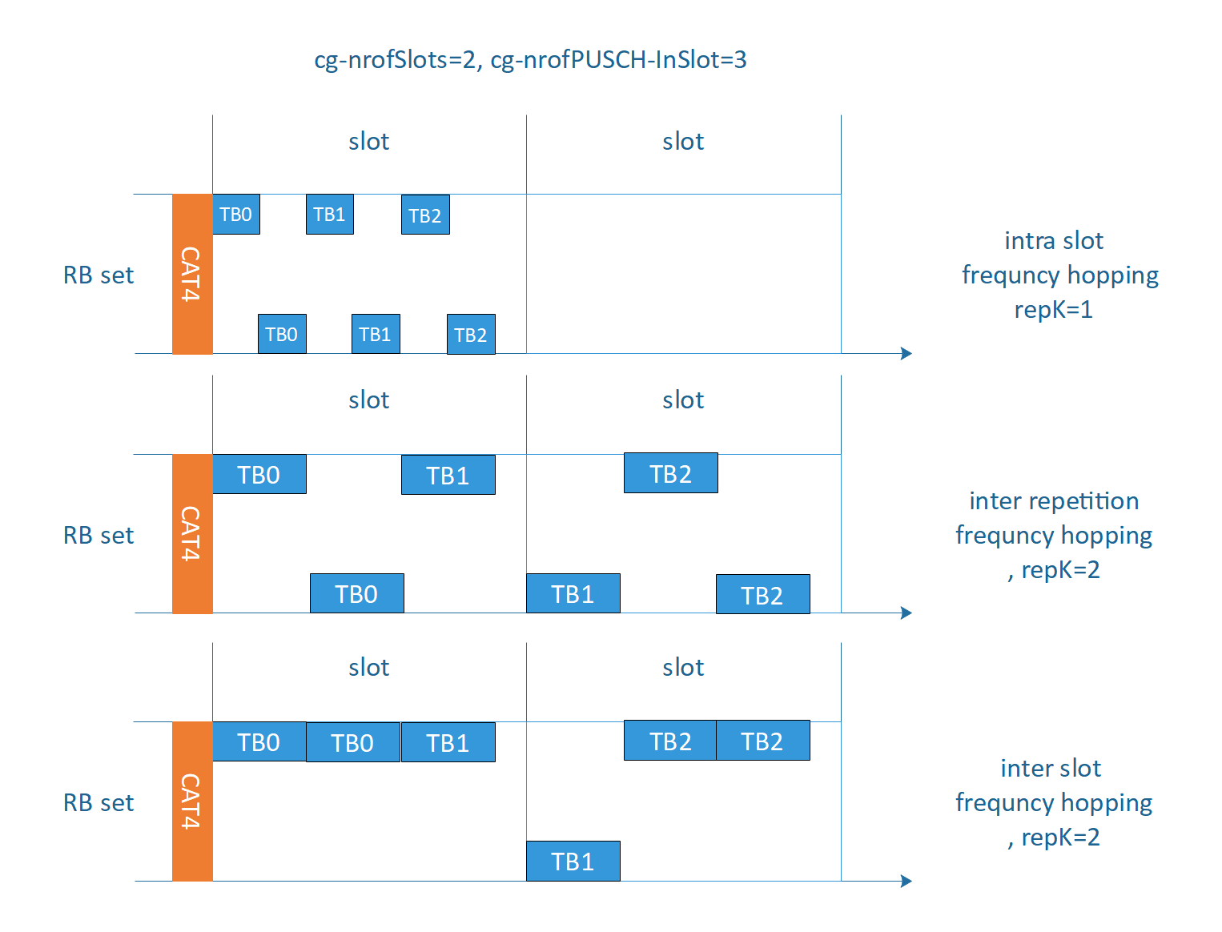  Figure 1 Intra slot, inter repetition and inter slot frequency hopping for configured grant PUSCH transmission when with cg-nrofSlots, cg-nrofPUSCH-InSlot are configured.

Question 2: If Alt. 1 is adopted, which one of the following TPs is preferred for Rel-16 CR?
- TP1 in [2]
-----------------------------------------------------------TP1 for 38.214 6.3.1-------------------------------------------------------------
<unchanged part omitted>
For PUSCH repetition Type A (as determined according to procedures defined in Clause 6.1.2.1 for scheduled PUSCH, or Clause 6.1.2.3 for configured PUSCH), a UE is configured for frequency hopping by the higher layer parameter frequencyHoppingDCI-0-2 in pusch-Config for PUSCH transmission scheduled by DCI format 0_2, and by frequencyHopping provided in pusch-Config for PUSCH transmission scheduled by a DCI format other than 0_2, and by frequencyHopping provided in configuredGrantConfig for configured PUSCH transmission. One of two frequency hopping modes can be configured:
- Intra-slot frequency hopping, applicable to single slot and multi-slot PUSCH transmission and each of multiple PUSCH transmissions scheduled by a DCI if the higher layer parameter pusch-TimeDomainAllocationListForMultiPUSCH is configured and each of multiple configured grant PUSCH transmissions in a configuration where the higher layer parameter cg-nrofSlots and cg-nrofPUSCH-InSlot are provided.
- Inter-slot frequency hopping, applicable to multi-slot PUSCH transmission.
<unchanged part omitted>
-----------------------------------------------------------TP1 for 38.214 6.3.1-------------------------------------------------------------

- TP2 in [5] (Note: It seems original TP in [5] is based Rel-17 spec and thus changed based on Rel-16 spec)
-----------------------------------------------------------TP2 for 38.214 6.3.1-------------------------------------------------------------
<unchanged part omitted>
For PUSCH repetition Type A (as determined according to procedures defined in Clause 6.1.2.1 for scheduled PUSCH, or Clause 6.1.2.3 for configured PUSCH), a UE is configured for frequency hopping by the higher layer parameter frequencyHoppingDCI-0-2 in pusch-Config for PUSCH transmission scheduled by DCI format 0_2, and by frequencyHopping provided in pusch-Config for PUSCH transmission scheduled by a DCI format other than 0_2, and by frequencyHopping provided in configuredGrantConfig for configured PUSCH transmission. One of two frequency hopping modes can be configured:
- Intra-slot frequency hopping, applicable to single slot and multi-slot PUSCH transmission and each of multiple PUSCH transmissions scheduled by a DCI if the higher layer parameter pusch-TimeDomainAllocationListForMultiPUSCH is configured and configured PUSCH transmission when cg-RetransmissionTimer is configured.
- Inter-slot frequency hopping, applicable to multi-slot PUSCH transmission.
<unchanged part omitted>
-----------------------------------------------------------TP2 for 38.214 6.3.1-------------------------------------------------------------
- Please indicate your preference and comments to the above TPs if Alt. 1 is adopted.
Company | Preferred TP | Comment
Huawei, HiSilicon |  | We prefer Alt 2.

Question 3: If Alt. 2 is adopted, do you agree the following TP for Rel-16 CR?
- TP3 in [6]
-----------------------------------------------------------TP3 for 38.214 6.3.1-------------------------------------------------------------
<unchanged part omitted>
For PUSCH repetition Type A (as determined according to procedures defined in Clause 6.1.2.1 for scheduled PUSCH, or Clause 6.1.2.3 for configured PUSCH), a UE is configured for frequency hopping by the higher layer parameter frequencyHoppingDCI-0-2 in pusch-Config for PUSCH transmission scheduled by DCI format 0_2, and by frequencyHopping provided in pusch-Config for PUSCH transmission scheduled by a DCI format other than 0_2, and by frequencyHopping provided in configuredGrantConfig for configured PUSCH transmission. One of the following frequency hopping modes can be configured:
- Intra-slot frequency hopping, applicable to single slot and multi-slot PUSCH transmission, each of multiple PUSCH transmissions scheduled by a DCI if the higher layer parameter pusch-TimeDomainAllocationListForMultiPUSCH is configured, and PUSCH transmission when the higher layer parameters cg-nrofSlots and cg-nrofPUSCH-InSlot are provided with repK=1.
- Inter-slot frequency hopping, applicable to multi-slot PUSCH transmission.
- Inter-repetition frequency hopping, applicable to PUSCH transmission when the higher layer parameters cg-nrofSlots and cg-nrofPUSCH-InSlot are provided with repK > 1.
<unchanged part omitted>
In case of inter-slot frequency hopping, the starting RB during slot is given by:
,
where is the current slot number within a radio frame, where a multi-slot PUSCH transmission can take place, is the starting RB within the UL BWP, as calculated from the resource block assignment information of resource allocation type 1 (described in Clause 6.1.2.2.2) and is the frequency offset in RBs between the two frequency hops.
In case of inter-repetition frequency hopping, the starting RB for the n-th repetition follows that of an actual repetition within the n-th nominal repetition of PUSCH Repetition Type B with inter-repetition frequency hopping in Clause 6.3.2.
<unchanged part omitted>
-----------------------------------------------------------TP3 for 38.214 6.3.1-------------------------------------------------------------
- Please indicate your comments to the above TP if Alt. 2 is adopted.
Company | Comment
Huawei, HiSilicon | We support avove TP as the proponent if Alt. 2 is adopted

Question 4: If any alternative other than Alt. 1 and Alt. 2 is preferred, please provide corresponding TP in the following table:
Company | Comment

Summary of Round1
[TBD]

Conclusion
[TBD]

Reference
- TS 38.214, Physical layer procedures for data, V16.8.0.
- R1-2201070, Discussion on frequency hopping for PUSCH with a configured grant, vivo
- R1-2201071, Draft CR on frequency hopping for PUSCH with a configured grant, vivo
- R1-2201072, Draft CR on frequency hopping for PUSCH with a configured grant, vivo
- R1-2201398, Clarification on frequency hopping for CG-PUSCH, ZTE, Sanechips
- R1-2201622, Discussion on the frequency hopping for CG-PUSCH in unlicensed band, Huawei, HiSilicon
- R1-2201623, Corrections on frequency hoppping for CG-PUSCH in TS38.214, Huawei, HiSilicon

