3GPP TSG RAN WG1 #108-e R1-22xxxxx
e-Meeting, February 21st – March 3rd, 2022

Agenda item: 7.2.12
Source: Moderator (NTT DOCOMO, INC.)
Title: Summary on Rel-16 NR others discussion
Document for: Discussion and Decision
- Introduction
This contribution summarizes the discussions and proposals in AI 7.2.12 for Rel-16 NR others discussion not covered by AI 7.2.1-7.2.11.

Based on the discussions summarized in Section 2, the moderator suggests having an email discussion on the proposal in [1] as below.
FL proposal #1 of email discussion:
[108-e-AI7.2.12-NR-Others-01] Email discussion for clarification on PUSCH with UCI Only and DMRS Multiplexing
- For Rel-16 and later releases, discuss whether to specify one unified UE behaviour when a UE is scheduled a PUSCH FDMed with DMRS and “UL-SCH indicator” in an UL DCI is 0 or to adopt the following conclusion made at RAN1#107-e
  - “It is up to UE implementation to handle the case where an UL DCI includes UL-SCH indicator = 0 and an indication of FDM between UL-SCH and DMRS”

Companies are encouraged to check above FL proposal and to provide feedback if any in below.
Company | Comment
CATT | The same contribution is submitted in R1-2202368 under agenda itme 7.1. Given that the issue was discussed in AI 7.1, it is suggested to handle under AI 7.1 in this meeting as well.
NTT DOCOMO | Two comments.  - Agree with CATT. This issue was discussed under AI 7.1 at the previous meeting. Discussion in this meeting should be done under AI 7.1.  - We do not think email thread for this issue is necessary. At the previous meeting, we have a conclusion as “up to UE implementation”. The conclusion is not limited to Rel-15, thereby the same should be applied to Rel-16 or later unless significant issue is found. Now the proposal is to specify UE behavior further, but we do not see the reason why such a CR is necessary.
Moderator (NTT DOCOMO) | Thanks for the feedbacks!  As pointed, the issue is also discussed in AI7.1 based on the same contribution from the proponent, and hence I would like to follow the guidance to be provided by RAN1 chair in AI7.1 on how to handle this issue.

- Discussion on other issues

  - Clarification on PUSCH with UCI Only and DMRS Multiplexing [1]
Following proposal is provided in [1], based on the discussion at RAN1#107-e meeting on the same issue [2].
[1] | When UL-SCH is NOT present on PUSCH, i.e., ‘UL-SCH indicator’ in an UL DCI format is 0, there is ambiguity on what to be transmitted on non-DMRS RE(s) in the DMRS symbol(s) if the network indicates data is FDMed with DMRS. Two possible interpretations on UE behaviour are as follows:  - Interpretation #1: UE does not transmit anything on non-DMRS RE(s) in the DMRS symbol(s) – see Figure 1(a)  - Interpretation #2: UE generates and transmits dummy bits on non-DMRS RE(s) in the DMRS symbol(s) – see Figure 1(b)  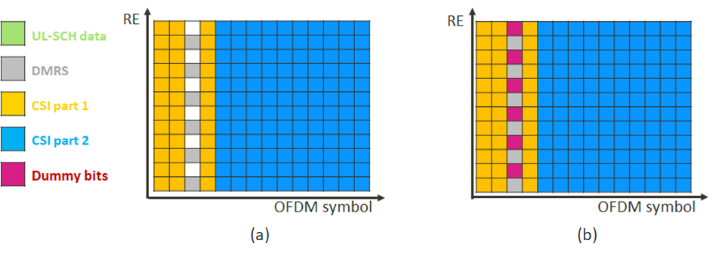  Figure 1. Two possible UE behaviours if PUSCH with UCI only is allowed to be FDMed with DMRS  Observation 1: When UL-SCH is NOT present on PUSCH, i.e., ‘UL-SCH indicator’ in an UL DCI format is 0, there is ambiguity on what to be transmitted on non-DMRS RE(s) in the DMRS symbol(s) if the network indicates data is FDMed with DMRS. Two possible interpretations on UE behaviour are shown in Figure 1.  This issue was discussed in RAN1 #107e and concluded to be left for UE implementation in R15 as below [1]:  Conclusion  It is up to UE implementation to handle the case where an UL DCI includes UL-SCH indicator = 0 and an indication of FDM between UL-SCH and DMRS.  Observation 2: Although a conclusion for R15 as shown above is achieved in RAN1 #107e, “up to UE implementation” still means network and UE may have different understanding on whether to include non-DMRS RE(s) in DMRS symbol(s) for PUSCH scrambling, which can affect PUSCH decoding.  In order to avoid the ambiguity on UE behaviour and ensure PUSCH performance, we propose:  Proposal 1: To amend the spec hole, specify one unified UE behaviour when a UE is scheduled a PUSCH FDMed with DMRS and “UL-SCH indicator” in an UL DCI is 0, in R16 or later releases.

Regarding the conclusion discussed at the RAN1#107-e meeting, there was a comment that “this conclusion is for both Rel-15 and Rel-16” [2]. Therefore, some companies may think it is already concluded for Rel-16, but the proponent would intend to discuss this issue again for Rel-16 and also possibility to specify one unified UE behaviour for later releases in this meeting.

Based on the above, following proposal can be discussed in RAN1#107-e meeting.

Discussion point #1
- For Rel-16 and later releases, discuss whether to specify one unified UE behaviour when a UE is scheduled a PUSCH FDMed with DMRS and “UL-SCH indicator” in an UL DCI is 0 or to adopt the following conclusion made at RAN1#107-e
  - “It is up to UE implementation to handle the case where an UL DCI includes UL-SCH indicator = 0 and an indication of FDM between UL-SCH and DMRS”

Reference
[1] R1-2202051 Clarification on PUSCH with UCI Only and DMRS Multiplexing MediaTek Inc.
[2] R1-2112666 Summary for [107-e-NR-7.1CRs-11] #18 PUSCH DMRS with UCI Only Moderator (MediaTek Inc.)

