3GPP TSG-RAN WG1 Meeting #105-e R1-210xxxx
e-Meeting, May 10th – 27th, 2021

Agenda item: 7.1
Source: Moderator (Apple Inc.)
Title: Summary of email discussion [105-e-NR-7.1CRs-13] on the correction for HARQ-ACK timing in Rel-16
Document for: Discussion and Decision

1 Introduction
This contribution provides the summary for the following email discussion in RAN1#105-e:
Issue#28
R1-2105075 Correction for HARQ-ACK timing in Rel-16 Apple, Ericsson
[105-e-NR-7.1CRs-13] Issue#28: Correction for HARQ-ACK timing in Rel-16 – Sigen (Apple) by May 25
- For Rel-16 only

Section 2 provides the background information. Section 3 captures the detailed email discussions. Section 4 summarizes the outcome of the email discussion.

2 Background
For HARQ-ACK, the PUCCH for HARQ-ACK is transmitted in UL slot n+k, where k is indicated in UL DCI, and n is determined based on PDSCH. When UL SCS is larger than DL SCS, two different interpretations existed in the history of RAN1 discussions. The issue was further discussed in RAN1#104b-e [1], and it was concluded that two different interpretations can exist in Rel-15, but it is important to achieve a common understanding for Rel-16.
Conclusion:
For HARQ-ACK timing in Rel-15, in case UL SCS is larger than DL SCS, there are two different interpretations:
- Interpretation 1: k = 0 corresponds to the last UL slot that overlaps with the PDSCH
- Interpretation 2: k = 0 corresponds to the last UL slot that overlaps with the DL slot for the PDSCH
Further discuss this issue for Rel-16 in future meetings.

Assuming an example as shown in Fig. 1 where DL uses 15 kHz SCS and UL uses 30 kHz SCS, with interpretation 1 k=0 would correspond to UL slot 6, while with interpretation 2 k=0 would correspond to UL slot 7.
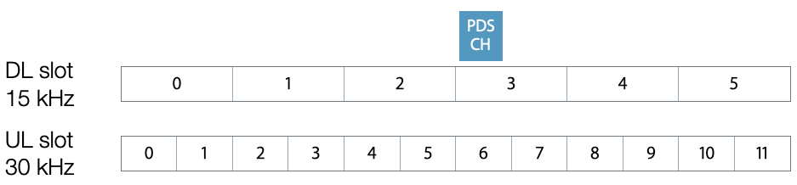
Figure 1 Example of HARQ-ACK timing
The following point was raised in [2]:
“Purely from HARQ-ACK timing perspective, adopting either interpretation seems to be fine, except that interpretation 2 is aligned with the original agreement.
However, for the pseudo-code for the Type-1 HARQ-ACK codebook construction to work properly, interpretation 2 should be adopted. Basically, the highlighted part below only makes sense if the end of DL slot for PDSCH is used as the reference.”
Excerpt from TS 38.213 Clause 9.1.2.1

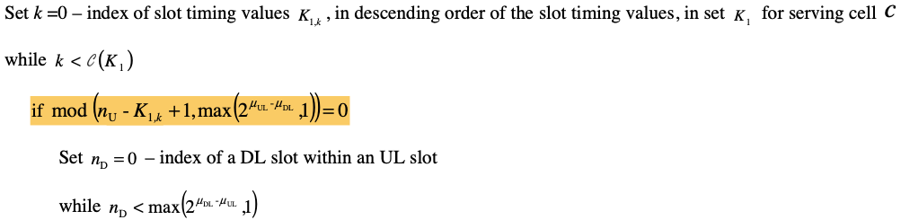
Due to the above reason, it was proposed in [2] to adopt interpretation 2 and a corresponding TP was provided.

To better understand the issue for Type 1 HARQ-ACK codebook with interpretation 1, a very simple example is provided in Figure 2.
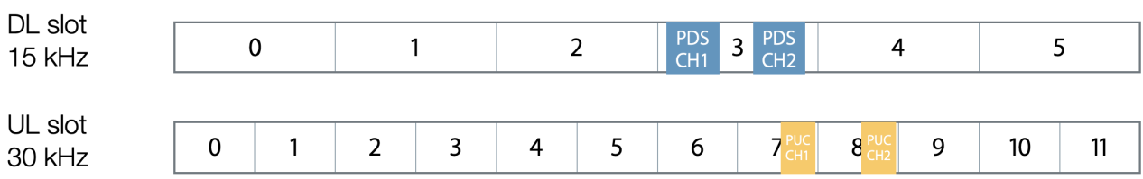
Figure 2 An example of Type-1 HARQ-ACK codebook construction for K1 set = {1}
In this example, it is assumed that the set of K1 values is {1} (i.e. consisting of a single value).
According to interpretation 1,
- for PDSCH1, K1=1 means that the HARQ-ACK should be provided in UL slot 7 (e.g. PUCCH1). For PDSCH2, K1=1 means that the HARQ-ACK should be provided in UL slot 8 (e.g. PUCCH2).
- However, if we follow the pseudo code for Type-1 HARQ-ACK codebook construction, for the HARQ-ACK codebook constructed in UL slot 7, as the highlighted condition is not satisfied (i.e., mod(7-1+1, 2) is not 0), there is not any DL slot that would have HARQ-ACK mapped to UL slot 7.
- On the other hand, for HARQ-ACK codebook constructed in UL slot 8, as the highlighted condition is satisfied, the TDRA entries in DL slot 3 would have HARQ-ACK mapped to UL slot 8, even though PDSCH1 cannot indicate HARQ-ACK in slot 8 with K1=1.
This means that the HARQ-ACK for PDSCH1 is lost in the codebook construction, and the UE would never transmit it to the gNB.
With interpretation 2, such an issue does not exist.

3 Email Discussions

3.1 First Round of Email Discussion
It is very important for RAN1 to conclude on a single interpretation for the HARQ-ACK timing in Rel-16, in order to support the case when UL SCS is larger than DL SCS. Companies are invited to provide their views on which interpretation should be adopted for Rel-16 and the reasoning behind it (taking into account the issue of Type-1 HARQ-ACK codebook discussed in Section 2).
Companies please indicate which interpretation you support for Rel-16.
Interpretation 1
Interpretation 2 | Qualcomm, OPPO, Nokia, NSB, Huawei, HiSilicon, ZTE, MediaTek

Companies please provide detailed reasons why you support interpretation 1 or 2.
Company | Comments
Qualcomm | The slot of the PDSCH reception is the reference for k=0, rather than the actual PDSCH symbols due to the reasons we have discussed in the last meeting. At least from Rel-16 spec, we should have a reasonable common interpretation.
OPPO | Although we agree in principle with what the draft CR proposed, we are a bit confused by the example given in background section. In this example, because K1={1}, then any n_{U} that is odd number would not meet the condition of mod(n_{U}-K1+1, 2)=0. This failure seems more related to the setup of K1, because if another assumption is made on K1, such as K1={only even number(s)}, any n_{U} that is even number would not meet the condition of mod(n_{U}-K1+1, 2)=0, which means the situation flips between UL slot 7 and UL slot 8. The given example does not seem quite relevant to the justification of either interpretation.
Nokia, NSB | Agree with Qualcomm.
Huawei, HiSilicon | This issue has been discussed extensively at the last meeting. Even though there are different views for Rel-15, the original intention is clear enough and should be clarified in Rel-16.
ZTE | Share the view with Qualcomm.
MediaTek | Agree with Qualcomm.

3.2 Second Round of Email Discussion

4 Outcome of the Email Discussion

References
- R1-2104105, Summary of email discussion [104b-e-NR-7.1CRs-04] on the correction for HARQ-ACK timing, Moderator (Apple Inc.), RAN1#104b-e, April 2021.
- R1-2105075, Correction for HARQ-ACK timing in Rel-15 and Rel-16, Apple, Ericsson, RAN1#105-e, May 2021.

