[100b-e-NR-5G_V2X_NRSL-PHYstructure-01]
Email discussion/approval regarding TBS determination for PSSCH

[100b-e-NR-5G_V2X_NRSL-PHYstructure-01] Email discussion/approval regarding TBS determination for PSSCH
- A. How to deal with PSFCH overhead
- B. How to deal with PSSCH DMRS overhead
- C. How to deal with 2nd SCI overhead
- D. How to deal with CSI-RS/PT-RS
- E. Whether/how to use indication of sl_xOverhead
till 4/27, with potential TP till 4/30 – Jeongho (SS)

This document has the following questions.
A. How to deal with PSFCH overhead in determination of TBS for PSSCH?
B. How to deal with PSSCH DMRS overhead in determination of TBS for PSSCH?
C. How to deal with the 2nd SCI overhead in determination of TBS for PSSCH?
D. How to deal with SL CSI-RS and PT-RS in determination of TBS for PSSCH?
E. Whether and how to define/use high layer parameter sl_xOverhead for determination of TBS for PSSCH?

A. How to deal with PSFCH overhead in determination of TBS for PSSCH?
Based on the submitted contributions, there are the following alternatives and supporting companies.
- Alt A-1. The number of PSSCH symbols are based on the slot having the PSSCH (i.e., dynamically changed)
  - [LGE]
- Alt A-2. The number of PSSCH symbols are obtained as the average on the all slots in the resource pool. (e.g., if N=2, then the average value can be 3 symbols divided by 2, where 3 symbols includes additional gap symbol and 2 PSFCH symbols).
  - [Huawei, HiSilicon], [ZTE, Sanechips], [Nokia, NSB], [CATT], [Panasonic]
- Alt A-3. The overhead due to PSFCH is indicated by the corresponding 1st SCI.
  - [OPPO], [Ericsson](based on the initial Tx)
- Alt A-4. The overhead due to PSFCH is indicated by the corresponding 2nd SCI.
  - [Qualcomm]
- Alt A-5. The number of PSSCH symbols are obtained as the maximum on the all slots in the resource pool. (i.e. always assume there is PSFCH in the slot) (e.g., if N=2, then the overhead value is 3 symbols, where 3 symbols includes additional gap symbol and 2 PSFCH symbols).
  - [vivo], [Spreadtrum]
- Alt A-6. A pre-configured parameter is used for the actual overhead for PSFCH. (FFS: the pre-configured parameter can be the same as “sl_xOverhead” or separate from it.
  - [Intel], [Apple], [NEC], [NTT DCM], [InterDigital]

Based on the contributions, the following proposal can be made.
Proposal 1. The number of PSSCH symbols are obtained as the average on the all slots in the resource pool. (e.g., if N=2, then the average value can be 3 symbols divided by 2, where 3 symbols includes additional gap symbol and 2 PSFCH symbols).
Please share your views if Proposal 1 is agreeable or, if not, please share your views on the reason why it is not workable. When sharing views, please share you views on FFS, if there is, to be discussed together.
Company | Views
NTT DOCOMO | Motivation of ‘average’ is unclear for us. In our understanding, overhead that is dynamically changed should be considered by xOverhead. This is principle in Uu. The same principle should be adopted for SL.  # In our contribution, we support Alt A-6. Our company is added in the above.
Huawei, HiSilicon | Agree. This enables the number of PSFCH symbols to reflect the PSFCH configuration (PSFCH periodicity {0, 1, 2 ,4}) in the resource pool, and therefore allows PSFCH overhead to be counted as close to the target values for the transmission of a TB and its retransmission(s), whilst avoiding introduction of additional L1 signaling overhead.  PS. The proposal should refer to PSFCH, instead of PSSCH.
LG | We are supportive A-1.  According to the analysis in our contribution (R1-2001884), if the actual PSFCH overhead is not considered for TBS determination, even though actual overheads are used for PSSCH DMRS and 2nd-SCI, the actual coding rate error with respect to target coding rate is large. We observed that PSFCH overhead is dominant factor compared to other overheads.  In other words, when we targets to minimize the actual coding rate error, we should consider the actual PSFCH overhead for TBS determination. Otherwise, the actual coding rate error cannot be minimized.  Following figure shows the actual coding rate error for A-2/B-3/C-1/D-1. According to the figure, the actual coding rate error is still large when A-3 is supported.  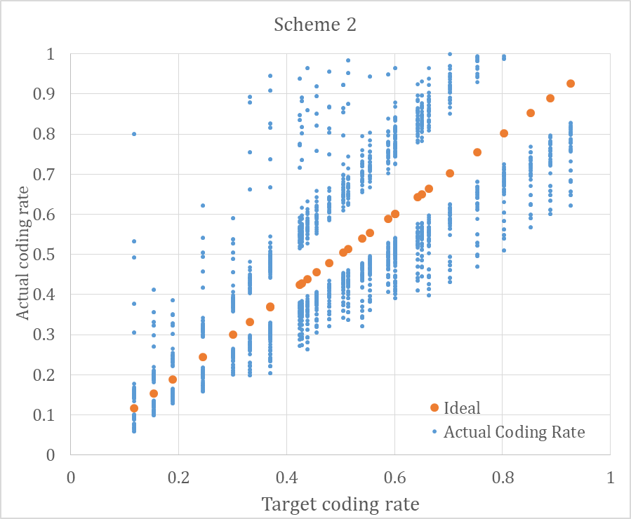
Intel | Agree, it is important to have the overhead for TBS determination as close as possible to the actual value. For the case of PSFCH only the average can be taken, as otherwise the TBS calculated from transmissions of the same TB in slots containing PSFCH would be different to the once in slots without PSFCH.
Futurewei | The average number of PSFCH over all slots is acceptable
Apple | We are not convinced with a fractional number of PSFCH symbols, if averaging is taken. Our thinking is as follows:  If PSFCH periodicity is 1 slot, then the number of PSFCH symbols is equal to 3 for PSFCH symbols and GP symbol before PSFCH.  If PSFCH periodicity is 0 slot, then the number of PSFCH symbols is equal to 0.  If PSFCH periodicity is 2 or 4 slots, then the number of PSFCH symbols is (pre)configured per resource pool, which is an integer value between 0 and 3.  In our view, this (pre)configured integer value is different from xoverhead, which is counted per RB or per sub-channel.
CATT | Agree.  As the PSFCH overhead is varied slot by slot due to the PSFCH configuration, it should be considered as a reference overhead to keep the same TB size between transmission and retransmission. Furthermore, the average is the closest to the actual value without extra fields in SCI.
Ericsson | Proposal 1 is not agreeable to us. In our view, using the PSFCH overhead in the slot of the initial transmission of a TB is the most reasonable approach. The indication can be in the 1st or 2nd SCI (to facilitate the case the initial transmission is missed.) We think that Alt-1, Alt-3, Alt-4 are essentially the same with minor differences.
TCL | The proposal is acceptable to us.  A dynamic approach like Alt-1, Alt-2 or Alt-3 is also fine.
InterDigital | Not support the proposal. Alt-A6 can support the proposal by configuration as well and provides more flexibility based on the scheduling policy.
Sharp | We support A-1 to minimize the target coding rate error as LGE’s comments.
Qualcomm | We proposed using a one-bit indicator in SCI-2 (could also be in SCI-1) to provide the transmitter with the ability to better control the maximum effective coding rate, by making the decision on whether to count PSFCH overhead or not for a given retransmission. This enables the transmitter to adapt to the selected slots (all with PSFCH, all without, mixed) instead of always having effective coding rate higher than the target for slots with PSFCH.  For a retransmission to be combinable with another, both the TBS and the LDPC base graph need to be the same. The LDPC base graph is determined based on MCS (and TBS); therefore, it is not always possible to change MCS between retransmissions even if the TBS remains the same. The additional flexibility of dynamically indicating PSFCH would help with this aspect.
ZTE, Sanechips | Agreed. As analyzed in R1-2001577, the PSFCH overhead could be accounted for as an average across all slots within a resource pool.
Panasonic | We support proposal 1 (Alt A-2). the number of PSSCH symbols are obtained as the average on the all slots in the resource pool. We observe the PSFCH overhead is largest overhead when the resource allocation of frequency domain is large. Alt A-2 has no impact on both RRC signalling and SCI signalling. We are also ok with Alt A-5 with maximum overhead. It is suitable for lower coding rate. The Tx UE can select suitable MCS to achieve the target BLER with PSFCH overhead knowledge.

B. How to deal with PSSCH DMRS overhead in determination of TBS for PSSCH?
Based on the submitted contributions, there are the following alternatives and supporting companies.
- Alt B-1. Consider the reference DMRS overhead as configured. (i.e., there is a new RRC parameter to indicate)
  - [Huawei, HiSilicon], [Intel], [Apple]
- Alt B-2. Include DMRS overhead in sl_xOverhead
  - [LGE], [Ericsson], [Spreadtrum], [NEC], [InterDigital]
- Alt B-3. Actual number of REs for DMRS (i.e. reuse Rel-15 NR Uu) (FFS: actual number of REs, or number of Res per PRBs for PSSCH times the number of DMRS symbols, this is to be discussed together due to PSCCH overlap.)
  - [ZTE, Sanechips], [vivo], [OPPO], [NTT DCM], [Qualcomm], [Mitsubishi]
- Alt B-4. Actual number of REs for DMRS, and UE indicates the same DMRS pattern between initial transmission and retransmission.
  - [vivo]
- Alt B-5. Assume the maximum density among configured patterns
  - [CATT]

Based on the contributions, the following proposal can be made.
Proposal 2. The actual number of REs for PSSCH DMRS is used for PSSCH TBS determination.
Please share your views if Proposal 2 is agreeable or, if not, please share your views on the reason why it is not workable. When sharing views, please share you views on FFS, if there is, to be discussed together.
Company | Views
NTT DCOOMO | Support.  For FFS part, actual number of REs should be subtracted. That is, PSCCH overlap should be considered for the subtraction. Otherwise, subtracted amount is not the actual number of REs for DM-RS. Motivation of Alt B-3 is lost in this case.
Huawei, HiSilicon | The number of PSSCH symbols varies for the transmission of a TB and its retransmission(s) dependent on presence of PSFCH in a slot subject to PSSCH DMRS table in TS38.211. Allowing changes of DMRS is beneficial for retransmission reliability. In order for same TBS for (re-)transmissions of TB, averaging DMRS configuration based on can be used as a reference DMRS overhead in time domain.  On the other hand, in frequency domain, since PSCCH and PSSCH DMRS can be FDMed, the number of REs among PRBs are not same. Instead of using $N_{R}^{'}∙n_{PRB}$, calculation of REs per i-th PRB is more appreciate, i.e. $\sum_{i=1}^{n_{PRB}}{N_{R,i}^{'}}$ to capture the variation of REs per PRB.
LG | Unlike NR Uu link, in NR sidelink, PSSCH DMRS can be FDMed with PSCCH depending on the number of allocated sub-channels, the number of PSSCH symbols, and the indicated DMRS pattern. In other words, even thouhg the same number of sub-channels and the same DMRS patterns are indicated between initial transmission and retransmission, when initial transmission occurs in PSFCH-slot and retransmission occurs in non-PSFCH-slot, the number of REs for PSSCH DMRS could be different.  According to the analysis in our contribution (R1-2001884), even though reference number of REs for PSSCH DMRS is used for TBS determination, the actual coding rate error would not highly increase. Meanwhile, it can increase the possibility that the same TBS is enabled between initial transmission and retransmission.  Following figures show the actual coding rate error and the PMF for the cases with the same TBS (red color) for A-1/B-2/C-3/D1.  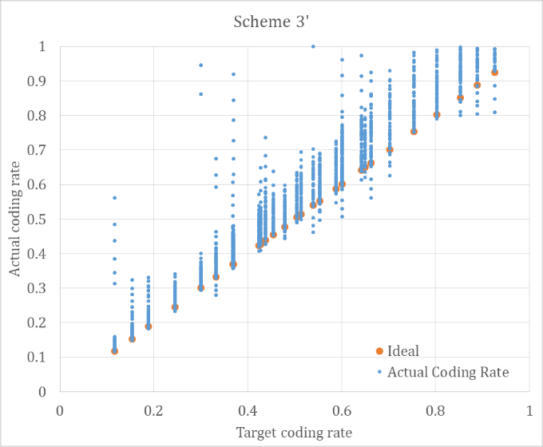  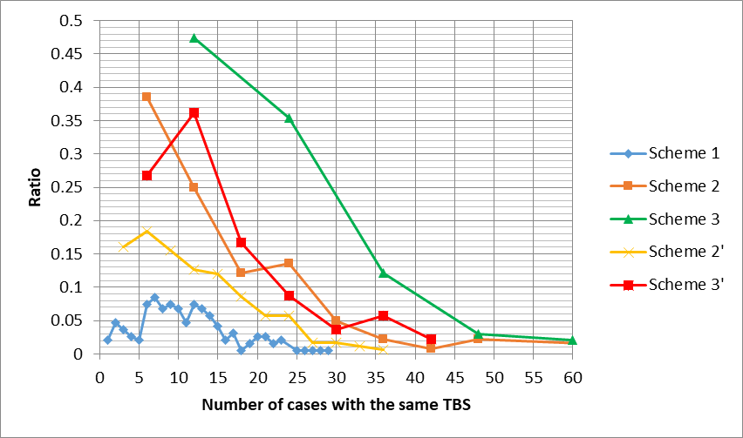
Intel | Disagree, this proposal would result in different TBS of transmissions of the same TB for the case that a different PSSCH DMRS density is used, or that the PSFCH is not present in all slots. It is dependent on the presence of the PSFCH as the PSSCH DMRS overhead is dependent on it. This discussion needs to be related to the RRC configuration of the PSSCH DMRS time density for the cases w/o PSFCH.
Futurewei | B-3: actual number of DMRS RES, assuming that no PSFCH or PSCCH is present
Apple | Not agree.  The actual number of PSSCH symbols may change between initial transmission and retransmission(s), due to the presence of PSFCH symbols. Subsequently, the actual number of PSSCH DMRS symbols may change between initial transmission and retransmission(s), based on Table 8.4.1.2.2-1 from TS38.211. Hence, Proposal 2 does not work.  To align the number of PSSCH DMRS symbols for TBS calculation from initial transmission or retransmission(s), we need to rely on the reference number of PSFCH symbols, which we discussed for Proposal 1. Specifically, the number of PSSCH DMRS symbols can be selected from a (pre)configured set, depending on the reference number of PSFCH symbols.  Also, as mentioned by other companies that PSSCH DMRS can be FDMed with PSCCH, the actual number of REs for PSSCH DMRS need to be counted separately symbol by symbol, based on the reference number of PSSCH DMRS symbols.  We support Alt B-1, but does not mean a new RRC parameter is introduced to indicate the number of PSSCH DMRS symbols. Instead, the reference number of PSSCH DRMS symbols depends on the reference number of PSFCH symbols.
CATT | Disagree.  Under the influence of PSFCH resource, the overhead of same PSSCH DMRS pattern in a slot with PSFCH and a slot without PSFCH can be different. The actual number of REs for PSSCH DMRS can’t be directly used for PSSCH TBS determination.  The reference overhead of PSSCH DMRS is more acceptable. As the rule to select DMRS patterns has not been decided, and a (pre-)configured resource pool can be used for all of unicast, groupcast, and broadcast for a given UE, the maximum density DMRS pattern should be always used for broadcast and groupcast(type-1) which are more common scenarios. So we prefer to use the maximum density as the PSSCH DMRS overhead.
Ericsson | Although our preference is including DMRS overhead in N_oh, we could be fine with the proposal.
TCL | We agree with this proposal.
InterDigital | Not support the proposal, the DMRS density should be possible to change between initial transmission and retransmission. When a Tx UE has no channel information or outdated channel information, the Tx UE should increase DM-RS density for retransmission when the Tx UE received NACK increase the error occurred due to poor channel estimation quality. Otherwise, the Rx UE may not recover the data even after a couple of retransmission receptions.  If we allow to use the same TBS irrespective of the available REs for PDSCH for retransmission case (same as NR Uu), we are ok with the proposal in condition with that the proposal only applies for initial transmission.
Sharp | Agree with proposal 2.
Qualcomm | We agree with the proposal.  - We’re ok to keep the FFS for now. We propose to use the overhead per PRB, which depends on the selected DMRS pattern.
ZTE, Sanechips | Agreed. Regarding the FFS part we think the exact number of DMRS should be accounted for, meaning the DMRS overhead may vary symbol by symbol depending on whether PSCCH is present.
Panasonic | We support the proposal as the resources of DMRS would be usually constant over a TB transmission as the channel condition would be no significant difference in these periods.

C. How to deal with the 2nd SCI overhead in determination of TBS for PSSCH?
Based on the submitted contributions, there are the following alternatives and supporting companies.
- Alt C-1. Consider the actual number of REs occupied by the 2nd SCI (FFS: whether to use of averaged or reference beta offset for 2nd SCI, or use the exactly same number of Res occupied by the 2nd SCI)
  - [Huawei, HiSilicon], [OPPO], [CATT], [Ericsson], [NEC], [NTT DCM], [Qualcomm], [Apple], [Intel]
  - FFS: how to resolve chicken-and-egg problem with the number of coded symbols of the 2nd SCI
- Alt C-2. Consider the reference number of REs for occupied by the 2nd SCI
  - [Nokia, NSB]
- Alt C-3. Introduce higher layer parameter, e.g., sl_xOverhead
  - [ZTE, Sanechips], [vivo], [LGE], [Spreadtrum], [InterDigital]
- Alt C-4. Assume zero overhead
  - [Futurewei], [Panasonic]

Based on the contributions, the following proposal can be made.
Proposal 3. The actual number of REs occupied by the 2nd SCI is used for PSSCH TBS determination.
Please share your views if Proposal 3 is agreeable or, if not, please share your views on the reason why it is not workable. When sharing views, please share you views on FFS, if there is, to be discussed together.
Company | Views
NTT DOCOMO | Support with the following.  For FFS part, our preference to resolve the chicken-egg problem is to update rate-matching formula. The current formula uses TBS. If the formula is updated as independent to TBS like UCI on PUSCH without UL-SCH, the issue is resolved. We understand that this means reverting the previous agreement. If there is objection, we are OK to support Alt C-3.  In our memory, rate-matching formula like UCI on PUSCH without UL-SCH was closed to be supported, but the formula was updated before reaching agreements without sufficient analysis. Now we have problem, then we hope that reverting is agreeable..
Huawei, HiSilicon | - The circular dependency between 2nd-stage SCI modulated symbol determination and TBS determination needs be removed to calculate 2nd-stage SCI overhead.  - Inappropriate choice of beta-offset value from a (pre-)configured set of values would cause potential decoding failure on 2nd-stage SCI. TX UE can detect this as DTX (i.e. no HARQ feedback from RX UE), and retransmits with an adjusted beta-offset value. Hence allowing change of beta-offset among retransmission(s) is beneficial to improve reliability of control information.  Thus, the 2nd-stage SCI overhead is determined based on 2nd-stage SCI modulated symbols number (after removal of TBS constraint) by using averaging beta-offset values as provided by SL-BetaOffsets, i.e. $\sum_{i=1}^{4}{{β_{i}^{SCI2}}/4}$.
LG | The number of REs for 2nd-SCI would be dependent on MCS (regardless of whether TBS is directly used or not), the value of beta, the 2nd-SCI payload size, and gamma value (which will be determined by the mapping of PSCCH, PSSCH, PSSCH DMRS, PT-RS). The 2nd-SCI format payload size will be the same between initial transmission and retransmission. MCS could be changed to enable the same TBS between initial transmission and retransmission. On the value of gamma, depending on how the 2nd-SCI is mapped or rate-matched around other signals, its value could be changed across initial transmission and retransmission.  In short, it would be difficult to fix the number of REs for the 2nd-SCI even though the value of beta offset is fixed.  Meanwhile, according to the analysis in our contribution (R1-2001884), even though reference number of REs for 2nd-SCI is used for TBS determination, the actual coding rate error would not highly increase. Meanwhile, it can increase the possibility that the same TBS is enabled between initial transmission and retransmission.  Following figures show the actual coding rate error and the PMF for the cases with the same TBS (red color) for A-1/B-2/C-3/D1.
Intel | Agree, the actual spectral efficiency should be as close as possible to the nominal one given defined by the MCS table. This means it needs to be ensured that the 2nd stage PSCCH REs are always the same across different transmissions of the same TB, as otherwise the resulting TBS would be different.
Futurewei | C-4: assume zero overhead for 2nd SCI. We are not convinced that using the actual number of REs will ensure same TBS across (re-)transmissions.
Apple | We prefer to introduce a reference 2nd SCI overhead calculation formula, just for the purpose of TBS calculation. This reference formula does not depend on TBS, but depends on target coding rate, QPSK modulation for 2nd SCI overhead, and a reference beta offset (pre)configured per resource pool.  Also, in the calculation of upper bound on the total allowed number of REs that are used for 2nd SCI transmission (i.e., $⌈α\sum_{l=0}^{N_{symbol}^{PSSCH}-1}{M_{sc}^{SCI2}\left(l\right)}⌉$, the number of allocated symbols for PSSCH except AGC symbol (i.e., $N_{symbol}^{PSSCH}$) should also consider the reference number of PSFCH symbols, such that initial transmission and retransmission(s) have the same value.
CATT | Agree.  But the Rate matching of 2nd-stage SCI should be discussed first. The number of coded modulation symbols for 2nd SCI transmission is determined by the TBS in the current version of TS 38.212. If 2nd SCI resource determination can be independent to TBS, and the number of modulation symbols for 2nd SCI is unchanged during initial transmission and re-transmissions, using the actual overhead of 2nd SCI for TBS determination will be perfectly reasonable.
Ericsson | Agree.  - The circular dependency between 2nd-stage SCI modulated symbol determination and TBS determination needs be removed to calculate 2nd-stage SCI overhead.  - In our view the number of coded modulation symbols for the 2nd SCI does not need to remain the same across rext of the same TB. This is to maintain the same TBS across the retx, by changing MCS of the shared channel, the beta_offset and gamma values.
TCL | Agree.
InterDigital | Disagree with the proposal. We are not sure if the same TBS is ensured for the same TB with (re-)transmissions if the actual number of REs is used. C-3 is the preferred option.
Sharp | We support C-3/C-4. We agree with LGE’s comment that it is hard to ensure the very same number of REs between initial and retransmission, e.g. as a matter of MCS adjustment, etc. Besides, to ensure the same TBS between initial transmission and retransmission, TBS determination in NR Uu includes other quantization procedures and there are entries in MCS table specially for retransmission (e.g. indexes 28-31 in Table 5.1.3.1-2), hence, similar mechanism can be adopted for NR SL.
Qualcomm | We agree with the proposal.  - The dependency of the number of second-stage control modulation symbols on TBS should be removed. The details can be discussed when the equation is discussed next meeting.  - Using the exact number of 2nd-stage control REs helps ensure the closest match between effective and target spectral efficiency. It also reduces cases where the effective code rate of data (SL-SCH) would increases beyond the decodability limit, e.g. if the actual number of 2nd-stage control REs is larger than the average or reference. Since allocation size cannot change between retransmissions in sidelink, decreasing the spectral efficiency of 2nd-stage control comes at the cost of an increase in data spectral efficiency. This is limitation that needs to be condiered and is different from the flexibility offered by Uu. That said, we’re ok with keeping this point FFS for now.
ZTE, Sanechips | We see two alternatives to account for the 2nd SCI overhead in TBS. Our preference is to use the high layer parameter sl_xoverhead whose value range, taking 2nd SCI overhead into account, has been provided in R1-2001577. Alternatively, if actual REs of 2nd SCI should be calculated as proposed, we would prefer to calculate the number as follows, where Q_{m} is the modulation order of the 2nd SCI  $$Q_{SCI2}^{'}=\text{min}\left\{\left\lceil \frac{\left(O_{SCI2}+L_{SCI2}\right)∙β_{offset}^{SCI2}∙}{Qm⋅R}\right\rceil , \left\lceil α\sum_{l=0}^{N_{symbol}^{PSSCH}-1}{M_{sc}^{SCI2}(l)}\right\rceil \right\}+γ$$
Panasonic | We can support proposal(C-1). The REs occupied by the 2nd SCI resources would be usually constant over a TB transmission as we don't see specific usage to change coding rate of 2nd SCI over a TB transmission. If 2nd SCI coding rate needs to be changed, it is not required to have soft combining among transmissions as a new TB transmission. If how to resolve chicken-and-egg problem is concluded, C-1 is preferable. If it is not concluded, we support C-4 (no overhead). the Tx UE selects lower MCS with 2nd SCI overhead knowledge in order to achieve the target BLER.

D. How to deal with SL CSI-RS and PT-RS in determination of TBS for PSSCH?
Based on the submitted contributions, there are the following alternatives and supporting companies.
- Alt D-1. Introduce higher layer parameter, e.g., sl_xOverhead
  - [Huawei, HiSilicon], [ZTE, Sanechips], [OPPO], [Nokia, NSB], [LGE], [Intel], [CATT], [Ericsson], [Spreadtrum], [NEC], [Qualcomm], [InterDigital]
- Alt D-2. Assume always present
  - [Futurewei], [Mitsubishi] (only for CSI-RS)
- Alt D-3. Consider actual number of REs
  - [Futurewei] (only for PT-RS), [Apple], [Mitsubishi] (only for PT-RS)

Based on the contributions, the following proposal can be made.
Proposal 4. Introduce and use the higher layer parameter sl_xOverhead to handle the overhead due to SL CSI-RS and PT-RS PSSCH TBS determination.
Please share your views if Proposal 4 is agreeable or, if not, please share your views on the reason why it is not workable. When sharing views, please share you views on FFS, if there is, to be discussed together.
Company | Views
NTT DOCOMO | Support (with adding ‘at least’ before SL CSI-RS since other overhead could be included as well, which is dependent on discussions for A/B/C.)
Huawei, HiSilicon | - PT-RS RE mapping can be changed for a transmission and its retransmission caused by changes of PSSCH DMRS pattern, i.e. can vary per PSSCH per UE.  - Given that a TB can be (re-)transmitted up to 32 times, it is not necessary to restrict CSI-RS to be present or absent in every (re-)transmission.  Thus, SL-CSI-RS and SL-PT-RS overhead, a fairly small number of REs, similarly as Uu, can be accounted for by introducing a higher layer parameter $N_{oh}^{PRB}$ (pre-)configured per resource pool.
LG | We are supportive of introducing sl_xOverhead for TBS determination. We think the sl_xOverhead can be used to represent the overhead of PSSCH DMRS, 2nd-SCI, SL CSI-RS, and PT-RS.  Following figures are to compare the set of proposals in the FL summary and our proposal.  Actual coding rate error for A-2/B-3/C-1/D-1 (the set of proposals in the FL summary) is as follows:  Actual coding rate error for A-1/B-2/C-3/D-1 is as follows:  The probability mass function of the number of cases with the same TBS across a variety of combination of the existence of SL-CSI, the different density of PT-RS, the different density of DMRS, different MCS, the different number of sub-channels for PSSCH, the different number of REs for 2nd-SCI.  Orange color is A-2/B-3/C-1/E-1, and red color is A-1/B-2/C-3/E-1.  According to the analysis, both scheme can ensure enabling the same TBS between initial transmission and retransmission, but the actual coding rate error of A-1/B-2/C-3/E-1 is much better than that of A-2/B-3/C-1/E-1.
Intel | Partly agree. If PT-RS are configured a corresponding overhead should be configured for the TBS calculation. Due to the dynamic presence of the CSI-RS they cannot be considered in the TBS calculation.
Futurewei | We do not agree: D-2 for CSI-RS (assume always present), D-4 for PT-RS (actual number of REs)
Apple | We think that the actual number of REs for CSI-RS and PT-RS can be obtained, and hence the rough estimation of these overheads via sl-xoverhead can be avoided.
CATT | For CSI-RS, only 2 REs per PRB, it can be assumed always presence or not.  For PT-RS, it is more accurate to calculate the actual number of PT-RS REs based on the transmission bandwidth and MCS with the assumption that non-PSFCH symbols are used.
Ericsson | Agree.
TCL | Agree, similarly to Uu this can be accounted for in sl_xOverhead.
InterDigital | Support the proposal
Sharp | We support D-3. The actual REs number for both SL CSI-RS and PT-RS can be determined by UE.
Qualcomm | We agree with the proposal, the overhead of CSI-RS and PT-RS is relatively small. It is simplest to follow Uu procedure and include that overhead in xOverhead
ZTE, Sanechips | Agreed. Uu logical could be re-used in this aspect as analyzed in R1-2001577
Panasonic | Seeing the majority views, we are ok to the proposal.

E. Whether and how to define/use high layer parameter sl_xOverhead for determination of TBS for PSSCH?
Based on the submitted contributions, there are the following alternatives and supporting companies.
- Alt E-1. Define sl_xOverhead and (pre-)configure this parameter per resource pool
  - [InterDigital]
- Alt E-2. Define sl_xOverhead and indicate this parameter by the 1st SCI
  - [LGE]
- Alt E-3. Not define sl_xOverhead
Please share your views on this issue.
Company | Views
NTT DOCOMO | Alt E-1.
Huawei, HiSilicon | This seems better handled by deriving from other proposals.  $N_{oh}^{PRB}$ is only needed for SL-CSI-RS and SL-PT-RS as (pre-)configured per resource pool, similarly as in NR Uu.
LG | We are supportive of E-2.  Unlike NR Uu link, PSCCH will be always confined within PSSCH transmission, and PT-RS will not be mapped on the resources used for PSCCH. In this case, the suitable value of sl_xOverhead would be different across different number of allocated sub-channels for the PSSCH transmission.  Furthermore, when we consider sl_xOverhead is used to represent PSSCH DMRS and/or 2nd-SCI in addition to CSI-RS and PTRS, this trend will be strengthened.  According to our analysis, the total sum of overhead for 2nd-SCI, PSSCH DMRS, SL CSI-RS, and PT-RS is shown in following figure.  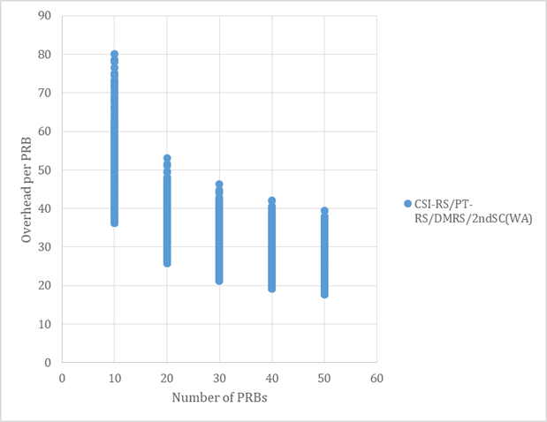  In this case, it would be beneficial to further reduce the actual coding rate error that SCI indicate the value of sl_xOverhead.
Intel | This is dependent on Discussion D. We agree that this should be a resource pool wide configuration.
Futurewei | E-3: no need to define such a parameter: see answers to previous questions
Apple | We prefer Alt. E-3.
CATT | Ale. E-3.  Same as for previous answer.
Ericsson | Alt E-1
TCL | Alt E-1
InterDigital | Alt E-1
Sharp | We support E-3 if C-4 agreed and E-1 if C-3 agreed.
Qualcomm | We prefer Alt E-1 and are ok with Alt E-2 (the indication can be in 2nd SCI) to provide the transmitter with additional flexibility if needed.
ZTE, Sanechips | Alt E-1
Panasonic | Our original preference is Alt E-3. Seeing the majority of proposal 4, we are also ok to with Alt E-1. We don't see the motivation of Alt E-2.

