3GPP TSG-RAN WG1 Meeting #100bis-e R1-200xxxx
e-meeting, April 20th – 30th, 2020

Agenda Item: 7.2.1
Source: Moderator (ZTE)
Title: Text proposal of clarification on the slot offset
Document for: Discussion

Introduction
This document is intended to address the following remaining issues by email discussion.
Agreements:
- Strive to work out a TP in this meeting, based on TP#1a/1b/1c in the appendix and the inputs to this meeting, to clarify the reference point of the slot offset in TS 38.213.
To check TPs till 4/30

Text proposal of clarification on the slot offset
The status of the first phase discussion is summarized as follows.

- 7 out of 12 companies thought the current spec is clear. 1 company expressed strong concern on the description of the current spec.
- 2 companies supported the TP#1a with potential updates, while the original proponent of TP#1a thought the current spec is clear.
- 3 companies supported the TP#1c, including the original proponent of TP#1b.

[Moderator] If only half of the companies believe the current spec is clear, it means something that we can do better. Please kindly check if the TP#1a and TP#1c are also acceptable, and if not please share with the group what the concern is.

The suggestion is to collect all the concerns in the following table and see if the concern can be well addressed.
Company | Comment (concerns, if any, on the current spec, TP#1a and TP#1c respectively)
Intel | This issue was discussed extensively in the last e-meeting. In our view, we still think the spec is clear and we do not need to change the spec.
NTT DOCOMO | We still have the concern on the current spec. The description of the current spec are ambiguous, and can be interpreted differently as shown in following figure. When msgAPUSCH-timeDomainOffset indicates the middle of the PUSCH slot, some UEs may interpret PUSCH slot #3 is the first PUSCH slot for MsgA PUSCH transmission, and on the other hand other UEs may interpret PUSCH slot #4 which is next complete slot is the first PUSCH slot for MsgA PUSCH transmission. We should be careful for such round-up operation.  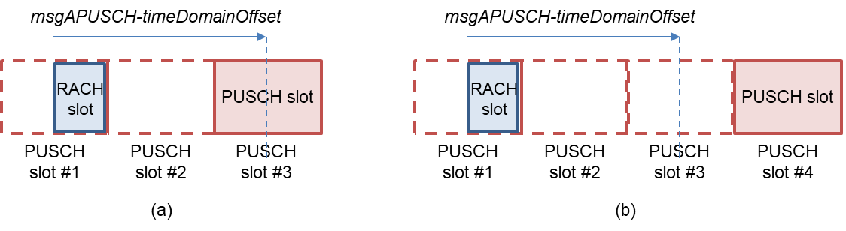  Since these two interpretations lead different msg.A PUSCH time domain resource, it has the significant impact.  At least some companies consider the current spec is ambiguous even though we are the expert on the spec, and we should make sure someone first looking at the spec can easily understand the specification.  A company who has no concern on the current spec has to explain the clear logic leading the one interpretation based on the current spec which everyone can understand.  For the TP, we prefer the TP#1c.
CATT | We prefer to the TP#1c for clarifying the slot offset as suggested by our contribution R1-2002064.
Spreadtrum | Since the SCS for MsgA PRACH can be configured different from that for MsgA PUSCH, we should consider both cases: (1) the PRACH slot is longer than the PUSCH slot (2) the PUSCH slot is longer than the PRACH slot. Make the spec clearer, it is necessary to clarify the reference point of slot offset. Both TP#1a and TP#1c can work, we prefer to TP#1c for simple wording.  We have another concern, if the PUSCH slot is longer than the PRACH slot, it is possible that two or more PRACH slots are associated with one PUSCH slot, how to map the preambles of every PRACH slot to the PUSCH occasions associated with DMRS resources? According to the current spec, “a UE determines a first slot for a first PUSCH occasion in an active UL BWP from msgAPUSCH-TimeDomainOffset that provides an offset”, a first slot for a first PUSCH occasion is the same in this case, is it allowed that more PRACH slots are mapped to the same PUSCH slot?

Information for the cover page
Reasons for change
To clarify the reference point of the slot offset between PRACH and PUSCH.
Summary of changes
Implement the above updates
Specs/Sections impacted
TS 38.213, Section 8.1A.

Text proposal
Proposal is to be updated based on the inputs…

References
- R1-2002819, Summary of email discussion [100b-e-NR-2step-RACH-04], Moderator (ZTE)

Appendix

TP#1a
----------------------------- Start of TP #1a for TS 38.213 ----------------------------
8.1A PUSCH for Type-2 random access procedure
<Unchanged Text Omitted>

For mapping one or multiple preambles of a PRACH slot to a PUSCH occasion associated with a DMRS resource, a UE determines a first slot for a first PUSCH occasion in an active UL BWP as $\left\lfloor n⋅\frac{2^{μ_{PUSCH}}}{2^{μ_{PRACH}}}\right\rfloor +K$, where n is the PRACH slot, $μ_{\text{PUSCH}}$ and $μ_{\text{PRACH}}$ are the subcarrier spacing configurations for PUSCH and PRACH, respectively, and K is provided by msgAPUSCH-TimeDomainOffset . The UE does not expect to have a PRACH preamble transmission and a PUSCH transmission with a msgA in a PRACH slot or in a PUSCH slot. The UE expects that a first PUSCH occasion in each slot has a same SLIV [6, TS 38.214] for a PUSCH transmission that is provided by startSymbolAndLengthMsgAPO.
<Unchanged Text Omitted>
--------------------------- End of TP #1a -----------------------------------------------

TP#1c
----------------------------- Start of TP #1b for TS 38.213 ----------------------------
8.1A PUSCH for Type-2 random access procedure
<Unchanged Text Omitted>

For mapping one or multiple preambles of a PRACH slot to a PUSCH occasion associated with a DMRS resource, a UE determines a first slot for a first PUSCH occasion in an active UL BWP from msgAPUSCH-TimeDomainOffset that provides an offset, in number of slots in the active UL BWP, relative to the start of a PUSCH slot including the start of each PRACH slot.
<Unchanged Text Omitted>
----------------------------- End of TP #1b -----------------------------------------------

Companies views collected in the first phase discussions
Company | Comment
Samsung | Although we propose the TP same as the TP#1b, but after a check, we find the TP from DCM seems better, because it can also cover the case that PRACH slot is longer than the PUSCH slot.
Huawei, HiSi | Alt 3.
Ericsson | Alt 3.
CATT | Prefer to Alt.3
NTT DOCOMO | Alt.2 among the above alternatives, and as Samsung mentions, we also prefer our TP than the TP#1b. Our TP is:  “relative to the start of a PUSCH slot including the start of each PRACH slot.”  We have a strong concern with Alt.3, since different UE interpretations on the indicated PUSCH slot would be possible.
vivo | Although we proposed TP#1a in our Tdoc, we are also fine with Alt.3 without capturing any TP. In other word, current spec is clear.
LG Electronics | It is need to keep the agreement that the reference point of slot offset is PRACH slot. Also, spec change is necessity for resolving the indication ambiguity. Hence, we prefer to adopt Alt.1 in principle. It is need to modify the formula as below:  n⋅2μPUSCH2μPRACH+K+nslotRA  - μPRACH is subcarrier spacing for PRACH slot.  (i.e., 2μPRACH=1 for FR1, 2μPRACH=4 for FR2)  - μPUSCH is subcarrier spacing for PUSCH slot.  (i.e., 2μPUSCH∈{1,2,[4]} for FR1, 2μPUSCH∈{4,8} for FR2)  - For aligning with slot index for PUSCH, n (RACH subframe or slot index) is multiplied by scaling factor 2μPUSCH2μPRACH∈{1,2,[4]}.  - K is provided by msgAPUSCH-TimeDomainOffset  - For resolving an PUSCH indication ambiguity, add a parameter $n_{slot}^{RA}$ which is defined in TS38.211  - $n_{slot}^{RA}∈\left\{0,1\right\}, when$‘Number of PRACH slots within a subframe or a 60kHz slot’ is equal to 2.  - Others, $n_{slot}^{RA}=0$
Spreadtrum | To make the spec clear, we also prefer DCM TP than the TP#1b:  “relative to the start of a PUSCH slot including the start of each PRACH slot.”  For TP#1b, it isn’t clear for the case that PRACH slot is longer than the PUSCH slot.
Nokia | Alt. 3, specifications are clear as they are
Intel | Alt. 3. Current spec is clear
Qualcomm | We prefer Alt 3 of Proposal 1.
Apple | We are ok with Alt. 1 to make the spec clearer.

