Title: Standard Deviation of Delays versus RMS Delay Spread

File: SCM-053-QCOM-DSRatio

Source: Steven Howard
QUALCOMM Inc.
(781) 276-0904
showard@qualcomm.com

Date: September 17, 2002

Notice

©2002 Third Generation Partnership Project Two (3GPP2). All rights reserved. Permission is granted for copying, reproducing, or duplicating this document only for the legitimate purposes of 3GPP2 and its organizational partners. No other copying, reproduction, or distribution is permitted.

Copyright Notification
No part may be reproduced except as authorized by written permission.
The copyright and the foregoing restriction extend to reproduction in all media.

© 2002, 3GPP Organizational Partners (ARIB, CWTS, ETSI, T1, TTA, TTC).
All rights reserved.

Introduction
In SCM-044, which was presented in Seattle, RMS Delay Spread, Excess Delay, and Profile Width statistics from a multiple-input-multiple-output (MIMO) wideband channel measurement system were reported. Since the standard deviation of delays to the RMS Delay Spread ratio is a parameter of proposed system level spatial channel models [1,2], it was requested that this ratio be derived for the measurements reported in SCM-044. A description of the MIMO wideband channel measurement system, the measurement areas, and the measurement processing can be found in SCM-044.

Standard Deviation of Delays versus RMS delay spread
Using the thresholded Power Delay Profile (PDP) of each antenna pair at each location, the standard deviation of the delays (SDD) and the root mean square (RMS) Delay Spread (DS) is calculated. It is the ratio of these two values (SDD/RMSDS) that is reported on here. A measured PDP is first thresholded at 10 dB above the estimated noise floor. The ratio is computed for this threshold where all the detected signal delays are used. The SDD and RMSDS, particularly the SDD, are sensitive to the threshold used for the PDP. A second threshold is applied to the PDP that is set at a level with respect to the maximum of the PDP and then the SDD, RMSDS, and their ratio are computed again. The thresholds used w.r.t. the maximum PDP value were –10 dB, -15 dB, -20 dB, -25 dB, and –30 dB.
The distribution of the SDD/RMSDS ratio for Lowell is shown in Figure 1 and for Worcester in Figure 2. This summarized in Table I.
Table I – SDD/RMSDS ratio statistics
Area | Threshold | Mean | Std. Dev. | Median
Lowell | Max - 10 dB | 1.26 | 0.20 | 1.24
Lowell | Max - 15 dB | 1.78 | 0.31 | 1.79
Lowell | Max - 20 dB | 2.35 | 0.37 | 2.31
Lowell | Max - 25 dB | 3.40 | 0.73 | 3.47
Lowell | Max - 30 dB | 4.04 | 1.03 | 4.08
Lowell | Noise + 10 dB | 5.02 | 1.89 | 4.83
Worcester | Max - 10 dB | 1.21 | 0.19 | 1.18
Worcester | Max - 15 dB | 1.45 | 0.33 | 1.40
Worcester | Max - 20 dB | 1.74 | 0.47 | 1.64
Worcester | Max - 25 dB | 2.17 | 0.69 | 1.99
Worcester | Max - 30 dB | 2.57 | 0.90 | 2.38
Worcester | Noise + 10 dB | 3.29 | 1.31 | 3.05

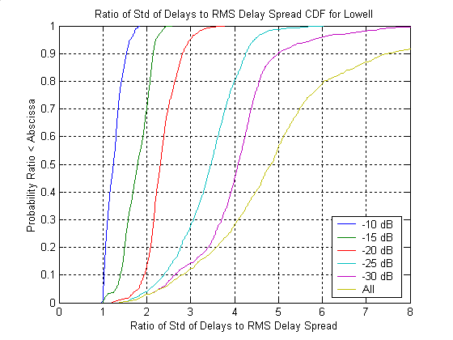
Figure 1 – CDF of SDD/RMSDS for different thresholds from Lowell.

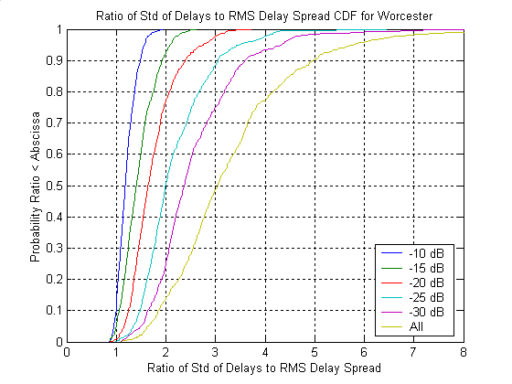
Figure 2 – CDF of SDD/RMSDS for different thresholds from Worcester.

References

[1] Motorola, “Path Characteristics for Spatial Channel Model”, SCM-041, August 1, 2002, Teleconference.
[2] Lucent, “Wideband System Level Model and Statistics”, SCM-042, August 1, 2002, Teleconference.

