**3GPP TSG RAN WG1 email discussion [5G-ACIA]**

**December 14-18, 2020**

**Source: Huawei, HiSilicon**

**Title: Simulation results for 5G-ACIA in the first round**

**Document for: Discussion and decision**

# Introduction

AT RAN#89, the following was agreed in [RP-202069](https://protect2.fireeye.com/v1/url?k=41a5db26-1f051960-41a59bbd-86fc6812c361-73f443258ff773bf&q=1&e=bc078f84-983d-45f3-ab31-19e60d911036&u=https%3A%2F%2Fwww.3gpp.org%2Fftp%2Ftsg_ran%2FTSG_RAN%2FTSGR_89e%2FDocs%2FRP-202069.zip) on providing evaluations for 5G-ACIA:

|  |
| --- |
| * Start an offline email-based activity to provide evaluation results for 5G-ACIA * One company volunteers as moderator * Proposes a work plan to follow * Ericsson is willing do this * Discussions are on the RAN1_NR reflector * Email activity only during short periods (< week) distributed across the time allocated to the activity * No email activity in weeks before/during/after RAN1 meetings or RAN defined inactive periods * All companies should strive to limit email activity as much as possible * Outcome of the offline discussion will directly go to RAN without need for discussion in RAN1 nor need for LS from RAN1 to RAN * Target completion by RAN#91 * At RAN#91, RAN will decide on a response LS to 5G-ACIA |

The moderator made the following proposal on a timeline:

|  |
| --- |
| 1. 12-16 October 2020  * Discussion on which URLLC features to include in the evaluations and simulation assumptions  1. 14-18 December 2020  * First round of simulation results  1. 22-26 February 2021  * Second round of simulation results  1. 8-12 March 2021  * Finalization of the report to RAN#91 |

In this paper we present our simulation assumptions and results for the round of simulation results.

# Simulation assumptions

After the initial email discussion, the final agreements on the simulation assumptions are given below:

|  |  |  |  |  |  |  |  |  |  |  |  |  |  |  |  |  |  |  |  |  |  |  |  |  |  |  |  |  |  |  |  |  |  |  |  |  |  |  |  |  |  |  |  |  |  |  |  |  |  |  |  |  |  |  |  |  |  |
| --- | --- | --- | --- | --- | --- | --- | --- | --- | --- | --- | --- | --- | --- | --- | --- | --- | --- | --- | --- | --- | --- | --- | --- | --- | --- | --- | --- | --- | --- | --- | --- | --- | --- | --- | --- | --- | --- | --- | --- | --- | --- | --- | --- | --- | --- | --- | --- | --- | --- | --- | --- | --- | --- | --- | --- | --- | --- |
| **Agreements:**   * The simulation assumptions given in Table 1 are agreed * Additional simulation parameters are taken from TR 38.824.   Table 1 - Agreements on the simulation assumptions   |  |  |  | | --- | --- | --- | | Parameters | 5G-ACIA LS | **Agreement** | | Factory hall size | 120x50 m | As in 5G-ACIA LS | | Room height | 10 m | As in 5G-ACIA LS | | Inter-BS/TRP distance | Depending on the number of TRPs, which are evenly deployed in the factory hall. Simulation company should provide the number of BSs/TRPs used in the simulation. | According to proposed layout below | | BS/TRP antenna height | 1.5 m for InF-SL and InF-DL 8m for InF-SH and InF-DH | As in 5G-ACIA LS | | Layout – BS/TRP deployment | Depending on the number of TRPs | 12 TRPs within area with the same 2D placement as in TR 38.901 and TR 38.824. | | Channel model | UC-2: InF-DH > InD-DL > InF-SH > InF-SL | Mandatory: InF-DH  Optional: InD-DL, InF-SH, InF-SL | | Carrier frequency and simulation bandwidth | TDD 4 GHz: 100 MHz 30 GHz: 160 MHz | As in 5G-ACIA LS | | TDD DL-UL configuration | Simulation company should report the used DL-UL configuration. | Companies should report the used DL-UL configuration. 1:1 DL-UL configuration is recommended. | | Number of UEs per service area | Up to 50 per service area, e.g., 10, 20, 40, and 50 | As in 5G-ACIA LS | | UE distribution | All UEs randomly distributed within the respective service area. | As in 5G-ACIA LS | | Message size | 48 bytes | 48 bytes | | DL traffic model | DL traffic arrival with option-1, option-2, and option-3. | 5G-ACIA Option 1 is mandatory. Companies are also encouraged to provide results for option 3 | | UL traffic model | UL traffic is symmetric with DL, and DL-UL traffic arrival time relationship with option-1 and option-2 | As in 5G-ACIA LS with Option 1 as mandatory | | CSA requirements | UC-#2: 99.9999% | UC-#2: 99.9999% | | Performance metrics | 1) CSA: single CDF of CSA distribution of all UEs in factory hall 2) Latency: single CDF of latency distribution of all UEs in factory hall 3) Percentage of UEs satisfying requirements  4) resource utilization | As in 5G-ACIA LS with 3) and 4) as low priority  Note: For metric 2) it is clarified that a packet transmission cannot be performed after the latency deadline. The collected statistics cannot exceed the latency requirement. The packets exceeding the deadline are visible in the UE packet error statistics | | E2E latency & air interface latency | E2E latency: 1 ms for UC#2 | E2E latency: 1 ms for UC#2  Air interface latency: 1ms | | UE speed | Linear movement | Linear movement: 75 km/h  No explicit UE mobility (nor handovers) are modeled in the evaluations. | | BS antenna mount |  | Option 1 (1 sector per BS) from 38.824 is used | |

# Calibration

The coupling loss and DL geometry are presented below for calibration purposes.

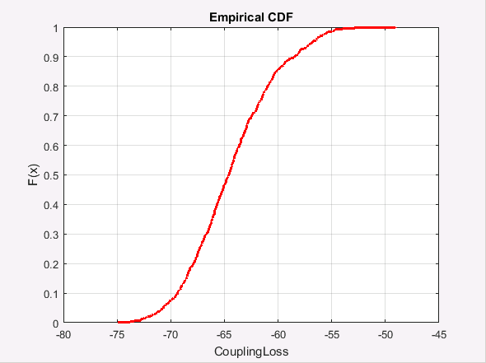 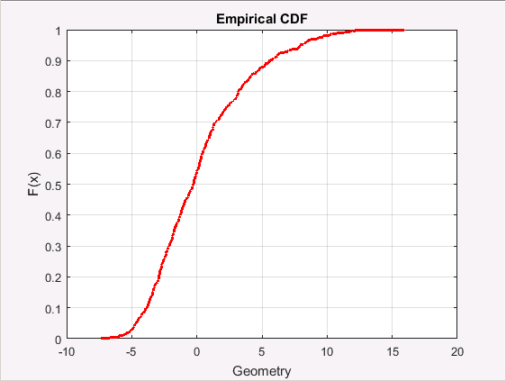

1. Coupling loss (b) DL geometry

Figure 1 - Distribution of the coupling loss and DL geometry

# Simulation results

For the agreed layout shown in Figure 2 for simulation, cell cooperation can and should be implemented in practice to further improve the performance. That is, the 12 BSs are treated as remote radio units (RRUs) that are connected to one baseband unit (BBU) through fibers to enable coordinated signal processing and transmission. This deployment, named as *distributed MIMO (D-MIMO)*, can provide significant SINR improvement and hence gives a great performance gain due to either coordinated or coherent transmissions from different BSs.

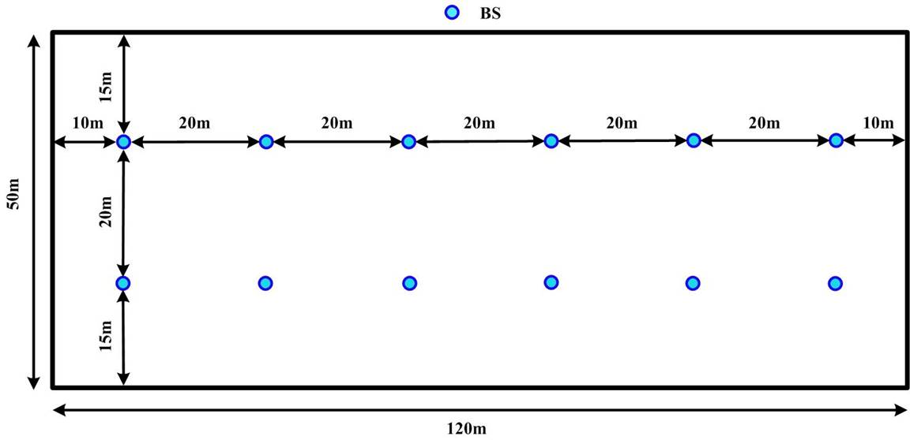

**Figure 2 -** Simulation scenario and BS layout

***Observation and additional simulation assumption 1: In the given environment, the BSs can be treated as RRUs and cell cooperation should be assumed for the simulations.***

## Simulation results for 4GHz

For the 4 GHz carrier frequency, the SCS is set to 30 kHz, and the self-contained frame structure of 6D:2S:6U is adopted.

Since the packet arrival is deterministic, pre-scheduling is employed to remove the time for the transmission and the processing of DCIs from the latency budget for a packet, both at the base station and at the UE side. Specifically, for downlink transmission, the scheduling is done in advance to guarantee the DL DCI as well as the PDSCH can be transmitted on the first TTI starting $T_{1}$ after the packet arrival, where $T_{1}$ denotes the necessary time for DL data processing, including the TB assembling in the higher layer, the coding, modulation and precoding processes at base band, and the preparation for transmitting at the RF side. Similarly, for the UL transmission, the process of SR is omitted and the BS sends an UL grant to the UE prior to the packet arrival. Then upon the packet arrival, the UE immediately processes the data and transmits the PUSCH in the first available UL TTI starting $T_{2}$ after the packet arrival, where $T_{2}$ denotes the necessary time for UL data processing, including the TB assembling in the higher layer, the coding, modulation and precoding processes at base band, and the preparation for transmitting at the RF side.

In the simulations, $T_{1}$ and $T_{2}$ are set to 3OS in case of 30 kHz SCS, this corresponds to nearly 55% of $N_{2}$ with for the aggressive processing time Capability #2. Meanwhile, the data decoding at the BS and the UE are also set to 3OS, which corresponds to nearly 65% of $N_{1}$ with Capability #2.

***Additional simulation assumption 2: Dynamic scheduling is used both for UL and DL. But due to the deterministic characteristic of the data arrival, pre-scheduling can be performed which reduces the latency in uplink and downlink processing.***

In the following simulations, three metrics are evaluated, i.e. reliability, CSA and latency. During the simulations, a total number of $N_{T}$ packets are generated for every UE.

**The reliability** of one UE is computed as the 1 – PER and $PER=N_{error}/N_{T}$ with $N_{error}$ denoting the number of packets that are blocked out of transmission or unsuccessfully decoded at the receiver within the latency deadline.

**The CSA** of one UE, is calculated according to the formula in the LS from 5G-ACIA, as shown below:

$$CSA=1-\sum_{n=2}^{∞}{P_{E}(n)\frac{nT_{I}-T_{s}}{nT_{I}}}$$

A survival time of one transfer interval, i.e. $T_{s}=T_{I}$ is assumed. Further $P_{E}(n)$ is computed as $P_{E}\left(n\right)=\frac{N_{E}(n)}{N_{T}/n}=\frac{n×N_{E}(n)}{N_{T}}$ with $N_{E}(n)$ denoting the number of occurrences that *n* consecutive packets are wrongly delivered. Note, that 1 occurrence of 3 consecutive wrongly delivered packets cannot be deemed as two occurrences of 2 consecutive wrongly delivered packets.

**The E2E latency** of a packet, if the packet is transmitted and successfully decoded at the receiver, includes the necessary *processing time* and *alignment delay at the transmitter*, the *transmission time*, and the necessary *processing time at the receiver*. Here, the alignment delay is the time gap between the time instance at which the transmitter finishes the signal processing and the beginning of the next available transmission TTI. If the packet transmission is blocked or unsuccessfully decoded at the receiver within the latency deadline, the E2E latency is set to 1ms.

***Assumptions on overhead:***

***The overhead for DCI in the downlink TTI and the overhead of SRS in the uplink TTI are set to 20%, and Type-2 DMRS is considered, leading to a DMRS overhead of about 6%.***

### Simulation results for single-layer SU transmission

The performance in terms of reliability and CSA for the single-layer SU scheme are shown in the following table. In the simulations, the simulation time is 1e5 s and hence $N_{T}=$ 1e8 packets are generated for every UE.

The performance is very good since the achieved SINR is large in case of single-layer SU transmission. In the simulation, the MCS table 3 is used and hence the highest possible MCS is (772/1024, 64QAM). Accordingly, one packet occupies at least 2 PRBs in the simulation, limiting the maximum number of supported UEs to be 273/2*2 = 272 with 273 being the maximum number of PRBs in 100MHz bandwidth in case of 30 kHz SCS.

Table 2 - Percentage of UEs satisfying 1ms E2E latency and 99.9999% reliability/CSA requirement

|  |  |  |  |  |
| --- | --- | --- | --- | --- |
| SU- MIMO: Max Number of users | Reliability | | CSA | |
| DL | UL | DL | UL |
| 272 | 100% | 100% | 100% | 100% |

The E2E latency distribution is shown in the following figure. Since the pre-scheduling method is used and the processing time at the BS and UE is the same, the DL and UL transmissions also have the same E2E latency distribution.

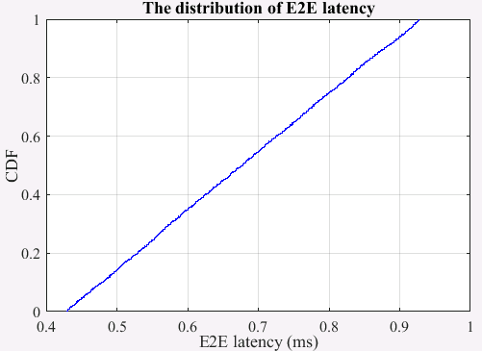

**Figure 3 -** Distribution of the E2E latency for DL and UL transmissions

### Simulation results for MU transmission

For MU transmission, the maximum number of transmission layers for one UE is set to 1 and the maximum number of layers of paired UEs on one resource is set to *L*.

The performance in terms of reliability and CSA for the MU scheme in the downlink transmission are shown in the following table. For *L* = 2, the resulting SINR is very high due to the presence of only one inter-layer interference and also because there are enough antennas at the UE side for interference cancellation. As a result, the target reliability can be guaranteed even when a packet transmission occupies 2 RBs, i.e., using the highest MCS . But for *L* = 4, it becomes difficult for the UE to always perfectly cancel the three layers of inter-UE interference. As a result, a larger number of RBs should be allocated to enable smaller coding rates and hence to provide a better error correction capability. Comparing the case of 544 UEs, the performance of *L* = 2 is better than performance of *L* = 4, implying that it is better to set a small rank, but still being larger than one, for spatial multiplexing in URLLC applications.

Due to 1ms survival time is considered, the performance of CSA is very good, and a minimum of 2 RBs is sufficient to guarantee the 99.9999% CSA requirements. This can also be derived from the detailed distribution of PER and 1-CSA in Figure 4. It is shown that all users can achieve a PER smaller than 1e-3 even although no users can achieve a PER of 1e-6 in case of 1088 UEs, while all UEs can achieve a CSA larger than 1-1e-7 in the same case.

Table 3 Percentage of UEs satisfying 1ms E2E latency and 99.9999% reliability/CSA requirement in the DL transmission

|  |  |  |  |
| --- | --- | --- | --- |
| MU-MIMO  Number of users | Reliability | | CSA |
| *L* = 4 | *L* = 2 | *L* = 4 |
| 525 | 100% | 100% | 100% |
| 544 | 87.5% | 100% | 100% |
|  |  |  |  |
| 900 | 0% | / | 100% |
| 1000 | 0% | / | 100% |
| 1088 | 0% | / | 100% |

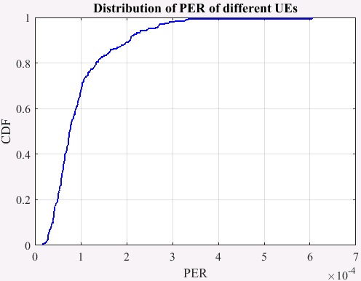 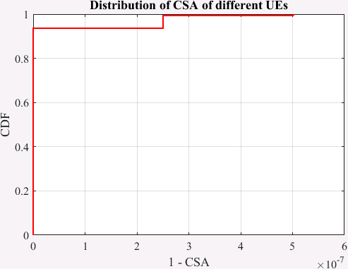

(a) PER (b) CSA

**Figure 4** Distribution of achieved BLER and 1-CSA in the DL transmission for *L*=4 and 1088 UEs

The distribution of the E2E latency for DL transmission in case of *L*=4 and 1088 UEs is shown in the following figure. It can be found that for successfully decoded packets, the E2E latency depends on the alignment delay at the transmitter, and there is a very small parts of packets which is unsuccessfully decoded and hence the E2E latency is 1 ms

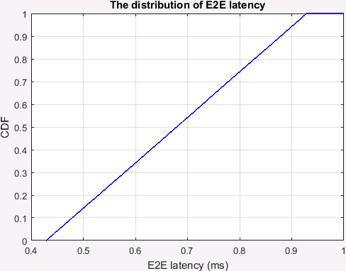 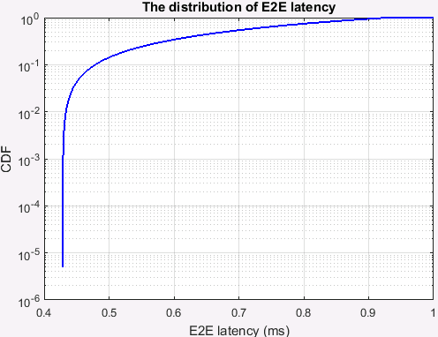

**Figure 5** Distribution of the E2E latency in the DL transmission for *L*=4 and 1088 UEs

# Conclusion

In this paper we presented the simulation results for the 4GHz carrier frequency. Due to cell cooperation, the SINR is very good and a large number of UEs can be supported.

For SU MIMO, up to 272 UE can be supported, while still fulfilling the E2E latency, reliability and CSA requirements.

For MU schemes, at least for DL, more UEs can be supported. Allowing spatial multiplexing of 2 UEs, the maximum of 544 UEs still meet the latency, reliability and CSA requirements. Allowing 4 UEs to be multiplexed, 1088 UE can be supported while still fulfilling CSA and latency requirements. However, the reliability requirement cannot be met for these cases.

In general in can be concluded that at least for DL, the MU transmission is better than the SU scheme due to enhanced spectrum efficiency even though some inter-layer interference would be incurred, especially when a survival time of one transfer interval is considered in CSA.