3GPP TSG CT WG3 Meeting #136 C3-244xxx

Maastricht, NL, 19 - 23 August, 2024

**Title: LS on service consumers of Nnwdaf/Ndccf/Nmfaf related services**

**Response to: -**

**Release: Rel-18**

**Work Item:** **eNA_Ph3**

**Source: CT3**

**To: SA2**

**Cc:**

**Contact person: Xiaojian Yan**

**yan.xiaojian@zte.com.cn**

**Send any reply LS to: 3GPP Liaisons Coordinator,** [**mailto:3GPPLiaison@etsi.org**](mailto:3GPPLiaison@etsi.org)

**Attachments: *-***

# 1 Overall description

As specified in the procedure of Analytics Exposure using DCCF/MFAF in clause 6.1.4 of TS 23.288, analytics consumer(s) (e.g. NFs/OAM) can subscribe/unsubscribe to NWDAF analytics and be notified of analytics information via the DCCF, using Ndccf_DataManagement_Subscribe service operation. And the MFAF sends the notifications received from the NWDAF to the analytics consumer(s) as configured by the DCCF, and the analytics consumer(s) retrieve from the MFAF analytics if indicated by Nmfaf_3caDataManagement_Notify Fetch Instructions.

According to that, any analytics consumer is the consumer of Ndccf_DataManagement and Nmfaf_3caDataManagement services.

However, LMF is an analytics consumer (i.e. consumer of Nnwdaf_AnalyticsSubscription and Nnwdaf_AnalyticsInfo services) but not the consumer of Ndccf_DataManagement and Nmfaf_3caDataManagement services, as shown in the following tales from TS 23.288:

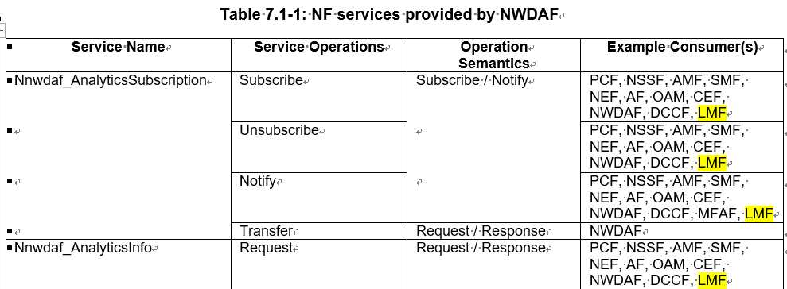

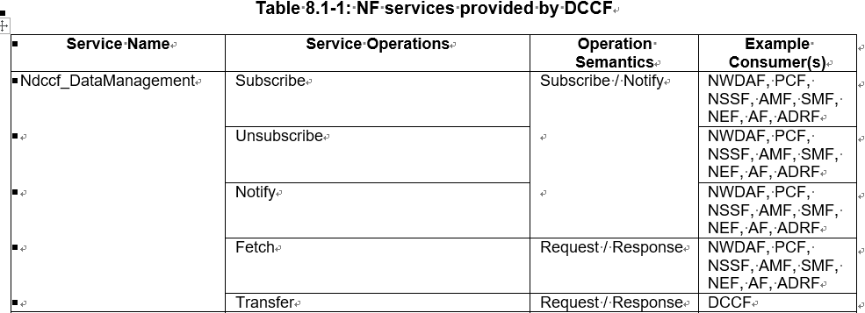

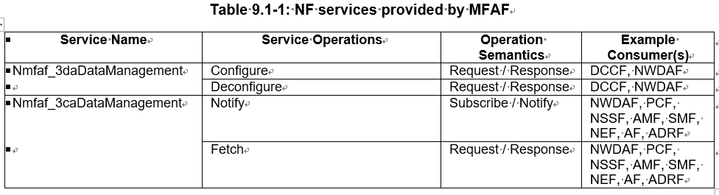

We also noticed that OAM and CEF are analytics consumers but not the consumers of Ndccf_DataManagement and Nmfaf_3caDataManagement services.

**Question 1**: Are the LMF, OAM and CEF the consumer of Ndccf_DataManagement and Nmfaf_3caDataManagement services?

TS 23.288, clause 5A.1

NOTE: Nnwdaf_DataManagement service can be used to collect historical data or runtime data. For collecting historical and runtime analytics, Nnwdaf_AnalyticsSubscription service is used.

TS 23.288, clause 5B.1

Data may be stored in the ADRF by:

- a consumer sending the ADRF an Nadrf_DataManagement_StorageSubscriptionRequest requesting that the ADRF subscribes to receive data or analytics for storage. The ADRF then subscribes to the NWDAF or DCCF for data or analytics.

However, in TS 23.288, 6.2B.3 Historical Data and Analytics Storage via Notifications, only Nnwdaf_DataManagement_Subscribe is supported in 6b for the ADRF subscribes to the NWDAF for data/analytics, Nnwdaf_AnalyticsSubscription_Subscribe is missing. In addition, ADRF is not the consumer of Nnwdaf_AnalyticsSubscription/Nnwdaf_AnalyticsInfo services as shown in above Table 7.1-1.

**Question 1**: Is the ADRF the consumer of Nnwdaf_AnalyticsSubscription and Nnwdaf_AnalyticsInfo services? Is Nnwdaf_AnalyticsSubscription/Nnwdaf_AnalyticsInfo service used by the ADRF for collecting analytics?

# 2 Actions

**To: SA2**

**ACTION:** CT3 kindly asks SA2 to answer the above question and amend 3GPP TS 23.288 accordingly.

# 3 Dates of next TSG CT WG 3 meetings

CT3#137 October 10– 14, 2024 Hefei, CN

CT3#138 November 18– 22, 2024 Orlando, US