**3GPP TSG-CT WG3 Meeting #120eC3-221abc**

**E-Meeting, 17th – 25th February 2022**

Title: LS on AF specific UE ID retrieval

Release: Release 17

**Work Item: EDGEAPP**

Source: CT3

To: SA2, SA3, SA6

Cc: CT4

**Contact person: Tianmei Liang**

**maria.liang@ericsson.com**

**Send any reply LS to:** 3GPP Liaisons Coordinator, <mailto:3GPPLiaison@etsi.org>

Attachments: None

**1. Overall Description:**

CT3 observes some misalignment on AF specific UE ID retrieval in TS 23.501, TS 23.502 and TS 23.558, would like to share CT3 observations and questions(**Q**) for aligned solution and requirement from stage 2.

**CT3 observation 1:**

*ACR(Anonymous Customer Reference) as user information is only present in clause* *8.6.5.3.2 UE Identifier API request in SA6 TS* *23.558:*

8.6.5.3.2 UE Identifier API request

**Table 8.6.5.3.2-1: UE Identifier API request**

|  |  |  |
| --- | --- | --- |
| **Information element** | **Status** | **Description** |
| User information | M | Information about the User or UE available with the EAS for e.g. ACR (Anonymous Customer Reference as specified in OMA-TS-REST_NetAPI_ACR [16]) or the IP address etc. |
| Security Credentials | M | Security credentials of the EAS. |

*While ACR is not present in SA2 TS**23.501 and* *TS 23.502. TS 23.502 in clause 5.2.6.27.2 Nnef_UEId_Get operation only defines IPv4/IPv6 address or MAC address as UE address:*

5.2.6.27.2 Nnef_UEId_Get operation

**Service operation name:** Nnef_UEId_Get

**Description:** Get the UE identifier.

**Inputs, Required:** UE address (i.e. IPv4/IPv6 address or MAC address), AF Identifier.

**Inputs, Optional:** IP domain, AF Identifier, Application port ID, MTC Provider Information.

**Outputs, Required:** Result, AF specific UE Identifier represented as an External Identifier.

**Outputs, Optional:** None.

**Q1 To SA6**: Whether ACR as User information is only handled in UE Identifier API between EAS and EES, and whether EES will translate the ACR into the UE address to invoke AF specific UE ID retrieval from NEF?

**CT3 observation 2:**

*In SA6 LS S6-211082 describes the GPSI is also temporary:*

*"***On SA2's question #2 and #3:**

If GPSI is designed to be in the form of an External Identifier per AF and is also temporary (based on e.g. temporal validity or invalidated on a request by the subscriber), it will help in preventing the tracking of user’s behaviour across AFs."

*While SA2 specifications have no description on how to implement the GPSI as "tempoary", only in TS 23.502 Table 5.2.3.3.1-1: UE Subscription data types adding “and associated application information (e.g. Application Port ID) with table Note 15:*

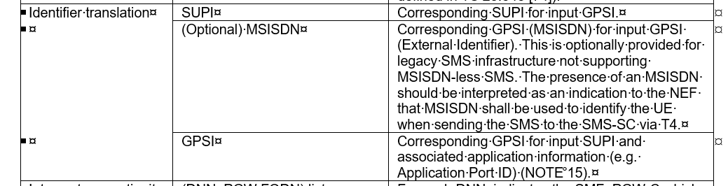



Besides, SA3 LS [S3-212355](https://urldefense.com/v3/__https:/www.3gpp.org/ftp/tsg_sa/WG3_Security/TSGS3_103e/Docs/S3-212355.zip__;!!BhdT!hiZxKQ34b_v4EUtFBrOpxJQ6QFGIZ3CnuU750Fh1OAEhp4CxKlu6fbljGmRW4Kf56486ELUxb0rHUaOSArVvgJsv7A$) to SA2 and SA6 including below description:

“SA3 has not yet concluded that the use of a temporary identifiers justifies the gain. SA2 is recommended to proceed with the use of **permanent identifiers** only at this stage for this feature. SA3 will inform SA2 if SA3 later concludes on the use of temporary identifiers and the desired properties of such temporary identifiers.”

**Q2 to SA3**: Whether SA3 has concludes and informed SA2 on the use of temporary identifiers or not?

**Q3 to SA2**: How is a temporary identifier in the form of an External Id provided to the UE Subscription data in UDM service and stored per application/AF, then how can it be retrieved per application/AF?

**Q4 to SA2**: How can the GPSI in the form of an external identifier be invalidated/deactivated on-demand by the user (or automatically by the 3GPP network e.g. when validity timer expires as per user’s authorization) as per SA6 requirements?

**Q5 to SA2 and SA6**: Is this AF-specific static GPSI in the form of an external identifier dynamically generated if one doesn’t already exist in the UDM/UDR?

**CT3 observation 2:**

*In clause* *4.15.10 AF specific UE ID retrieval in TS* *23.502 describes the step 3-4 NEF with BSF interaction as optional while the procedure figure arrow lines of step 3 and step4 are mandatory.*

3-4. The NEF may use the Nbsf_Management_Discovery service operation with UE address and IP domain and /or DNN and/or S-NSSAI. to retrieve the session binding information of the UE. If no SUPI is received in the session binding information from the BSF, the NEF replies to the AF with a Result value indicating that the UE ID is not available.

**Q6 to SA2**: Whether step 3-4 in clause 4.15.10 of TS 23.502 should be mandatory or not? If not, how does the NEF retrieve the GPSI in the form of an external identifier from the UDM without interacting with the BSF.

**CT3 observation 3:**

*Clause* *4.15.10 AF specific UE ID retrieval in TS* *23.502 it states:*

*"*5. The NEF interacts with UDM to retrieve the AF specific UE Identifier via the Nudm_SDM_Get service operation. The request message includes SUPI and at least one of Application Port ID, MTC Provider Information or AF Identifier.

6. The UDM responds to the NEF with an AF specific UE Identifier represented as an External Identifier for the UE which is uniquely associated with the Application Port ID, MTC provider Information and/or AF Identifier.*"*

**Q7 to SA2**: If there is no AF-specific UE ID available in the UDM in step 5, how to provide and return an AF-specific UE ID in step 6?

**2. Actions:**

**To SA2, SA6:**

**ACTION:** CT3 asks SA2 and SA6 to kindly consider and reply above questions and consider the needed updates in the related specifications.

**3. Date of Next CT3 Meetings:**

3GPP TSG CT3#121-e 04th – 08th April 2022 E-Meeting

3GPP TSG CT3#122-e 12th - 20th May 2022 E-Meeting