3GPP TSG-CT WG1 Meeting #138-e C1-22abcd

E-Meeting, 10th – 14th October 2022 (was C1-225949)
CR-Form-v12.2
CHANGE REQUEST
 | 24.587 | CR | 0266 | rev | 1 | Current version: | 17.7.0
For HELP on using this form: comprehensive instructions can be found at
http://www.3gpp.org/Change-Requests.

Proposed change affects: | UICC apps |  | ME | X | Radio Access Network |  | Core Network | X

Title: | Correction to V2X message family
Source to WG: | Huawei, HiSilicon
Source to TSG: | CT1
Work item code: | TEI17, eV2XARC_Ph2 |  |  |  |  |  | Date: |  |  | 2022-10-11
Category: | F |  |  |  |  |  | Release: |  |  | Rel-17
 | Use one of the following categories:  F (correction)  A (mirror corresponding to a change in an earlier release)  B (addition of feature),  C (functional modification of feature)  D (editorial modification)  Detailed explanations of the above categories can  be found in 3GPP TR 21.900. |  |  |  |  |  |  |  | Use one of the following releases:  Rel-8 (Release 8)  Rel-9 (Release 9)  Rel-10 (Release 10)  Rel-11 (Release 11)  …  Rel-16 (Release 16)  Rel-17 (Release 17)  Rel-18 (Release 18)  Rel-19 (Release 19)
Reason for change: |  | The specification uses the standard ISO 29281-1 2013 for the definition of V2X message family (see clause 9.2).  However, that standard version was withdrawn by ISO and it should not be used by implementation:  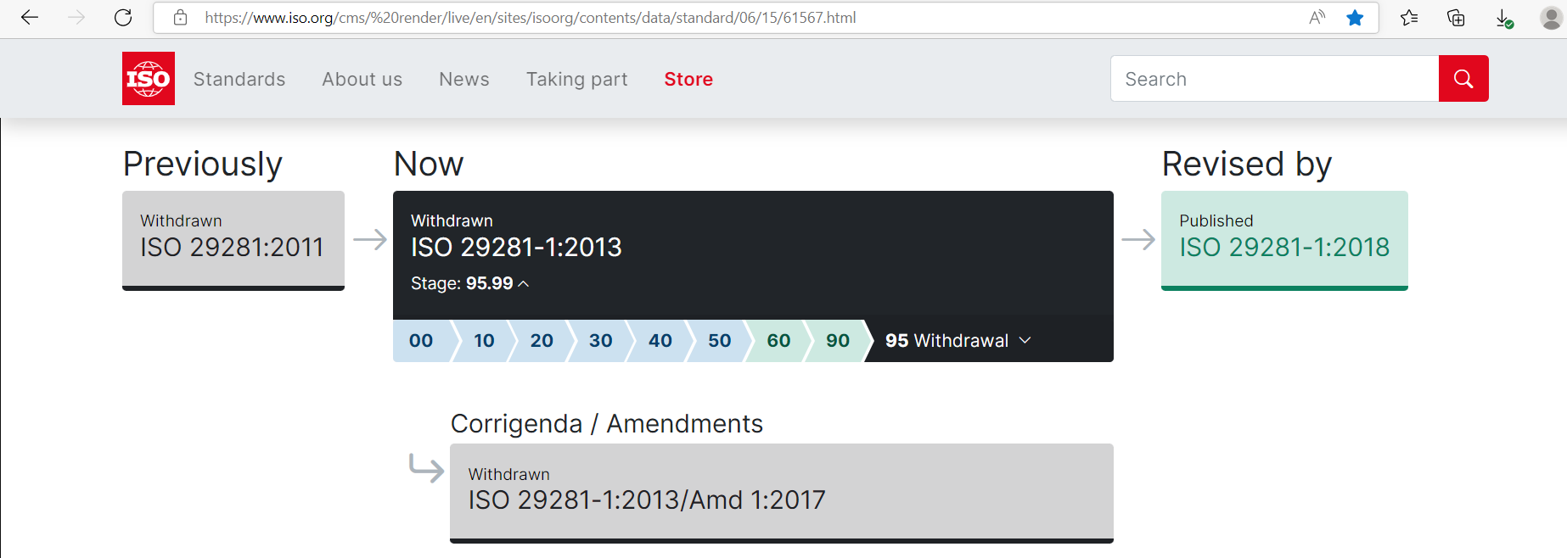  The version to use according to ISO is ISO 29281-1:2018. Rel-17 implementations will be developed in the years to come so they should not use a withdrawn version of the standard.
Summary of change: |  | Use of ISO 29281-1:2018 is indicated in the reference clause which is used for implementation of V2X message family.  Backwards compatibility analysis  The CR is backwards compatible as there is no change on the signalling.
Consequences if not approved: |  | Wrong use of version of the ISO standard for implementation. Current version was withdrawn by ISO in 2018 and it should not be used for new implementations.
Clauses affected: |  | 2
 |  | Y | N
Other specs |  |  | X | Other core specifications |  |  |  | TS/TR ... CR ...
affected: |  |  | x | Test specifications |  |  |  | TS/TR ... CR ...
(show related CRs) |  |  | x | O&M Specifications |  |  |  | TS/TR ... CR ...
Other comments:
This CR's revision history: |  | V1: backwards compatibility analysis added, and typos on the cover sheet fixed.

* * * First Change * * * *

2 References
The following documents contain provisions which, through reference in this text, constitute provisions of the present document.
- References are either specific (identified by date of publication, edition number, version number, etc.) or non-specific.
- For a specific reference, subsequent revisions do not apply.
- For a non-specific reference, the latest version applies. In the case of a reference to a 3GPP document (including a GSM document), a non-specific reference implicitly refers to the latest version of that document in the same Release as the present document.
[1] 3GPP TR 21.905: "Vocabulary for 3GPP Specifications".
[2] 3GPP TS 23.122: "Non-Access-Stratum (NAS) functions related to Mobile Station (MS) in idle mode".
[3] 3GPP TS 23.287: "Architecture enhancements for 5G System (5GS) to support Vehicle-to-Everything (V2X) services".
[4] 3GPP TS 23.502: "Procedures for the 5G System (5GS); Stage 2".
[5] 3GPP TS 24.386 "User Equipment (UE) to V2X control function; protocol aspects; Stage 3".
[6] 3GPP TS 24.501: "Access-Stratum (NAS) protocol for 5G System (5GS); Stage 3".
[7] 3GPP TS 24.588: "Vehicle-to-Everything (V2X) services in 5G System (5GS); User Equipment (UE) policies; Stage 3".
[8] 3GPP TS 38.300: "NR; NR and NG-RAN Overall Description; Stage 2".
[9] 3GPP TS 38.304: "User Equipment (UE) procedures in Idle mode and RRC Inactive state".
[10] 3GPP TS 38.323: "NR; Packet Data Convergence Protocol (PDCP) specification".
[11] 3GPP TS 38.331: "NR; Radio Resource Control (RRC) protocol specification".
[12] ETSI EN 302 636-3 v1.2.1: "Intelligent Transport Systems (ITS); Vehicular Communications; GeoNetworking; Part 3: Network Architecture".
[13] IEEE 1609.3 2016: "IEEE Standard for Wireless Access in Vehicular Environments (WAVE) -- Networking Services".
[14] IETF RFC 768: "User Datagram Protocol".
[15] IETF RFC 4291: "IP Version 6 Addressing Architecture".
[16] IETF RFC 4862: "Neighbor Discovery for IP version 6 (IPv6)".
[17] ISO 29281-1:2018: "Intelligent transport systems -- Communication access for land mobiles (CALM) -- Non-IP networking -- Part 1: Fast networking & transport layer protocol (FNTP)".
[18] ISO TS 17419 ITS-AID AssignedNumbers: http://standards.iso.org/iso/ts/17419/TS17419%20Assigned%20Numbers/TS17419_ITS-AID_AssignedNumbers.pdf
[19] IETF RFC 1035: "DOMAIN NAMES - IMPLEMENTATION AND SPECIFICATION".
[20] 3GPP TS 33.536: "Security aspects of 3GPP support for advanced Vehicle-to-Everything (V2X) services".
[21] 3GPP TS 33.501: "Security architecture and procedures for 5G system".
[22] 3GPP TS 24.526: "User Equipment (UE) policies for 5G System (5GS); Stage 3".
[23] ISO/IEC 10118-3:2018: "IT Security techniques – Hash-functions – Part 3: Dedicated hash-functions".
[24] CCSA YD/T 3707-2020: "Technical requirements of network layer of LTE-based vehicular communication".
[25] IETF RFC 793: "Transmission Control Protocol."
[26] 3GPP TS 24.007: "Mobile radio interface signalling layer 3; General aspects".
[27] 3GPP TS 24.554: "Proximity-services (ProSe) in 5G System (5GS) protocol aspects; Stage 3".
* * * End of Changes * * * *

