Invitation to the ETSI SMG3 WPC & 3GPP TSG-CN/WG2 Meeting
to be held at Carlton Highland Hotel, North Bridge, Edinburgh, Scotland on the 17-21 May 1999.

Dear Delegates,

On behalf of Nortel Networks I have pleasure in inviting you to the next SMG3 WPC & 3GPP TSG-CN/WG2 meeting, to be held at the above venue and hosted by our selves. The meeting will start on Monday 17th May and will finish on Friday 21st May in the afternoon.

A registration form is attached for your completion and this needs to be returned by April 16th to Sarah Norton on +44 (0) 1628 434034. Delegates are asked to make there own reservations directly with the hotel listed, a booking form is attached and must be sent by 16th April. Any document you wish to submit to the meeting should be sent via e-mail to Franco.Settimo@etsi.fr, no later than May 11th.

Finally, Nortel Networks is delighted to invite you to a social event that will take place on 19th May. Please complete and return the attached form to Sarah Norton if you wish to attend the social event, detailing any special dietary requirements for the evening.

We look forward to seeing you in May!

Yours sincerely

Nik Allen

Registration Form

ETSI SMG3 WPC & 3GPP TSG-CN/WG 2 meeting

17-21 May 1999

ON COMPLETION, PLEASE FAX THIS FORM TO
+44 (0)1628 434034 - ATTENTION OF SARAH NORTON
BY 16th April

ETSI SMG3 WPC & 3GPP TSG-CN/WG2 Meeting 17 - 21 May 1999

Venue:

Carlton Highland Hotel

North Bridge

Edinburgh

Scotland

I wish to attend the above meeting and my details are as follows:
(IN BLOCK CAPITALS PLEASE)

Christian Name: | ……………………….. | Surname: | …………………………………
Company Name  & Address: | ………………………………………………………………………………...
……………………………………………………………………………………………………………..

Your E Mail Address: | …………………………………………………………………………………
Tel No: | ……………………….. | Fax No: | …………………………………

Status Of ETSI Membership (please circle)

3GPP Individual Organisational Market Representative Other
Member Partner Rep Partner

Category Of Membership (please circle)

Administration Public Network Operator Manufacturer

User Private Service Provider/Research Body etc.

Other - Please specify …………………………

Social Event Form

ETSI SMG3 WPC & 3GPP TSG-CN/WG2 meeting

19th May 1999

ON COMPLETION, PLEASE FAX THIS FORM TO
+44 (0)1628 434034 - ATTENTION OF SARAH NORTON
BY 16th April

Christian Name: | ………………………… | Surname: | ……………………………..

Will you attend the social event on
May 19th, in Edinburgh? YES NO

Do you have any special dietary
requirements? YES NO

Are you vegetarian? YES NO

Other: ______________________________________________

______________________________________________

Hotel Reservation Form

Nortel Networks / SMG3WPC & 3GPP TSG-CN/WG2 meeting 17-21 May 1999

ON COMPLETION, PLEASE FAX THIS FORM TO THE HOTEL DIRECTLY – NO LATER THAN 16th April 1999

Carlton Highland Hotel,
North Bridge, Edinburgh, Scotland
Tel: +44(0) 131 472 3000
FAX: +44 (0) 131 556 2691

Christian Name: | ………………………… |  | Surname: | ……………………………..
Company Name & Address: |  | ……………………………………………………………………  ……………………………………………………………………
Tel No: | …………………………. |  | Fax No: | ……………………………..
I would like to request  ….. Single room(s)  Rate per single room per night  Mon-Fri £95.00 |  |  | Arrival Date:  ……………………. |  | Departure Date:  ……………………
Credit card Number:

Expiry Date:
Signature

To the Hotel: PLEASE CONFIRM BY RETURN OF FAX, Thank you.

ETSI SMG3 WPC and 3GPP TSG-CN/WG2

Meeting 17 - 21 May 1999

Directions to Carlton Highland Hotel, North Bridge, Edinburgh

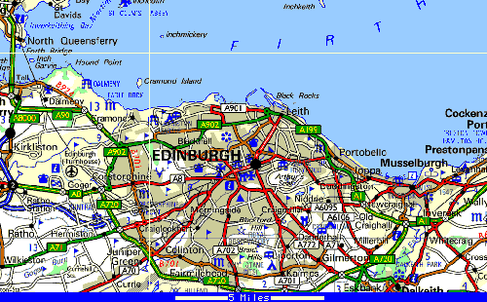

From Edinburgh Airport by Bus
A frequent bus service runs from the airport terminal forecourt to Haymarket Station and
the city centre terminus at Waverley Station. The fare is approximately £3.40 for a single journey. The Carlton Highland Hotel is located a short walk from Waverley Station (See hotel location map).

From Edinburgh Airport by Taxi
Taxis (cabs) are available from the airport terminal forecourt. Edinburgh City Centre is a 20-minute journey and costs approximately £14-15. Telephone. +44 131 344 3344 for details of other fares. Average journey costs are about £1.50 per mile. All cabs are licensed by the police and have taxi meters fitted. The drivers have photo ID's prominently displayed on their person.

ETSI SMG3 WPC and 3GPP TSG-CN/WG2

Meeting 17 - 21 May 1999

Hotel Information

Carlton Highland Hotel,

North Bridge, Edinburgh, EH1 1SD.
TEL: +44 (0) 131 472 3000
FAX: +44 (0) 131 556 2691
Hotel Guest FAX: +44(0) 131 472 3097

Rate per single room per night Mon-Fri £95.00

Rooms have been reserved until 16th April 1999 – Please book using the attached form before this date.

Location of Hotel

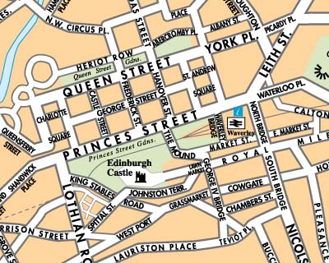
Carlton Highland Hotel
Waverley Train
Station

Alternative accommodation and general information about Edinburgh can be found on the Edinburgh Tourist Board web site http://www.edinburgh.org/.

