Source: MCC
Title: Financial Report for Year 2001 As At March 2002
Agenda item: 4.1

Document for:
Decision
Discussion
Information | X

This report provides detailed information on financial matters concerning the Mobile Competence Centre for year 2001. For completeness and understanding, it contains information relating to the support provided to 3GPP as well as the support provided by MCC to other non-3GPP related bodies.
The figures used throughout this report are based on those available on 14 January 2002, and which were further revised on 4 March. They are believed to be accurate and have now been subjected to an external audit.

Table of Contents
1 Year 2001 MCC Expenditure 3
1.1 MCC Staff Expenditure (Officers and Assistants) 3
1.2 MCC Contracted Support Experts Expenditure 4
1.2.1 MCC Contracted Support Experts Expenditure including non remunerated experts 4
1.2.2 MCC Contracted Support Experts Expenditure excluding non remunerated experts 5
1.2.3 MCC Contracted Experts Expenditure Detailed Breakdown by Activity 6
1.3 MCC Travel and Subsistence 10
2 Year 2001 Expenditure for 3GPP Task Forces 10
2.1 MCC Task Force 160 - 3GPP ATSs and PIXIT for UE R99 (Budget is 494 kEUR) 10
2.2 MCC Task Force 171 - ICS for GSM GPRS (GERAN) (Budget is 40 kEUR) 11
2.3 MCC Task Force 139 (MSG) (Budget is 23,7 kEUR) 11
3 MCC Subcontracts 12
3.1 S12 - Adaptive Multi Rate Wide Band (AMR WB) Selection Phase 12
3.2 S14 & S15 - Adaptive Multi-Rate Wide Band (AMR-WB) Characterisation Phase 1 12
3.3 A5/3 Algorithm Development (Task S18) 13
4 Contingency 13
5 Year 2001 Partner Contributions 14
5.1 Breakdown of Partner Contributions 14
5.1.1 ARIB 14
5.1.2 CWTS 14
5.1.3 ETSI 14
5.1.4 T1 14
5.1.5 TTA 15
5.1.6 TTC 15
5.1.7 GSM Association 15
5.1.7 Total income expected from Partners 15
5.2 Invoices and credit notes issued in 2001 16
5.3 Payments received in year 2001 from 3GPP Organizational Partners 17

1 Year 2001 MCC Expenditure

MCC Staff Expenditure (Officers and Assistants)
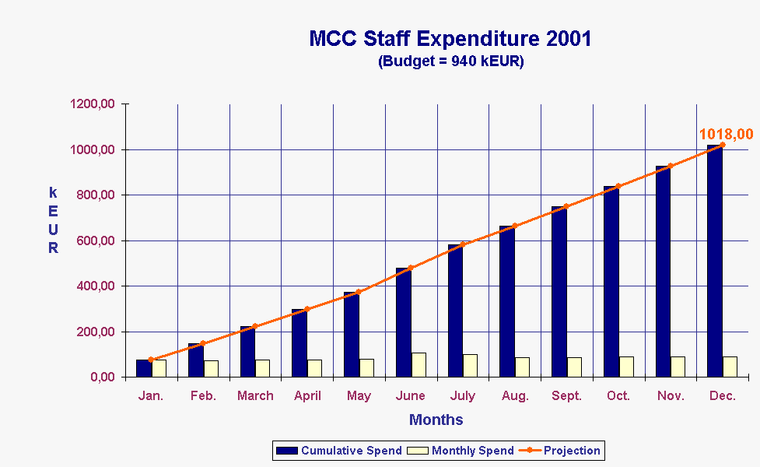

The chart given above shows the year 2001 expenditure on MCC staff (ie permanently employed ETSI Secretariat Staff). The staff complement has not changed throughout this year and remains as 4 Support Officers, 5 Assistants, and one Department Head as follows:
David BOSWARTHICK
John MEREDITH
Maurice POPE
Adrian ZOICAS
Marlène FORINA
Karen HUGHES
Susanna KOOISTRA
Florence RAVOIRE
Emmanuelle WURFFEL
Adrian SCRASE
There has been a slight increase in staff cost due to contractual seniority rises which have led to a small year end overspend. These figures also include the cost of annual leave entitlement that has not been taken during 2002 due to workload conditions. The year expenditure closed at 1018 kEUR against a budget of 940 kEUR.
It should be noted that the total expenditure includes 22kEUR of resource used to support non-3GPP tasks and that the total year end Staff expenditure for 3GPP related tasks, is therefore 996 kEUR.

1.2 MCC Contracted Support Experts Expenditure

MCC Contracted Support Experts Expenditure including non remunerated experts
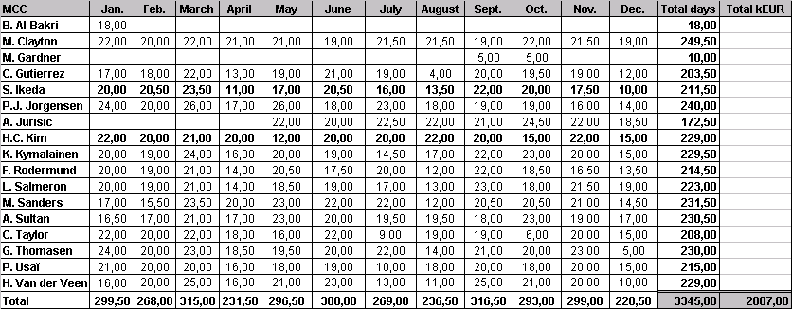
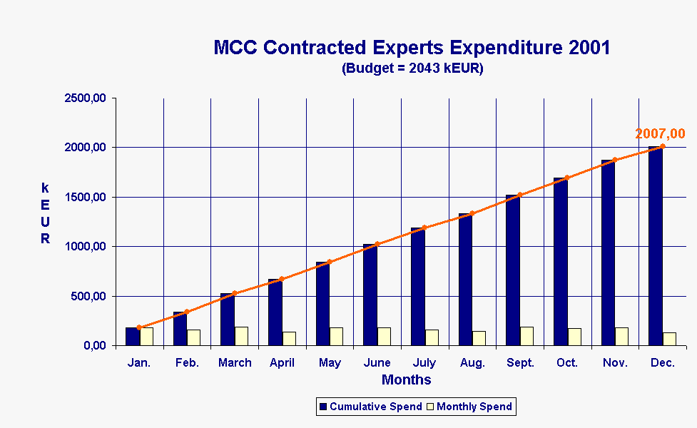
This chart includes the equivalent monetary value of the experts provided by ARIB and TTA

This chart shows the year 2001 expenditure for all Contractors employed within MCC, including the non remunerated experts provided by ARIB and TTA. The value of the non-remunerated experts is included pro rata in this table. The year end expenditure closed at 2007 kEUR against a budget of 2043 kEUR.

MCC Contracted Support Experts Expenditure excluding non remunerated experts
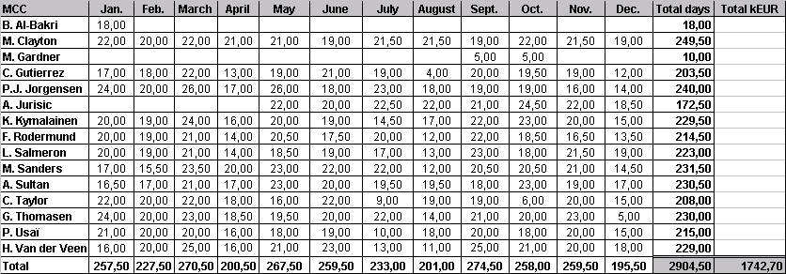
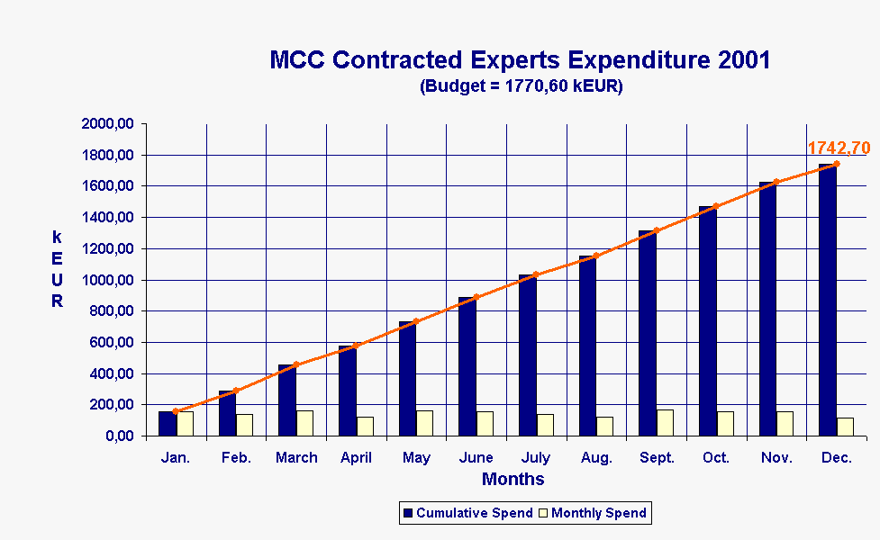
This chart excludes the equivalent monetary value of the experts provided by ARIB and TTA

At the beginning of 2001, the value of the two non-remunerated experts provided by ARIB and TTA were set at a fixed value rather than being calculated pro-rata. This chart shows the year end situation excluding these two experts. The year end expenditure closed at 1742,70 kEUR against a budget of 1770,60 kEUR.

1.2.3 MCC Contracted Experts Expenditure Detailed Breakdown by Activity

3GPP (RAN, CN, T, SA)
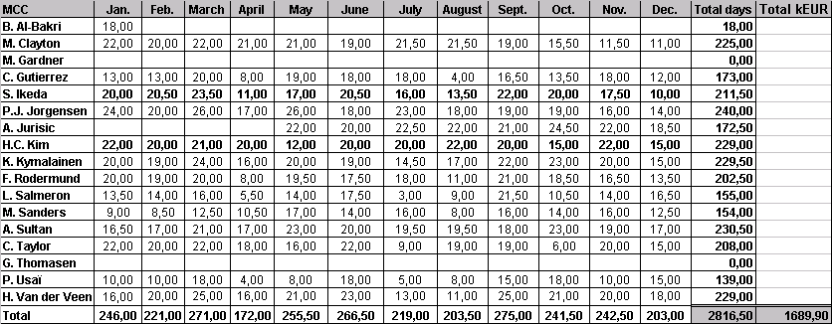
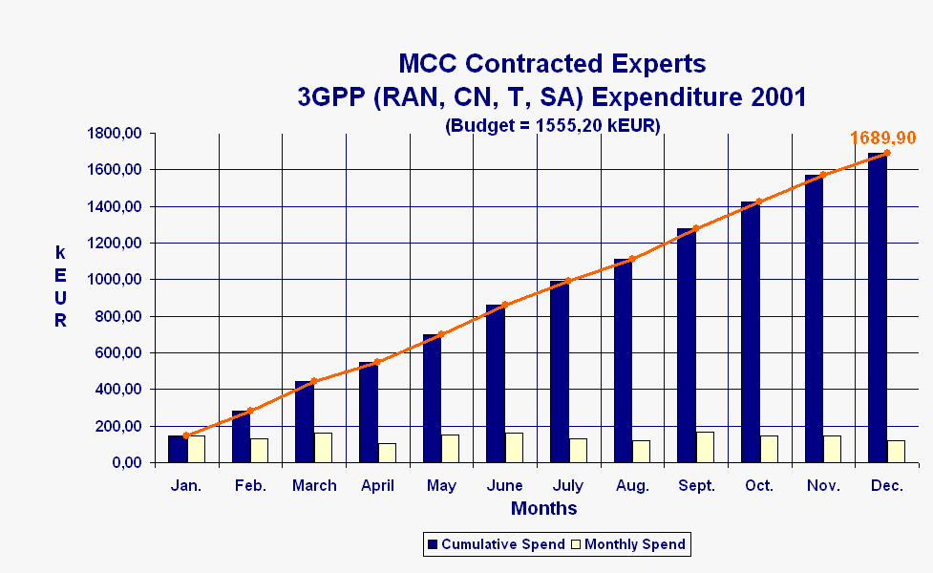

This chart shows the use of Contractor resources for the support of 3GPP TSGs SA, CN, RAN and T, but excluding those Contractor resources used for the support of TSG GERAN. It can be seen that more resource has been used for the support of these bodies than was first planned and this has led to a year end expenditure of 1689,90 kEUR against a budget of 1555,20 kEUR.

3GPP (GERAN)
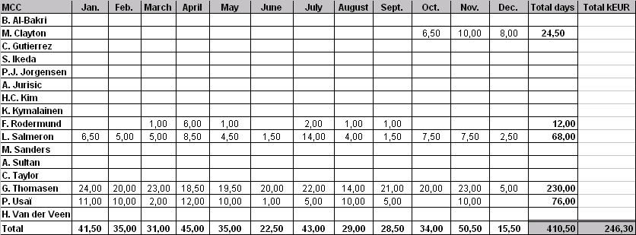
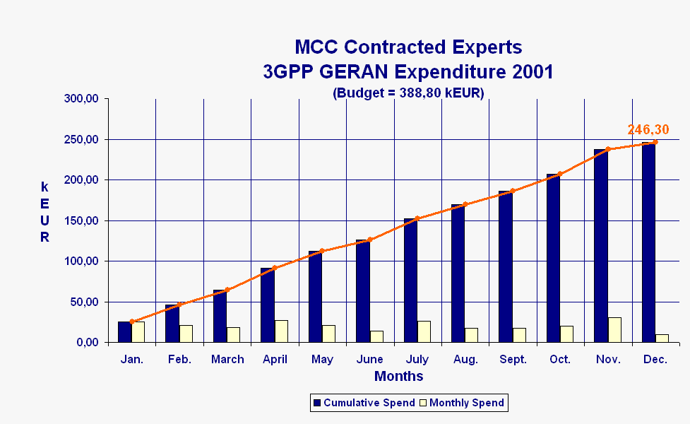

This chart shows the Contractor resources used for the support of GERAN. It can be seen that less resources have been used for the support of GERAN than was first predicted and this has led to a year end expenditure of 246,30 kEUR against a budget of 388,80 kEUR.

ETSI EP SCP
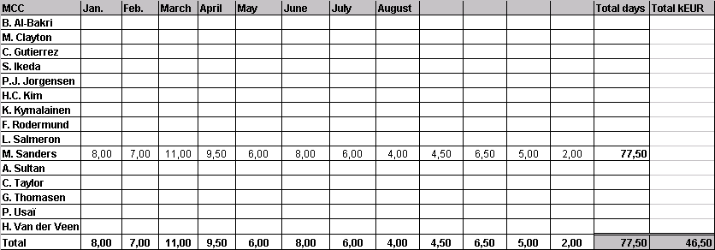
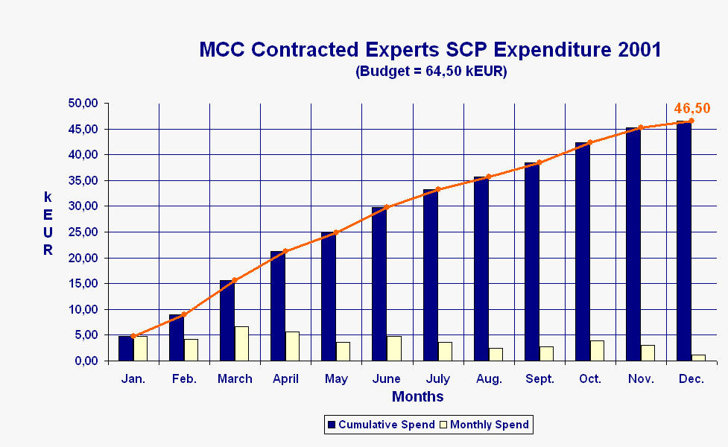

This chart shows the resources used for the support of ETSI SCP (Smart Card Platform). It can be seen that the year end expenditure for this activity was 46,50 kEUR against a budget of 64,50 kEUR.
It should be noted that this activity is currently 100% funded by ETSI.

ETSI TC MSG
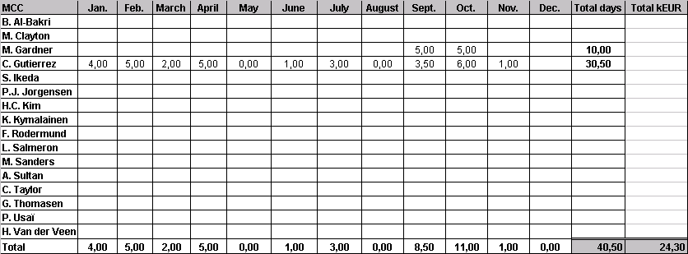
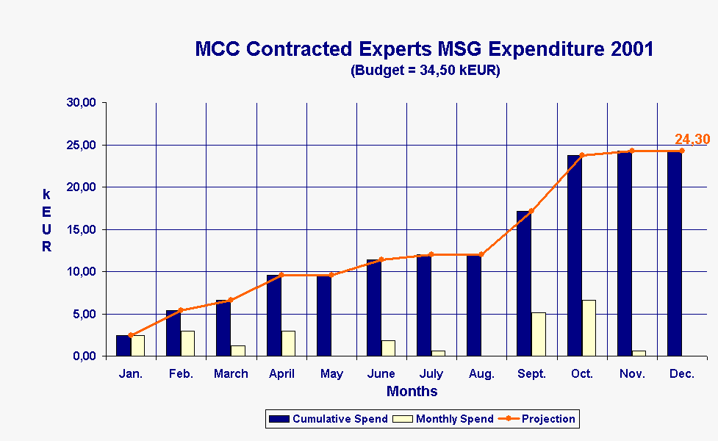

This chart shows the resources used for the support of the ETSI MSG activity. It can be seen that the year expenditure was 24,30 kEUR against a budget of 34,50 kEUR.
It should be noted that this activity is currently 100% funded by ETSI.

1.3 MCC Travel and Subsistence
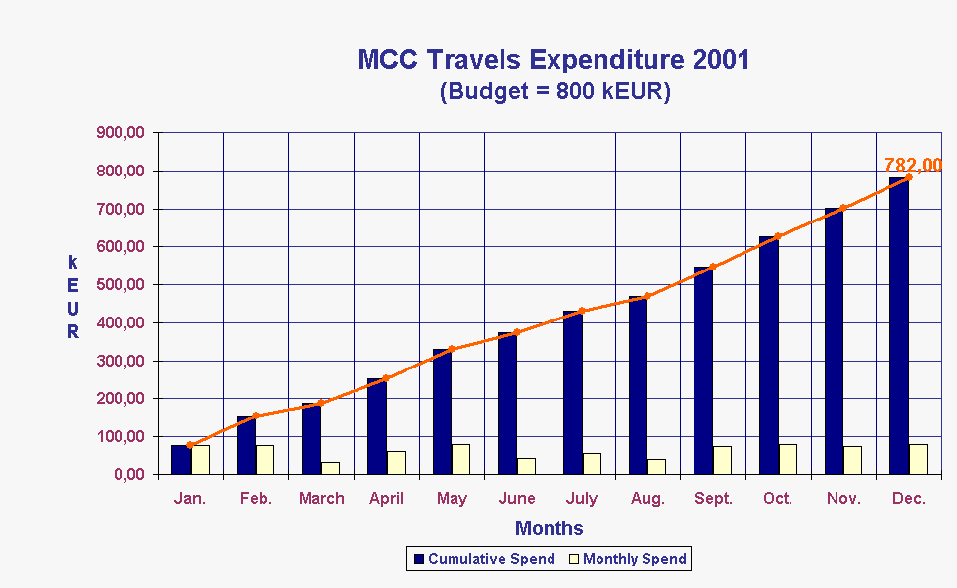

This chart shows the travel and subsistence expenditure for MCC. It can be seen that the year end expenditure closed as 782 kEUR against a budget of 800 kEUR. MCC has undertaken a total of 233 travels (103 European, and 130 Intercontinental). A detailed breakdown of the travels incurred is available if required, but is considered to be too detailed for this report.
It should be noted that the 2001 budget contained a provision of 19 kEUR for travel associated with non-3GPP tasks and that this leads to a year end travel expenditure for 3GPP related activities of 763 kEUR.

2 Year 2001 Expenditure for 3GPP Task Forces

MCC Task Force 160 - 3GPP ATSs and PIXIT for UE R99 (Budget is 494 kEUR)

Total of resources used:
MCC | Jan. | Feb. | March | April | May | June | July | August | Sept. | Oct. | Nov. | Dec. | Total days | Total kEUR
C. Barbu | 17,00 | 18,50 | 19,50 | 13,50 | 18,50 | 16,50 | 17,50 |  |  |  |  |  | 121,00
V. Bardaux | 11,00 | 15,00 | 17,00 | 6,00 | 15,00 | 8,00 | 21,00 | 14,00 | 10,00 | 15,00 | 22,00 | 15,00 | 169,00
O. Bergenbruen |  | 13,00 | 12,00 | 15,00 | 10,00 | 15,00 |  |  |  | 10,00 | 2,00 |  | 77,00
R. Fu | 27,00 | 24,50 | 13,00 |  |  |  |  |  |  |  |  |  | 64,50
P. Gandhi | 4,00 | 2,00 | 9,00 |  |  |  |  |  |  |  |  |  | 15,00
J. Gold | 3,00 | 5,00 | 2,00 |  |  | 19,00 | 14,00 | 10,00 | 14,00 | 23,00 | 11,00 |  | 101,00
M. Abdul |  |  |  |  | 9,00 | 22,00 | 23,00 | 24,00 | 24,00 | 25,00 | 3,00 |  | 130,00
J. Stolle |  |  |  |  | 18,00 | 16,00 | 20,00 | 13,00 | 7,00 | 6,00 |  |  | 80,00
J. Stromme |  |  |  |  |  |  | 4,00 | 19,00 | 18,00 | 16,00 | 19,00 | 14,00 | 90,00
N. Wang | 12,00 |  |  |  |  |  |  | 26,50 | 25,00 | 26,00 | 27,00 | 25,50 | 142,00
E. Weber | 8,00 |  |  |  |  | 7,00 | 22,00 | 18,00 |  |  |  |  | 55,00
Total | 82,00 | 78,00 | 72,50 | 34,50 | 70,50 | 103,50 | 121,50 | 124,50 | 98,00 | 121,00 | 84,00 | 54,50 | 1044,50 | 626,70

Resources payed from MCC budget
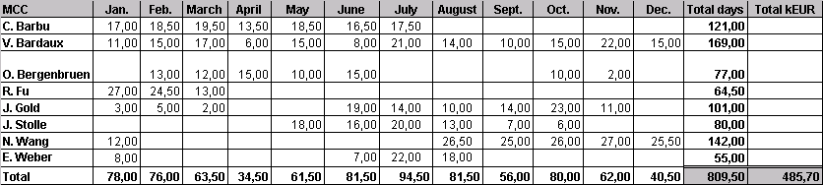
Voluntary Resources provided by 3GPP Individual members
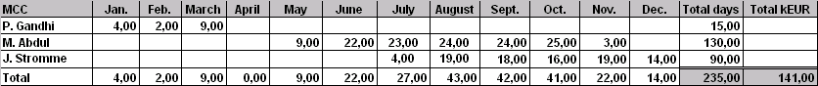

Task 160 is the continuing task, under the leadership of TSG T, for the development of TTCN test suites for 3GPP User Equipment. The budget for this activity totaled 494 kEUR in 2001, which included 156 kEUR assigned during the year from the contingency. In addition, a call was made for voluntary contributions which resulted in additional resources being made available having a value of 141 kEUR. At the year end, expenditure totaled 485,70 kEUR against a budget of 494 kEUR. (The value of the voluntary contributions received amounted to 141 kEUR).

MCC Task Force 171 - ICS for GSM GPRS (GERAN) (Budget is 40 kEUR)
This activity (fully funded by ETSI) was closed on 23 May 2001 with the work being completed within the prescribed budget.

MCC Task Force 139 (MSG) (Budget is 23,7 kEUR)

This activity (fully funded by ETSI) has now closed.

MCC Subcontracts

3.1 S12 - Adaptive Multi Rate Wide Band (AMR WB) Selection Phase
This task was performed exclusively under subcontract with resources provided voluntarily by 3GPP Individual members (results presented here for information only).
Voluntary contributions have been received as follows:
Organization | Contribution
Motorola UK | 150,00
Ericsson | 150,00
Texas Instruments | 150,00
Nokia Research | 150,00
Nortel Networks | 37,50
T-Nova | 37,50
FT | 37,50
Siemens | 37,50
Total (kEUR) | 750,00

Subcontracts have been issued to the following entities:
Subcontract | Organization | Expenditure
01 | ARCON | 47,50
02 | ARCON | 30,00
03 | ARCON | 25,00
04 | AT&T | 80,00
05 | FT | 40,00
06 | COMSAT Labs | 47,50
07 | COMSAT Labs | 90,00
08 | DYNAST Inc | 80,00
09 | NTT | 60,00
Total (kEUR) |  | 500,00

This implies that, to date, a total amount of 500 kEUR has been subcontracted for this task.

S14 & S15 - Adaptive Multi-Rate Wide Band (AMR-WB) Characterisation Phase 1
Sub-contracts are referenced S14 for HOST Laboratories and S15 for LISTENING Laboratories.
250 kEUR were left from the previous selection phase of AMR-WB. They have been allocated as follows:
HOST Laboratories (22,50 kEUR/experiment)
Company’s name | Contract No. | Contact Person | Amount contracted | Paid by ETSI
ARCON – USA | S14/01 | Mr. J.E. Brunelle | 22,50 | 15,00
COMSAT LMGT – USA | S14/02 | Mr. D.W. Utley | 22,50 | 22,50
Total in kEUR |  |  | 45,00 | 37,50

LISTENING Laboratories
Company’s name | Contract No. | Contact Person | Amount contracted | Paid by ETSI
ARCON – USA | S15/01 | Mr. J.E. Brunelle | 12,00
BT Plc – UK | S15/02 | Mr. P.J. Arden | 22,00 | 11,00
T-Nova DT Berkom –DE | S15/03 | Ms. I. Islami | 22,00 | 11,00
Dynastat, Inc. – USA | S15/04 | Mr. I. Panzer | 23,00 | 11,00
France Télécom – FR | S15/05 | Mr. J.L. Courbon  & Mr. D. Pascal | 22,00 | 22,00
COMSAT LMGT – USA | S15/06 | Mr. D. Utley | 23,00 | 23,00
NTT-AT Corp. – JP | S15/07 | Mr. I. Irii | 12,00
Nokia Research – FIN | S15/08 | Mr. D. Tallroth | 23,00 | 23,00
Nortel Networks Ltd - CA | S15/09 | Mr. A. Patrick | 12,00 | 12,00
Total in kEUR |  |  | 171,00 | 113,00

Note: 2 kinds of tests were formulated: 1 ACR (Absolute Category Rating) and 1 DCR (Degradation Category Rating).
1 ACR was given a price of 11 kEUR.
1 DCR was given a price of 12 kEUR.
From the allocated funding (250 kEUR), a total amount of 216 kEUR has been contracted.
Payments have been made in instalments during 2001: part after approval of TSG-SA#12 on 18-21 June 2001, part after approval of TSG-SA#13 on 24-27 September 2001 and part after TSG-SA#14 approval on 17-20 December 2001.

A5/3 Algorithm Development (Task S18)
Task S18 is the development of a new GSM algorithm to replace A5/2. It will be largely based on the Kasumi core used for the 3G algorithm. The development cost will be shared equally by ETSI, Committee T1 and the GSM Association. 84,66 kEUR has been allocated from the year 2001 contingency for this activity. The work has not yet started but it is expected that the work will be completed during 2002 and within the prescribed budget.

Contingency
Contingency | Contingency Allocated
552,70 kEUR | 156 kEUR (STF 160-TTCN Testing)
 | 84,66 kEUR (S18-GSM A5/3 Algorithm)
Balance
312,04 kEUR

The Contingency for this year was set at 552,70 k EUR. Two allocations have been made throughout the year from the contingency, one allocation of 156 kEUR for Task 160, and one allocation of 84,66 kEUR for Task S18 (to be complemented by 42,33 kEUR provided by the GSM Association). This leaves 312,04 kEUR remaining in the contingency at the year end.

Year 2001 Partner Contributions

5.1 Breakdown of Partner Contributions
The following tables provide a breakdown of the contributions provided by the Organizational Partners for 3GPP funding in year 2001.

5.1.1 ARIB
Budget category | Amount (kEUR)
Equal division of Support budget (RAN, T, SA, CN) | 468,38
Proportional division of Support budget (RAN, T, SA, CN) | 202,89
Equal division of Specific tasks budget (shared between ARIB and TTC) | 42,25
Total | 713,52
Deduction for provision of human resources | 136,20
Amount due | 577,32

5.1.2 CWTS
Budget category | Amount (kEUR)
Contribution to Support budget (RAN, T, SA, CN) | 180,00
Amount due | 180,00

5.1.3 ETSI
Budget category | Amount (kEUR)
Equal division of Support budget (RAN, T, SA, CN) | 468,38
Proportional division of Support budget (RAN, T, SA, CN) | 1 796,99
Equal division of Support budget (GERAN) | 303,99
Proportional division of Support budget (GERAN) | 490,64
Equal division of Specific tasks budget | 84,50
Amount due | 3144,50

5.1.4 T1
Budget category | Amount (kEUR)
Equal division of Support budget (RAN, T, SA, CN) | 468,38
Proportional division of Support budget (RAN, T, SA, CN) | 144,92
Equal division of Support budget (GERAN) | 303,99
Proportional division of Support budget (GERAN) | 117,33
Equal division of Specific tasks budget | 84,50
Amount due | 1 119,12

5.1.5 TTA
Budget category | Amount (kEUR)
Equal division of Support budget (RAN, T, SA, CN) | 468,38
Proportional division of Support budget (RAN, T, SA, CN) | 98,54
Equal division of Specific tasks budget | 84,50
Total | 651,42
Deduction for provision of human resources | 136,2
Amount due | 515,22

5.1.6 TTC
Budget category | Amount (kEUR)
Equal division of Support budget (RAN, T, SA, CN) | 468,38
Proportional division of Support budget (RAN, T, SA, CN) | 98,54
Equal division of Specific tasks budget (shared between ARIB and TTC) | 42,25
Amount due | 609,17

5.1.7 GSM Association
Budget category | Amount (kEUR)
Contribution to A5/3 Algorithm development | 42,33
Amount due | 42,33

5.1.8 Total income expected from Partners
TOTAL CONTRIBUTION EXPECTED FROM PARTNERS (INC HUMAN RESOURCES) = 6 460,06 kEUR
TOTAL PAYMENT EXPECTED FROM PARTNERS (EXCL HUMAN RESOURCES) = 6187,66 kEUR

5.2 Invoices and credit notes issued in 2001
The following credit notes and invoices were addressed to 3GPP Partners during early 2001.

ARIB (Japan)
CREDIT NOTE dated 09/04/2001: 70 270 EUR
INVOICE dated 09/04/2001: 577 320 EUR

CWTS (China)
INVOICE dated 09/04/2001: 180 000 EUR

ETSI (France)
CREDIT NOTE dated 09/04/2001: 186 570 EUR
INVOICE dated 09/04/2001: 3 144 500 EUR

T1 (USA)
CREDIT NOTE dated 09/04/2001: 28 350 EUR
INVOICE dated 09/04/2001: 1 119 120 EUR

TTA (Korea)
CREDIT NOTE dated 09/04/2001: 31 220 EUR
INVOICE dated 09/04/2001: 515 220 EUR

TTC (Japan)
CREDIT NOTE dated 09/04/2001: 50 130 EUR
INVOICE dated 09/04/2001: 609 170 EUR

GSM Association
INVOICE not yet issued 42 333 EUR

5.3 Payments received in year 2001 from 3GPP Organizational Partners
The following payments have been received from 3GPP Partners during year 2001.

ARIB (Japan)
Amount due 507 050 EUR
- paid on 27/06/2001: 507 050 EUR

CWTS (China)
Amount due 180 000 EUR
- paid on 27/08/2001: 180 000 EUR

ETSI
Amount due 2 957 930 EUR
- paid on 09/04/2001: 2 957 930 EUR

T1 (USA)
Amount due 1 090 770 EUR
- paid on 12/07/2001: 700 000 EUR
- paid on 14/09/2001 390 770 EUR

TTA (Korea)
Amount due 484 000 EUR
- paid on 05/07/2001: 241 979 EUR
- paid on 27/08/2001: 242 021 EUR

TTC (Japan)
Amount due 559 040 EUR
- paid on 04/07/2001: 559 040 EUR

Total received from Partners: 5 778 790 EUR
at 10 September 2001

Amount outstanding from Partners: 42 333 EUR (GSMA)
at 23 January 2002

