**3GPP TSG-SA5 Meeting #158 *S5-247074***

Orlando, USA, 18 – 22 November 2024

**Source: Ericsson, Vodafone, Deutsche Telekom, Telecom Italia, Nokia, Rakuten, AT&T**

**Title: Signalling traffic monitoring management operations of the drafted TS28.abc**

**Document for: Approval**

**Agenda Item: 6.19.22**

# 1 Decision/action requested

***For approval.***

# 2 References

[1] S5-245981 new WID signalling monitoring

[2] S5-245336, initial skeleton of draft TS28.abc signalling monitoring

# 3 Rationale

Defines Signalling traffic monitoring management operations

# 4 Detailed proposal

*** START OF NEXT CHANGE ***

# 2 References

The following documents contain provisions which, through reference in this text, constitute provisions of the present document.

- References are either specific (identified by date of publication, edition number, version number, etc.) or non‑specific.

- For a specific reference, subsequent revisions do not apply.

- For a non-specific reference, the latest version applies. In the case of a reference to a 3GPP document (including a GSM document), a non-specific reference implicitly refers to the latest version of that document *in the same Release as the present document*.

[1] 3GPP TR 21.905: "Vocabulary for 3GPP Specifications".

[x2] 3GPP TS 28.532: "Generic management services".

[x3] 3GPP TS 28.533: "Management and orchestration; Architecture framework"

[x14] 3GPP TS 33.501: " Security architecture and procedures for 5G System "

*** START OF NEXT CHANGE ***

# 5 Signalling traffic monitoring management (stage 2)

## 5.1 Overview

The STM Management Producer is configured by an authorized STM Management Consumer via a secured link. The network signalling messages at 5GC control plane are the target to be collected. Any collected signalling traffic messages are forwarded by the STM Data Producer to the STM Data Consumer using a secured tunnel.

NOTE: The STM Data Producer, and the STM Data Consumer are left for implementation. They are the endpoints of the interfaces used for streaming of the signalling message copies.

The STM Management Producer may be configured by an authorized STM Management Consumer located in OAM system. And the STM configuration may be enabled/disabled by an authorized STM Management Consumer located in OAM system or located in external monitoring system. When STM Management Consumers are located in different systems, the different STM Management Consumers have different authorization, resulting in a different visibility of the same STM Management Producer. Where the STM Management Consumer is located is out of scope of this specification.

Examples of signalling traffic monitoring deployment scenarios are shown in Figure 5.1-1 and Figure 5.1-2. It’s up to implementation, whether the STM Data Producer is located inside the 5G NF as showed in the figure 5.1-1 or outside the 5GC NF as shown in figure 5.1-2.

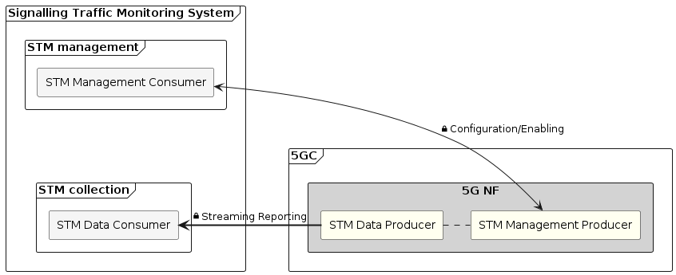

Figure 5.1-1 Signalling traffic monitoring deployment scenario - 1

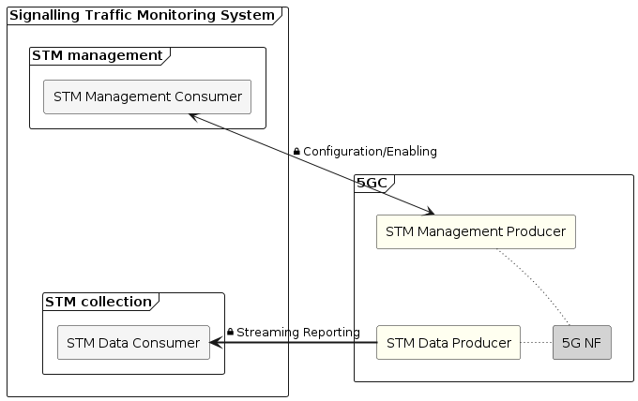

Figure 5.1-2 Signalling traffic monitoring deployment scenario - 2

## 5.2 STM Provisioning

This clause provides the stage 2 definitions of STM provisioning operations, including creation and deletion, as well as enablement and disablement, for managing STM reporting control objects. According to clause 4.2.2 of 3GPP TS 28.533 [x3], these operations are the MnS component type A. The operations specified in this clause in combination with a NRM (MnS component type B) constitute a MnS, as defined in clause 4.3 of 3GPP TS 28.533 [x3] providing generic provisioning services for supported NRM (MnS component type B) of all MnS.The creation operation is invoked by STM Management Consumers to request a STM Management Producer to create, one or more STM control objects using createMOI or changeMOIs operations as specified in 3GPP TS 28.532[x2]. Once the STM control object is created, it may be enabled or disabled by the STM Management Consumer.

NOTE: The STM control objects can be also preconfigured, as per MNO decision

If the STM control object is enabled by the STM Management Consumer, the STM Data Producer shall start collecting and reporting the signalling messages according to the STM control object definition. The enablement operation may be invoked by the STM Management Consumer using changeMOI containing only the enablement attribute.

If the STM control object is disabled by the STM Management Consumer, the collecting and reporting the signalling messages shall be stopped. The disablement operation may be invoked by the STM Management Consumer using changeMOI containing only the disablement attribute, without STM control object deletion.

If the STM Management Consumer is located in the external monitoring system, it may be only allowed to perform enabling and disabling operation on the STM control object.

The deletion operation is invoked by STM Management Consumers to request a STM Management Producer to remove one or more STM control objects using deleteMOI or changeMOIs operations as specified in 3GPP TS 28.532[x2]. Upon successful removal of the STM control objects, the STM Data Producer shall stop collecting and reporting any signalling traffic.

The STM provision operations shall be secured according to 3GPP TS 33.501 [x14].

## 5.3 STM Streaming

STM reporting consists of STM signalling message copies that shall be output to streams. The STM Data Consumer URI is provided by a STM Management Consumer to indicate where the STM report shall be streamed to.

In case of a failure to report the requested signalling protocol messages, a STM administrative message may be sent to the STM Data Consumer.

The STM streaming service shall be secured according to 3GPP TS 33.501 [x14].

*** START OF NEXT CHANGE ***

# Annex B (informative): Plant UML source code

## B.1 STM architecture

The following PlantUML source code is used to describe STM architecture. As depicted by Figure 5.1.-1:

@startuml

frame "Signalling Traffic Monitoring System" as STMsystem {

  frame  "STM management" as Zone2 {

    rectangle "STM Management Consumer" as STMConsumer1 #whitesmoke

  }

  frame "STM collection" as Zone3 {

    rectangle "STM Data Consumer" as STMConsumerURI #whitesmoke

  }

}

frame "5GC" as Zone1 {

  rectangle "5G NF" as NF1 #lightgrey {

    rectangle "STM Management Producer" as STMProducer2 #ivory

    rectangle "STM Data Producer" as STMProducer1 #ivory

  }

}

STMConsumer1 <-> STMProducer2  : <&lock-locked>Configuration/Enabling

STMConsumer1 -[hidden]- STMConsumerURI

STMProducer1 => STMConsumerURI: <&lock-locked>Streaming Reporting

STMProducer1 . STMProducer2

@enduml

## B.2 STM architecture

The following PlantUML source code is used to describe STM architecture. As depicted by Figure 5.1.-2:

@startuml

frame "Signalling Traffic Monitoring System" as STMsystem {

  frame  "STM management" as Zone2 {

    rectangle "STM Management Consumer" as STMConsumer1 #whitesmoke

  }

  frame "STM collection" as Zone3 {

    rectangle "STM Data Consumer" as STMConsumerURI #whitesmoke

  }

}

frame "5GC" as Zone1 {

  together {

    rectangle "5G NF" as NF2 #lightgrey

    rectangle "STM Data Producer" as STMProducer2 #ivory

    rectangle "STM Management Producer" as STMProducer1 #ivory

  }

}

STMConsumer1 -[hidden]-- STMConsumerURI

STMProducer2 ~ NF2

STMProducer1 ~ NF2

STMProducer1 -[hidden]- STMProducer2

STMConsumer1 <--> STMProducer1 : <&lock-locked>Configuration/Enabling

STMProducer2 ==> STMConsumerURI : <&lock-locked>Streaming Reporting

@enduml

*** END OF CHANGE ***