**3GPP TSG-SA5 Meeting #158 *S5-247199***

**Orlando, USA, 18 - 22 November 2024**

**Source: China Mobile**

**Title: TR28.915 Rapporteur clean up**

**Document for: Approval**

**Agenda Item: 6.19.5**

# 1 Decision/action requested

***In this box give a very clear / short /concise statement of what is wanted.***

# 2 References

[1] 3GPP draft TR 28.915: “Management and orchestration; Study on management aspects of Network Digital Twin v0.1.0”.

[2] SP-231727 "New Study on management aspects of Network Digital Twin"

# 3 Rationale

This pCR proposes following aspects of Rapporteur clean up:

1. Add the missing evaluations for all of the use cases.
2. Complete the issues are not addressed in the present document.
3. Address the issues from MCC.

# 4 Detailed proposal

|  |
| --- |
| **First Changes** |

# 3 Definitions of terms, symbols and abbreviations

## 3.1 Terms

For the purposes of the present document, the terms given in 3GPP TR 21.905 [1] and the following apply. A term defined in the present document takes precedence over the definition of the same term, if any, in 3GPP TR 21.905 [1].

**example:** text used to clarify abstract rules by applying them literally

**Network Digital Twin (NDT):** virtual replica of mobile network or part of one, that captures its attributes, behaviour and interactions

NOTE: Mobile network includes both RAN and Core.

## 3.2 Symbols

Void.

## 3.3 Abbreviations

For the purposes of the present document, the abbreviations given in 3GPP TR 21.905 [1] apply. An abbreviation defined in the present document takes precedence over the definition of the same abbreviation, if any, in 3GPP TR 21.905 [1].

DT Digital Twin

ES Energy Saving

NDT Network Digital Twin

|  |
| --- |
| **Second Changes** |

## 4.3 Potential uses of NDTs

NDTs may support many use cases in network management and automation. In all the use cases, NDTs provide modelling capabilities that are then applied by the network management and automation functions or applications to achieve the desired outcomes.Use cases where NDT may provide support include:

- Use case 1: Network management RAN ES policy verification using NDT- Use case 2: Signalling storm analysis

- Use case 3: Emergency preparedness (see clause 5.3).

- Use case 4: Network failure and risk prediction (see clause 5.4).

- Use case 5: NDT support to network automation

- Use case 6: Using NDT to generate ML training data

- Use case 7: Nested NDTs

- Use case 8: Visualization of network topology and traffic

- Use case 9: Configuration verification

- Use case10: Network issue inducement

- Use case 11: Measuring customer satisfaction with the network services

|  |
| --- |
| **Third Changes** |

## 5.1 Use case 1: Network management RAN ES policy verification using NDT

### 5.1.1 Description

When configuring the energy saving for RAN, normally the policy is applied in execution with monitoring and optimization loop to minimize the influence on network service quality. That's to say, there could be multiple ES policies executed iteratively in actual mobile network until the network performance, e.g. energy efficiency of NG-RAN, UE throughput in gNB, etc., meets certain requirements from operators.

This may bring two problems from network management perspective:

- Redundant ES policies configurations due to conservative adjustment on ES policy for each iteration.

- Risk of unexpected deterioration in actual mobile network performance.

The digital twin technology may be used to evaluate the impact of RAN ES policy while satisfying simulation performance requirements (e.g. precision, maximum run time, etc.).

The consumer could request the NDT to verify the impact of behaviour (e.g. the configuration of RAN energy saving policies) and receive the report of simulated impact generated by NDT.

### 5.1.2 Potential requirements

**REQ-NDT-FUN-01:** The NDT should have the capability to estimate the impact of network management RAN ES policies.

**REQ-NDT-FUN-02:** The NDT should have the capability allowing the consumer to configure the network management RAN ES policies.

**REQ-NDT-FUN-03:** The NDT should have the capability to report the simulated impact of network management RAN ES policies.

|  |
| --- |
| **Fourth Changes** |

## 

## 5.4 Use case4: Network failure and risk prediction

### 5.4.4 Evaluation of potential solutions

The solution described in clause 5.4.3 provides the NRM extension needed for the NDT to provide modelling of network behavior that supports network failure and risk prediction. The normative work on NDT network failure and risk prediction should progress following the outline in solution in clause in clause 5.4.3.

|  |
| --- |
| **Fifth Changes** |

#### 5.6.3.2 Solution 2



Figure 5.6.3.2-1: procedure of simulated data generation for ML model training

Pre-condition: NDT is created and can support the simulated data generation:

1. The MnS consumer, e.g. ML training function, makes preparation of ML model training and decides to collect simulated data to enrich ML model training dataset.

2. The MnS consumer requests NDT to generate simulated data. The request parameters may include:

- Object: the managed object which the simulated data is related to, e.g. network slice.

- Data type: the type of data that needs to be generated by NDT for certain managed object, e.g. KPIs/alarms.

3. NDT the prepares the simulated data as requested in step 2. NDT simulates the injection and then collects the required simulation data if the injection is contained in step 2.

4. MnS producer reports the simulated data to MnS consumer. The simulated data is for specific managed object with specific data type as requested in step 2.

### 5.6.4 Evaluation of potential solutions

The common part of solution 1 and 2:

- Solution 2 assumes that there is already an NDT that is created. The parameters simulation scope and simulation data are used for the creation of NDT(s).

- Object in solution 2 represents the managed object which the simulated data is related to, which is similar with the Data source introduced in solution 1.

- Data type in solution 2 represents the type of data that needs to be generated by NDT, which is similar with the Date type and data subtype introduced in solution 1.

- Both solution 1 and 2 have the NDT service request step sent to MnS producer which asks for simulated data generation.

- Both solution 1 and 2 have the report sent to MnS consumer which may contain the simulated data used for ML model training

The specific part of solution 1:

- According the description for step 2-4 in solution 1, before the NDT generates the simulated data, the MnS producer needs to tell the MnS consumer the simulation scope, data and time and waiting for the feedback from MnS consumer to decide whether to execute the task or not.

It’s recommended to keep common part as baseline of normative work and leave the specific part as optional steps during the whole solution procedure.

## 5.7 Use case 7: Nested NDTs

### 5.7.1 Description

An NDT may use or rely on other NDTs as layered/nested components.

EXAMPLE: An NDT that simulates load prediction, e.g. for the RAN energy saving purposes may rely on 2 NDTs - "DT-1" that models network traffic but relies on another DT that models user movement "DT-1" and "DT-2" that models the active equipment of the cell. And "DT‑2" may also be composed of other DTs as illustrated by figure 5.7.1-1. The MnS consumer relying on the simulation services of NDT "A" should be enabled get information on the structure of the DT relations and configure the characteristics of DTs.



Figure 5.7.1-1- An example of nested NDTs for load prediction

### 5.7.2 Use cases

### 5.7.2.1 Traceability of NDT composition

The DTs that are components of the NDT are composed in a particular way to provide a specific modelling service. Due to the dependency and nested characteristics of NDTs, any errors, malfunctions, or degradation of service may propagate and effect the services of overall NDT. Therefore, it is necessary to have the NDT's capabilities information.

An MnS consumer consuming the services of an NDT may need to configure or modify the composition of the NDT or the mapping and relationship of the DTs with respect to each other. Any modifications in these characteristics would change the context of the NDT resulting in a need for performing validation and feasibility checks. Any modification to the connected nested NDTs should be assessed and a report is provided on the validity and conformity with guaranteed services and feasibility of the new composition.

As an example, the MnS consumer may want to know whether the NDT models traffic for a city or for a village, i.e. whether the NDT has capabilities for a city or for a village. An NDT with city capabilities a then be requested to simulate a specific city.

### 5.7.3 Potential requirements

**REQ-NDT-1:** The management system should have a capability enabling an authorized NDT MnS consumer to request information about the NDT capabilities.

**REQ-NDT-2:** The management system should have a capability enabling an authorized NDT MnS consumer to subscribe to receive information about any modifications in the characteristics of a NDT capability supported by the MnS producer.

**REQ-NDT-3:** The management system should have a capability enabling an authorized NDT MnS producer to inform the consumers of the validity and feasibility of the modifications in NDT capabilities.

### 5.7.4 Potential Solutions

Introduce on the NDT <IOC>:

* An attribute that lists the ids of the NDT capabilitiescomposing the (N)DT. It may be named dTComponentIds. The ids of DTs in this attribute indicate the reliance of the NDT on the included DTs to provide its services.
* An attribute that describes the compositional information required to compose the components in dTComponentIds to provide a meaningful operational NDT service. It may be named nDTContext. An NDT may be associated to more than one NDTContexts indicating multiple potential compositional relations. The may NDTContext may contain:

- An identifier of the nDTcontext to be used to differentiate the multiple NDTContexts associated to one NDT.

- A map or graph describing the relations among the components, i.e. which component can provide input to which other component.

### 5.7.5 Evaluation of solutions

The potential solution described in clause 5.7.4 is a fully NRM-based approach that extends the existing NRM to realize Traceability of NDT composition in nested NDTs. The solution allows NDT MnS consumer to request information about the NDT capabilities, subscribe to and receive information about any modifications in the characteristics of a NDT capability as well as enabling NDT MnS producer to inform the consumers of the validity and feasibility of the modifications. The solution involves simple extensions to the NRM which are implementable. Therefore, the solution described in clause 5.7.4 is a feasible solution for enabling traceability of NDT composition in nested NDTs.

## 5.8 Use case8: Visualization of network topology and traffic

### 5.8.1 Description

The visualization of the network is helpful in some management capabilities for the network operators.

EXAMPLE 1: The visualization of network shows the network topology and information of each contained NFs including the overall performance statistics information (including, the number of simultaneous UEs and PDU sessions), this helps to knowledge the real time status and performance related information of the network. E.g., 5G LAN-type service defined in 5GS enables Ethernet or IP unicast, multicast or broadcast communication via local switch, N6-based or N19-based forwarding methods. Several UPFs may construct the LAN topology via N19 interface. The 5G LAN topology visualization, will be helpful in management capabilities for the network operation.

EXAMPLE 2: Based on the visualization of user or signaling traffic, it helps to quickly detect abnormal traffic and root cause of a service failure.

By collecting and the synchronizing real time data from the mobile network, the management system can create a network digital twin. The created network digital twin can provide the capability of network visualization, which not only shows the topology of the network, but also displays the simulation image of the real network which includes both network elements (e.g. 5GC NFs or gNB) information and infrastructure resource information.

In case of 5G LAN topology visualization, the management system can use NDT to simulate a digital twin of 5G LAN group by collecting and the synchronizing real time topology data from the mobile network.

- When the 5G VN group members' PDU Sessions are served by different PSA UPFs and N19-based forwarding is applied, after the SMF creates a group-level N4 Session with each involved UPF to enable N19-based forwarding and N6-based forwarding, the NDT can simulate the UPF connection topology for this specific 5G VN group.

- When utilizing Ethernet-based 5G LANs, once the UPF detects devices behind UE, the NDT can simulate the connection status of these devices according to the UPF detected information, while also reflecting the topological connection with the UEs. With such capability, when a new device behind UE connected/removed from the UE, and even a device moved from one UE to another, the NDT can simulate the topological connection change.

The consumer could request the NDT for the supported capability of visualization of network topology and traffic and may further receive the detail information (e.g. the location information) for the consumer to obtain the visualization information of the network.

### 5.8.2 Potential requirements

**REQ-VISUAL_NDT-01:** NDT should have a capability to indicate its support visualization of network topology and traffic (e.g., 5G LAN network topology and traffic, including both UPF connection topology and the UE/device behind UE connection topology).

**REQ-VISUAL_NDT-02:** NDT should have a capability to report the visualization information of the network (e.g., 5G LAN network topology and traffic).

### 5.8.3 Potential solutions

#### 5.8.3.1 Solution 1

This solution addresses the following issues of use case 8. When the visualization of network topology and traffic is required by MnS consumer, NDT is used for topology visualization and traffic simulation and analysis. E.g., 5G LAN topology visualization and user plan traffic simulation. The NDT utilizes network related information to generate a report of topology visualization and traffic simulation results with the following approach.

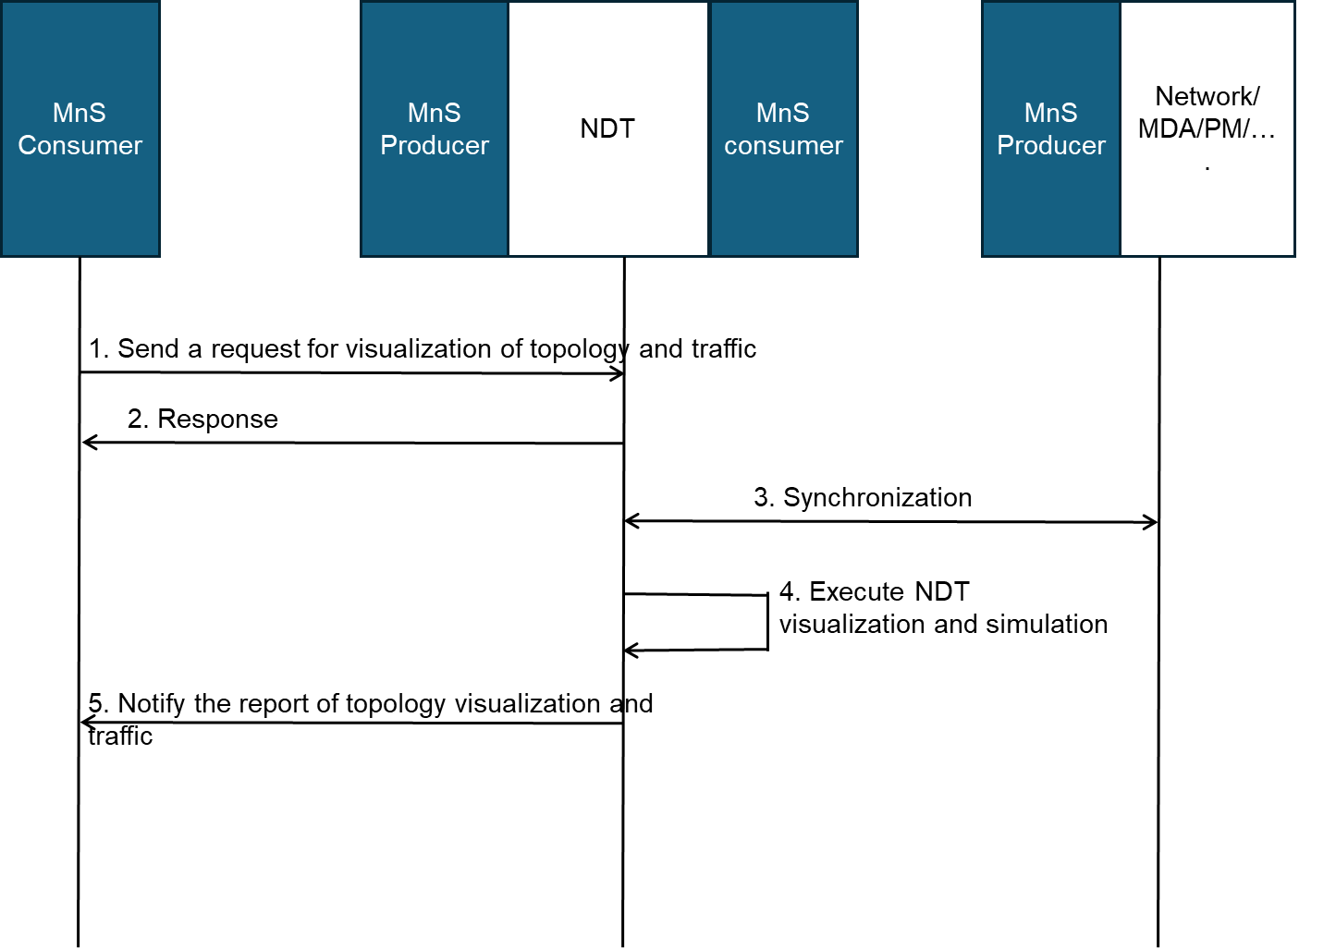

Figure 5.8.3.1-1: NDT for visualization of network topology and traffic

1. The MnS consumer sends a request to NDT as the MnS provider for visualization of network topology and the traffic modelling, including the simulated network objects (e.g. 5G VN group) and the required actions on the simulated network objects (e.g. topology visualization, simulation information, user plane traffic modelling).

2. The NDT as the MnS provider provides a response to MnS consumer indicating the status of the request based on a feasibility check (success or failure).

3. The NDT as the MnS consumer synchronizes the network objects related information from MnS providers for network topology visualization and traffic modelling. In case of 5G VN group, the 5G VN group identifier, 5G VN group topology, N19 tunnel information, device behind UE status, device information may be included.

4. The NDT executes the network topology simulation and visualization and optionally the traffic modelling and generates the report.

5. The NDT as the MnS provider sends the notification of report including the results to MnS consumer. The report can include:

- Visible network topology: report the visualization information.

- traffic modelling: Use of network simulation to simulate the traffic model.

#### 5.8.3.2 Solution 2

NRM IOC for simulated network or NDT instance that can provide the attributes based on NDT scenarios in 3GPP management system.

* The MOI information related to simulated network or NDT instance
* The scope of NDT (e.g., RAN, core network NFs, deployment location, duration etc.)
* The NDT related management data:
  + The fault information (e.g., NF fault status) related to NDT instance
  + The performance information (e.g., service KPIs) related to the simulated network or NDT

Based on the description above, the visualization of a NDT instance may correlate particular sets of management data.

After creation and/or configuration of the NDT instance, the output of NDT can be visualized. The output of NDT can be carried in nDTOutput as described in clause 5.2.3.3 solution 3 of Signaling storm analysis.

Note: the way to achieve visualization of NDT is implementation related.

### 5.8.4 Evaluation of potential solutions

The solution described in clause 5.8.3 provides the NRM extension needed for the NDT to provide the network topology and traffic visualization modelling of network behaviour. The solution allows NDT MnS consumer to request the NDT to do the network simulation, visualization and traffic modelling. Therefore, the normative work on NDT support to visualization of network topology and traffic should progress following the outline in solution in clause in clause 5.8.3. To support the topology of visibility, the existing SMF IOC and the corresponding KPIs and performance measurements reported by UPF can be utilized.

The solution described in clause *5.8.3* indicates the output of NDT can be visualized, the way to achieve visualization of NDT does not need to be standardised. The normative work on NDT visualization will focus on modelling of the simulated network or NDT instance in solution in solution in clause 5.8.3.

## 5.9 Use case 9: Configuration verification

### 5.9.1 Description

When operating a mobile network, various configuration and software/hardware modifications (are required to achieve or preserve an efficient operational state (e.g. software updates, launching new instances, terminating instances, etc.). It is difficult to predict the impact of the configurations and operations because mobile network is built by many components. Unintended network failures can occur because of the new or updated settings and operations.

For example, 5GC is responsible for managing and controlling the mobile network, such as processing call requests and session connections from UEs. Incorrect configuration (e.g. conflict IP address setting at NFs, wrong TAC setting at AMF, etc.) may increase the risk of network failure. In the worst case, it may cause network interruptions and impact the user experience, this may also cause economic loss to the service providers. Therefore, to ensure the correct configuration, especially when updating some of the parameters of 5GC NFs is very important. The digital twin technology may be used to evaluate the impact when updating configuration of one or more 5GC NFs and check whether the new configuration has any side effects of the network (e.g. cause performance degradation or failure).

In another example, when the wireless coverage of a RAN base station cannot meet the performance requirements, updating the RAN base station configuration or creating a new RAN base station may be required. By using NDT, the RAN network performance can be simulated with the new changes and evaluate the result to check whether the network performance can meet network coverage goal.

By using NDT, consumer can investigate potential impact in the network operation when new settings are applied (e.g. in which NF does congestion or service disruption occur and how many subscribers are impacted, etc.).

As an example, the impact of the configurations and operations is verified using NDT as follows:

1) The network operator wants to introduce new configurations or do some operation.

2) The network operator synchronizes the replica network to ensure that the replica network is up to date.

3) The network operator applies new configuration or operation to the replica network.

4) The replica network simulates the behavior of the mobile network.

5) The network operator observes and analyses the behavior of the replica network.

6) The network operator decides to apply new configuration or operation.

Consumers can request NDT to simulate various configuration settings and operations and analyze potential impact on the operation of the real network as a result.

One more detail example in the network operation and management, is key events assurance (e.g. large sports events, and major festival assurance ), which can cause major impacts to the services provided by a mobile network. During key events, a large number of end users may use the network in a specific region at the same time. In this case, the operator's network has to bear burst traffic, which can be several folds of the average traffic. Such high traffic may approach or exceed the system capacity designed by the customer for routine operation and may cause unstable network operation and engender emergent issues. The operator needs the network to work properly and stably during the key events. Network digital twin allows the possibility to simulate real time network performance and service availability under such high traffic, and verify the network adjustment in the replica network.

The additional procedure description of using NDT for key event assurance could be explored in more detail as follows:

1. Under dynamic burst traffic, the network operator verifies network adjustment in the replica network, including network parameter adjustment, features activation/deactivation, spare parts deployment and etc, where some network capacities may reach to the maximum or limitation.
2. In real time, the network operator wishes to simulate, synchronize, verify network adjustment or methods of failure recovery in the replica network if alarm or failure are emerging during ongoing event in the real network.
3. Additional verification of network adjustment, could include network topology changes, traffic re-distribution, service priorities and restriction, network spare parts deployment and etc.

### 5.9.2 Potential requirements

**REQ-NDT-FUN-01:** The NDT should have the capability allowing the consumer to submit provisioning MnS operations to the NDT.

**REQ-NDT-FUN-02:** The NDT should have the capability to report the result of applied configuration changes.

### 5.9.3 Potential solutions

#### 5.9.3.1 Potential solution 1



Figure 5.9.3.1-1: NDT for configuration verification

1. MnS consumer requests NDT to create an NDT instance with modeling requirements. The modeling requirements are used to specify the scope of the network to be modelled either using simulation or emulation based method, which may include:

- NDT scope: the area of actual mobile network or the managed object that needs to be simulated or emulated in NDT. For instance, a geography area, a network slice, etc.

- Modeling data: the selected data to be modeled by NDT, e.g. 5GC PM data as defined in 3GPP TS 28.552 [7] and 3GPP TS 28.554 [8], CM data as defined in 3GPP TS 28.541 [6] and 3GPP TS 28.622 [10], etc.

2. Based on the modeling requirements given in step 1, the MnS producer sends the inquiry request for the network object related information and synchronizes the data from the managed entities.

3. MnS producer notifies MnS consumer that the NDT instance is created.

4. MnS consumer requests NDT to verify the provisioning operation to be implemented. The request parameters may include:

- Provisioning operation type: the operation as defined in 3GPP TS 28.532 [11], e.g. modifyMOIAttributes operation.

- Configuration data: the 5GC NRM configuration data as described in 3GPP TS 28.541 [6] carried in the operation.

- Impact detectors: specified performance metrics and/or alarm types that needs to be collected and reported by NDT after the behaviour happens in NDT.

5. NDT runs the provisioning operation to be verified and collects its impact on the NDT instance. The impact could be performance measurement or alarm reporting from the NDT instance.

6. MnS producer reports the impact and result when implementing the provisioning operation on the NDT instance to MnS consumer. The report content may include the impact which is a key-value list where the keys contain the impact detectors specified in step 4. Alarms are reported if any raised.

#### 5.9.3.2 Potential solution 2

The solution described in clause 5.5.3.can be reused for the verification of configurations, with no extra additions. In particular:

- The configurations to be verified are part of the nDTConfigurationPlan.

- The outcomes of the configurations are part of the PMs and KPIs in the nDTOutput.

### 5.9.4 Evaluation of potential solutions

The common part of solution 1 and solution 2:

1. nDTSimulationScope in solution 2, which represents the scope to be modelled or simulated by the NDT instance, is similar with NDT scope given in solution 1.

2. nDTConfigurationPlan in solution 2, which indicates the configurations to be verified by NDT, can be specialized by Provisioning operation type and Configuration data given in solution 1.

3. nDTOutput in solution 2, which represents the output of the verification service, is similar with report given in solution 1.

The specific parameters for configuration verification use case mentioned in solution 1:

1. Modeling data: the selected data to be modeled by NDT, e.g., 5GC PM data as defined in TS 28.552[7]/28.554[8], CM data as defined in TS 28.541[6]/28.622[10], etc

2. Impact detectors: specified performance metrics and/or alarm types that needs to be collected and reported by NDT after the behaviour happens in NDT.

It’s recommended to keep common attributes as the NDT NRM solution framework, based on which the use case specific attributes are defined case by case.

## 5.10 Use case10: Network issue inducement

### 5.10.1 Description

This use case describes how a network issue can be induced using NDT. In order to develop a resilient network, the behavior and performance of the network should be monitored during certain network failure issue e.g. node/functionality failure, service degradation etc. In order to plan for the optimal network configuration in case of such network failure issue, the scenario itself need to be induced in the network. It is desirable, to use NDT for such an inducement process. A particular issue can be induced in the NDT instead of real network. After a particular issue is induced, the performance of the network can be monitored, other degradation/faults/failure can be identified and the mitigation actions can be decided and reported. The following are some of the examples of the issues that can be induced.

The network slice performance degradation in terms of low PDU session establishment success rate or in terms of high latency can be induced, in a NDT, to see how the related network functions will behave when the PDU session establishment success rate is degraded. The remedial actions can be decided to mitigate the problem.

The coverage hole can be induced, in a NDT, to see how the related services are getting effected. The remedial actions can be decided to mitigate the problems arising due to the induced coverage hole.

NDT can be used for fault injection experiments avoiding impact on the physical network while measuring and monitoring the impact of each injected fault in the NDT simulation. This could be leveraged, to build a training dataset for enhancing and enriching detection and diagnosing systems capabilities. In addition, NDT could be leveraged for improving root causes analysis.

Mobile network has become crucial infrastructure and the impact of network failures on society can be substantial. Therefore, it is important to consider measures against potential future network failures. To this end, it is useful to proactively analyse potential future network failures (e.g. analyse potential network failures caused by component failures like VMs or containers turned down). It is impossible to cause issues in actual commercial networks because it would affect users. Therefore, the use of Digital Twin can be investigated for this purpose.

NDT fault injection analysis is described in ETSI GR ZSM 015 [5], clause 5.13. In this use case, it is described as non-disruptive way of doing fault injection studies. Network digital twin simulates potential fault scenarios and provide results. This enables operator to learn network anomaly patterns of different faults.

For example, mobile networks are built on physical resources and can be built on virtualization technologies. Predicting the impacts on the network induced by the failures on physical resources (e.g. CPU, memory, storage failure of physical servers or port and transmission error of physical networks) or virtual resources (e.g. stopping of VMs or containers, host OS failures) can be challenging. Additionally, with the introduction of technologies like containers, the number of components in a mobile network increase, making it difficult to analyse the network-wide impacts of a single component failure. In the increasingly complex modern networks, it can also be difficult to ascertain the effectiveness of the countermeasures to those failures.

Furthermore, to allow verification of countermeasures, operator can repeat simulation of a failure on the network within NDT after applying the countermeasures, and observe the results, which can confirm the effectiveness of the countermeasures.

The consumer can request NDT to simulate failures and receive the simulation results regarding the impact on the network.

Moreover, network failures can sometimes cause issues originating in a part of the network to propagate throughout the entire network. In such cases, it is necessary to simulate not just individual components, but the entire network or a significant part as network digital twin. Additionally, as networks are structured in layers, an issue in one layer can impact other layers. Therefore, to accurately reproduce the entire network or its parts, it is crucial that 3GPP management system provide the network topology including how network elements are interconnected.

### 5.10.2 Potential requirements

**REQ-NDTN_Induce-1:** The NDT should support a capability enabling a network issue (e.g. fault/failure) to be induced.

**REQ-NDTN_Induce-2:** NDT should have a capability enabling the MnS consumer to measure and monitor the impact of the injected issue in a simulation environment.

**REQ-NDTN_Induce-3:** The management system should have a capability to provide topology data for simulating and/or emulating network failures in NDT.

### 5.10.3 Potential solutions

In order to induce a particular network scenario the consumer need to voluntarily update management data (including performance and configuration data) in a way that may result in a particular network issue. The solution requires consumer to indicate details on which management data is to be updated and how.

Introduce a data type and an attribute on the NDT of the fault to be injected or simulated by the NDT instance. This may be called nDTFaultInject. This may include the following information:

* Information related with simulation data that need to be voluntarily updated to inject a particular issue:
* Data: This will define which management data is to be updated artificially in order to induce a particular network issue. The management data includes:

- Performance data: The name of the performance measurement or the KPI as defined in 3GPP TS 28.552 [7] and 3GPP TS 28.554 [8].

- MDT/Trace data: The name of MDT measurements as defined in 3GPP TS 32.422 [12].

- Configuration data: The name of the attribute from any of the available MOIs; Type of failure (e.g. CPU, memory, storage failure of physical servers or port and transmission error of physical networks, stopping of VMs or containers, host OS failures); Reference to node where failure to be induced; Information representing the evaluation of the injected issues. This may be called nDTFaultSignature and will contain information about the impacts of the fault e.g. node performance data, node fault data

* Threshold: This will define the threshold for a particular management data. Once the threshold is reached the simulation data will be updated.
* Condition: This will define the condition that has to be satisfied in order to update the simulation data. This can be defined in terms of location and time.
* Updates: This will define the induced values for the simulation data.
* Mitigation: This will define the mitigation actions in terms of network reconfiguration to handle the simulated network failure scenario.



Figure 5.10.3-1

1. NDT consumer request to create an NDT providing details of NDT including information related to simulation data.

2. The NDT is created.

3. Producer send a response to consumer.

4. Producer then activates the NDT and monitor the same for performance.

5. Producer check the simulation data information, received in step 1, to confirm whether the indicated simulation data need to be updated.

6. Producer updates the simulation data internally.

7. Producer monitor the NST for performance degradation and failures. Based on the issues identified producer decides the mitigation actions and update the NDT with the same.

8. Producer notifies consumer about the updating of NDT characteristics related with mitigation actions.

### 5.10.4 Evaluation of potential solutions

Only one potential solution is proposed. The proposed solution satisfies all the requirements and is considered feasible. The normative work on NDT support for network issue inducement should progress following the outline in clause 5.10.3.

## 5.11 Use case 11: measuring customer satisfaction with the network services

### 5.11.1 Description

The Net Promoter Scores (NPS) are used to promote or detract the operator's network service (TM forum IG1307 [3]). If the net promoter scores are too low, operators wish to find the root cause of the low score and method to improve the score. The net promoter scores are affected by many factors, e.g. customer service, data package prices, network usage experience and etc, which can be classified into product NPS, network NPS, and service NPS according to TM forum IG1307 [3]. Network NPS is used to measure customer satisfaction with the network services from network usage perspective, which could be digital twin technology to model and simulate end-user behaviours in network.

The satisfaction of network service is affected by combining factors, and the digital twin technology is desirable to model and simulate the customer usage experiences by integrating multi-domain data sources which include network performance and user experience data, fault prediction, and non 3GPP management system data such as user complaint data and network NPS survey data. This proactive approach allows CSPs to identify potential detractors who are not satisfied with services on the entire network, monitor the end user journey, gain deeper insights into the end user's needs, and perform refined experience management based on user groups.

### 5.11.2 Potential requirements

**REQ-NDT-FUN-01:** The NDT should have the capability to simulate end-user's network usage behaviour to restore the service usage record in terms of time sequence, e.g. call record, call drop-out, services experience, etc.

### 5.11.3 Potential solutions

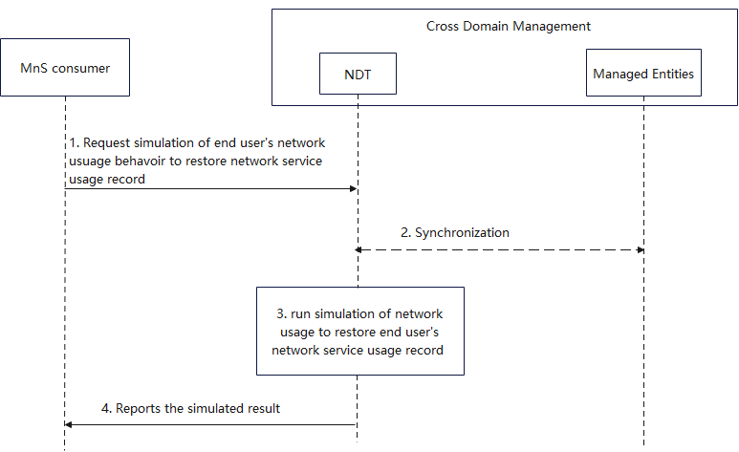

Figure 5.11.3-1: procedure of end-user's network usage behaviour with the network services

1. MnS consumer requests NDT to simulate network usage behaviour. The request parameters may include:

* Interaction restoration between network and end-users: restoring the past network status in a digital twin environment, usage behaviour of network to have user experience modelling. For example, user traffic distribution, poor service quality distribution, low network performance distribution and etc.
* Simulation data: the selected data that collected for NDT simulation, e.g., network performance and fault data, user experience data, non 3GPP management system data including user complaint data and network NPS survey data and etc.
* Performance requirements: the expected network simulation performance of NDT. For instance, the time spent for the network simulation, the expected proximity between the network simulation results and the actual network execution outcome.

1. Based on the simulation requirements given in step 1, NDT collects the data from the managed entities within the specified simulation scope, time and data type.
2. NDT runs the simulation of network usage behaviours to restore the service usage record in terms of time sequence.
3. NDT reports the simulated result to MnS consumer. The result may include the network service usage record of end user to be provided to other network functionality, e.g. MDA, for further analysing if network services satisfy the customer satisfaction, and identifying the potential detractors who are not satisfied with services on the entire network.

### 5.11.4 Evaluation of potential solutions

The potential solution described in clause 5.11.3 provides the approach that simulate the end-user’s network usage behaviour to restore network service usage record for further analysis of specific network factors most affecting their experience and awareness of potential detractor locations and corresponding time slots on the entire network. The solution satisfies the requirement for the NDT to implement the interaction simulation between end-user behaviour and network services. .

|  |
| --- |
| **End of Changes** |