**3GPP TSG-SA5 Meeting #158 *S5-247282***

**Orlando, United States, 18th Nov 2024 - 22nd Nov 2024**

|  |  |  |  |  |  |  |  |  |
| --- | --- | --- | --- | --- | --- | --- | --- | --- |
| *CR-Form-v12.3* | | | | | | | | |
| **CHANGE REQUEST** | | | | | | | | |
|  | | | | | | | | |
|  | **28.310** | **CR** | **0054** | **rev** | **1** | **Current version:** | **16.9.0** |  |
|  | | | | | | | | |
| *For* ***[HE](http://www.3gpp.org/3G_Specs/CRs.htm" \l "_blank)******[LP](http://www.3gpp.org/3G_Specs/CRs.htm" \l "_blank)*** *on using this form: comprehensive instructions can be found at  <http://www.3gpp.org/Change-Requests>.* | | | | | | | | |
|  | | | | | | | | |

|  |  |  |  |  |  |  |  |  |
| --- | --- | --- | --- | --- | --- | --- | --- | --- |
| ***Proposed change affects:*** | UICC apps |  | ME |  | Radio Access Network | **X** | Core Network |  |

|  |  |  |  |  |  |  |  |  |  |  |
| --- | --- | --- | --- | --- | --- | --- | --- | --- | --- | --- |
|  | | | | | | | | | | |
| ***Title:*** | Rel-16 CR TS28.310 Correction of Capacity Booster Cell State | | | | | | | | | |
|  |  | | | | | | | | | |
| ***Source to WG:*** | ZTE Corporation | | | | | | | | | |
| ***Source to TSG:*** | S5 | | | | | | | | | |
|  |  | | | | | | | | | |
| ***Work item code:*** | TEI16 | | | | |  | ***Date:*** | | | 2024-10-31 |
|  |  | | | |  | |  | | |  |
| ***Category:*** | **F** |  | | | | | ***Release:*** | | | Rel-16 |
|  | *Use one of the following categories:* ***F*** *(correction)* ***A*** *(mirror corresponding to a change in an earlier release)* ***B*** *(addition of feature),* ***C*** *(functional modification of feature)* ***D*** *(editorial modification)*  Detailed explanations of the above categories can be found in 3GPP [TR 21.900](http://www.3gpp.org/ftp/Specs/html-info/21900.htm). | | | | | | | | *Use one of the following releases: Rel-8 (Release 8) Rel-9 (Release 9) Rel-10 (Release 10) Rel-11 (Release 11) … Rel-17 (Release 17) Rel-18 (Release 18) Rel-19 (Release 19)  Rel-20 (Release 20)* | |
|  |  | | | | | | | | | |
| ***Reason for change:*** | | When a capacity booster cell is fully overlaid by candidate cell(s) and traffic in the ES area resumes to a high level, the capacity booster cell should be deactivated rather than activated. Additionally, there are some editorial corrections. | | | | | | | | |
|  | |  | | | | | | | | |
| ***Summary of change:*** | | The correction of capacity booster cell’s state. | | | | | | | | |
|  | |  | | | | | | | | |
| ***Consequences if not approved:*** | | The capacity booster cell cannot return to the notEnergySavingState state, leading to potential traffic congestion in the candidate cell and ultimately diminishing network performance and user experience. | | | | | | | | |
|  | |  | | | | | | | | |
| ***Clauses affected:*** | | 5.1.3.2.2, 5.1.3.3 | | | | | | | | |
|  | |  | | | | | | | | |
|  | | **Y** | **N** |  | | | |  | | |
| ***Other specs*** | |  | **X** | Other core specifications | | | | TS/TR ... CR ... | | |
| ***affected:*** | |  | **X** | Test specifications | | | | TS/TR ... CR ... | | |
| ***(show related CRs)*** | |  | **X** | O&M Specifications | | | | TS/TR ... CR ... | | |
|  | |  | | | | | | | | |
| ***Other comments:*** | |  | | | | | | | | |
|  | |  | | | | | | | | |
| ***This CR's revision history:*** | | Revision of S5-246325 | | | | | | | | |

#### Start of changes

##### 5.1.3.2.2 Intra-RAT energy saving

Intra-RAT energy saving focuses on a scenario where the gNB candidate cells provide the coverage for the NR capacity booster cell that is switched off. Intra-RAT energy saving (ES) consists of distributed energy saving where the energy saving decision is made in the NR cells with MnS producer(s) assist to provide relevant information, such as policies, and centralized energy saving where the energy saving decision is made in MnS producer (see clause 15.4 in TS 38.300 [13]).

For the distributed energy saving, the NR capacity booster cell may decide to enter the energy saving mode when it detects that its traffic load is below certain threshold, and its coverage can be provided by the candidate cells. However, the NR capacity booster cell can be switched off only after the handover actions to off-load its traffic to the candidate cells is completed (see clause 15.4.2 in TS 38.300 [13]). The candidate cell decides to re-activate the NR capacity booster cell when it detects additional capacity is needed (see clause 15.4.2 in TS 38.300 [13]).

For the centralized energy saving, MnS producer collects the traffic load performance measurements from the NR capacity booster cell and candidate cells, and may request a NR capacity booster cell to enter the energy saving mode when its traffic is below certain threshold. The NR capacity booster may initiate handover actions to off-load the traffic to the neighbouring cells (see clause 15.4.2 in TS 38.300 [13]) prior to entering into the energy saving mode.

#### The Second Change

#### 5.1.3.3 Capacity booster cell fully overlaid by candidate cell(s)

An NG-RAN node, which connects with 5GC to provide boost capacity, may enter into energySaving state if there is radio coverage by other radio systems – be another NG-RAN node or an entity of another radio access technology - for the whole coverage area of the NG-RAN node in question, see figure 5.1.3.3-1 for gNB capacity booster cell fully overlaid by candidate cell(s) case.

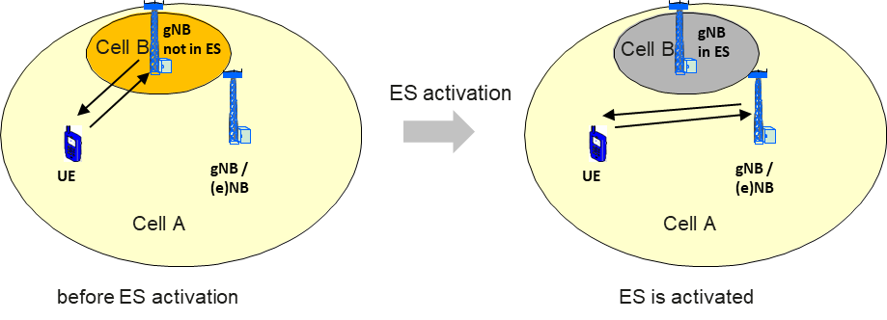

Figure 5.1.3.3-1: gNB capacity booster cell fully overlaid by candidate cell(s)

This use case applies both for Intra- and Inter-RAT Energy Saving.

**Inter-frequency Intra-RAT gNB Coverage**

Two gNB cells (Cell A, Cell B) with separate frequency bands cover the same geographical area. Cell B has a smaller size than Cell A and is covered totally by Cell A. Generally, Cell A is deployed to provide continuous coverage of the area, while Cell B increases the capacity of the special sub-areas, such as hot spots. The ES activation procedure in the coverage of Cell B (ES area) may be triggered in case that light traffic in Cell B is detected. Cell B ES deactivation may also be triggered when the traffic of ES area (measured by candidate Cell A) resumes to a high level. A Cell B capable of ES probing can execute the ES probing procedure and based on Cell B measurements the centralized or distributed ES management can decide if the Cell B needs to be activated and take portion of the traffic from Cell A.

#### End of changes