**3GPP TSG-SA5 Meeting #158 *S5-247259***

Orlando, Florida, USA 18 - 22 November 2024

|  |  |  |  |  |  |  |  |  |
| --- | --- | --- | --- | --- | --- | --- | --- | --- |
| *CR-Form-v12.3* | | | | | | | | |
| **CHANGE REQUEST** | | | | | | | | |
|  | | | | | | | | |
|  | **28.538** | **CR** | **0102** | **rev** | **1** | **Current version:** | **19.1.0** |  |
|  | | | | | | | | |
| *For* [***HE******LP***](http://www.3gpp.org/3G_Specs/CRs.htm#_blank)*on using this form: comprehensive instructions can be found at* [*http://www.3gpp.org/Change-Requests*](http://www.3gpp.org/Change-Requests)*.* | | | | | | | | |
|  | | | | | | | | |

|  |  |  |  |  |  |  |  |  |
| --- | --- | --- | --- | --- | --- | --- | --- | --- |
| ***Proposed change affects:*** | UICC apps |  | ME |  | Radio Access Network |  | Core Network | **X** |

|  |  |  |  |  |  |  |  |  |  |  |
| --- | --- | --- | --- | --- | --- | --- | --- | --- | --- | --- |
|  | | | | | | | | | | |
| ***Title:*** | Rel-19 CR 28.538 update Fault management | | | | | | | | | |
|  |  | | | | | | | | | |
| ***Source to WG:*** | Huawei | | | | | | | | | |
| ***Source to TSG:*** | SA5 | | | | | | | | | |
|  |  | | | | | | | | | |
| ***Work item code:*** | eECM | | | | |  | ***Date:*** | | | 2024-11-08 |
|  |  | | | |  | |  | | |  |
| ***Category:*** | **A** |  | | | | | ***Release:*** | | | Rel-19 |
|  | *Use one of the following categories:* ***F*** *(correction)* ***A*** *(mirror corresponding to a change in an earlier release)* ***B*** *(addition of feature),* ***C*** *(functional modification of feature)* ***D*** *(editorial modification)*  Detailed explanations of the above categories can be found in 3GPP [TR 21.900](http://www.3gpp.org/ftp/Specs/html-info/21900.htm). | | | | | | | | *Use one of the following releases: Rel-8 (Release 8) Rel-9 (Release 9) Rel-10 (Release 10) Rel-11 (Release 11) … Rel-17 (Release 17) Rel-18 (Release 18) Rel-19 (Release 19)  Rel-20 (Release 20)* | |
|  |  | | | | | | | | | |
| ***Reason for change:*** | | Fault supervision MnS has been removed from TS 28.532, and the related work has been defined in TS 28.111 since in Rel 18. | | | | | | | | |
|  | |  | | | | | | | | |
| ***Summary of change:*** | | Fault supervision related solution needs to be updated to align with TS 28.111. | | | | | | | | |
|  | |  | | | | | | | | |
| ***Consequences if not approved:*** | | The existing solution for Fault supervision is no longer valid. | | | | | | | | |
|  | |  | | | | | | | | |
| ***Clauses affected:*** | | 2, 7.3.2 and 7.3.3 | | | | | | | | |
|  | |  | | | | | | | | |
|  | | **Y** | **N** |  | | | |  | | |
| ***Other specs*** | |  | **X** | Other core specifications | | | | TS/TR ... CR ... | | |
| ***affected:*** | |  | **X** | Test specifications | | | | TS/TR ... CR ... | | |
| ***(show related CRs)*** | |  | **X** | O&M Specifications | | | | TS/TR ... CR ... | | |
|  | |  | | | | | | | | |
| ***Other comments:*** | |  | | | | | | | | |
|  | |  | | | | | | | | |
| ***This CR's revision history:*** | |  | | | | | | | | |

|  |
| --- |
| **1st Change** |

# 2 References

The following documents contain provisions which, through reference in this text, constitute provisions of the present document.

- References are either specific (identified by date of publication, edition number, version number, etc.) or non‑specific.

- For a specific reference, subsequent revisions do not apply.

- For a non-specific reference, the latest version applies. In the case of a reference to a 3GPP document (including a GSM document), a non-specific reference implicitly refers to the latest version of that document *in the same Release as the present document*.

[1] 3GPP TR 21.905: "Vocabulary for 3GPP Specifications".

[2] 3GPP TS 23.558: "Architecture for enabling Edge Applications".

[3] 3GPP TS 28.541: "Management and orchestration; 5G Network Resource Model (NRM); Stage 2 and stage 3".

[4] 3GPP TS 28.622: "Telecommunication management; Generic Network Resource Model (NRM) Integration Reference Point (IRP); Information Service (IS)".

[5] 3GPP TS 28.532: "Management and orchestration; Generic management services".

[6] ETSI GS NFV-IFA 013 V3.4.1 "Network Functions Virtualisation (NFV) Release 3; Management and Orchestration; Os-Ma-nfvo reference point -Interface and Information Model Specification".

[7] ETSI GS NFV-IFA 011 (V3.3.1): "Network Functions Virtualisation (NFV) Release 3; Management and Orchestration; VNF Descriptor and Packaging Specification".

[8] 3GPP TS 28.550: "Management and orchestration; Performance assurance".

[9] Void.

[10] 3GPP TS 28.552: "Management and orchestration; 5G performance measurements".

[11] 3GPP TS 23.501: "System architecture for the 5G System (5GS); Stage 2".

[12] 3GPP TS 28.658: "Telecommunications management; Evolved Universal Terrestrial Radio Access Network (E-UTRAN) Network Resource Model (NRM) Integration Reference Point (IRP): Information Service (IS)".

[13] 3GPP TS 38.300: "NR; Overall description; Stage-2".

[14] GSMA OPG: "Operator Platform Telco Edge Requirements; Version 2.0".

[15] ETSI GS MEC 010-2 (v 2.2.1) (2022-02): " Multi-access Edge Computing (MEC); MEC Management; Part 2: Application lifecycle, rules and requirements management".

[16] 3GPP TS 23.548: "5G System Enhancements for Edge Computing".

[17]ETSI GS NFV-SOL 005 V4.4.1: "Network Functions Virtualisation (NFV) Release 4; Protocols and Data Models; RESTful protocols specification for the Os-Ma-nfvo Reference Point".

[18]3GPP TS 32.160: " Management service template".

[19] 3GPP TS 28.623: "Telecommunication management; Generic Network Resource Model (NRM) Integration Reference Point (IRP); Solution Set (SS) definitions".

[x] 3GPP TS 28.111: "Management and orchestration; Fault management (FM)".

|  |
| --- |
| **2nd Change** |

### 7.3.2 EDN NF performance impacted by 5GC NF alarm

Figure 7.3.2-1 depicts a procedure to describe how an ECSP management system can consume fault management MnS to receive 5GC NF alarms.

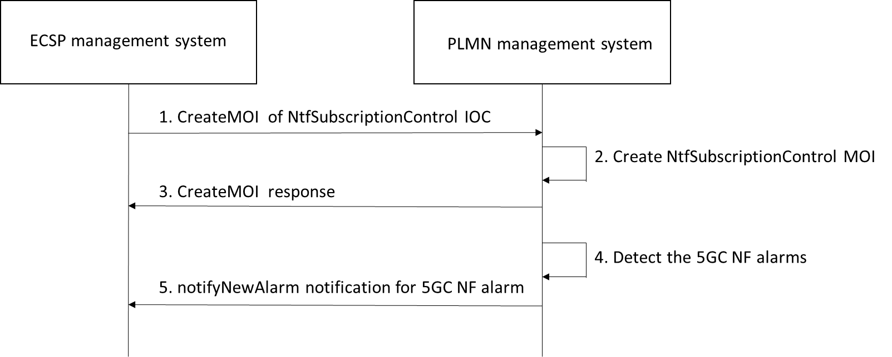

Figure 7.3.2-1: EDN NF performance impacted by 5GC NF alarm

1. ECSP sends a createMOI request (see createMOI operation defined in TS 28.532 [5]) with NtfSubscriptionControl IOC (see TS 28.622 [4]) including notificationTypes related to the fault management as defined in TS 28.111 [x] to subscribe 5GC NFs (i.e., UPF, PCF, NEF, SCEF) related alarms.

2. PLMN management system creates the MOI for NtfSubscriptionControl IOC.

3. PLMN management system sends a response to the ECSP management system indicating the NtfSubscriptionControl MOI has been successfully created.

4. PLMN management system detects the 5GC NF alarms.

5. PLMN management system sends notifyNewAlarm notification to indicate the 5GC NF alarms being detected.

### 7.3.3 5GC NF issues resulted from EDN NF alarms

Figure 7.3.3-1 depicts a procedure to describe how a PLMN management system can consume fault management MnS to receive EDN NF alarms.

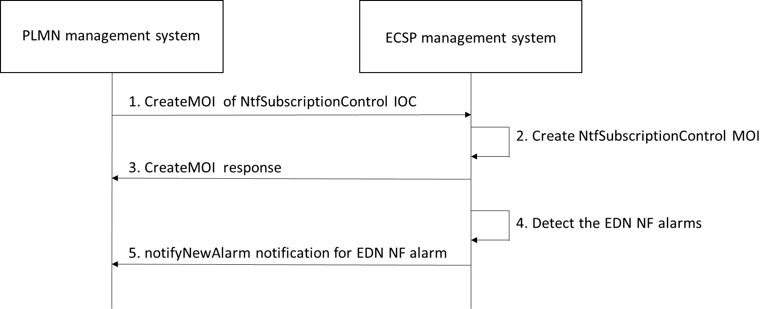

Figure 7.3.3-1: 5GC NF issues resulted from EDN NF alarms

1. PLMN management system sends a createMOI request (see createMOI operation defined in TS 28.532 [5]) with NtfSubscriptionControl IOC (see TS 28.622 [4]) including notificationTypes related to the fault management related notification as defined in TS 28.111 [x] to subscribe EDN NFs (i.e., EAS, EES, ECS) related alarms.

2. ECSP management system creates the MOI for NtfSubscriptionControl IOC.

3. ECSP management system sends a response to the PLMN management system indicating the NtfSubscriptionControl MOI has been successfully created.

2. ECSP management system detects the EDN NF alarms.

3. ECSP management system sends notifyNewAlarm notification to indicate the EDN NF alarms being detected.

|  |
| --- |
| **End of Change** |