**3GPP TSG-SA5 Meeting #158S5-246442**

**11 - 15 November 2024, Orlando, Florida**

**Source: Nokia, Ericsson**

**Title:** **Rel-19 pCR 28.915 General use case on NDT**

**Document for: Approval**

**Agenda Item: 6.19.4**

# 1 Decision/action requested

***The group is asked to discuss and agree on the proposal.***

# 2 References

[1] 3GPP TR 28.915 -110 “Study on management aspects of Network Digital Twin”.

# 3 Rationale

TR28.915 has studied several use cases on Network Digital Twin. The use cases and their potential requirements and solutions have significant similarity among them requiring for a general solution that applies to all of them and to which extendsions can be provided for the special use cases that cannot be met by the general solution. This pCR is to add the general use case with correspiondign requirements and general solution

# 4 Detailed proposal

|  |
| --- |
| **Start of modification** |

# 5 Use cases

## 5.A General use case on NDT modelling the behavior of a network

### 5.A.1 Description

This use case captures the general aspects that ar ecommnon to all use cases that have been discussed in clauses 5.1 to 5.11. It does not propose new capabilities but captures the common features that can be described once for use by any NDT application use case.

The network digital twin has been defined as an entity that models the behavior of a network. The NDT can be used for many different use cases (called NDT application use cases) each of which may be differently implemented. For all the use cases, an MnS producer exposes generic NDT services that are agnostic to the specific application use cases. The MnS consumers are enabled to request a certain network scenario describing configurations to be instantiated and modelled by the NDT. The provided results will be sent to the MnS consumers. The use cases share a common framework which includes the following:

- The NDT should enable the MnS cosumer to define the network scenario that should be modelled, including the characteristics of such a scenario which may translate into specific NDT models to be used, e.g. for the specific antenna or radio types.

- The NDT should enable the MnS cosumer to define the desired configuration(s) of the defined network scenario including defining characteristic for the user terminals (such as speed) and services to be consumed.

- The NDT should enable the MnS cosumer to define the network metrics that should be evaluated in the modelling, including measurements and KPIs on the diffenet network functions and processes.

- The NDT should provide to the MnS cosumer the outcomes of the modelling evaluation including the characteristics and configurations of the scenario that was evaluated, the outcoems on the diffenet network metrics that are captured during the evaluation.

- The MnS consumer should be able to manage a given NDT instance or the related modelling process.

### 5.1.2 Potential requirements

REQ-GENNDT-1: The 3GPP management system should support a capability enabling an MnS consumer to instantiate and manage a network digital twin to be used to model and evaluate the behavior of a network instance.

REQ-GENNDT-2: The NDT should support a capability enabling an MnS consumer to define the network scenario that should be modelled

REQ-GENNDT-3: The NDT should support a capability enabling an MnS consumer to define the desired configuration(s) of the defined network scenario including defining characteristic for the user terminals

REQ-GENNDT-4: The NDT should support a capability enabling an MnS consumer to define the network metrics that should be evaluated by the NDT in the modelling, including measurements and KPIs on the diffenet network functions and processes

REQ-GENNDT-5: The NDT should support a capability enabling an MnS consumer to label a specific NDT instance with a purpose for which it instantiated and to trigger the instance for the stated purpose

REQ-GENNDT-6: The NDT should support a capability to provide an output to the MnS cosumer representing the outcomes of the modelling evaluation including the characteristics and configurations of the scenario that was evaluated, the outcoems on the diffenet network metrics that are captured during the evaluation.

REQ-GENNDT-7: The NDT should support a capability enabling an MnsS consumer to manage a given NDT instance or the related modelling process

### 5.A.3 Potential solutions

The solution propses the information model represented by Figure 5.1.3-1 and outimed below

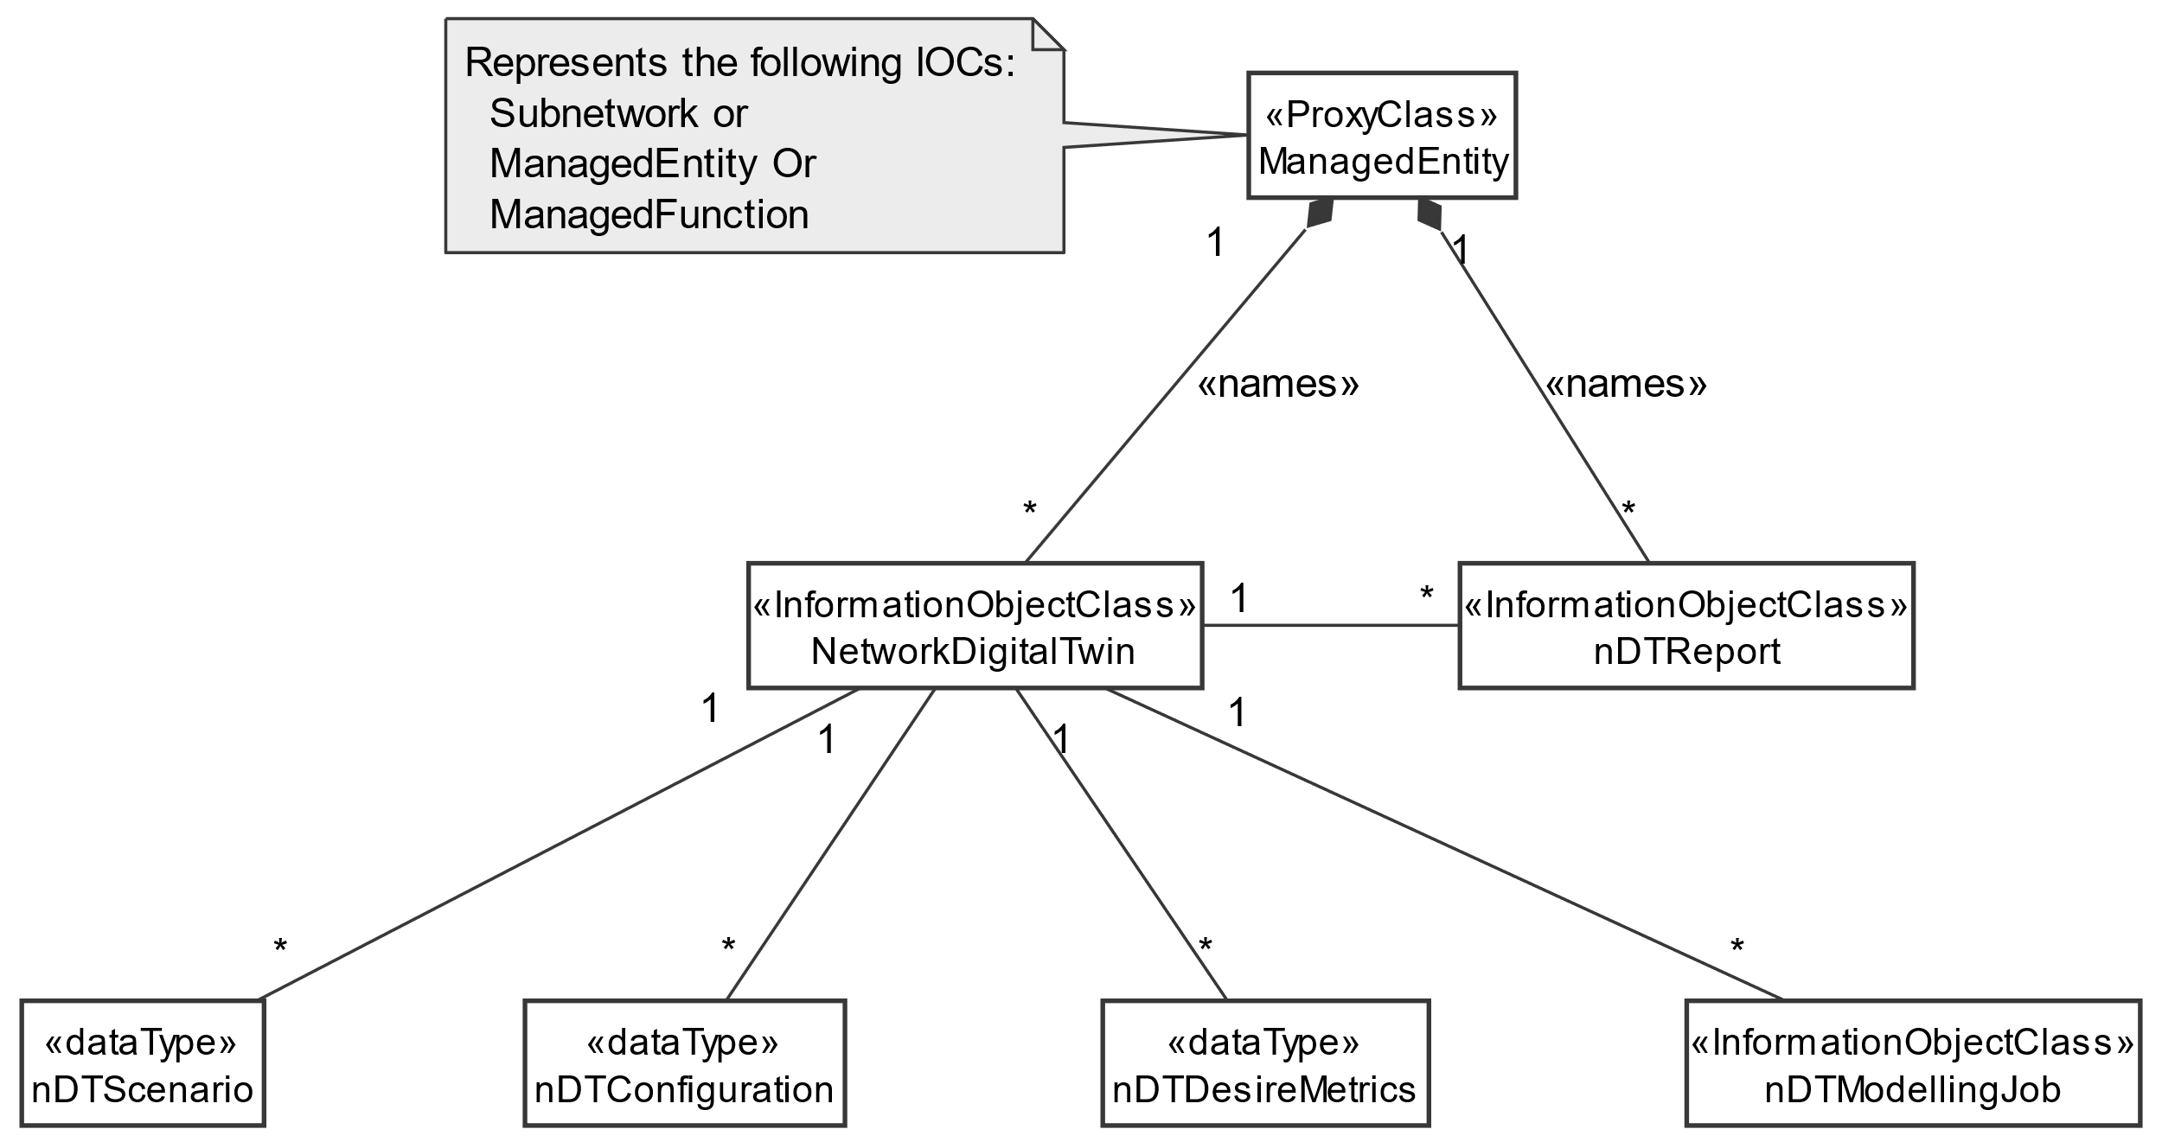

Figure 5.1.3-1 Network Digital Twin NRM control fragment

- introduce an IOC for an NDT, NetworkDigitalTwin.

- introduce a data type for the network scenario to be modeled and simulated, nDTScenario. An NDT instance may have one or more nDTScenario(s) to support the case that several scenarios may need to be evaluated by the given NDT instance.

- introduce a data type for the desired configuration to be modeled and simulated, nDTConfiguration. An NDT instance may have one or more nDTConfiguration to support the case that several configurtions may need to be evaluated for a given NDT instance. If several nDTConfiguration are included in a scenario with several nDTScenario(s), a metric of evaluation will be expected for each specific pair of nDTScenario and nDTConfiguration.

- introduce an attribute representing the list of metrics to be captured or computed in the evaluation. Entries in the list may be configured by the MnS consumer to to indicate the specific outputs they wish to see. The attribute may be called nDTDesireMetrics.

- introduce an attribute representing the purpose for which the NDT instance is created. The attribute may be called nDTPurpose, as an enumeration with specific values (e.g. SYNTHTICDATAGENERATION, VALIDATION, etc.) it may also be a sting that allow any purpose to be added.

- introduce an IOC for the NDT modelling and evaluation process. The datatype may be called nDTModellingJob. The nDTModellingJob can be suspended resumed or cancelled by the MnS consumer.

- introduce an IOCfor the NDT output. The datatype may be called nDTReport. It includes all information related to the specific NDT instance and related nDTModellingJob

- introduce on the nDTReport a data types and corresponding attributes for the nDTScenarioinformation and the nDTConfiguration information

- introduce on the nDTReport a data type and corresponding attribute for the hash function representing the outputs per pair of of nDTScenario and nDTConfiguration.

### 5.5.4 Evaluation of solutions

The solution described in clause 5.A.3 provides the NRM extension needed for the general management and use of a Network Digital Twin. The solution is a general solution that provides the baseline for any NDT application use case. It can be extended with specific attributes to support specific applications of NDT. The normative work should start with this general use case and its requirements and general solution as the baseline on which other NDT use case can be added.

|  |
| --- |
| **Next modifications** |

# 6 Conclusions

The present document conducted a study on NDT in the present document, which describes the terms and concepts of NDT. The present document also identified and documented the use cases and corresponding potential requirements, possible solutions by using the NDT.

It is recommended to start the normative work with the general use case and corresponding requirements and general solution that provides the basic framework for the use and life cycle management of NDTs. Special new use-case-specific requirements that are not met by the general use case can then be added.

There are multiple valid and valuable use cases which may benefit from NDT. Solutions are proposed which are based on a new Management Service and associated network resource modelling.

1. Focus on selected grouping scenarios, in each group capturing the common characteristics of different use cases:

1) Scenario group 1: Generic capabilities:

- Nested NDTs.

- NDT support to network automation.

- Using NDT to generate data for ML model training

2) Scenario group 2: Verification: checking a given policy, configuration, scenario, traffic condition, etc.:

- RAN energy saving policy verification.

- Signalling storm configuration verification.

- Emergency preparedness.

- Network failure and risk prediction.

2. Develop the new proposed Management Service to support above scenarios by using the NDT.

3. Develop the detailed datatypes to support the new proposed Management Service.

|  |
| --- |
| **Next modifications** |

Annex A:  
PlantUML Code for figures

# A.1 Network Digital Twin NRM control fragment (Figure 5.A.3-1)

@startuml

skinparam ClassStereotypeFontStyle normal

skinparam ClassBackgroundColor White

skinparam shadowing false

skinparam monochrome true

hide members

hide circle

class ManagedEntity <<ProxyClass>>

class NetworkDigitalTwin <<InformationObjectClass>>

class nDTScenario <<dataType>>

class nDTConfiguration <<dataType>>

class nDTDesireMetrics <<dataType>>

class nDTModellingJob <<InformationObjectClass>>

class nDTReport <<InformationObjectClass>>

ManagedEntity "1" *-- "*" NetworkDigitalTwin: <<names>>

ManagedEntity "1" *-- "*" nDTReport: <<names>>

NetworkDigitalTwin "1" -- "*" nDTScenario

NetworkDigitalTwin "1" -- "*" nDTConfiguration

NetworkDigitalTwin "1" -- "*" nDTDesireMetrics

NetworkDigitalTwin "1" -- "*" nDTModellingJob

NetworkDigitalTwin "1" -right- "*" nDTReport

note left of ManagedEntity

Represents the following IOCs:

Subnetwork or

ManagedEntity Or

ManagedFunction

end note

@enduml

|  |
| --- |
| **End of modifications** |