**3GPP TSG-SA5 Meeting #158 *S5-247227d1***

**Orlando, USA, 18 - 22 October 2024**

**3GPP TSG-SA Meeting #102SP-231723**

**Edinburgh, UNITED KINGDOM, 11th Dec 2023 - 15th Dec 2023**

**Source: SA WG5**

**Title: New SID: Study on energy efficiency and energy saving aspects of 5G networks and services**

**Document for: Approval**

**3GPP TSG-SA5 Meeting #152 *S5-238353***

**Chicago, US, 13 - 17 November 2023**

**Source: Huawei (moderator)**

**Title: New SID on energy efficiency and energy saving aspects of 5G networks and services**

**Document for: Approval**

**Agenda Item: 6.2.3**

3GPP™ Work Item Description

Information on Work Items can be found at <http://www.3gpp.org/Work-Items>   
See also the [3GPP Working Procedures](http://www.3gpp.org/specifications-groups/working-procedures), article 39 and the TSG Working Methods in [3GPP TR 21.900](http://www.3gpp.org/ftp/Specs/html-info/21900.htm)

Title: Study on energy efficiency and energy saving aspects of 5G networks and services

Acronym: FS_Energy_OAM_Ph3

Unique identifier: 1020021

Potential target Release: Rel-19

# 1 Impacts

|  |  |  |  |  |  |
| --- | --- | --- | --- | --- | --- |
| Affects: | UICC apps | ME | AN | CN | Others (specify) |
| Yes |  |  | X | X |  |
| No | X | X |  |  | X |
| Don't know |  |  |  |  |  |

# 2 Classification of the Work Item and linked work items

## 2.1 Primary classification

### This work item is a …

|  |  |
| --- | --- |
| X | Study |
|  | Normative – Stage 1 |
|  | Normative – Stage 2 |
|  | Normative – Stage 3 |
|  | Normative – Other* |

**\* Other = e.g. testing**

## 2.2 Parent Work Item

|  |  |  |  |
| --- | --- | --- | --- |
| Parent Work / Study Items | | | |
| Acronym | Working Group | Unique ID | Title (as in 3GPP Work Plan) |
|  |  |  |  |

### 2.3 Other related Work Items and dependencies

|  |  |  |
| --- | --- | --- |
| Other related Work /Study Items (if any) | | |
| Unique ID | Title | Nature of relationship |
| 940036 | Study on new aspects of EE for 5G networks Phase 2 | The Rel-18 study in SA5 on 5G energy efficiency and energy saving. |
| 940037 | Enhancements of EE for 5G Phase 2 | The Rel-18 work item in SA5 on 5G energy efficiency and energy saving. |
| 960019 | Study on Energy Efficiency as service criteria | The Rel-19 study in SA1 describes use cases and potential requirements in relation with this study. |
| 1000033 | Energy Efficiency as Service Criteria | The Rel-19 work item in SA1 provides Stage 1 requirements in relation with this study. |
| 1010029 | Feasibility Study on 5GS Enhancement for Energy Efficiency and Energy Saving | The Rel-19 study in SA2 studies potential enhancements to the 5G system, for which this study will study the OAM support. |

# 3 Justification

There are many initiatives on energy efficiency / energy saving in 3GPP and other SDOs / fora. In 3GPP, SA5 has been mandated by TSG SA to lead the work on this topic within SA. Our assumption here is that this mandate is reconducted for Release 19.

SA1, after the completion of its Rel-19 study on energy efficiency as a service criteria (FS_EnergyServ) has now started its corresponding Rel-19 work item (EnergyServ). SA2 has recently approved its Rel-19 study on 5GS Enhancement for Energy Efficiency and Energy Saving as a Service criteria.

In parallel, TSG RAN is also preparing its Rel-19 prioritized topics, energy saving being one of them, according to many operators’ input to the Rel-19 preparation workshop. Based on this, it’s more than likely that some OAM support may be needed in case new RAN energy saving features are introduced in Rel-19.

In addition, during the past years, SA5 has been working jointly with external SDOs / groups on EE and will continue to synchronize with e.g. ETSI TC EE, ITU-T SG5, NGMN GFN (Green Future Networks), ETSI NFV ISG, and more recently with ITU-T SG11.

To summarize this, in Rel-19, SA5 needs to work on:

* Left-over topics from Rel-18 (the SA5 Rel-18 work item on EE is planned to be completed by December 2023)
* New topics coming from other SA WGs, in particular SA1 ‘Energy efficiency as a service criteria’ (EnergyServ) and SA2 Rel-19 Energy Efficiency Study on 5GS Enhancement for Energy Efficiency and Energy Saving as a Service criteria (approved at SA#101)
* OAM support to new RAN features, mainly focused on energy saving
* Coordination with other SDOs / fora to build comprehensive and consistent solutions for EE

**Left-over SA5 topics from Rel-18**

This includes EE-related topics which were either part of the objectives of the Rel-18 SA5 work and could not be addressed, or which have been addressed in the study phase but could not reach any consensus to go for the normative work. This includes:

* Study new EE KPIs and measurements, e.g. for new types of network slices
* Consideration of Container-based VNFs and possible impacts to metrics collected from NFV MANO so as to be able to estimate their energy consumption based on e.g. their virtual CPU usage, virtual memory usage, etc.
* Study new use cases, requirements and solutions for energy efficiency and energy saving, applying to NG-RAN and/or 5GC and/or network slicing, including AI/ML assisted energy saving.
* Study deployment scenarios involving multiple actors, e.g. in case of passive RAN sharing, active RAN sharing, MNO VNFs hosted on private cloud or public cloud, etc.

**New Rel-19 topics from other SA WGs**

This mainly includes considering requirements expressed by SA1, related to ‘energy efficiency as a service criteria’. At the time when this paper is drafted, only potential requirements are available in TR 22.882. SA1 normative requirements, once they are introduced in TS 22.261 (see SA1 WID in SP-230520), will have to be considered by SA5. These will likely include:

* Consideration of energy consumption measurement/estimation at the following granularities: at customer level, at service level, at application level, etc.
* Consideration of how to map measured or estimated energy consumption onto carbon emissions.
* Estimation of carbon emissions efficiency and consideration of carbon emissions saving in the 5G system. Investigate the potential impact on 3GPP management system for supporting carbon-aware communication service
* Consideration of how the CSP may expose aforementioned information to the CSC, be it B2C or B2B, or to the application service provider
* Support communication service-level energy consumption measurement of network functions. Note: The granularity of service level energy consumption measurement could vary according to different situations, for example, sub-slice level while several services share the same network slice, or user level based on average calculation, etc.
* Support of different energy states of network elements and network functions

In addition, SA2 approved, at SA#101, its Release 19 Study Item on “Feasibility Study on 5GS Enhancement for Energy Efficiency and Energy Saving” (FS_CNEES), which includes the following objectives (see SP-231192):

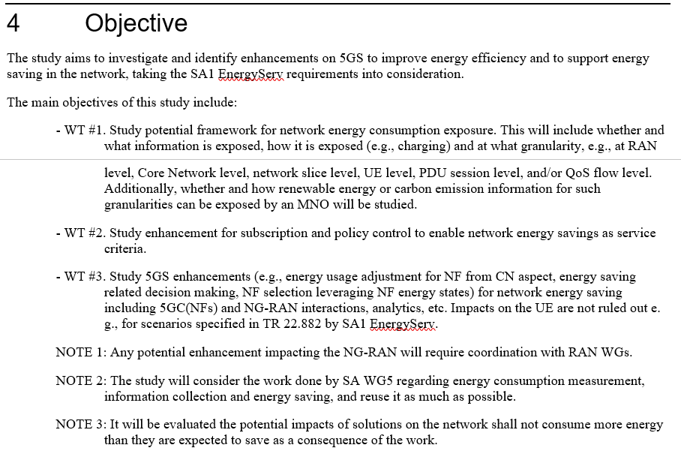

SA5 may have to consider the work done in SA2 Release 19 and vice versa.

Energy consumption and energy efficiency can be addressed at different granularities, from coarsest grain to finest grain:

1. Network Element (e.g. gNB) / Network Function (e.g. SMF, UPF)
2. Network domain (e.g. NG-RAN, 5G Core)
3. Cross-domain (e.g. Network Slice)
4. Communication Service (e.g. Voice, SMS, Private network, Network Slice as a Service)
5. Customer / Subscriber
6. UE (a customer may have multiple UEs)
7. Application / PDU session.

NOTE 1: Aforementioned items 1 to 4 have already been (in past releases), and will continue to be (in Rel-19), addressed by SA5 OAM.

NOTE 2: Aforementioned items 5 to 6 are not in the scope of SA5, given that UE-level and Customer / Subscriber-level measurements cannot be provided by OAM. Wrt. item 7, whether SA5 OAM can provide relevant PDU session-level measurements is FFS.

NOTE 3: Whether SA5 Charging may have a solution for items 5 to 7 is not addressed by this discussion paper.

NOTE 4: TR 22.882 potential requirements such as e.g. ‘the 5G system shall support a mechanism to perform energy consumption credit limit control for services’ are not in the scope of SA5 OAM.

**OA&M support to new Rel-19 RAN energy saving features**

This is still open discussion in TSG RAN. However, one can observe that several operators have mentioned ‘Energy saving’ as one of their key topics for Rel-19. Their expectations can be categorized as follows:

* UE power saving features
* Network power saving features.
* SA5 OAM may provide support for the management of network power saving features only. These features can be sub-categorized into:
* Air interface (Uu) energy saving features
* NG-RAN wide energy saving features (e.g. new Xn messages, etc.)

SA5 OAM may have to specify new performance measurements and/or new KPIs or to define new configuration parameters.

**Coordination with other SDOs / fora to build comprehensive and consistent solutions for EE**

This includes:

* Continue the existing collaboration with ETSI TC EE 02 on a unified architecture for the control and monitoring of PEE (Power, Energy, Environmental) parameters of ICT equipment in RAN sites
* Potentially start collaborating with ETSI EE EEPS / ITU-T SG5 on multi-dimensional network energy efficiency metrics (including e.g. QoE, coverage, etc.)
* Continue considering recommendations from NGMN GFN project
* Continue exchanging information with ITU-T study groups on our respective outcomes.

NOTE: ETSI OEU (Operational energy Efficiency for Users) ISG deliverables may have to be considered as well, in particular when related to carbon emissions. Collaboration with other SDOs / fora to be studied case by case.

**Other**

During Rel-19, SA5 shall continue maintaining their comprehensive view of 3GPP work on energy efficiency and energy saving started in Rel-18. This study on energy efficiency and energy saving aspects of 5G networks and services may also have to monitor other study and/or work items in SA5 or other WGs where some EE aspects are addressed, and propose harmonized solutions to them if deemed relevant.

# 4 Objective

The objectives of this study include:

**WT-1: Left-over SA5 topics from Rel-18**

WT-1.1 Study new or enhanced Energy Consumption (EC) and Energy Efficiency (EE) KPIs and measurements, e.g. for new types of network slices, RAN sharing, etc.

WT-1.2 Consideration of containerized VNFs, study enhancements to virtualized NF EC KPIs, including containerized VNF/VNFCs, and possible impacts to metrics collected from NFV MANO so as to be able to estimate their energy consumption based on e.g. their virtual CPU usage, virtual memory usage, etc.

WT-1.3 Study new use cases, requirements and solutions for energy efficiency and energy saving, applying to NG-RAN and/or 5GC and/or network slicing, (including but not limited to intent based, analytics based and AI/ML assisted energy saving)

**WT-2: New Rel-19 topics from other SA WGs**

WT-2.2 Study whether and how mapping measured or estimated energy consumption measurements on to carbon emissions is possible. Study the estimation of carbon emissions efficiency and how to achieve carbon emissions saving in the 5G system. Additionally, whether and how renewable energy consumption information can be obtained will be studied

NOTE: the exact scope of WoP#2 may have to be adjusted depending on ongoing Rel-19 SA1 work item (EnergyServ) and SA2 study item (FS_EnergySys) outcomes.

**WT-4: Coordination with other SDOs / fora to build comprehensive and consistent solutions for EE**

WT-4.1 Continue the existing collaboration with ETSI TC EE 02 on a unified architecture for the control and monitoring of PEE (Power, Energy, Environmental) parameters of ICT equipment in RAN sites

WT-4.2 Potentially start collaborating with ETSI EE EEPS / ITU-T SG5 on multi-dimensional network energy efficiency metrics (including e.g. QoE, coverage, etc.)

WT-4.3 Continue considering recommendations from NGMN GFN project

WT-4.4 Continue exchanging information with ITU-T study groups on our respective outcomes

WT-4.5 Potential collaboration with other SDOs, fora, etc.

**WT-5: Other**

WT-5.1 Continue maintaining SA5 comprehensive view of 3GPP work on energy efficiency and energy saving started in Rel-18

WT-5.2 This study on EE aspects of 5G networks and services may also have to monitor other study and/or work items in SA5 or in other WGs where some EE aspects are addressed, and propose harmonized solutions to them if deemed relevant.

Potential collaboration will be needed with the following groups: SA1, SA2, RAN WGs, NGMN GFN, ETSI

EE 02, ETSI EE EEPS, ITU-T SG5, SG11, SG13, ETSI NFV, ETSI GS OEU.

## TU estimates and dependencies

|  |  |  |  |  |  |
| --- | --- | --- | --- | --- | --- |
| **Work Task ID** | **TU Estimate**  **(Study)** | **TU Estimate**  **(Normative)** | **RAN Dependency**  **(Yes/No/Maybe)** | **SA Dependency**  **(Yes/No/Maybe)** | **Non-3GPP Dependency** |
| WT-1 | 0.5 | 0.5 | No | No | No |
| WT-2 | 2 | 1 | No | Yes (SA1, SA2) | No |
| WT-3 | 0 | 0.5 | Yes (RAN1, RAN2, RAN3) | No | No |
| WT-4 | 1 | 0.5 | No | No | Yes (ETSI EE, ETSI NFV, NGMN, ITU-T, …) |
| WT-5 | 0.5 | 0.5 | Yes (RAN1, RAN2, RAN3) | Yes (all SA WGs) | No |

**Total TU estimates for the study phase: 4**

**Total TU estimates for the normative phase: 4**

**Total TU estimates: 8**

# 5 Expected Output and Time scale

|  |  |  |  |  |  |
| --- | --- | --- | --- | --- | --- |
| New specifications {One line per specification. Create/delete lines as needed} | | | | | |
| Type | TS/TR number | Title | For info  at TSG# | For approval at TSG# | Rapporteur |
| Internal TR | 28.880 | Study on energy efficiency and energy saving aspects of 5G networks and services | TSG#104  (June 2024) | TSG#106  (Dec. 2024) | Secondary Rapporteur: Ashutosh Kaushik (Samsung) |

|  |  |  |  |
| --- | --- | --- | --- |
| Impacted existing TS/TR {One line per specification. Create/delete lines as needed} | | | |
| TS/TR No. | Description of change | Target completion plenary# | Remarks |
|  |  |  |  |
|  |  |  |  |

# 6 Work item Rapporteur(s)

Primary Rapporteur: Jean-Michel Cornily (Huawei), jean.michel.cornily@huawei.com

Secondary Rapporteur: Ashutosh Kaushik (Samsung), ashutosh19.k@samsung.com

# 7 Work item leadership

SA5

# 8 Aspects that involve other WGs

The following WGs address aspects related to this study:

- SA1 and SA2, for aspects described in WT-2 and WT-5

- RAN1, RAN2 and RAN3, for aspects described in WT-3 and WT-5.

# 9 Supporting Individual Members

|  |
| --- |
| Supporting IM name |
| Huawei |
| China Mobile |
| Deutsche Telekom |
| Rakuten Mobile |
| Vodafone |
| AsiaInfo |
| CATT |
| China Telecom |
| China Unicom |
| ZTE |
| Verizon |
| Nokia |
| Telefonica |
| NEC |
| Ericsson |
| PI Works |
| Samsung |
| Microsoft |
| AT&T |
| DISH Network |