3GPP TSG-SA5 Meeting #158 S5-247150d1

Orlando, United States, 18th Nov 2024 - 22nd Nov 2024
CR-Form-v12.3
CHANGE REQUEST
 | 32.130 | CR | 0037 | rev | - | Current version: | 18.3.0
For HELP on using this form: comprehensive instructions can be found at
http://www.3gpp.org/Change-Requests.

Proposed change affects: | UICC apps |  | ME |  | Radio Access Network | X | Core Network | X

Title: | Rel-19 CR TS 32.130 Add concepts and background for Indirect Network Sharing
Source to WG: | China Unicom
Source to TSG: | SA5
Work item code: | DUMMY |  |  |  |  |  | Date: |  |  | 2024-11-08
Category: | B |  |  |  |  |  | Release: |  |  | Rel-19
 | Use one of the following categories:  F (correction)  A (mirror corresponding to a change in an earlier release)  B (addition of feature),  C (functional modification of feature)  D (editorial modification)  Detailed explanations of the above categories can  be found in 3GPP TR 21.900. |  |  |  |  |  |  |  | Use one of the following releases:  Rel-8 (Release 8)  Rel-9 (Release 9)  Rel-10 (Release 10)  Rel-11 (Release 11)  …  Rel-17 (Release 17)  Rel-18 (Release 18)  Rel-19 (Release 19)  Rel-20 (Release 20)
Reason for change: |  | As agreed in S5-246289, WT-2 Management aspects of Indirect Network Sharing is agreed.  According to the definition in clause TS 22.261 and TS 23.501, Indirect Network Sharing is a type of NG-RAN Sharing in which the communication between the Shared NG-RAN and the Participating Operator’s core network is routed through the Hosting NG-RAN Operator’s core network. In RAN Sharing operations, NG-RAN resources can be used by multiple network operators. Indirect Network Sharing is one of the possible sharing methods.
Summary of change: |  | Add concepts and background for Indirect Network Sharing
Consequences if not approved: |  | Missing the explanationof the concepts and background for Indirect Network Sharing
Clauses affected:
 |  | Y | N
Other specs |  |  | X | Other core specifications |  |  |  | TS/TR ... CR ...
affected: |  |  | X | Test specifications |  |  |  | TS/TR ... CR ...
(show related CRs) |  |  | X | O&M Specifications |  |  |  | TS/TR ... CR ...
Other comments:
This CR's revision history:

1st Change

4.1 RAN sharing scenarios
Various network sharing scenarios exist, amongst which one category is RAN sharing which can be divided into the following (non exhaustive) list of sub-categories:
- Passive RAN sharing, also known as infrastructure sharing (including site sharing).
- Active RAN sharing, where active network elements of the RAN are shared:
- RAN-only sharing (MOCN; see TS 23.251 [5] and TS 23.501 [7]), i.e. BTSs / BSCs (respectively NodeBs / RNCs and eNodeBs) in a 2G Radio Access Network (respectively a 3G Radio Access Network and an E-UTRA network) , and gNBs in a 5G NR network;
- Gateway Core Network (GWCN; see TS 23.251 [5]), in which not only the Radio Access Network elements are shared but also part or all of the Core Network elements (there is no passive core network sharing).
- Indirect Network Sharing (see TS 23.501[7]), in which Core Network functions are connected and Radio Access Network functions are shared through the connections of Core Network functions.
The following figures depict the MOCN scenarios:

Figure 4.1-1: E-UTRAN MOCN network sharing scenario

Figure 4.1-2: NG-RAN MOCN Network Sharing with same cell identity broadcast scenario

Figure 4.1-3 NG-RAN MOCN Network Sharing with multiple cell identity broadcast scenario
In GWCN, besides sharing Radio Access Network nodes, the POPs also share Core Network nodes (see TS 23.251 [5] – clause 4.1).
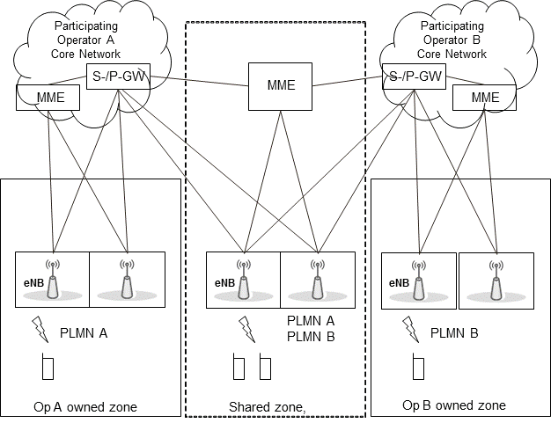
Figure 4.1-4: GateWay Core Network (GWCN)
End of Changes

