3GPP TSG-SA5 Meeting #158 S5-247125
Orlando, USA, 18- 22 November 2024

Source: Rakuten Mobile, TELUS, CMCC, Mavenir

Title: pCR 28.869 enhance use case description requirement and solutions for data streaming for cloud native network function

Document for: Approval
Agenda Item: 6.19.6

1 Decision/action requested
The group is asked to discuss and approve.

2 References
[1] 3GPP TR 28.869 v0.4.0 Study on cloud aspects of management and orchestration
[2] SP-231730 New SID: Study on Cloud Aspects of Management and Orchestration

3 Rationale
This contribution enhance the content of use case, requirement and solution for WT-2 use case 2, data streaming for cloud native network function.

4 Detailed proposal
It proposes to make the following changes to TR 28.869 [1].
1st Change

5.2.2 Use case #2: data streaming for cloud-native NF deployment

Description
Data streaming in large scale cloud native deployment requires high performance for moving large amount of data among microservices in real-time, high availability for strong resiliency and fault protection (e.g. a failure in central cloud could affect the entire city) and high scalability for the dynamic scaling of cloud-native application workloads.
Currently 3GPP management system support WebSocket based data streaming for PM, tracing and analytic [10] which establish single or multiple point-to-point connections between the streaming data reporting MnS consumer and MnS producer. In cloud native deployment, both NFs and management system are realized in many micro-services whose workload instances are running in parallel, dynamically scaled in and out, and maybe distributed across multiple server nodes and cloud sites. Maintaining, scaling, and failure healing for the dedicated keepalive connections among the micro-services in a more dynamic environment becomes more expensive in terms of the complexity and the resource taken comparing against conventional deployment environment.
In cloud native deployment, more efficient, highly scalable, and fault-tolerant streaming solution allowing parallel streaming from the micro-services may be needed. Furthermore, the management of streaming connections, resource allocations, scaling, and resiliency for data streaming in cloud native environment is a complicated task. The 3GPP management system shall evolve to address the challenges considering the use of existing industry solutions.

2nd Change

5.2.2.3 Potential solutions

5.2.2.3.1 Solution #1: Management data streaming based on message bus
This potential solution proposes the addition of a new reporting method for management data for network functions running in the cloud. The solution proposes the use of message bus for the reporting of management data from the MnS producer to the MnS consumer as shown in figure 5.2.2.3.1-1.
MnS producer
MnS consumer
Message bus communication

Management data job control (e.g., PM or trace job creation, PM metric subscription, conveying end-point information)

Figure 5.2.2.3.1-1: Potential solution for management data streaming based on message bus
The proposed solution enables MnS producer(s) to stream management data to the message bus when ready while also enabling the MnS consumer(s) to consume the data from the message bus whenever they need to. In addition, this potential solution decouples the production of management data from the consumption of management data.
Annex B provides an implementation example using the management data streaming solution based on message bus.
3rd Change

Annex <B> (informative):
Example implementations using management data streaming solution based on message bus
Figures B-1 below illustrates an example implementation using the potential solution for data streaming based on message bus. An NF sends the produced data to the message broker via message bus communication protocol (e.g. Kafka binary protocol over TCP) and application(s) in the management system consumes data from the message broker. The MnS consumer can request e.g. creation of the PM or trace jobs in the NF, subscribe to PM metrics as well as convey message broker end-point(s) and other related configurations to the MnS producer.

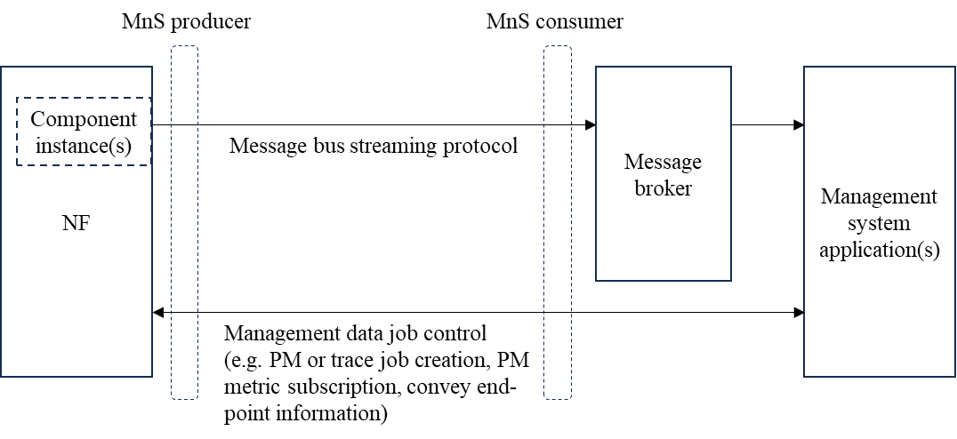
Figure B-1: Implementation example using management data streaming solution based on message bus

End of changes

