3GPP TSG-SA5 Meeting #158 S5-247125
Orlando, USA, 18- 22 November 2024

Source: Rakuten Mobile, TELUS, CMCC, Mavenir

Title: pCR 28.869 enhance use case description requirement and solutions for data streaming for cloud native network function

Document for: Approval
Agenda Item: 6.19.6

1 Decision/action requested
The group is asked to discuss and approve.

2 References
[1] 3GPP TR 28.869 v0.4.0 Study on cloud aspects of management and orchestration
[2] SP-231730 New SID: Study on Cloud Aspects of Management and Orchestration

3 Rationale
This contribution enhance the content of use case, requirement and solution for WT-2 use case 2, data streaming for cloud native network function.

4 Detailed proposal
It proposes to make the following changes to TR 28.869 [1].
1st Change

5.2.2 Use case #2: data streaming for NF realized by NF Deployment

Description
Data streaming in large scale cloud native deployment requires high performance for moving large amount of data among microservices in real-time, high availability for strong resiliency and fault protection (e.g. a failure in central cloud could affect the entire city) and high scalability for the dynamic scaling of cloud-native application workloads.
Currently 3GPP management system support WebSocket based data streaming for PM, tracing and analytic [10] which establish single or multiple point-to-point connections between the streaming data reporting MnS consumer and MnS producer. In cloud native deployment, both NFs and management system are realized in many micro-services whose workload instances are running in parallel, dynamically scaled in and out, and maybe distributed across multiple server nodes and cloud sites. Maintaining, scaling, and failure healing for the dedicated keepalive connections among the micro-services in a more dynamic environment becomes more expensive than conventional deployment environment.
In cloud native deployment, more efficient, highly scalable, and fault-tolerant streaming solution allowing parallel streaming from the micro-services may be needed. Furthermore, the management of streaming connections, resource allocations, scaling, and resiliency for data streaming in cloud native environment is a complicated task. The 3GPP management system shall evolve to address the challenges considering the use of existing industry solutions.

2nd Change

5.2.2.3 Potential solutions

5.2.2.3.1 Solution #1: Management data streaming based on message bus
This potential solution proposes the addition of a new reporting method for management data for network functions running in the cloud. The solution proposes the use of message bus for the reporting of management data from the MnS producer to the MnS consumer as shown in figure 5.2.2.3.1-1.
MnS producer
MnS consumer
Message bus communication

Management data job control (e.g., PM or trace job creation, PM metric subscription, conveying end-point information)

Figure 5.2.2.3.1-1: Potential solution for management data streaming based on message bus
The proposed solution enables MnS producer(s) to stream management data to the message bus when ready while also enabling the MnS consumer(s) to consume the data from the message bus whenever they need to. In addition, this potential solution decouples the production of management data from the consumption of management data.
Annex X provides an example interaction between MnS producer and MnS consumer for management data streaming based on message bus.

Annex <X> (informative): Example interaction between MnS producer and MnS consumer for management data streaming based on message bus

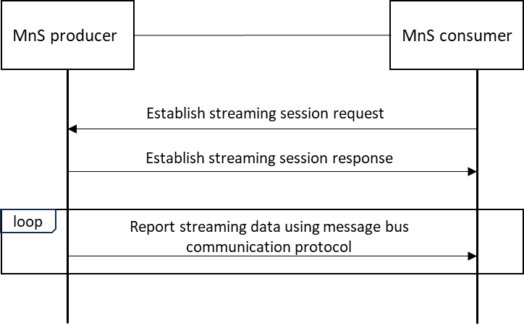
Figure X-1: Interactions between MnS producer and MnS consumer for management data streaming based on message bus
The interactions between MnS producer and MnS consumer for management data streaming based on message bus is illustrated in Figure X-1. The MnS consumer send request to the MnS producer to establish a message bus streaming session containing message bus communication related configurations, e.g. streaming session ID (equivalent to Kafka topic ID if Kafka is used), URI endpoints, partition information (if Kafka is used) and PM metrics list etc. The MnS producer after applying the configurations sends response to the MnS consumer. The MnS producer start reporting the streaming data to the MnS consumer using the configurated parameters and using message bus communication protocol, e.g. Kafka binary protocol over TCP.
End of changes

