3GPP TSG-SA5 Meeting #158 S5-247124
Orlando, USA, 18 - 22 November 2024

Source: Nokia

Title: Rel-19 pCR TR 28.869 Modify requirements, add new potential solution and evaluation for data streaming for cloud native NF

Document for: Approval
Agenda Item: 6.19.6

1 Decision/action requested
In this box give a very clear / short /concise statement of what is wanted.

2 References
[1] 3GPP TR 28.869, " Study on cloud aspects for management and orchestration."

3 Rationale
This pCR proposes to modify the use case requirements in clause 5.2.2 to remove the solution-specific aspects and add a new potential solution to support data streaming of management data that leverages the benefits of cloud native deployments. In addition, this pCR adds a section of evaluation of solutions related to data streaming for cloud native network function.

4 Detailed proposal
It is proposed that the following changes be made to clause 5.2.2 of TR 28.869 [1].

Begin Change

5.2.2.3 Potential solutions

5.2.2.3.X Solution #X: Management data streaming for cloud-native NF deployments
The proposed solution relies on existing streaming mechanisms to stream management data between the MnS producer and MnS consumer (as defined in clause 12.5 of TS 28.532[10]) as shown in Figure 5.2.2.3.X-1.
The proposed solution supports cloud-native deployments on the MnS producer and MnS consumer sides which comes with the benefits of scalability, redundancy and fault-tolerance. In terms of implementation of the proposed solution, a load balancer between the MnS consumer(s) and MnS producer(s) supports the distribution of the web-socket connections requests among the different MnS producers. If the MnS producer(s) leverage micro-service-based stateless architectures typical of cloud-native deployments, then it’s implementation specific how the MnS producers keep track of the stateful nature of the web-socket connection.

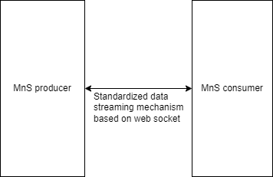
Figure 5.2.2.3.X-1: Management data streaming for cloud-native NF deployments

End of Change

