3GPP TSG-SA5 Meeting #158 S5-247113
Orlando, USA, 18 - 22 November 2024

Source: Nokia, Ericsson

Title: Rel-19 pCR TR 28.869 Resolve editor's note in Annex F and add note to Annex D and Annex E

Document for: Approval
Agenda Item: 6.19.6

1 Decision/action requested
In this box give a very clear / short /concise statement of what is wanted.

2 References
[1] 3GPP TR 28.869, " Study on cloud aspects for management and orchestration."

3 Rationale
This pCR resolves the editor’s note in Annex F of TR 28.869 [1] by updating the content and Figure F-1 to show the interactions between the 3GPP management system and the orchestration and management entity for the termination of the NF deployment instance. Further, this pCR replaces the term “cloud-native NF” with NF deployment as agreed. In addition, this pCR adds a note to Annexes D and E to clarify that at the normative phase, further clarification is required to decouple MOI LCM from the NF deployment LCM.

4 Detailed proposal
It is proposed that the following changes be made to Annex F, Annex D and Annex E of TR 28.869 [1].

First Change

Annex <F>: Example scenario using interactions with orchestration and management entity for termination of NF deployment instances
Figure F-1 depicts an example scenario for interaction with an orchestration and management entity for the termination of a 3GPP NF instance.

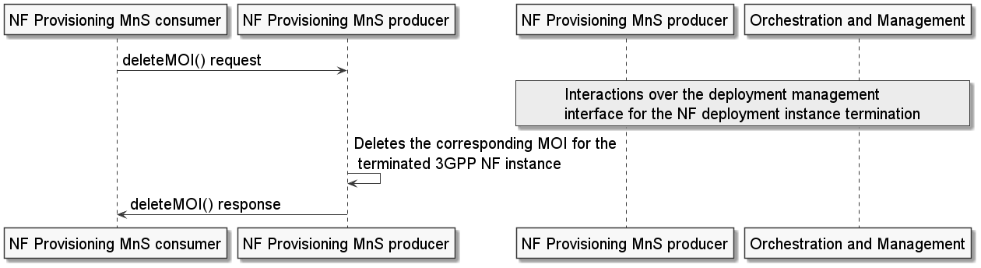
Figure F-1: Example scenario for interaction with the orchestration and management entity for the termination of a NF deployment instance
An authorized NF provisioning MnS Consumer requests the termination of a3GPP NF instance from the NF provisioning MnS producer by sending a deleteMOI request with DN of the 3GPP NF MOI.
The NF provisioning MnS producer responsible for interacting with the orchestration and management (O & M) entity invokes interactions with an O & M entity for the termination of the corresponding NF deployment instance(s) for the 3GPP NF instance. The NF provisioning MnS producer deletes the MOI of the 3GPP NF instance and sends the deleteMOI response to the NF provisioning MnS Consumer with the DN of the deleted MOI of the 3GPP NF instance.
Editor’s NOTE: It is to be clarified how to de-couple the MOI LCM from the NF deployment LCM.
Note: If the orchestration and management entity is ETSI NFV MANO, the interactions over the NF deployment management reference point are as specified in clause 7.12 of 28.531 [7].

Second Change

Annex <D> :Example scenario using interactions with orchestration and management entity for the creation of NF deployment instances
Figure D-1 depicts an example scenario for the interaction between the 3GPP management system and the orchestration and management entity for the creation of a NF deployment instance.
An authorized NF provisioning MnS Consumer requests the creation of a 3GPP NF by creating the ManagedFunction IOC on the NF provisioning MnS producer specifying the network function related requirements. If the 3GPP NF contains containerized or virtualized parts, the NF provisioning MnS producer derives the associated requirements for the NF deployment based on the network function related requirements.
Note: For the network function related requirements, see information model definition for NR NRM in clause 4 and information model definition for 5GC NRM in clause 5 in TS 28.541[17].
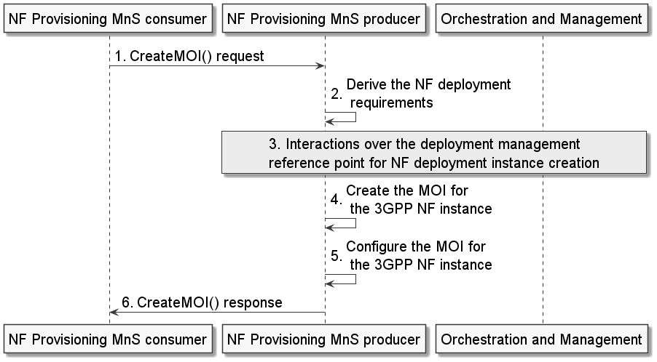
Figure D-1: Example scenario for interaction with orchestration and management entity for 3GPP NF creation procedure
The NF provisioning MnS producer invokes interactions with an orchestration and management entity for the creation of the NF deployment instance. Following the completion of the required interactions with the orchestration and management entity, the NF provisioning MnS producer creates the MOI for the 3GPP NF instance and configures the new MOI with corresponding information. The NF provisioning MnS producer sends the createMOI response to the NF provisioning MnS Consumer with the DN of the MOI of the 3GPP NF instance.
Editor’s NOTE: It is to be clarified how to de-couple the MOI LCM from the NF deployment LCM.
Note: If the orchestration and management entity is ETSI NFV MANO, the interactions over the deployment management reference point are as specified in clause 7.10 of 28.531[7].

Third Change

Annex <E> :Example scenario using interactions with orchestration and management entity for modification of NF deployment instances
Figure E-1 depicts an example scenario for interaction with orchestration and management entity for modification of an instance of a NF deployment.
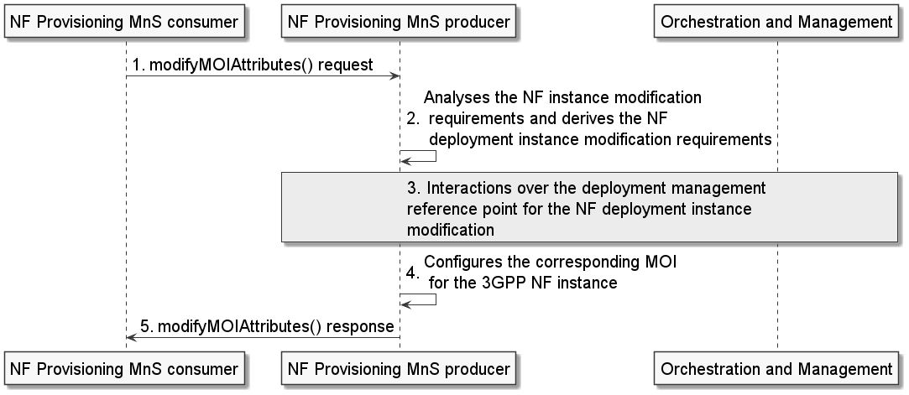
Figure E-1: Example scenario for interaction with orchestration and management entity for modification of an instance of a NF deployment
An authorized NF provisioning MnS Consumer requests modification of a 3GPP NF instance from the NF provisioning MnS producer by sending a modifyMOIAttributes request with DN of the MOI for the ManagedFunction and the network function related modification requirements. The NF provisioning MnS producer analyses the 3GPP NF instance modification requirements and derives the NF deployment modification requirements.
The NF provisioning MnS producer invokes interactions with an orchestration and management entity for the modification of the NF deployment instance. Following the completion of the required interactions with the orchestration and management entity, the NF provisioning MnS producer reconfigures the corresponding MOI for the 3GPP NF instance and sends the modifyMOIAttributes response to the NF provisioning MnS Consumer.
EDITOR’s NOTE: It is to be clarified how to de-couple the MOI LCM from the NF deployment LCM.
Note: If the orchestration and management entity is ETSI NFV MANO, the interactions over the deployment management reference point are as specified in clause 7.10 of 28.531[7].

End of Changes

