3GPP TSG-SA5 Meeting #158 S5-247112
Orlando, USA, 18 - 22 November 2024

Source: Rakuten Mobile

Title: pCR TR 28.869 Add new solution for termination of NF instance

Document for: Approval
Agenda Item: 6.19.6

1 Decision/action requested
For approval

2 References
- 3GPP TR 28.869 v1.1.0 Study on cloud aspects of management and orchestration.

3 Rationale
The contribution proposes to add a new solution for termination of NF instance

4 Detailed proposal
It is proposed to make the following changes to TR 28.869 [1].
1st Change

5.2.5.3.1 Use of deployment management reference point
In this solution the 3GPP management system interacts with an orchestration and management system using the deployment management reference point as described in clause 5.2.1.3, for termination of a NF deployment instance.
Figure 5.2.5.3.1-1 depicts a high-level view of proposed procedure for termination of a NF deployment instance.

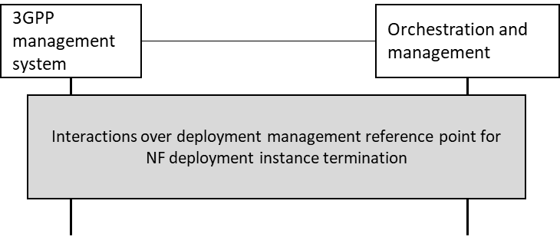
Figure 5.2.5.3.1-1: High level procedure for NF deployment instance termination
The 3GPP management system requests termination of a NF deployment instance from an orchestration and management system for LCM of NF deployment instances over deployment management reference point, and receives the result of the request for termination of the NF deployment instance from the orchestration and management system.
Annex F provides an example scenario using interactions with orchestration and management system for termination of NF deployment instances. If the orchestration and management system is ETSI NFV MANO, the interactions over deployment management reference point are as specified in clause 7.12 of 28.531 [7].
In some deployment scenarios, the descriptor could be used with information required to support a single NF deployment instance. In such a case, the 3GPP management system deletes the descriptor which results in subsequent termination of the corresponding NF deployment instance and remove its corresponding cloud resources.

End of Changes

