3GPP TSG-SA5 Meeting #158 S5-247111
Orlando, USA, 18 - 22 November 2024

Source: Rakuten Mobile

Title: pCR TR 28.869 Add new solution for modification of NF instance

Document for: Approval
Agenda Item: 6.19.6

1 Decision/action requested
For approval

2 References
- 3GPP TR 28.869 v1.1.0 Study on cloud aspects of management and orchestration.

3 Rationale
The contribution proposes to add a new solution for modification of NF instance

4 Detailed proposal
It is proposed to make the following changes to TR 28.869 [1].
1st Change

5.2.4.3.1 Use of deployment management reference point
In this solution the 3GPP management system interacts with an orchestration and management system using the deployment management reference point as described in clause 5.2.1.3, for modification of a NF Deployment instance.
Figure 5.2.4.3.1-1 depicts a high-level view of proposed procedure for modification of a NF Deployment instance.

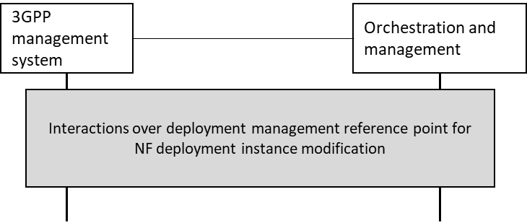
Figure 5.2.4.3.1-1: High level procedure for NF Deployment instance modification procedure
The 3GPP management system requests modification of a NF Deployment instance over deployment management reference point, and receives the result of the request for modification of the NF Deployment instance from the orchestration and management system.
If the orchestration and management system is ETSI NFV MANO, the interactions over deployment management reference point are as specified in clause 7.11 of TS 28.531 [7].
In some deployment scenarios, the descriptor could contain information required to support a single NF deployment instance. In such a case, the 3GPP management system modifies the descriptor which results in subsequent modification of the corresponding NF deployment instance.

End of Changes

