3GPP TSG-SA5 Meeting #158 S5-247111
Orlando, USA, 18 - 22 November 2024

Source: Rakuten Mobile

Title: pCR TR 28.869 Add new solution for modification of NF instance

Document for: Approval
Agenda Item: 6.19.6

1 Decision/action requested
For approval

2 References
- 3GPP TR 28.869 v1.1.0 Study on cloud aspects of management and orchestration.

3 Rationale
The contribution proposes to add a new solution for modification of NF instance

4 Detailed proposal
It is proposed to make the following changes to TR 28.869 [1].
1st Change

5.2.4.3.X Use of deployment management reference point based on declarative descriptor
In this case, as illustrated in figure 5.2.4.3.X-1, the modified requirements of the deployment of a NF deployment instance are conveyed from the 3GPP management system to the orchestration and management system via a modified version of the declarative descriptor that was used for creation of the NF deployment instance.
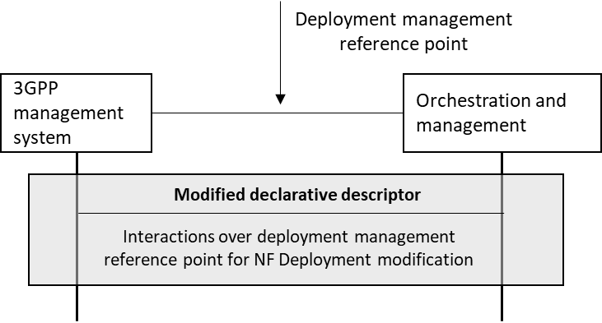
Figure 5.2.4.3.X-1. interaction between 3GPP management system and orchestration and management system using deployment management reference point based on declarative descriptor

End of Changes

