**3GPP TSG-SA5 Meeting #158 *S5-247106d2***

Orlando, USA, 18 - 22 November 2024

**Source:** **NTT DOCOMO, China Mobile**

**Title: pCR TR28.869 Cloud-native VNF traffic enforcer solution and evaluation**

**Document for: Approval**

**Agenda Item: 6.19.6**

# 1 Decision/action requested

***In this box give a very clear / short /concise statement of what is wanted.***

# 2 References

1. 3GPP TR 28.869 v1.1.0 Study on cloud aspects of management and orchestration.

# 3 Rationale

The contribution proposes to add evaluation of solutions for Cloud-native VNF traffic management. It also updates the solution description.

# 4 Detailed proposal

It proposes to make the following changes to TR 28.869 [1].

|  |
| --- |
| **1st Change** |

# 5 Use cases, potential requirements, and potential solutions

## 5.1 Use of VNF generic OAM functions

Editor's Note: This clause describes the use cases, issues, requirements, and solutions related to WT-1.

### 5.1.3 Use case #3: Cloud-native VNF Traffic management

#### 5.1.3.1 Description

Effective traffic management for cloud-native functions is essential to ensure high quality of service levels. Nevertheless, especially in containerized deployments additional challenges need to be considered since many OS containers realizing the cloud-native VNF instances are usually deployed per host, while OS containers are often created and destroyed rapidly, requiring the network to adapt quickly to topological changes. In the context of a cloud-native VNF, traffic management includes controlling the inbound/outbound traffic to, from and within the cloud-native VNF instance.

Traffic management actions to be considered in a 3GPP management system context are, for example, controlling the rate of incoming requests to prevent overloading services and directing traffic to different VNFCs realizing a cloud-native VNF. These actions can surge in the context of diverse OAM procedures of maintenance, re-configuration, and upgrade of NFs, etc. managed through the 3GPP management system.

The 3GPP management system needs to be able to support an operator to manage and orchestrate the traffic management actions for cloud-native VNF instances.

#### 5.1.3.2 Potential requirements

**REQ-CVNF_TM-1** The 3GPP management system should have the capability to support traffic management of cloud-native VNF instances.

**REQ-CVNF_TM-2** The reference point between 3GPP management system and external OAM entity should have the capability enabling the 3GPP management system to interact with external (non-3GPP) traffic management entities for the purpose of performing traffic management for cloud-native VNF instances.

#### 5.1.3.3 Potential solutions

##### 5.1.3.3.1 Traffic Enforcer function

As shown in figure 5.1.3.3.1-1, this solution introduces a platform entity that interacts with 3GPP management system for traffic management of cloud-native VNFs via a new PaaS reference point.

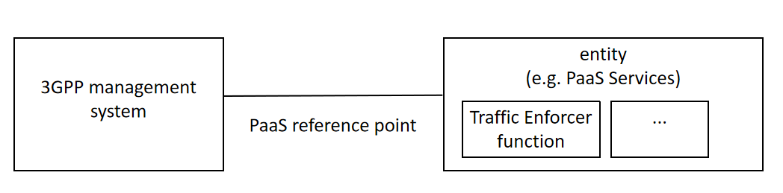

Figure 5.1.3.3.1-1: Traffic management of cloud native VNF

The solution proposes using Traffic Enforcer function defined in ETSI GS ISG NFV-IFA 049 [2], which is one of the VNF generic OAM functions. Some key functionalities supported by the Traffic Enforcer function are the capability to perform the required traffic blocking and rerouting operations on the VNFC instances for example in cases where a cloud-native VNF is under maintenance.

A cloud-native VNF internal component (i.e., VNFC using the ETSI NFV terminology) provides a defined sub-set of the cloud-native VNF's functionality. Refer to ETSI GR NFV 003 [11] for a definition of VNFCs. A single cloud-native VNF can be comprised by multiple VNFCs connected through an internal VNF Virtual Link.

Traffic management of cloud-native VNF instances can enable MnS producers like those exposing the MnS provision service e.g., when applying certain configuration to the NF and need to isolate certain components from others connected via the cloud-native VNF internal network.

According to ETSI GS ISG NFV-IFA 049 [2] Traffic Enforcer functionality can be called by functions residing inside the 3GPP management system or other VNF generic OAM functions (e.g. the Upgrade VNF function) or other PaaS Services (e.g. the Policy Agent).

The present solution addresses the potential requirement REQ-CVNF_TM-2.

Editor’s Note: update the solution description to better reflect the impact to the 3GPP management system.

|  |
| --- |
| **2nd Change** |

|  |
| --- |
| **End of Changes** |