3GPP TSG-SA5 Meeting #158 S5-247104
Orlando, USA, 18 - 22 November 2024

Source: Rakuten Mobile

Title: pCR TR 28.869 Add terminology for descriptor

Document for: Approval
Agenda Item: 6.19.6

1 Decision/action requested
For approval

2 References
- 3GPP TR 28.869 v1.1.0 Study on cloud aspects of management and orchestration.

3 Rationale
The contribution proposes to add terminology for the word “descriptor”

4 Detailed proposal
It is proposed to make the following changes to TR 28.869 [1].
1st Change

4.2 Terminology considerations

4.2.1 Terminology and concepts used in the present document
3GPP network function (NF) is specified in TS 23.501 [41]:
Network Function: A 3GPP adopted or 3GPP defined processing function in a network, which has defined functional behaviour and 3GPP defined interfaces.
To support cloud native concepts in 3GPP, an NF Deployment realizes [part of] 3GPP NF[s]. The use of NF Deployment is not limited by the technology, e.g. VM based, or container based.
A NF Deployment instance is a deployed software instance designed to run on cloud, deployed and managed using technologies and principles evolving in the cloud eco system. One fundamental cloud native principle is to partition systems into smaller, separately manageable parts. This allows for faster and more automated upgrades, improve operational efficiency and shorter time to market for new services.
A NF Deployment descriptor is a collection of all necessary information needed by the orchestration and management entity to select and configure the appropriate cloud resources and to deploy the NF Deployment instance.
The present study proposes, but does not limit, to use NF Deployment as concept and terminology in the present document. The instance(s) of NF Deployment is/are created, modified, or terminated through LCM related operations using an orchestration and management system.
NOTE 1: The term "cloud native VNF" and "NF deployment" used in the present document are closely related, nevertheless there is no consensus on their definition and concepts used in this present document and are expected to be investigated in the normative phase.
NOTE 2: The term "cloud native VNF" is used in clause 5.1 and "NF deployment" is used in clause 5.2 of the present document, these terms may all be updated in the normative phase.

2nd Change

4.2.2 Terminology alignment with ETSI NFV
In ETSI NFV according to ETSI GR NFV 003 [11]:
- terms virtualization and cloudification are used interchangeably.
- the terms "cloud-native VNF" and "cloud-native NF" are used interchangeably.
- a containerized NF, a container-based NF, a containerized VNF, and a container-based VNF refer to the same concept (i.e. VNF whose software components are deployed within OS containers) and are used interchangeably.
- the descriptor is VNFD, as per ETSI NFV specifications (see ETSI GS NFV-IFA 011 [22])
The above relationships and terminology are considered for example by ETSI GS NFV-IFA 049 [2] when describing the use of VNF generic OAM functions.
EXAMPLE: When describing that the Log aggregator supports the capability to collect different types of logs from different VNFs, both containerized VNFs and VM-based VNFs are considered.
3rd Change

5.2.3 Use case #3: Creation of a NF Deployment instance
…

5.2.3.3 Potential solutions
…

5.2.3.3.2 Use of deployment management reference point based on declarative descriptor
In this solution the 3GPP management system interacts with an orchestration and management system using the deployment management reference point as described in clause 5.2.1.3 for creation of a NF deployment instance. The deployment requirements for creating a workload of a NF are conveyed from the 3GPP management system to the orchestration and management system via a declarative descriptor.
Figure 5.2.3.3.2-1 depicts a high-level view of proposed procedure for creation of a NF deployment instance based on declarative descriptor.
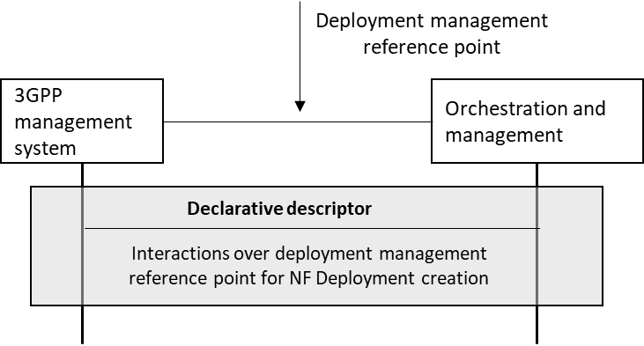
Figure 5.2.3.3.2-1: Interaction between 3GPP management system and orchestration and management system using deployment management reference point based on declarative descriptor
The declarative descriptor provides a declaration in high-level on what to be achieved by the orchestration and management system rather than how to achieve it.
If the orchestration and management system is ETSI NFV MANO, the interactions over deployment management reference point are as specified in clause 7.10 of 28.531 [7]. For the case of NFV-MANO, the declarative descriptor is VNFD, as per ETSI NFV specifications (see ETSI GS NFV-IFA 011 [22]).
NOTE: In case the orchestration and management system is ETSI NFV MANO, VNFD is defined to convey the deployment requirement information. For other industry solutions, currently there is no standardized descriptor.

End of Changes

