**3GPP TSG-SA5 Meeting #157 *S5-246440***

**14 - 18 October 2024, Hyderabad, India**

**Source: Nokia, Nokia Shanghai Bell**

**Title:** **Rel-19 pCR TR28.867 General CCL model and use for FM CLLs**

**Document for: Approval**

**Agenda Item: 6.19.4**

# 1 Decision/action requested

***The group is asked to discuss and agree on the proposal.***

# 2 References

[1] 3GPP TR 28.867-041 “Closed control loop management”.

# 3 Rationale

The CCL study 28.867 includes a use case on for fault management . The solution shows the required information but does not show how the CCL may be modelled to contain this information besides other information on other purposes including network problem resolution or service assurance.. This pCR adds the general model for a CCL including how it supports the difeent specific purposes.

# 4 Detailed proposal

|  |
| --- |
| **Start of modification** |

# 6 Conclusions and Recommendations

## 6.1 Closed control loop and intent

Intent and closed control loops are different, but complementary concepts as discussed in clause 4.x in Table 4.x.1. An intent manager may utilize one or several closed control loops for implementing the assurance of intent requirements. This means intent managers can become consumers of closed control loops.

One situation is that a closed control loop that provides (MnS producer) an intent API is configured using intent. This closed control loop therefore meets the definition of being an intent manager in the role of intent handler. Another situation is that the closed control loop acts as the intent owner by sending an intent. This means, that closed control loop can either be utilized as integral part of intent management or directly implement intent management. However, the functional scope of intent management exceeds the proposed scope of closed control loop. Intent management considers, for example, the negotiation of requirements and intent handlers are already driving deployment decisions and processes. Furthermore, the reporting on achievements and results to the source of intent is an integral part of intent management and realized through intent reports.

The normative work should follow the principles in the conclusion.

## 6.2 Dynamic CCL Creation

It is recommended to normatively define the use case and requirements as proposed in clause 5.1.1 and 5.1.2 respectively.

It is recommended to develop normative specification for the use case following the solution and its evaluation in clause 5.1.3 and 5.1.4 respectively.

The solutions described in the use cases are not final, they can be elaborated during normative phase

## 6.3 Triggered CCL

It is recommended to normatively define the use case and requirements as proposed in clause 5.2.1 and 5.2.2 respectively.

It is recommended to develop normative specification for the use case following the solution and its evaluation in clause 5.2.3 and 5.2.4 respectively.

The solutions described in the use cases are not final, they can be elaborated during normative phase

## 6.4 Use case 4: closed control loop for problem recovery

The use case of closed control loop for problem recovery is introduced in clause 5.4. In this scenario, the MnS producer for CCL management needs to support the capability to allow the MnS consumer to request a CCL for resolving the network problems identified in the MDA report and get the result of network problem resolved by the closed control loop.

The solution proposes to introduce the ProblemRecoveryRequest IOC to represent the MnS consumer's requirements for resolving network problem and ProblemRecoveryReport IOC to represent the result of network problem resolved by the closed control loop.

It is recommended to introduce the use case, requirements and corresponding solution for closed control loop for problem recovery in normative work. The detailed solution in clause 5.4.3 is used as baseline for normative work with following additional considerations during normative phase:- Clarify the goal and target for the ACCL for problem recovery during normative phase.

- The information model defined in clause 5.4.3 may be restructured to integrate with information models defined in other use cases during the normative phase.

The solutions described in the use cases are not final, they can be elaborated during normative phase

## 6.5 CCL creation based on Historical CCL data

It is recommended to normatively define the use case and requirements as proposed in clause 5.3.1 and 5.3.2 respectively.

It is recommended to develop normative specification for the use case following the solution and its evaluation in clause 5.3.3 and 5.3.4 respectively.

The solutions described in the use cases are not final, they can be elaborated during normative phase

## 6.6 CCL for fault management

It is recommended to normatively define the use case and requirements as proposed in clause 5.5.1 and 5.5.2 respectively.

It is recommended to develop normative specification for the use case following the solution and its evaluation in clause 5.5.3 and 5.5.4 respectively.

The solutions described in the use cases are not final, they can be elaborated during normative phase

## 6.7 CCL conflicts management

It is recommended to normatively define the use case and requirements as proposed in clause 5.6.1and 5.6.2 respectively.

It is recommended to develop normative specification for the use case following the solution and its evaluation in clause 5.6.3 and 5.6.4 respectively.

It is recommended to develop normative specification for :

- the "hierarchical coordination with distributed execution" approach as the means for handling conflicts among CCLs.

- the use case on goal targets conflicts handling following the solution in in clause 5.6.3.3 on goal targets coordination.

- the use case on direct actions conflicts handling following the solution in in clause 5.6.3.4 on direct actions coordination.

- the use case on Indirect targets conflicts handling following the solution in in clause 5.6.3.5 on Indirect targets coordination.

- the use case on Action-execution-time conflicts handling following the solution in in clause 5.6.3.6 on Action-execution-time coordination.

The solutions described in the use cases are not final, they can be elaborated during normative phase

## 6.8 CCL scope management

It is recommended to normatively define the use case and requirements as proposed in clause 5.7.2 and 5.7.2 respectively.

It is recommended to develop normative specification for the use case following the solution and its evaluation in clause 5.7.3 and 5.7.4 respectively.

The solutions described in the use cases are not final, they can be elaborated during normative phase

## 6.9 CCL-impact assessment and resolution

It is recommended to normatively define the use case and requirements as proposed in clause 5.8.1 and 5.8.2 respectively.

It is recommended to develop normative specification for the use case following the solution and its evaluation in clause 5.8.3 and 5.8.4 respectively.

The solutions described in the use cases are not final, they can be elaborated during normative phase

## 6.10 Consumers feedback on CCL actions

It is recommended to normatively define the use case and requirements as proposed in clause 5.9.1 and 5.9.2 respectively.

It is recommended to develop normative specification for the use case following the solution and its evaluation in clause 5.9.3 and 5.9.4 respectively.

The solutions described in the use cases are not final, they can be elaborated during normative phase

## 6.11 CCL decision escalation

It is recommended to normatively define the use case and requirements as proposed in clause 5.10.1 and 5.10.2 respectively.

It is recommended to develop normative specification for the use case following the solution and its evaluation in clause 5.10.3 and 5.10.4 respectively.

The solutions described in the use cases are not final, they can be elaborated during normative phase

## 6.12 Performance Evaluation of a Closed Control Loop

It is recommended to normatively define the use case and requirements as proposed in clause 5.11.2 and 5.11.2 respectively.

It is recommended to develop normative specification for the use case following the solution and its evaluation in clause 5.11.3 and 5.11.4 respectively.

The solutions described in the use cases are not final, they can be elaborated during normative phase

|  |
| --- |
| **Next modifications** |

Annex A:  
PlantUML Code for figures

# A.1 Relationship UML diagram for CCL Management

# A1.1 Closed Control Loop NRM fragment (Figure X.1-1)

@startuml

skinparam ClassStereotypeFontStyle normal

skinparam ClassBackgroundColor White

skinparam shadowing false

skinparam monochrome true

hide members

hide circle

class ManagedEntity <<ProxyClass>>

class ClosedControlLoop <<InformationObjectClass>>

class CCLProfile <<dataType>>

class CCLGoal <<dataType>>

class CCLScope <<dataType>>

class CCLReport <<InformationObjectClass>>

class CCLGoalStatus <<dataType>>

ManagedEntity "1" *-- "*" ClosedControlLoop: <<names>>

ManagedEntity "1" *-- "*" CCLReport: <<names>>

ClosedControlLoop "1" *-- "*" CCLProfile: <<names>>

ClosedControlLoop "1" *-- "*" CCLGoal: <<names>>

ClosedControlLoop "1" *-- "*" CCLScope: <<names>>

ClosedControlLoop "1" -right- "*" CCLReport

CCLReport "1" --> "*" CCLGoalStatus

note left of ManagedEntity

Represents the following IOCs:

Subnetwork or

ManagedElement

end note

note top of CCLProfile

Represents these CCL purposes:

CoomunicationServiceAssurance

NetworkProblemResolution

FaultManagement

...

end note

@enduml

|  |
| --- |
| **Next modifications** |

Annex X:  
Potential for CCL information modelling

# X.1 General Closed Control Loop Model

A General ClosedControlLoop IOC is introduced to represent the information for control fragments for a CCL. The ClosedControlLoop is name-contained by SubNetwork or ManagedElement and is associated with a CCLreport that contans reportedinformation about the CCL. Accordingly, the report about a CCL can existi even when the CCL is deleted.

The capabilities of the CCL are contained in one or more CCLProfiles that describe what the CCL is capable of doing or can be configured to do - including information the network resources for which the CCL can execute decisions and actions. So, the ClosedControlLoop is associated with one or more CCLProfile(s). The network resource may include a NetworkSlice or NetworkSliceSubnet, a RAN or CN subnet.The operational information about the CCL is constined in the CCLScope(s) and CCLGoal(s), so the ClosedControlLoop is associated with one or more CCLScope(s) and one or more CCLGoal(s). The CCLScope defines what the CCL has been configured to read, evaluate, control, etc; while the CCLGoal defines what the CCL is required to achieve for the defined scope.

For fault management for example, the CCL associated with a fault management has a CCLProfile that contains the general information and attributes defined in the fault management use case in clause 5.5.3.1. The specific specific targets to be achieved by a specific instance are then added to the CCL Goal.

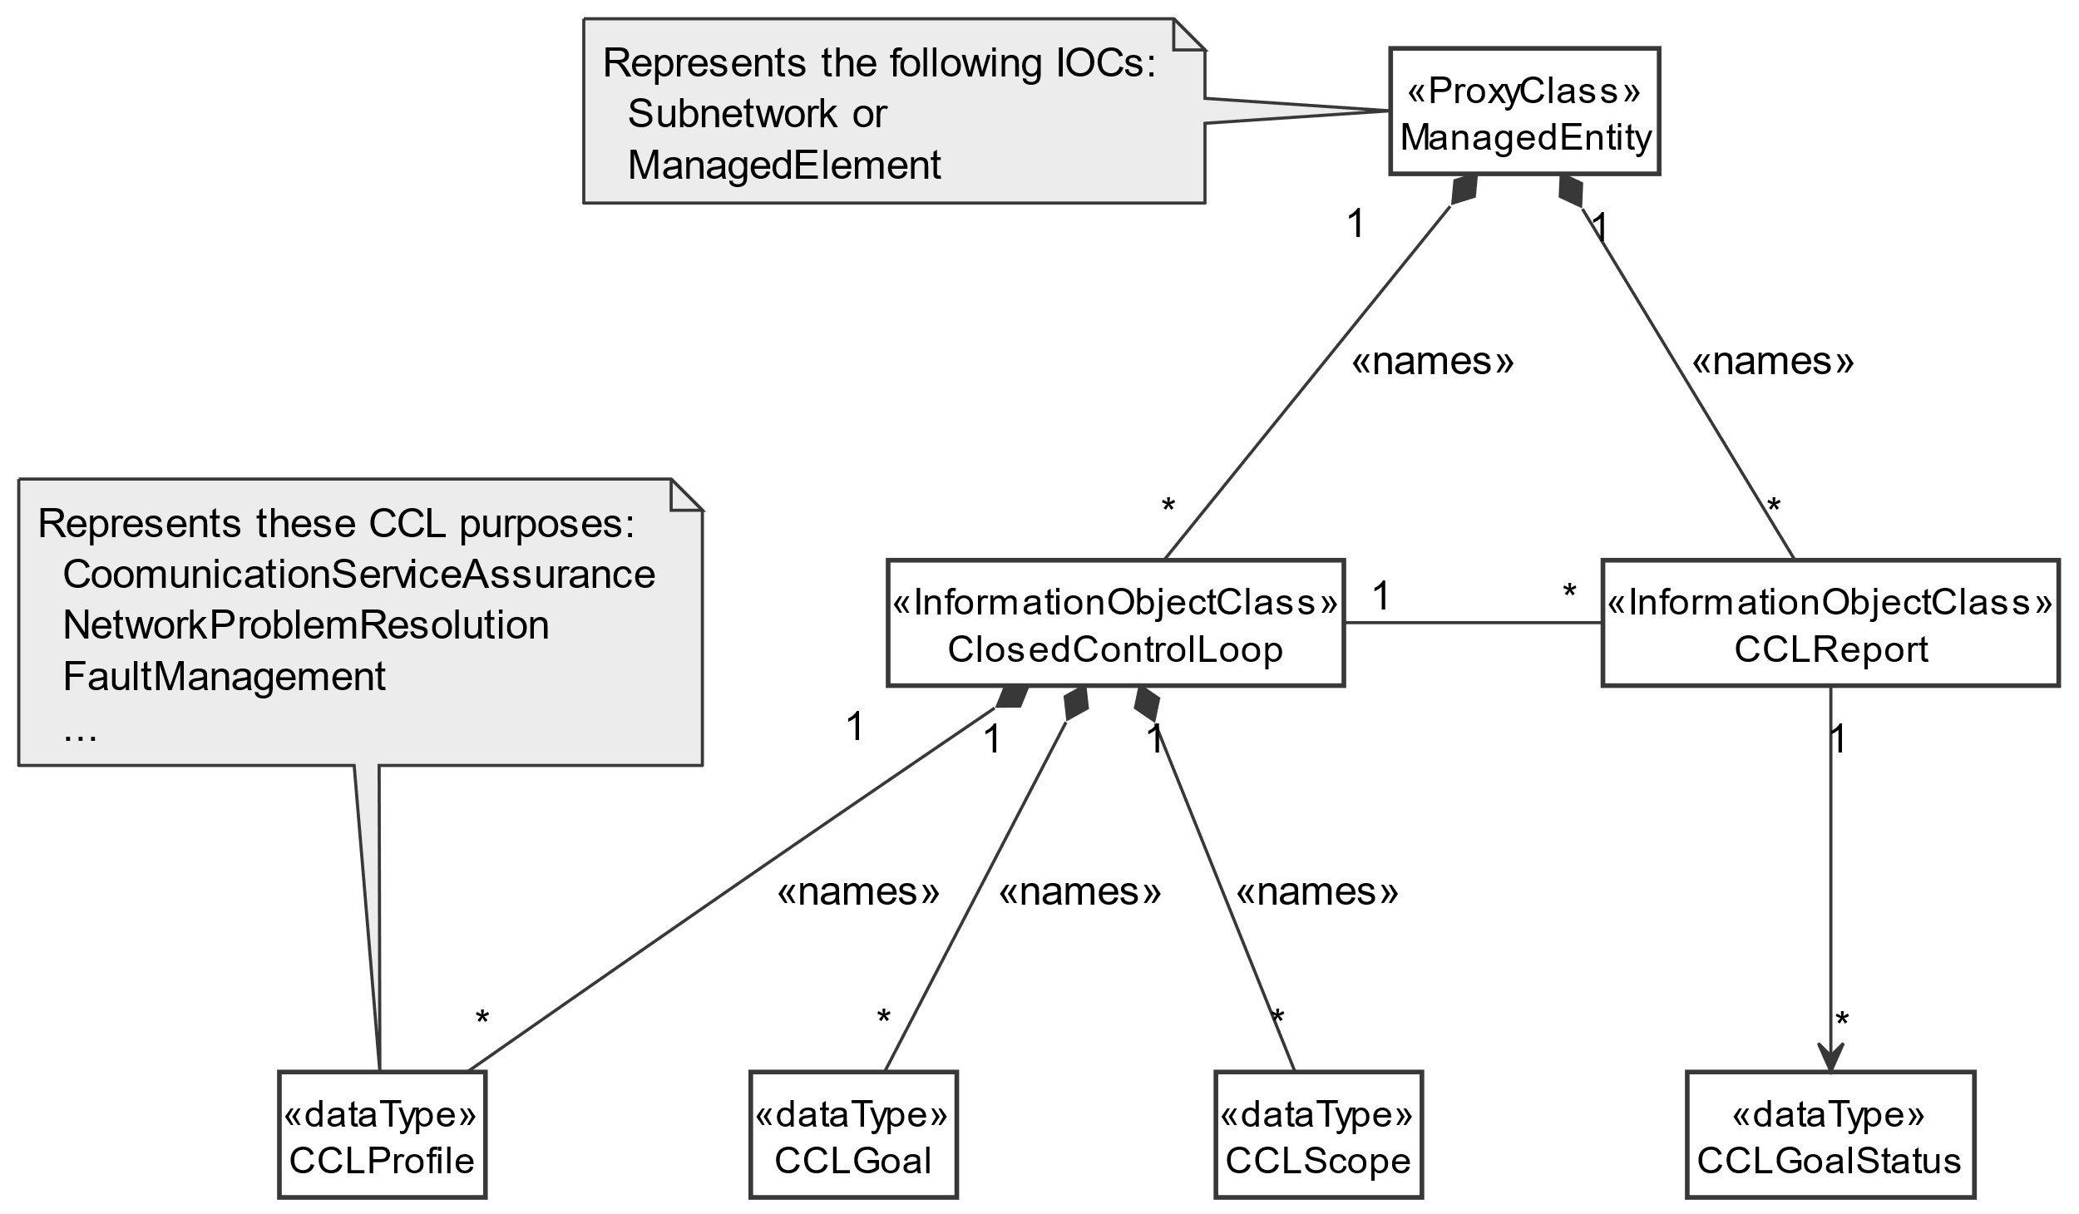

Figure X.1-1: Closed Control Loop NRM fragment

|  |
| --- |
| **End of modifications** |