**3GPP TSG-SA5 Meeting #158 *S5-246792rev1***

Orlando, USA, 18 - 22 November 2024

**Source:** **China Mobile, Nokia, NTT DOCOMO**

**Title: pCR Add Potential solution for Placement of NF Deployment instance**

**Document for: Approval**

**Agenda Item: 6.19.6**

# 1 Decision/action requested

***In this box give a very clear / short /concise statement of what is wanted.***

# 2 References

1. 3GPP TR 28.869 v1.1.0 Study on cloud aspects of management and orchestration.

# 3 Rationale

The contribution proposes to add a potential solution for Placement of NF Deployment instance, especially considering that “... Such industry solutions including ETSI NFV MANO and non ETSI NFV MANO can be used to address challenges related to NF Deployment instances e.g. for hybrid cloud deployments that deploy cloud native applications with hyperscale cloud providers” is described in clause 5.2.1.1 of this TR.

# 4 Detailed proposal

It proposes to make the following changes to TR 28.869 [1].

|  |
| --- |
| **1st Change** |

## 5.3 Support of different cloud deployment scenarios

### 5.3.1 Use case #1: Placement of NF Deployment instance

#### 5.3.3.1 Description

The distributed cloud deployment types enable the network to be deployed across different geographical locations. In this use case CSPs use the information about the available placement locations and resources in each, if available, to select the optimal location(s) for an NF. This provides the NOPs/CSPs with the choice of where a particular NF can be placed at the time of deployment. The parameters that can impact the choice of placement include geographical service area, performance in terms of latency and available bandwidth, as well as level of deployment complexity. In order to support distributed cloud deployments, the 3GPP management system needs to provide the capability for NOPs/CSPs to learn the available deployment locations.

NOTE :The mechanism to indicate the preferred placement of a particular NF is already supported by use of attribute 'locality' in the ManagedNfProfile datatype.

#### 5.3.3.2 Potential requirements

**REQ-1** The 3GPP management system should be able to collect information about the available deployment locations.

NOTE: The granularity of the location information is FFS.

#### 5.3.3.3 Potential solutions

As shown in figure 5.3.3.3-1, in this solution the 3GPP management system interacts with an orchestration and management entity over deployment management reference point for placement of NF Deployment instances to a specific location upon a request for a NF deployment.

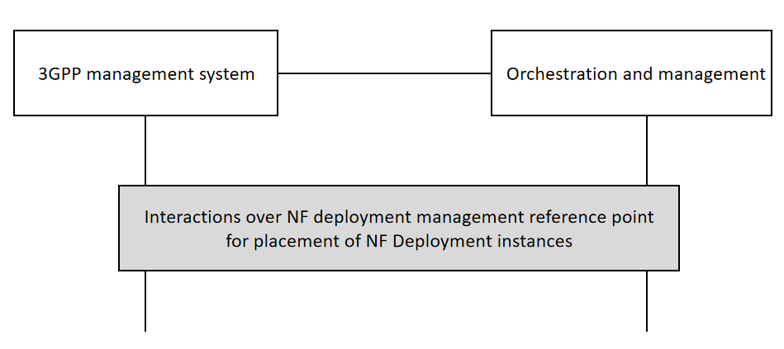

**Figure 5.3.3.3-1:** **High level procedure for placement of NF Deployment instances**

The 3GPP management requests placement of NF Deployment instance from an orchestration and management entity over the deployment management reference point upon a request for a deployment of a NF. The 3GPP management system can collect information about the available deployment locations from different orchestration and management entities,for the placement of NF Deployment instances.

If the relevant placement request is sent to ETSI NFV MANO through the deployment management reference point, NFV-MANO may need some related enhancements.

Editor’s Note: update the description of the solution, highlighting the impact to the 3GPP management system.

|  |
| --- |
| **End of Changes** |