3GPP TSG-SA5 Meeting #158 S5-246717
Orlando, USA, 18 - 22 November 2024

Source: Huawei, Ericsson, Nokia

Title: DP on way forward for Federated Network Information Model (FNIM)

Document for: Discuss and Endorsement
Agenda Item: 6.1

1 Decision/action requested
The group is asked to discuss and approval.

2 References
[1] S5-245781 Discussion paper on scope and cleanup of FNIM content.
[2] 3GPP TS 28.620 Telecommunication management; Fixed Mobile Convergence (FMC) Federated Network Information Model (FNIM) Umbrella Information Model (UIM).
[3] 3GPP TS 32.107 Telecommunication management; Fixed Mobile Convergence (FMC) Federated Network Information Model (FNIM).

3 Rationale
In SA5#157 meeting, S5-245781 was submitted and discussed, mainly focus on the 3 issues and 5 proposed options to address the issues for Federated Network Information Model (FNIM). Following are the issues documented in S5-245781：
/******************************Issues copied from S5-245781***********************/
Issue #1: The scope of TS 28.620 indicates that at the time of original publication is was necessary to define common model elements for wire-line and wireless networks. It is unclear whether such requirement is still valid for 3GPP SA5.
Issue #2: Numerous references to specifications in TS 28.620 have issues
Issue #3: The TMF solutions referenced include XML (MTOSI) and CORBA (MTNM) implementations. The relevance of these in context of the 3GPP SBMA architecture is unclear.
/******************************Issues copied from S5-245781***********************/

As S5-245781 described, the Federated Network Information Model (FNIM) which includes 8 abstract class (i.e. Domain_, ManagedElement_, Function_, ManagementSystem_, TopologicalLink_, TerminationPointEncapsulation_, LayerTermination_ and Top_) defined in TS 28.620 is initially developed for the context of FMC basic use cases for 3G and 4G, but all IOCs in 5G SBMA (including those IOCs in generic control NRM fragment, NR NRM fragment, 5GC NRM fragment and Network Slicing NRM fragment) are inherited from these abstract IOCs.
The group needs to take following aspects for consideration before discussing the detailed solution to address above identified issues.

Question#1: Whether the FMC feature is applicable for 5G network.
Observations for Question#1: TS 23.501 clause 4.2.8 described that the 5G System support Wireline access networks. The detailed information for wireless and wireline convergence access support for the 5G System specified in TS 23.316. So, it is obvious that 5G system support FMC feature.
Question#2: Whether the management use case and requirement for FMC management in TR 32.833 is applicable for management of 5G FMC feature.
Observations for Question#2: The use case and requirement for FMC management in TR 32.833 are not specific for any generations. So, it can be reused for the management of 5G FMC feature.
Question#3: Whether the content is TS 28.620 is applicable for 5G FMC management.
Observations for Question#3:
- The scope and 8 abstract classes (i.e. Domain_, ManagedElement_, Function_, ManagementSystem_, TopologicalLink_, TerminationPointEncapsulation_, LayerTermination_ and Top_) defined in TS 28.620 is generation agnostic and can be used for 5G. Also, all IOCs in 5G SBMA (including those IOCs in generic control NRM fragment, NR NRM fragment, 5GC NRM fragment and Network Slicing NRM fragment) are inherited from some of these abstract IOCs.
- In 3GPP Website, the TS 28.620 only applied for 3G and LTE.
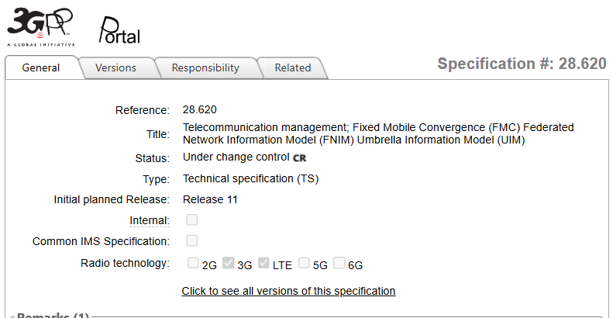

Based on above analysis, suggest to keep the TS 28.620 for 3G, LTE and 5G with following updates to address above issues (Similar as Potential Solution 2 proposed in S5-245781)
  - Update the 3GPP Website to indicate the TS 28.620 applied for 5G.
  - Update the references which have issues (e.g., invalid reference, old reference), including the reference [7], [8], [11], [14], [15], [16] in TS 28.620.
  - The TMF XML (MTOSI) and CORBA (MTNM) solution for FNIM are not referred by concrete 3GPP IOC implementation (including CORBA for 4G, YAML and YANG for 5G), TS 28.620 only described that for the instance whose class is defined by TM Forum, the format of the allowed values would be in conformant with that defined in TM Forum MTOSI SD1-25_objectNaming [16].

4 Detailed proposal
It is proposed to keep the TS 28.620 for 3G, LTE and 5G with following updates in Release 19
- Update the 3GPP Website to indicate the TS 28.620 is applied for 5G.
- Correct the TM Forum references in TS 28.620 which have issues (including ([7], [8], [11], [14], [15], [16]) and [17]).

Note: The action in above bullet 1 will be taken after the work in above bullet 2 is finished.

