**3GPP TSG-SA5 Meeting #158 *S5-246750rev1***

Orlando, USA, 18 - 22 November 2024

**Source: CSCN**

**Title: pCR 28.846 Add Possible Solution, Evaluation and Conclusion for satellite resource usage charging**

**Document for: Approval**

**Agenda Item: 7.5.1**

# 1 Decision/action requested

***The group is asked to discuss and approve the proposal.***

# 2 References

[1] 3GPP TS 28.846 Study on charging aspects of satellite access phase 3

[2] 3GPP TS 32.255 5G data connectivity domain charging; stage 2

# 3 Rationale

#### **3.1 satellite resource usage between SSP and MNO**

MNO can rent satellites from SSP which are to be used as a part of the backhaul between (R)AN and 5GC.

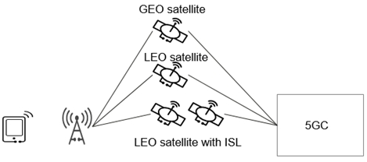

Figure 3-1: Example scenario that gNB has multiple candidate satellite backhauls

In order to enable GEO satellite edge computing, a UPF can be deployed on a satellite. Following figure shows a high-level architecture of Satellite Edge Computing via UPF on board.

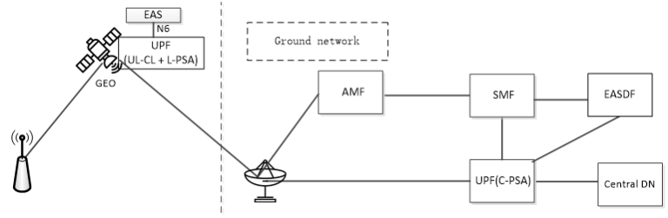

Figure 3-2: Satellite Edge Computing via UPF on-board

Editor's note: The above three figures are sourced from 3GPP TR 23.700-27 [3]

MNO has an agreement for rental of the satellite from SSP, and charging between MNO and SSP could be based on the total data volume transferred via the satellite or based on usage of satellite per EAS related to EAS deployment (EAS deployment, EAS modification, EAS termination) and infrastructure resource (virtual CPU usage, virtual memory usage, virtual disk usage, data volumes).

MNOs usually charge subscribers based on application-layer data, SSP can only collect the link-layer data utilized by each MNO. How to unify the charging data formats of both parties is worth considering.

#### **3.2 Existing interface for CHF to CHF**

N107 Reference point has been introduced for CHF to CHF in TS32.255[2].

Figure 3.2-1 depicts the 5G data connectivity converged charging architecture for roaming local breakout with V-CHF to H-CHF in reference point representation:

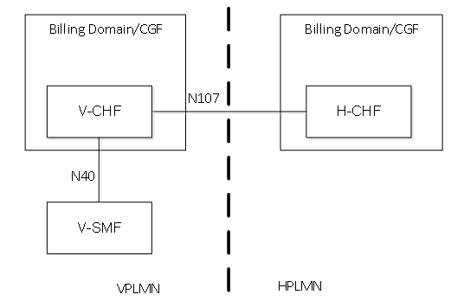

Figure 3.2-1: 5G data connectivity converged charging architecture in Local Breakout V-CHF to H-CHF scenario reference point representation

The N40 reference point is defined for the interactions between V-SMF and V-CHF, the N107 reference point is defined for the interactions between V-CHF and H-CHF.

For scenarios with MVNO (owning a CHF referred to as A-CHF) non-roaming, the N40 reference point is defined for the interactions between SMF and CHF owned by MNO, the N107 reference point is used for the interactions between CHF owned by the MNO and A-CHF owned by the MVNO.

# 4 Detailed proposal

This document proposes the following changes in TR 28.846 [1].

|  |
| --- |
| **First change** |

#### **6.3.4 Possible solutions**

#### **6.3.4.1 Solution #3.1: CDR in MNO for SSP to perform wholesale to MNO**

##### **6.3.4.1.1 General description**

A possible solution for key issue #3.1 and #3.2 covering requirements REQ-CH_ SAT_PH3_BH-01.

##### **6.3.4.1.2 Architecture description**



Figure 6.3.4.1.2-1: satellite resource usage charging architecture

The SMF and CEF interact with CHF using Nchf interface. The CHF produces CDRs which may be send for wholesale charging which then can be used to aggregate and calculate the amount of charging data per SSP separately. The wholesale part is only included for completeness and is currently outside the scope of 3GPP SA5.

SMF collect charging data related to satellite backhaul (satellite backhaul category, data volumes) for each subscriber.

CEF collect charging data related to EAS deployment (EAS deployment, EAS modification, EAS termination) and infrastructure resource (virtual CPU usage, virtual memory usage, virtual disk usage, data volumes).

##### **6.3.4.1.3 Procedures description**

The message flows for satellite backhaul for each subscriber would be the same as in clause 5.2.2 of TS 32.255.The CHF produces CDRs which may be send for wholesale charging which then can be used to aggregate and calculate the amount of charging data per SSP separately.

The message flows for infrastructure resource usage would be the same as in clause 5.2.2 of TS 32.257. The CHF produces CDRs which may be send for wholesale charging which then can be used to aggregate and calculate the amount of charging data per SSP separately.

The message flows for EAS deployment would be the same as in clause 5.2.3 of TS 32.257. The CHF produces CDRs which may be send for wholesale charging which then can be used to aggregate and calculate the amount of charging data per SSP separately.

#### **6.3.4.2 Solution #3.2: CDR in MNO for SSP with CHF to perform wholesale to MNO**

##### **6.3.4.2.1 General**

A possible solution for key issue #3.1 and #3.2 covering requirements REQ-CH_ SAT_PH3_BH-01.

##### **6.3.4.2.2 Reference architecture**

The architecture for MNO-CHF to SSP-CHF communication to support the charging for satellite resource usage between SSP and MNO is expected as illustrated by the figure:



Figure 6.3.4.2.2-1: CHF to CHF communication for satellite resource usage charging

The Nx reference point is used for the interactions between CHF owned by MNO and CHF owned by SSP.

The SMF and CEF interact with CHF using Nchf interface.

SMF collect charging data related to satellite backhaul (satellite backhaul category, data volumes) for each subscriber.

SMF collect charging data related to Local switch (satellite backhaul category, data volumes) for each subscriber.

CEF collect charging data related to EAS deployment (EAS deployment, EAS modification, EAS termination) and infrastructure resource (virtual CPU usage, virtual memory usage, virtual disk usage, data volumes).

The CDRs produced by MNO CHF may be sent to SSP CHF for wholesale charging through Nx interface, which then can be used to aggregate and calculate the amount of charging data per SSP separately. The wholesale part is only included for completeness and is currently outside the scope of 3GPP SA5.

Note: MNO and SSP can be provided by the same enterprise, then SSP can own CHF in satellite resource usage charging scenario.

##### **6.3.4.2.3 Procedures description**

The message flows for satellite backhaul for each subscriber would be the same as in clause 5.2.2 of TS 32.255.The CHF produces CDRs which may be send for wholesale charging which then can be used to aggregate and calculate the amount of data per SSP separately.

The message flows for infrastructure resource usage would be the same as in clause 5.2.2 of TS 32.257. The CHF produces CDRs which may be send for wholesale charging which then can be used to aggregate and calculate the amount of data per SSP separately.

The message flows for EAS deployment would be the same as in clause 5.2.3 of TS 32.257. The CHF produces CDRs which may be send for wholesale charging which then can be used to aggregate and calculate the amount of data per SSP separately.

### **6.3.5 Evaluation**

Solutions #3.1 and #3.2 both solve key issues #3.1 and #3.2. Solution #3.1 has no impact on the network architecture. Solution #3.2 requires the SSP to own a CHF then the CDRs produced by MNO CHF may be sent to SSP CHF for wholesale charging through Nx interface.

### **6.3.6 Conclusion**

It is concluded that the solution #3.1 and solution #3.2 are the feasible solutions. CHF to CHF communication to support satellite resource usage charging can be taken into normative work.

|  |
| --- |
| **End of change** |