**3GPP TSG-SA5 Meeting #158 *S5-246749rev1***

Orlando, USA, 18 - 22 November 2024

**Source: CSCN**

**Title: pCR 28.846 Add Charging requirements and Key issues for satellite resource usage charging**

**Document for: Approval**

**Agenda Item: 7.5.1**

# 1 Decision/action requested

***The group is asked to discuss and approve the proposal.***

# 2 References

[1] 3GPP TS 28.846 Study on charging aspects of satellite access phase 3

[2] 3GPP TS 23.501 System architecture for the 5G System (5GS)

[3] 3GPP TR 23.700-27 Study on 5G System with Satellite Backhaul

# 3 Rationale

MNO can rent satellites which are to be used as a part of the backhaul between (R)AN and 5GC.

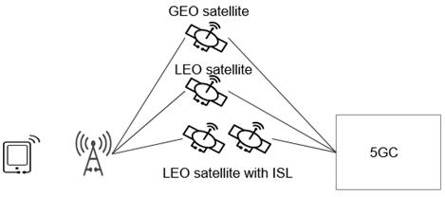

Figure 3-1: Example scenario that gNB has multiple candidate satellite backhauls

In order to enable GEO satellite edge computing, a UPF can be deployed on a satellite. Following figure shows a high-level architecture of Satellite Edge Computing via UPF on board.

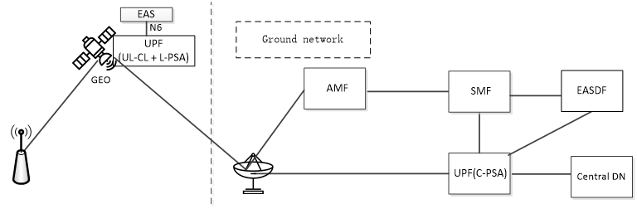

Figure 3-2: Satellite Edge Computing via UPF on-board

Editor's note: The above three figures are sourced from 3GPP TR 23.700-27 [3]

MNO has an agreement for rental of the satellite from SSP, and charging between MNO and SSP could be based on the total data volume transferred via the satellite or based on usage of satellite per EAS related to EAS deployment (EAS deployment, EAS modification, EAS termination) and infrastructure resource (virtual CPU usage, virtual memory usage, virtual disk usage, data volumes).

MNOs usually charge subscribers based on application-layer data, SSP can only collect the link-layer data utilized by each MNO. How to unify the charging data formats of both parties is worth considering.

# 4 Detailed proposal

This document proposes the following changes in TR 28.846 [1].

|  |
| --- |
| **First change** |

### **6.3.2 Potential charging requirements**

**REQ-CH_ SAT_PH3_BH-01**: The 5GS should support collecting and converging charging information related to satellite backhaul service or edge computing for per SSP separately.

### **6.3.3 Key issues**

#### **6.3.3.1 Key issue #3.1: Charging information required**

This key issue is for investigating how to support the charging for satellite resource usage between SSP and MNO considering REQ-CH_ SAT_PH3_BH-01. This investigation covers the following:

- identification of charging information required to support the satellite resource usage charging.

#### **6.1.3.2 Key issue #3.2: Charging architecture and procedure**

This key issue is for investigating how to support the charging for satellite resource usage between SSP and MNO considering REQ-CH_ SAT_PH3_BH-01. This investigation covers the following:

- identification of the charging architecture for the satellite resource usage between SSP and MNO;

- identification of how to conveying of charging information from MNO to SSP for SSP to perform wholesale charging to MNO.

|  |
| --- |
| **End of change** |