**3GPP SA4 #130 S4-241910**

**Orlando, US, November 18 - 22, 2024**

|  |  |  |  |  |  |  |  |  |
| --- | --- | --- | --- | --- | --- | --- | --- | --- |
| *CR-Form-v12.0* | | | | | | | | |
| **PSEUDO CHANGE REQUEST** | | | | | | | | |
|  | | | | | | | | |
|  | **26.822** | **CR** | pseudo | **rev** | **-** | **Current version:** | **1.0.0** |  |
|  | | | | | | | | |
| *For* [***HE******LP***](http://www.3gpp.org/3G_Specs/CRs.htm#_blank)*on using this form: comprehensive instructions can be found at* [*http://www.3gpp.org/Change-Requests*](http://www.3gpp.org/Change-Requests)*.* | | | | | | | | |
|  | | | | | | | | |

|  |  |  |  |  |  |  |  |  |
| --- | --- | --- | --- | --- | --- | --- | --- | --- |
| ***Proposed change affects:*** | UICC apps |  | ME | **x** | Radio Access Network |  | Core Network |  |

|  |  |  |  |  |  |  |  |  |  |  |
| --- | --- | --- | --- | --- | --- | --- | --- | --- | --- | --- |
|  | | | | | | | | | | |
| ***Title:*** | **[FS_5G_RTP_Ph2] Indication of the time gap within a data burst** | | | | | | | | | |
|  |  | | | | | | | | | |
| ***Source to WG:*** | Qualcomm Incorporated | | | | | | | | | |
| ***Source to TSG:*** |  | | | | | | | | | |
|  |  | | | | | | | | | |
| ***Work item code:*** | FS_5G_RTP_Ph2 | | | | |  | ***Date:*** | | | 11/18/2024 |
|  |  | | | |  | |  | | |  |
| ***Category:*** | **B** |  | | | | | ***Release:*** | | | Rel-19 |
|  | *Use one of the following categories:* ***F*** *(correction)* ***A*** *(mirror corresponding to a change in an earlier release)* ***B*** *(addition of feature),* ***C*** *(functional modification of feature)* ***D*** *(editorial modification)*  Detailed explanations of the above categories can be found in 3GPP [TR 21.900](http://www.3gpp.org/ftp/Specs/html-info/21900.htm). | | | | | | | | *Use one of the following releases: Rel-10 (Release 10) Rel-11 (Release 11) Rel-12 (Release 12)* *Rel-13 (Release 13) Rel-14 (Release 14) Rel-15 (Release 15) Rel-16 (Release 16)*  *Rel-17 (Release 17)*  *Rel-18 (Release 18)* | |
|  |  | | | | | | | | | |
| ***Reason for change:*** | | One aspect of Key issue 12: Enhancements of Data Burst Marking  When a data burst consists of multiple PDU Sets, there may be a time gap between the adjacent PDU Sets. This structure may be important for the application server and the base station:   * For the application server, it needs to decide which PDU Sets are grouped into a single data burst and this has implications on the trade-off between the prediction accuracy for the data burst characteristics and the delay * For the base station, it can use the time gap to decide when to stop waiting for the end of the data burst in case the rest of the data burst is lost in the network.   It is important to have an agreement on such time gap between the network and the traffic source. | | | | | | | | |
|  | |  | | | | | | | | |
| ***Summary of change:*** | | Added the motivation for signaling the time gap and potential solutions. | | | | | | | | |
|  | |  | | | | | | | | |
| ***Consequences if not approved:*** | | The data burst may not be as useful as intended. | | | | | | | | |
|  | |  | | | | | | | | |
| ***Clauses affected:*** | |  | | | | | | | | |
|  | |  | | | | | | | | |
|  | | **Y** | **N** |  | | | |  | | |
| ***Other specs*** | |  |  | Other core specifications | | | | TS/TR ... CR ... | | |
| ***affected:*** | |  |  | Test specifications | | | | TS/TR ... CR ... | | |
| ***(show related CRs)*** | |  |  | O&M Specifications | | | | TS/TR ... CR ... | | |
|  | |  | | | | | | | | |
| ***Other comments:*** | |  | | | | | | | | |
|  | |  | | | | | | | | |
| ***This CR's revision history:*** | |  | | | | | | | | |

.

* * * * 1st change (All New) * * * *

## 6.x Solution #x: Indication of the time gap in a data burst

### 6.x.1 Key Issue mapping

This maps to Key Issue #12.

### 6.x.2 The significance of the time gap

In 3GPP TS23.501[3], the data burst is defined as follows:

***Data Burst:*** *A set of multiple PDUs generated and sent by the application in a short period of time.*

*NOTE 1: A Data Burst can be composed of one or multiple PDU Sets.*

It is not clear what short means. When there are multiple PDU Sets in a data burst, there may be significantly larger time gaps between PDU Sets than the time gaps of PDUs within a PDU Set. This is seen in Figure 6.x-1, measured from an experiment detailed in 6.x.4. The time gap varies significantly. The figure shows the packet departure times vs the packet size at a split rendering server. At the blue circle (at time around 150ms), the time gap between the audio packets and the left video packets is 0.6ms, while at the red circle (at time around 170ms), it is 2.6ms.

The first question is how the server groups the PDU Sets. This has the implication on the tradeoff between the accuracy of the indication of the time to the next data burst (TTNB) and the size of the data burst. For example, at the blue circle, if the burst size is carried in an audio packet, the server needs to predict the size of the left video frame. Such prediction will come with an error, even if the left video frame size is known for certain at the time of the first video packet is generated and transmitted.

The second question is how the network should handle the indicated burst infomration. For example, if the second PDU Set is dropped by a DropTail router, the RAN does not know how long it needs to wait for the arrival of the end of the data burst. For example, at the red circle, if the audio packets are dropped by a router, the RAN may have to wait way beyond the time gap and this negatively affects the DRX operation.

If two PDU Sets (or groups of PDUs) are separated by a small time gap (which may be predictable in some instances, e.g., periodic video and periodic autido but with different periodicity), grouping them into a single data burst gives the RAN early information about the size of the upcoming traffic which could make resource allocation more efficient. This may not lead to error in the burst size because the size of the audio frame often is fixed at least in some implementations and the size of the video frame may be known at the time of transmtting the first video packet.

Therefore, it is important to have an agreement between the traffic soruce and the network on the time gaps within a data burst.

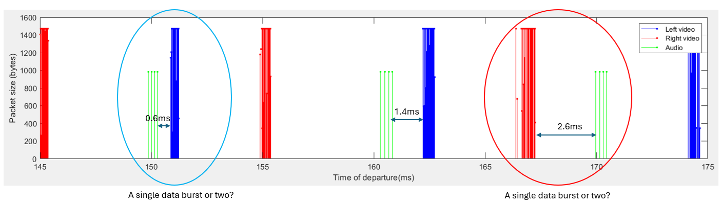

Figure 6.x-1 The time gap between PDU Sets at the egress of a split rendering server

### 6.x.3 The indication of the time gap within a data burst

To reduce the sginaling overhead while still providing the important information about the time gap, the maximum time gap can be considered being signaled. This leads to the following proposal.

**Proposal:** Consider normative work on indicating the maximum time gap within a data burst:

**Option 1:** the network tells the traffic source a maximum time gap that the traffic source is to use when grouping packets into a data burst.

**Option 2:** the traffic source indicats the maximum time gap within a data burst, and the indication can be made in an RTP header extension.

NOTE: this needs to be coordinated with SA2/RAN2.

### 6.x.4 The experimental setup

The setup is shown in Figure 6.x-2, where the HMD is connected to a split rendering server that performs split rendering via Wi-Fi 6 (IEEE 802.11ax). The content is Steam VR with complex graphics. The video codec is a commercial hardware HEVC codec with the IPPP GOP structure. The video frame rate is driven by the display refresh rate, which is 90 FPS. The audio frame rate is 100 FPS.

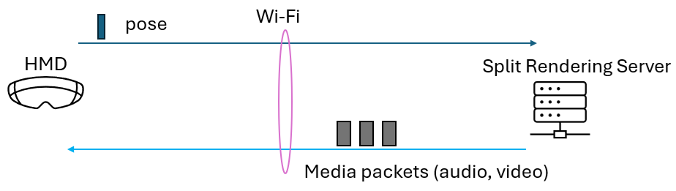

Figure 6.x-2 Experimental setup for measuring the paket departure times for split XR

* * * * End of 1st change * * * *